MY FEEDBACK FORM

S/N | PARAMETER | RESPONSE LEVEL
 |  | YES  (5 points) | NO  (0 points) | NOTSURE  (3points)
1 | Are you learning valuable information? | yes
2 | Are the explanations of concepts clear? | yes
3 | Is the Instructor’s delivery engaging? | yes
4 | Are there enough helpful practice activities? |  |  | Not sure
5 | Was the course description accurate? |  |  | Not sure
6 | Is the instructor knowledgeable about the topic? | yes
TOTAL SCORE |  | 20 | 0 | 6
FINAL REMARKS |  | NONE
EXCELLENT (5POINTS) |  | 4
FAIR (3 POINT) |  | 2
POOR (0 POINTS) |  | 0

NAME/SIGNATURE/DATE: GOODHEAD IBIGOMIE ISAAC; 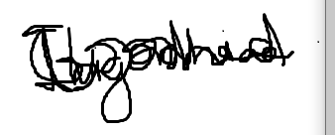.; 30TH APRIL

