SANI AHMAD DAHIRU
17/ENG03/049
CIVIL ENGINEERING

1a) Methods of levelling
Height of collimation system
Advantages
- It is rapid as it involves few Calculation
- There are two checks on the accuracy of RL calculation
- This system is suitable for longitudinal leveling where number of intermediate sights
- Visualization is not necessary regarding the nature of the ground
Disadvantages
- There is no check on the RL of the intermediate sight
- Errors in the intermediate RLs cannot be detected.

Rise and fall system
Advantages
- There is a check on the RL of the intermediate points
- Errors in the intermediate RLs can be detected as all the points are correlated
- There are three checks on the accuracy of RL calculation
- This system is suitable where there are no intermediate sights
Disadvantages
- It is laborious involving several calculations.
- Visualization is necessary regarding the nature of the ground

1b)

B.S | I.S | F.S | H OF C | R.L | DISTANCE
0.771 |  |  | 159.771 | 161 | 10
0.802 |  | 1.52 | 159.053 | 158.251 | 20
 | 2.311 |  |  | 156.742 | 30
3.580 |  | 1.990 | 160.643 | 157.063 | 40
 | 1.220 |  |  | 159.423 | 50
 | 3.675 |  |  | 156.968 | 60
2.408 |  | 4.020 | 159.031 | 156.623 | 70
 | 0.339 |  |  | 156.692 | 80
0.780 |  | 0.157 | 159.654 | 158.874 | 90
 | 1.535 |  |  | 158.119 | 100
 | 1.955 |  |  | 157.699 | 110
 | 2.430 |  |  | 157.224 | 120
 | 2.985 |  |  | 156.669 | 130
1.155 |  | 3.480 | 157.329 | 156.174 | 140
 | 1.960 |  |  | 155.369 | 150
 | 2.365 |  |  | 154.964 | 160
0.935 |  | 3.640 | 154.624 | 153.689 | 170
 | 1.045 |  |  | 153.579 | 180
 | 1.630 |  |  | 152.994 | 190
 |  | 2.545 |  | 152.079 | 200
$Σ$=10.431 |  | $Σ$=17.352

Check=$ΣF.S-ΣB.S$=R.L at first point-R.L at last point
=6.921=6.921

HC= RL + BS
HC(1) = 159+0.771=159.771
RL = HC-FS
RL(1)=159.771-1.52=158.251
HC(2)= 158.251+ 0.802=159.053
RL(2)= 159.053 – 2.311 =156.742
RL(3)=159.053-1.990=157.063
HC(3)=157.063+3.580=159.643
RL(4)=160.643-1.220=159.423
RL(5)=160.643-3.675=156.968
RL(6)=160.643-4.020=156.623
HC(4)=156.623+2.408=157.031
RL(7)= 154.031-0.339=158.692
RL(8)= 159.031-0.157=158.874
HC(5)=159.654+0.780=159.654
RL(9)= 159.654-1.535=158.119
RL(10)= 159.654-1.955=157.699
RL(11)= 159.654-2.430=157.224
RL(12)= 159.654-2.985=156.669
RL(13)= 159.654-3.480=156.174
HC(6)=157.329+1.155=155.329
RL(14)= 157.329-1.960=153.369
RL(15)= 157.329-2.365=153.964
RL(16)= 157.329-3.640=153.689
HC(7)=153.689+0.935=154.624
RL(17)= 154.624-1.045=153.579
RL(17)= 154.624-1.630=152.994
RL(17)= 154.624-2.545=152.079

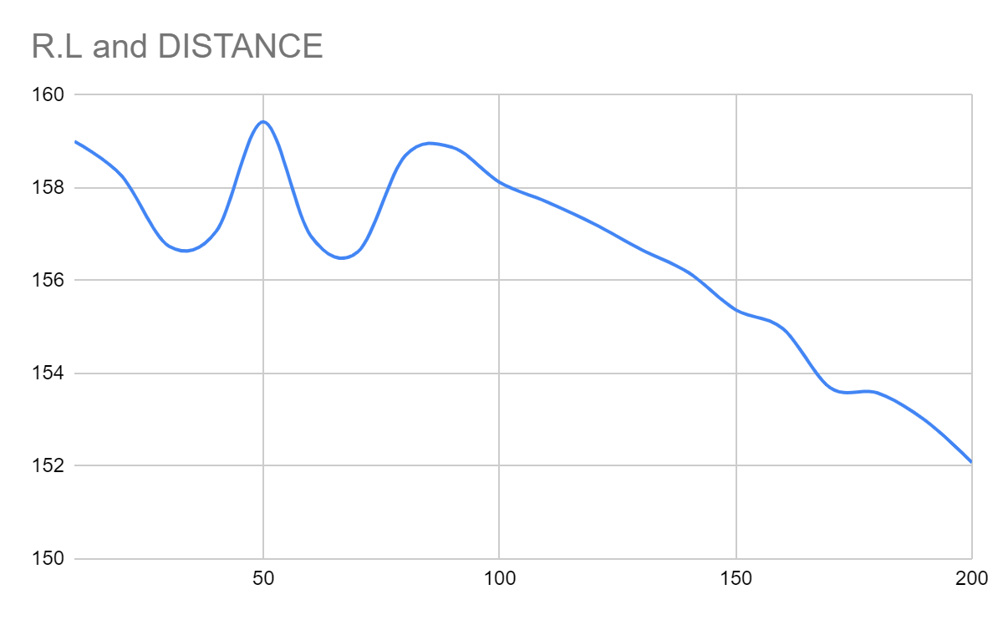

QUESTION 2

Chainage(m) | 0 | 30 | 60 | 90 | 120 | 150 | 180 | 210 | 240 | 270
Offset length(m) | 0 | 2.65 | 3.80 | 3.75 | 4.65 | 3.60 | 5.00 | 5.80 | 6.10 | 5.85

Using Mid-ordinate rule:
A=$Σ$hd

h1= $\frac{0+2.65}{2}$=1.325m

h2= $\frac{2.65+3.80}{2}$=3.225m

h3= $\frac{3.80+3.75}{2}$=3.775m

h4= $\frac{3.75+4.65}{2}$=4.2m

h5= $\frac{4.65+3.60}{2}$=4.125m

h6= $\frac{3.60+5.00}{2}$=4.3m

h7= $\frac{5.00+5.80}{2}$=5.4m

h8= $\frac{5.80+6.00}{2}$=5.9m

h9= $\frac{6.00+5.85}{2}$=5.925m

$$Σh=1.325+3.225+3.775+4.2+4.125+4.3+5.4+5.9+5.925$$
$Σh=$38.175m

d=30m
A=$Σhd$
= $38.175×30$
A= $1145.25m{}^{2}$

Using average ordinate rule

A=$\frac{ndΣO}{n+1}$

n=9

d=30
$$ΣO=0+2.65+3.80+3.75+4.65+3.60+5.00+5.80+6.10+5.85$$
$ΣO=$41.2m

A=$\frac{9×30×41.2}{9+1}$

A=$112.4m{}^{2}$

Using trapezoidal rule

A=$d(\frac{0{}_{1}+0{}_{n }}{2}+0{}_{2}+0{}_{3}+0{}_{4}............0{}_{n-1})$

$$d=30$$

A=$30(\frac{0+5.85}{2}+2.65+3.80+3.75+4.65+3.60+5.00+5.80+6.10)$

A=$30(38.275)$
A=$1148.25m{}^{2}$

Using Simpson's rule
$$A=\frac{d }{3 }\left[\left(0{}_{1}+0{}_{n}\right)+4\left(0{}_{2}+0{}_{4}+.........0{}_{n-1}\right)+2\left(0{}_{3}+0{}_{5}........0{}_{n-1}\right)\right]$$

$$d=30$$

Note: Last offset was removed because number of offsets were even

$$A=\frac{30}{3 }\left[\left(0+6.10\right)+4\left(2.65+3.75+3.60+5,80\right)+2\left(3.80+4.65+5.00\right)\right]$$
$$A=962m{}^{2}$$

Calculating for last offset using trapezoidal rule

A=$d(\frac{0{}_{1}+0{}_{n }}{2}+0{}_{2}+0{}_{3}+0{}_{4}............0{}_{n-1})$

$$A=30\left[\frac{6.40+5.85}{2}\right]$$
$$A=183.75m{}^{2}$$

Therefore $ΣA=962+183.75$

$$A=1145.75m{}^{2}$$

2b) Characteristics of contour lines include:

- Contour lines cross a watershed or ridge line at right angles. They form curves of U-shape round it with the concave side of the curve towards the higher ground.
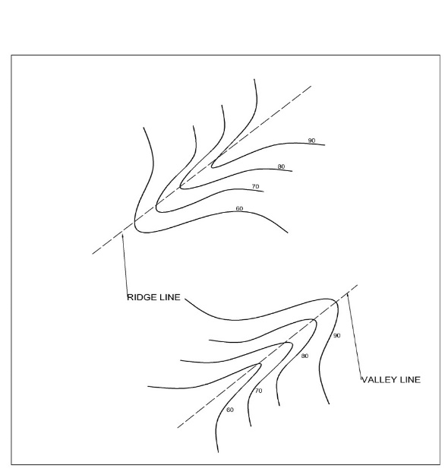
- Contour lines with V-shaped with convexity towards higher ground at right angles indicate valley.
- Contour lines meeting at a point indicate a vertical cliff.
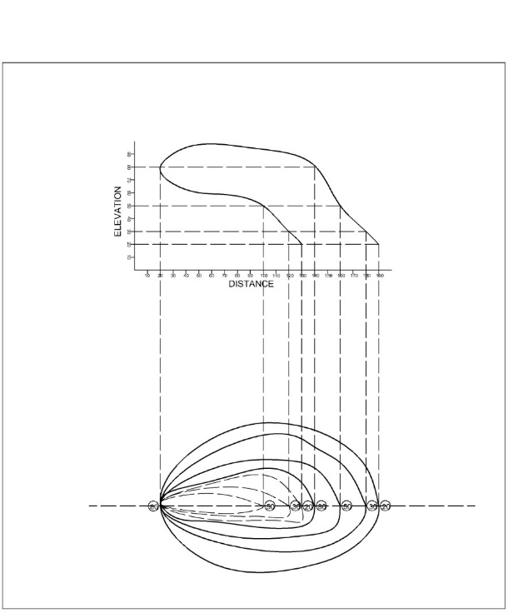

- A series of closed contour lines on the map indicates a depression if the higher values are outside.
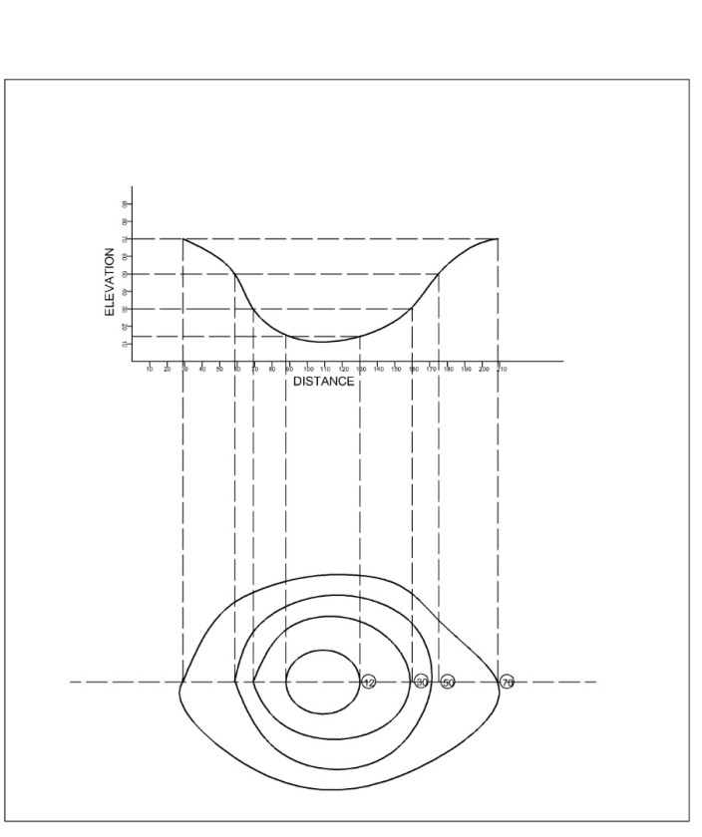
- A series of closed contour lines on the map represents a hill, if the values are inside.

