LAWAL ATINUKE HEPHZIBAH

CHEMICAL ENGINEERING

ENG222

18/ENG01/013

ZENER DIODE
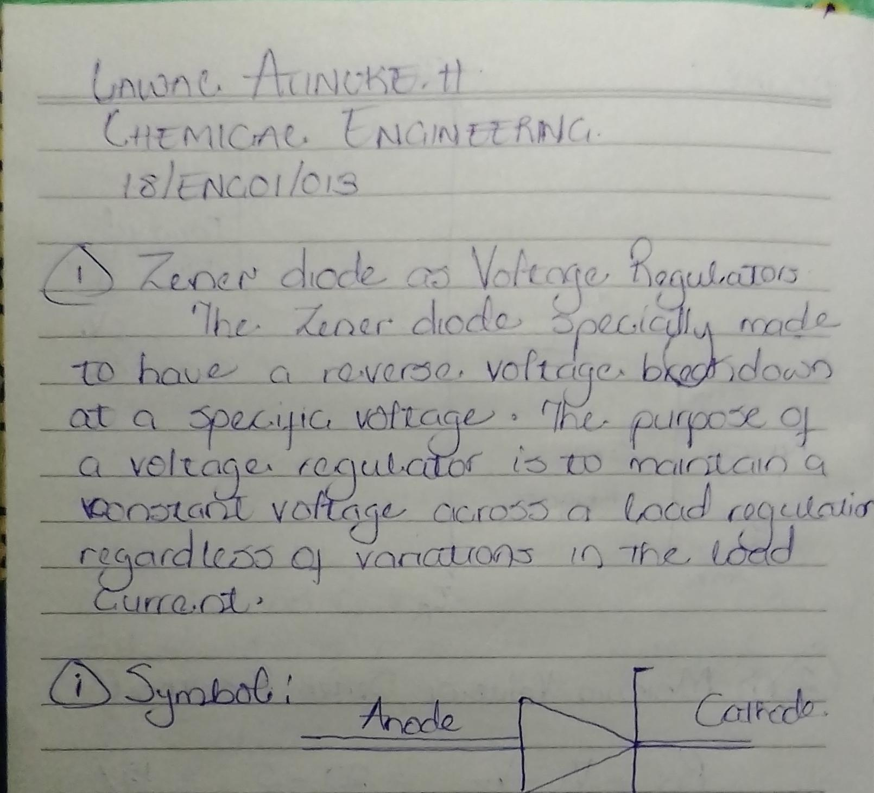
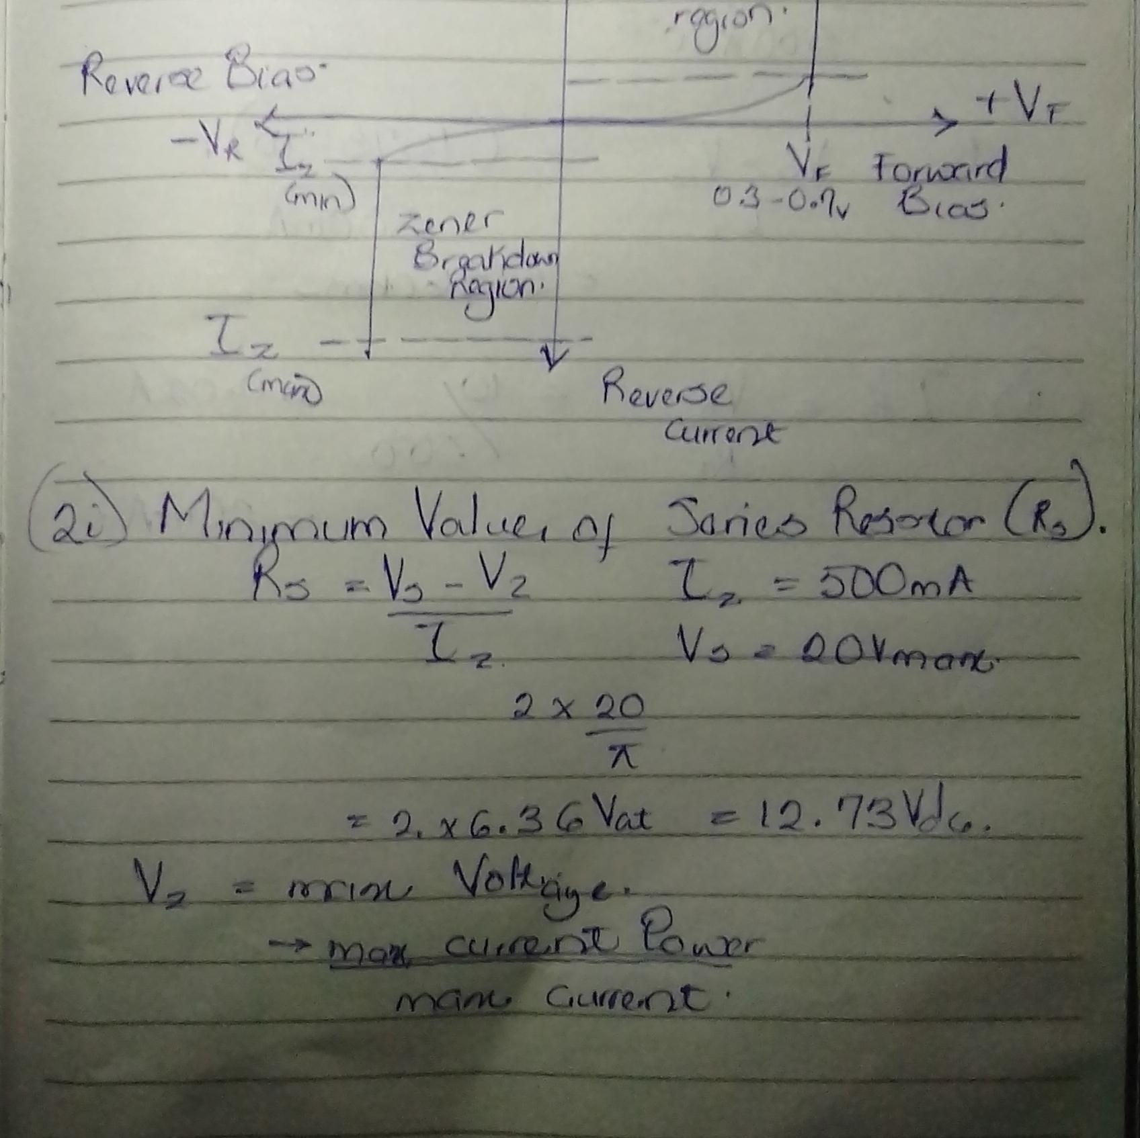
Z
