THOMPSON .C ARNOLD
18/ENG05/060
MECHATRONICS ENGIMEERING
ENG 222
BASIC ELECTRICAL ENGINEERING

- Describe a Zener diode regulator, and:
- Sketch the symbol and I-V characteristics curve

With Signal Diode, the “reverse biased” diode blocks current in the reverse direction, but will suffer from premature breakdown or damage if the reverse voltage applied across it is too high.
However, the Zener Diode or “Breakdown Diode” as they are sometimes called, are basically the same as the standard PN junction diode but are specially designed to have a low pre-determined Reverse Breakdown Voltage that takes advantage of this high reverse voltage. The zener diode is the simplest types of voltage regulator and the point at which a zener diode breaks down or conducts is called the “Zener Voltage” ( Vz ).
The Zener diode is like a general-purpose signal diode consisting of a silicon PN junction. When biased in the forward direction it behaves just like a normal signal diode passing the rated current, but as soon as a reverse voltage applied across the zener diode exceeds the rated voltage of the device, the diodes breakdown voltage is reached at which point a process called Avalanche Breakdown occurs in the semiconductor depletion layer and a current starts to flow through the diode to limit this increase in voltage.

Zener Diode I-V CharacteristicsjsdksjJJJh

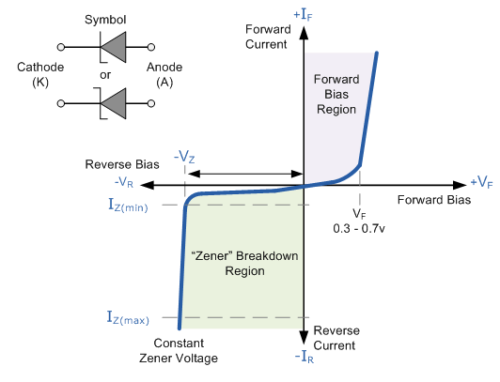

The Zener Diode is used in its “reverse bias” or reverse breakdown mode, i.e. the diodes anode connects to the negative supply. From the I-V characteristics curve above, we can see that the zener diode has a region in its reverse bias characteristics of almost a constant negative voltage regardless of the value of the current flowing through the diode and remains nearly constant even with large changes in current as long as the zener diodes current remains between the breakdown current I_{Z(min)} and the maximum current rating I_{Z(max)}.

This ability to control itself can be used to great effect to regulate or stabilise a voltage source against supply or load variations. The fact that the voltage across the diode in the breakdown region is almost constant turns out to be an important application of the zener diode as a voltage regulator.
The function of a regulator is to provide a constant output voltage to a load connected in parallel with it in spite of the ripples in the supply voltage or the variation in the load current and the zener diode will continue to regulate the voltage until the diodes current falls below the minimum I_{Z(min)} value in the reverse breakdown region.

- Sketch and label the circuit diagram

Zener Diode Regulator

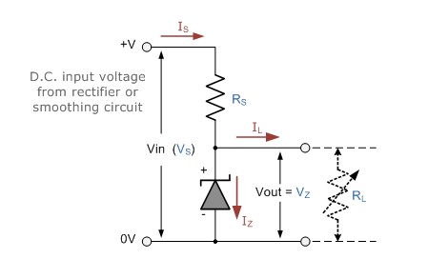

The resistor, R_{S} is connected in series with the zener diode to limit the current flow through the diode with the voltage source, V_{S} being connected across the combination. The stabilised output voltage V_{out} is taken from across the zener diode. The zener diode is connected with its cathode terminal connected to the positive rail of the DC supply so it is reverse biased and will be operating in its breakdown condition. Resistor R_{S} is selected so to limit the maximum current flowing in the circuit.
With no load connected to the circuit, the load current will be zero, ( I_{L} = 0 ), and all the circuit current passes through the zener diode which in turn dissipates its maximum power.
Also, a small value of the series resistor R_{S} will result in a greater diode current when the load resistance R_{L} is connected and large as this will increase the power dissipation requirement of the diode.
The load is connected in parallel with the zener diode, so the voltage across R_{L} is always the same as the zener voltage,
( V_{R} = V_{Z} )

Example
Zener Diode Example
A 5.0V stabilised power supply is required to be produced from a 12V DC power supply input source. The maximum power rating P_{Z} of the zener diode is 2W. Using the zener regulator circuit above calculate:
- The maximum current flowing through the zener diode.
- The minimum value of series resistor R_{S}
- The load current I_{L} if the 1 kΩ is connected across the diode
- The Zener current I_{Z} at full load
Solution

a. The maximum current flowing through the Zener diode

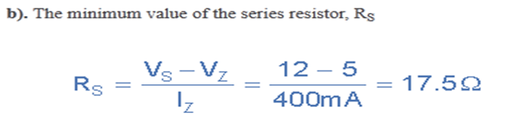

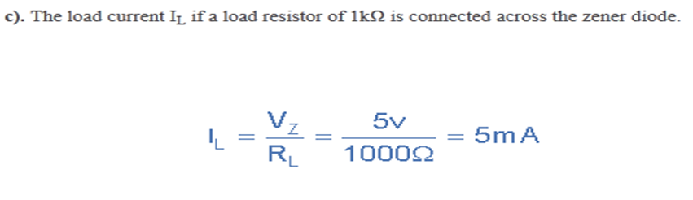
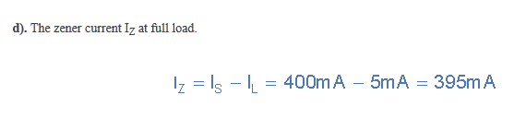

- Max power = 5w I2=500ma=0.5a , 20vmax

- Maximum current= max power = 5w =0.5a
Voltage v

V2=10volts
Minimum resistance = vs-vz
Iz

Vdc=0.637vmax
=0.637*20
=12.73vdc

Minimum resistance = 12.74-10 =5.48
0.5

- Load current Ic= Vz = 10 =0.02a or 20ma
Rl 500

Iz=Is-Ib
=500-20=480mA

