- A zener diode is always operated in its reversed biased condition. As such a simple voltage regulator circuit can be designed using a zener diode to maintain a constant dc output voltage across the load in spite of variations in the input voltage or changes in the load current.
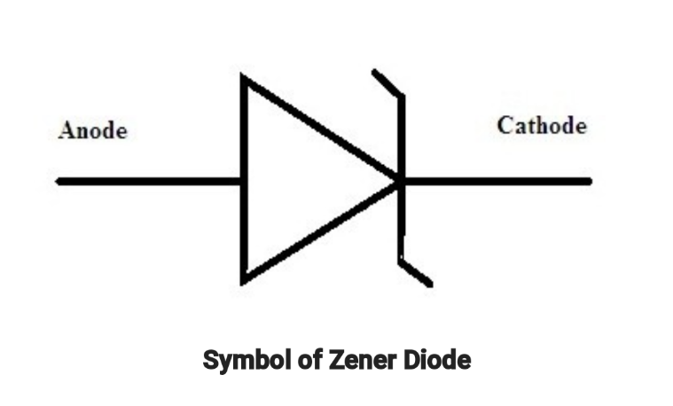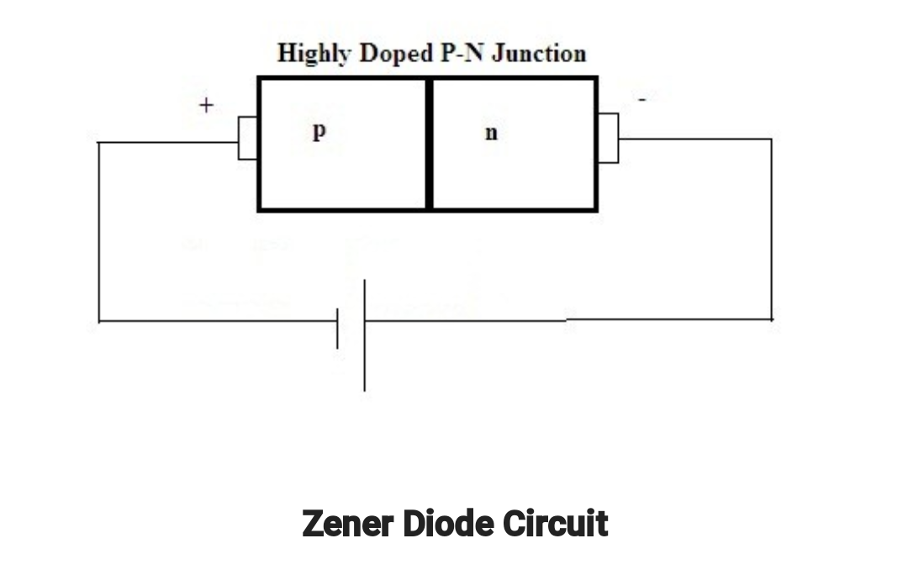

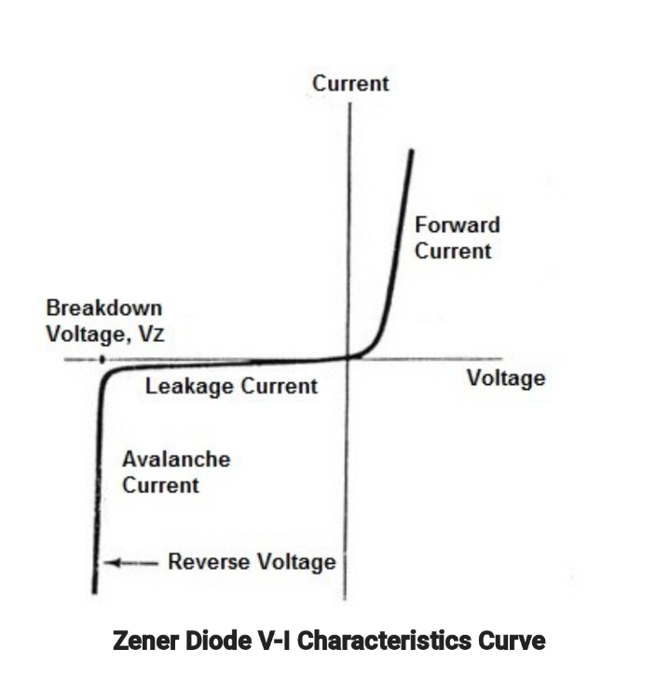
∕

- MAXIMUM CURRENT=MAX POWER/VOLTAGE=5w/v=0.5A
V₂=10 VOLTS
MAXIMUM RESISTANCE=V_{S}-V_{Z}/I_{Z}
Vdc=0.637X_{MAX}
=0.637*20
=12.74Vdc
Minimum resistance=12.74-10/0.5
=5.48Ω
II)Load current I_{L}=V_{Z}/R_{L} =
=10/500
=0.02A or 20Ma
I_{Z}=I_{S}-I_{L}
=500-20
=480mA

