NAME: TOULOPE TOLUSE
MATRIC NO: 15/ENG07/044
DEPARTMENT: CHEMICAL ENGINEERING
COURSE NAME: ALTERNATIVE ENERGY RESOURCES
COURSE CODE: CHE 574
DATE: 30TH APRIL 2020

ASSIGNMENT 1 Question
Kindly resubmit first assignment for CHE 574. Use all available literatures to answer the following over the weekend. 1. (a) With adequate mathematical relations, explain the various forms of energy (b) distinguish between the sustainable energy and resources and nonsustainable energy and resources 2. With the aid of appropriate pie chart or bar chart briefly discuss the typical energy resource mix for sustainable energy development and provide your own view the case for the Nigerian environment.

ASSIGNEMENT 3 Question
1.Monitor the average ambient temperature between on Monday, 17th and Friday, 21st of February 2020 and estimate the average daily thermal energy from the sun reaching land
2. With the aid of a beautiful diagram ONLY, describe anemometer.

ASSIGNMENT 4 Question
How much energy is being produced from the dams in Nigeria? Compare with the energy produced from crude. All the assignments can be submitted in one PDF

ASSIGNMENT ONE 1a.
With adequate mathematical relations, explain the various forms of energy.
There are two major forms are Kinetic Energy and Potential Energy.
A. KINETIC ENERGY: is the energy in moving objects or mass. Its mathematical relation is shown as; 𝑘𝑖𝑛𝑒𝑡𝑖𝑐 𝑒𝑛𝑒𝑟𝑔𝑦 = 1 2 𝑚 𝑥 𝑣𝑖2
Where m = mass
Vi = velocity
Examples of kinetic energy include mechanical energy, electrical energy etc.

i. Mechanical Energy: Mechanical energy is the energy a substance or system has because of its motion. For example, machines use mechanical energy to do work.

ii. Electric Energy: Electrical energy is the energy carried by moving electrons in an electric conductor. It is one of the most common and useful forms of energy. Example – Lightening. Other forms of energy are also converted to electrical energy. For example, power plants convert chemical energy stored in fuels like coal into electricity through various changes in its form.

B. POTENTIAL ENERGY: is any form of energy that has stored potential that can be put to future use. Examples include nuclear energy, chemical energy, etc. 𝑝𝑜𝑡𝑒𝑛𝑡𝑖𝑎𝑙 𝑒𝑛𝑒𝑟𝑔𝑦 = 𝑚𝑥𝑔𝑥ℎ Where m = mass g = acceleration due to gravity h = height

i. Chemical Energy: Chemical energy is energy stored in the bonds of chemical compounds (atoms and molecules). Chemical energy is released in a chemical reaction, often in the form of heat. For example, we use the chemical energy in fuels like wood, coal by burning them.

ii. Nuclear Energy: Nuclear energy is the energy that is trapped inside each atom. Nuclear energy can be produced either by the fusion (combining atoms) or fission (splitting of atoms) process. The fission process is the widely used method.

Advantages of nuclear power
• Nuclear power generation does emit relatively low amounts of carbon dioxide (CO2). The contribution of nuclear power plants to global warming is therefore relatively little. • It is possible to generate a high amount of electrical energy in one single plant.
Disadvantages of nuclear power
• The problem of safe disposal of radioactive waste exists • There exist high risks and the consequences of damage is great when accidents happen • The raw material Uranium is a scarce resource. Its supply is estimated to last only for the next 30 to 60 years, depending on the actual demand.
iii. Gravitational Energy: Gravitational energy is that energy held by an object in a gravitational field. Examples include water flowing down a waterfall.[1]

1b. Distinguish between renewable and nonrenewable sources of energy
Renewable resources are those that can be replaced as they are used. Examples are
i. Solar energy ii. Wind energy iii. Biomass iv. Water energy

Solar energy is the energy available from the sun. the sun is the ultimate energy resource available to man

Wind energy is driven by thermal energy of the sun and is used by sailing ships and for turning windmills.

Water energy provides the source of energy in modern dams, hydroelectric plants etc.

Biomass is the energy gotten from cornstalks, garbage, sugarcane, sea weed etc.

Nonrenewable resources are depleting; they cannot be replenished as they are used Examples are; i. Nuclear energy ii. Petroleum and Natural gas

Nuclear energy from radioactive materials: this produce enormous heat to operate turbines and drive ships and aircrafts. Fission and fusion energy are examples of nuclear energy

i. Petroleum and natural gas: these often occur together and they are currently constituting the world major resources. Such fuels are known as fossil fuels are a depleting energy resource. Other examples of fossil fuels are coal and wood [2]

2. With the aid of appropriate pie chart or bar chart briefly discuss the typical energy resource mix for sustainable energy development and provide your own view the case for the Nigerian environment.
The main areas of energy utilization in Nigeria are transportation and conversion of energy resources to electricity for household and industry. In the prevailing energy crisis, Nigeria’s energy consumption mix is dominated by over- dependence on biomass, particularly fuel wood as shown in 0-1 PIE CHART OF TYPICAL ENERGY RESOURCE MIX FOR SUSTAINABLE DEVELOPMENT IN NIGERIA Combustible renewable firewood inclusive has a record 80.2%, followed by natural gas 9.9% and oil 9.4%. Hydroelectricity has only 0.5%. In spite of the fact that oil is the mainstay of the economy, its contribution to the energy consumption mix is however appalling. The reason is not farfetched: less than 40% of Nigeria’s population is about 150 million people.[3]

TYPICAL ENERGY RESOURCE MIX FOR SUSTAINABLE DEVELOPMENT IN NIGERIA

ASSIGNMENT THREE 1.
Monitor the average ambient temperature between on Monday, 17th and Friday, 21st of February 2020 and estimate the average daily thermal energy from the sun reaching land
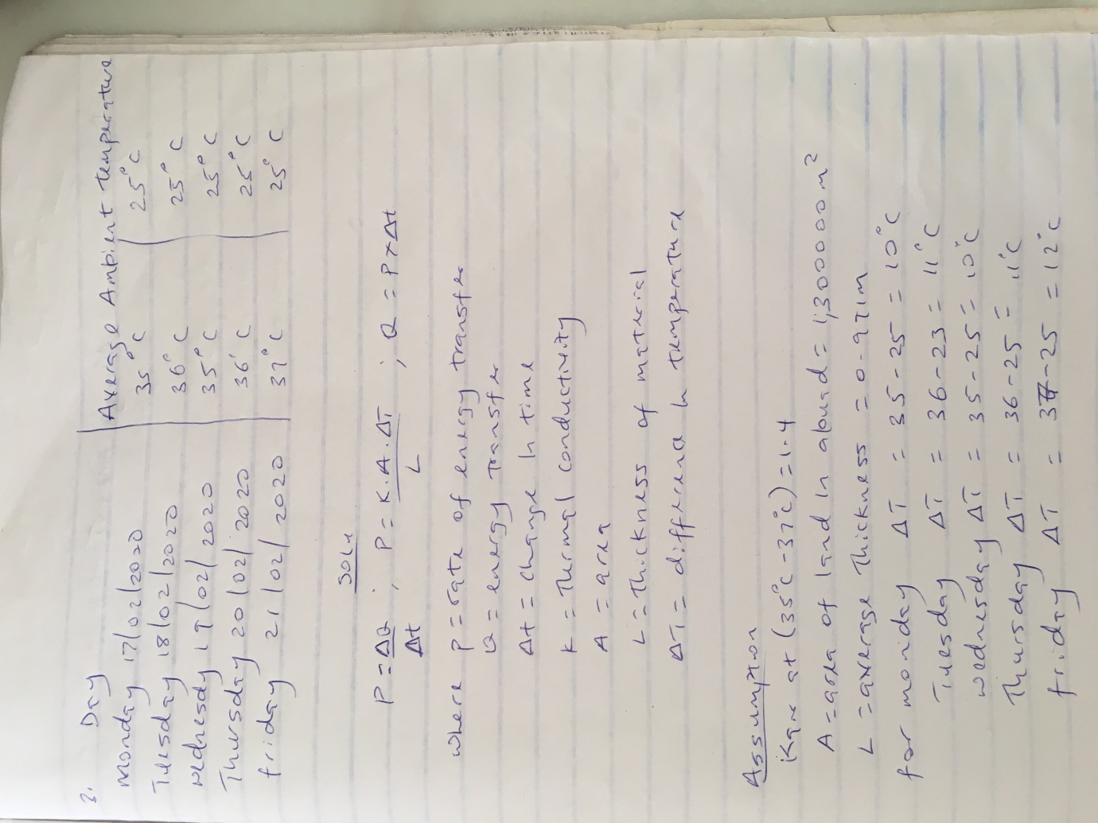

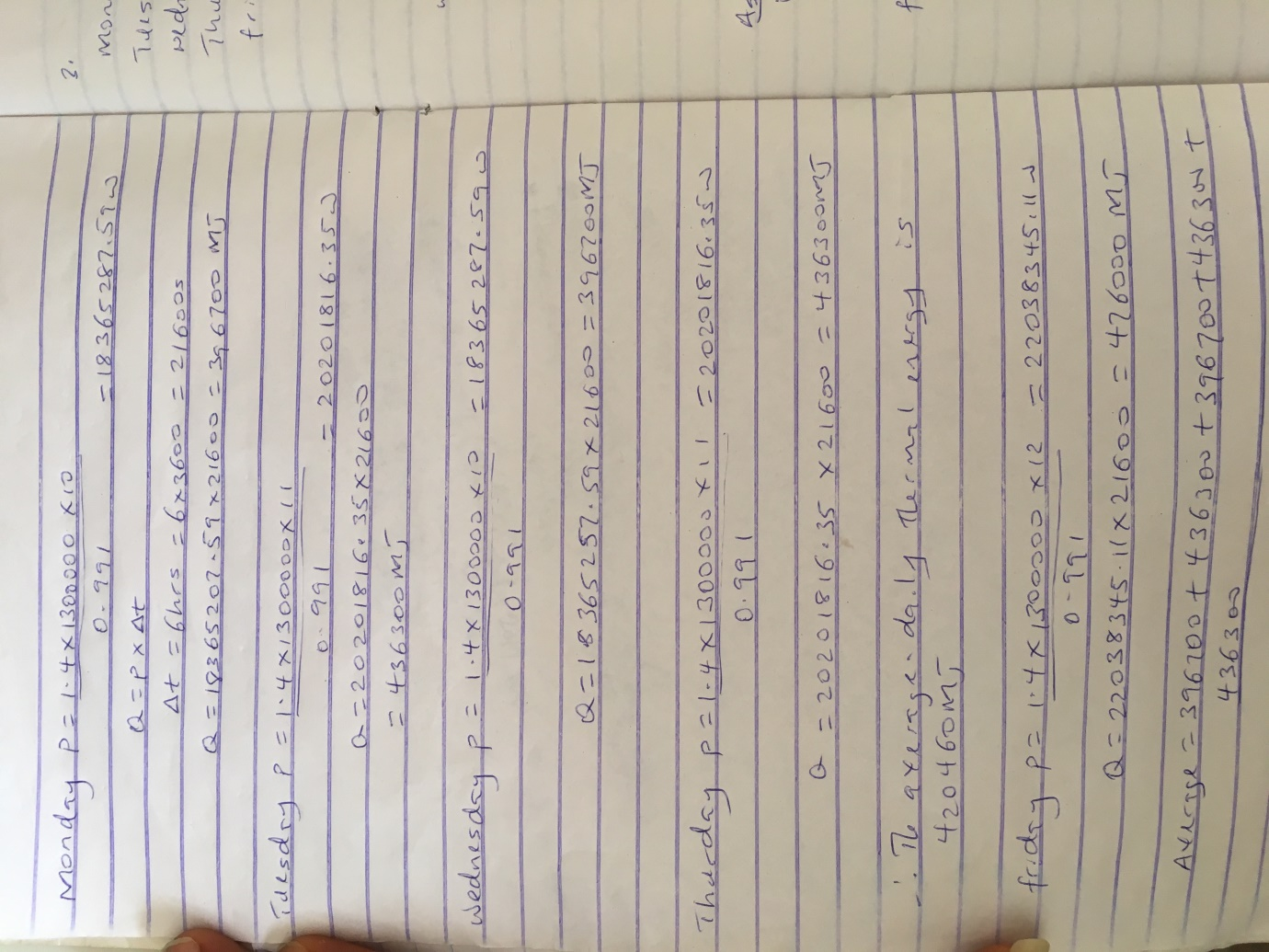

ASSIGNMENT FOUR
How much energy is produced from dams in Nigeria?
The total energy produced from these each power stations or dams can be seen in figure 0-3 LIST OF HYDROELETRIC STATIONS IN NIGERIA. Dams are used to produce hydroelectric power for cities and it has been very useful for a long time but the total energy produced from dams in Nigeria are quite large but not enough to power up the whole cities.
For example, the kanji dam was designed to produce 960 megawatts but since only eight turbines where installed it can only produce 760megawatts and this is not enough because of the increase in population growth and the corresponding demand of power. [4]

Compare with the energy produced from crude;
The country has four oil refineries (Port Harcourt I and II, Warri, and Kaduna) with a combined crude oil distillation capacity of 445,000 b/d, according to OGJ. This means that more energy is being produced from crude oil because we are one of the biggest producers of petroleum in Africa. Therefore, more energy is produced from crude oil.

