NAME: ADJUGAH UVIETOBORE JOSHUA
MATRIC. NUMBER: 18/ENG05/007
DEPARTMENT: MECHATRONICS ENGINEERING
COURSE CODE: ENG222
COURSE TITLE: BASIC ELECTRICAL ENGINEERING II

QUESTIONS
- DESCRIBE A ZENER DIODE REGULATOR
A Zener diode regulator simply means “Zener diode used as a voltage regulator”.
A Zener diode can be used to produce a stabilised voltage output with low ripple under varying load current conditions. By passing a small current through the diode from avoltage source, via a suitable current limiting resistor(R_{S}), the zener diode will conduct sufficient current to maintain a voltage drop of V_{OUT}.
- SKETCH THE SYMBOL AND I-V CHARACTERISTICS CURVE
SYMBOL: 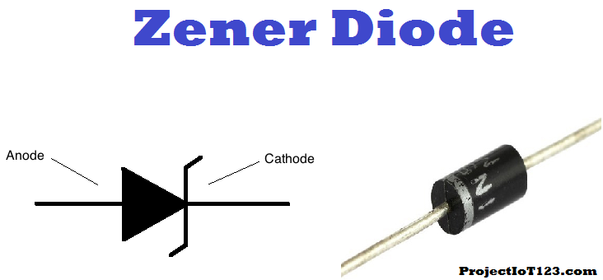

I-V CHARACTERISTICS CURVE:
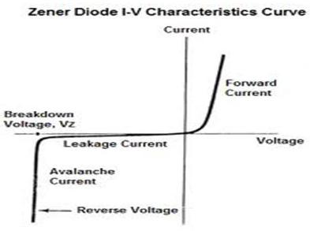
- SKETCH AND LABEL THE CIRCUIT DIAGRAM

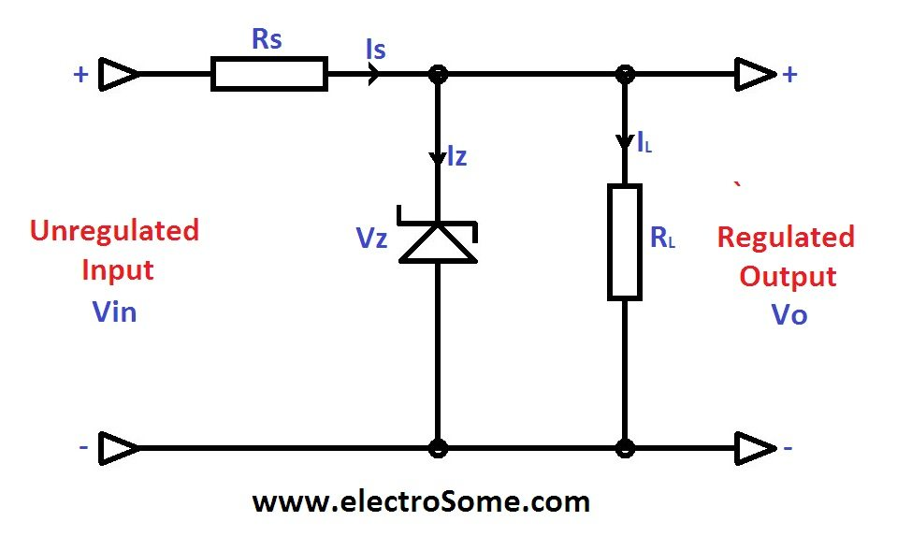

- Pz = 5W
Max Current (Is) = 500mA =0.5A
Vs = 20V
Vz = ?
R_{L}= 500 ohms
Rs = ?
Iz = ?
I_{L} = ?

- Vs = Pz / Is = 5 / 0.5 =10V
Rs = Vs – Vz / Is = 20-10 / 0.5 =20 ohms

- Iz = Is - I_{L}
Where I_{L} = V_{Z} / R_{L} = 10 / 500 = 0.02A
So, Iz = 0.5 – 0.02 =0.48A

