Ibrahimovic Bala Abdul-Salam
17/sci01/038

1a. Rise and fall. High of collimation
Advantage. Advantage
It’s easier to spot error. There two checks on the accuracy of Rleve values
There are three checks on it It’s faster than Rise and fall

Disadvantage. Disadvantage
It take time. It’s fairly to error
It involves much calculation. Errors in the intermediate sight can’t be detacted

B.S | I.S | F.S | H OF C | R.L | DISTANCE
0.771 |  |  |  | 148 | 10
0.802 |  | 1.52 | 148.053 | 147.251 | 20
 | 2.311 |  |  | 145.742 | 30
3.580 |  | 1.990 | 149.643 | 146.063 | 40
 | 1.220 |  |  | 148.423 | 50
 | 3.675 |  |  | 145.968 | 60
2.408 |  | 4.020 | 148.031 | 145.623 | 70
 | 0.339 |  |  | 147.692 | 80
0.780 |  | 0.157 | 148.654 | 147.874 | 90
 | 1.535 |  |  | 147.119 | 100
 | 1.955 |  |  | 146.699 | 110
 | 2.430 |  |  | 146.224 | 120
 | 2.985 |  |  | 145.669 | 130
1.155 |  | 3.480 | 146.329 | 145.174 | 140
 | 1.960 |  |  | 144.369 | 150
 | 2.365 |  |  | 143.964 | 160
0.935 |  | 3.640 | 143.624 | 142.689 | 170
 | 1.045 |  |  | 142.579 | 180
 | 1.630 |  |  | 141.994 | 190
 |  | 2.545 |  | 141.079 | 200
$Σ$=10.431 |  | $Σ$=17.352

Checks
front sights-back sights
17.352-10.431=6.922
OR
Check=$ΣF.S-ΣB.$R.L at first point-R.L at last point
=6.921=6.921

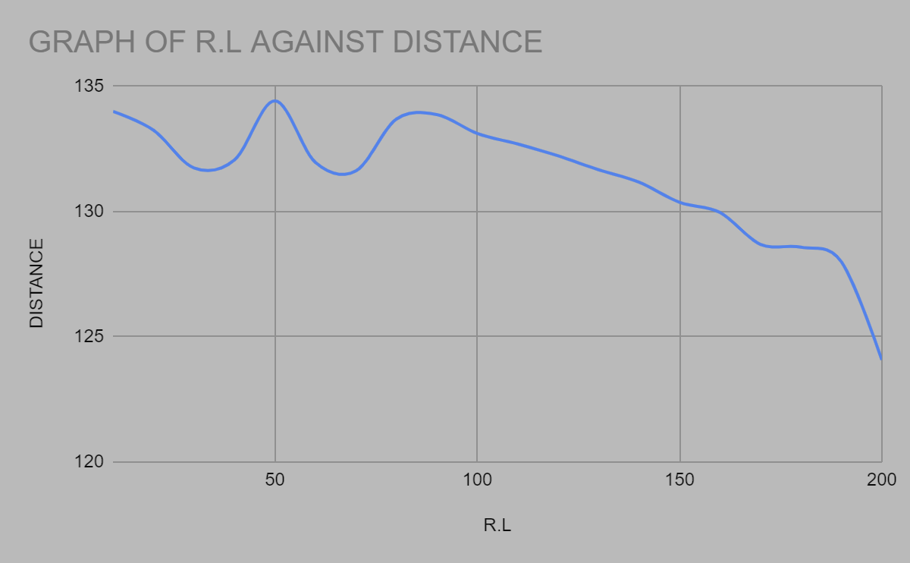

2.
Chainage(m) | 030 | 60 | 90 | 120 | 150 | 180 | 210 | 240 | 270
Offset length (m) | 02.65 | 3.80 | 3.75 | 4.65 | 3.60 | 5.00 | 5.80 | 6.10 | 5.85

Solutions

Using average method

A=ndEO.
N+1
N=9, d=30, EO= 41.3

A = 9×30×41.2 =1124 1112.4m^2. = 0.11124hecter
9+1. 10

Using mid-ordinate
$\frac{0+2.65}{2}$=1.325m

h2= $\frac{2.65+3.80}{2}$=3.225m

h3= $\frac{3.80+3.75}{2}$=3.775m

h4= $\frac{3.75+4.65}{2}$=4.2m

h5= $\frac{4.65+3.60}{2}$=4.125m

h6= $\frac{3.60+5.00}{2}$=4.3m

h7= $\frac{5.00+5.80}{2}$=5.4m

h8= $\frac{5.80+6.00}{2}$=5.9m

h9= $\frac{6.00+5.85}{2}$=5.925m

$$Σh=1.325+3.225+3.775+4.2+4.125+4.3+5.4+5.9+5.925$$
$Σh=$38.175m

d=30m

Using trapezoidal

A = d[O1+On + O2 +O3 ……….+On-1]
2
A = 851.95[ 4.058+ 3.80+3.75+4.65+3.60+5.00+5.80+6.10+5.85]
A= 36301.59m^2
A= 3.630Hecters

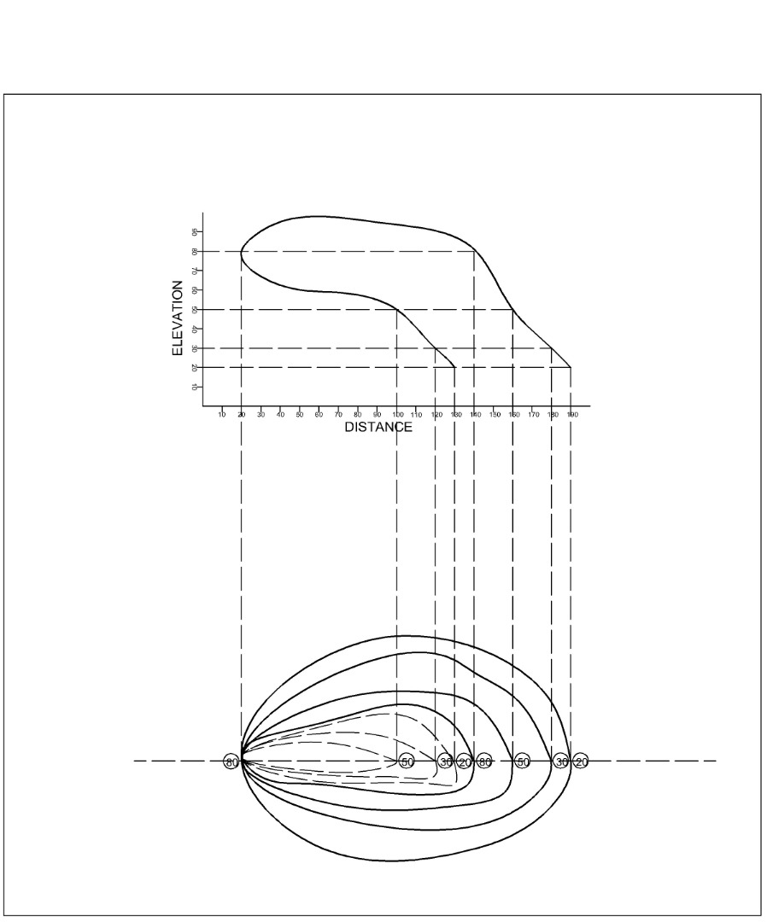
Plate1. Over hanging cliff… a contourlines can not Marge or cross one another on the map except in this case

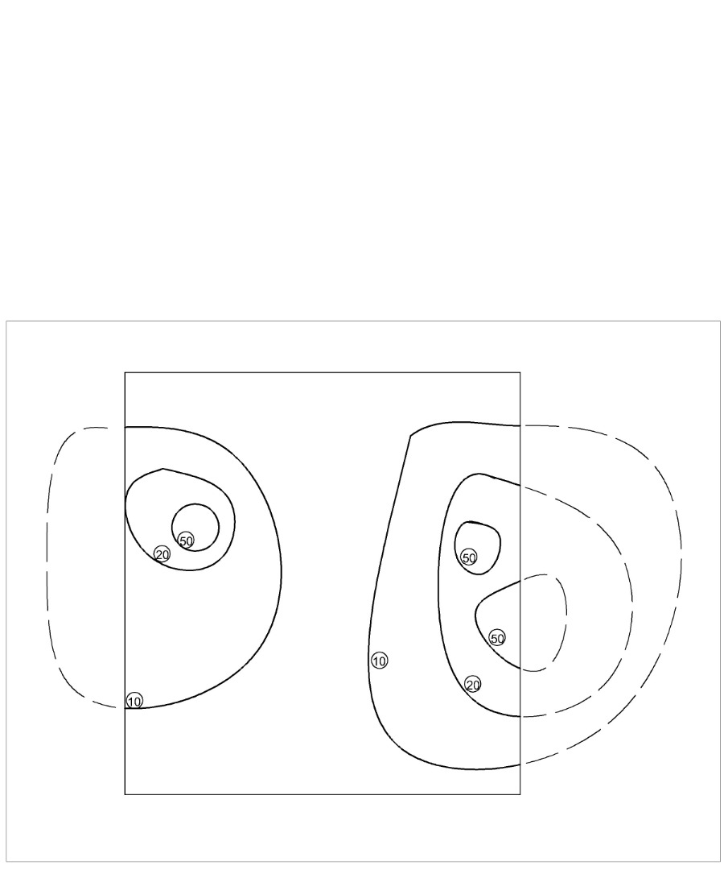

Plate2. Contourlines can not end anywhere but close on themselves either within or outside the limit of the map.

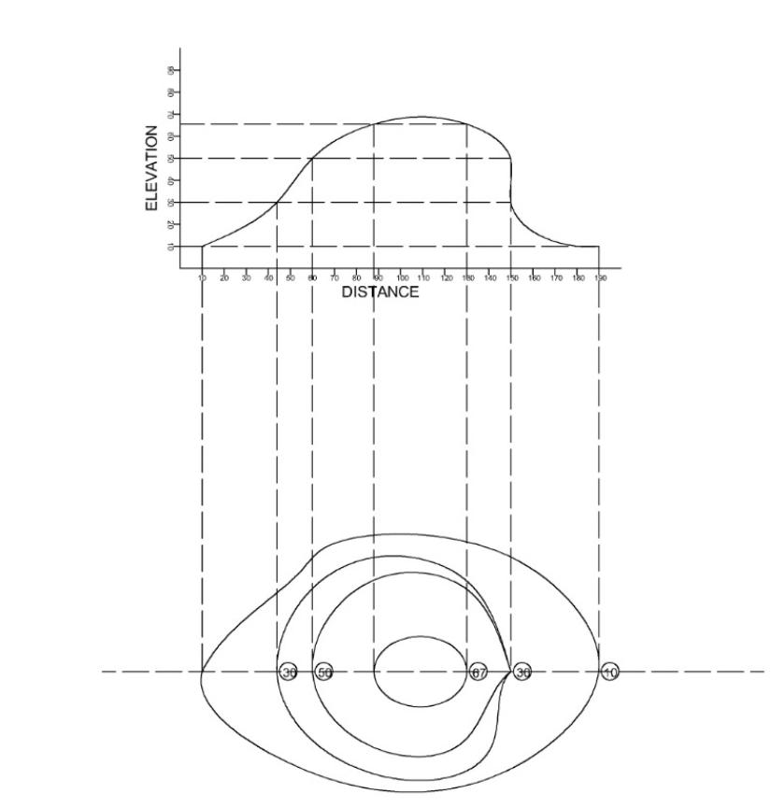
Plate3. Vertical cliff.. in this case several contours coincide and horizontal equivalent become 0

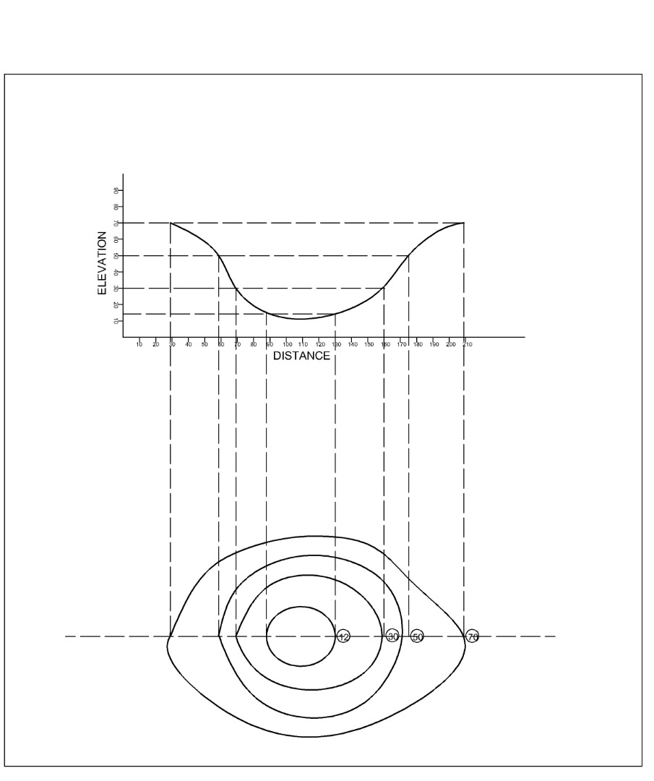
Plate4. It indicate depression if the higher values are outside

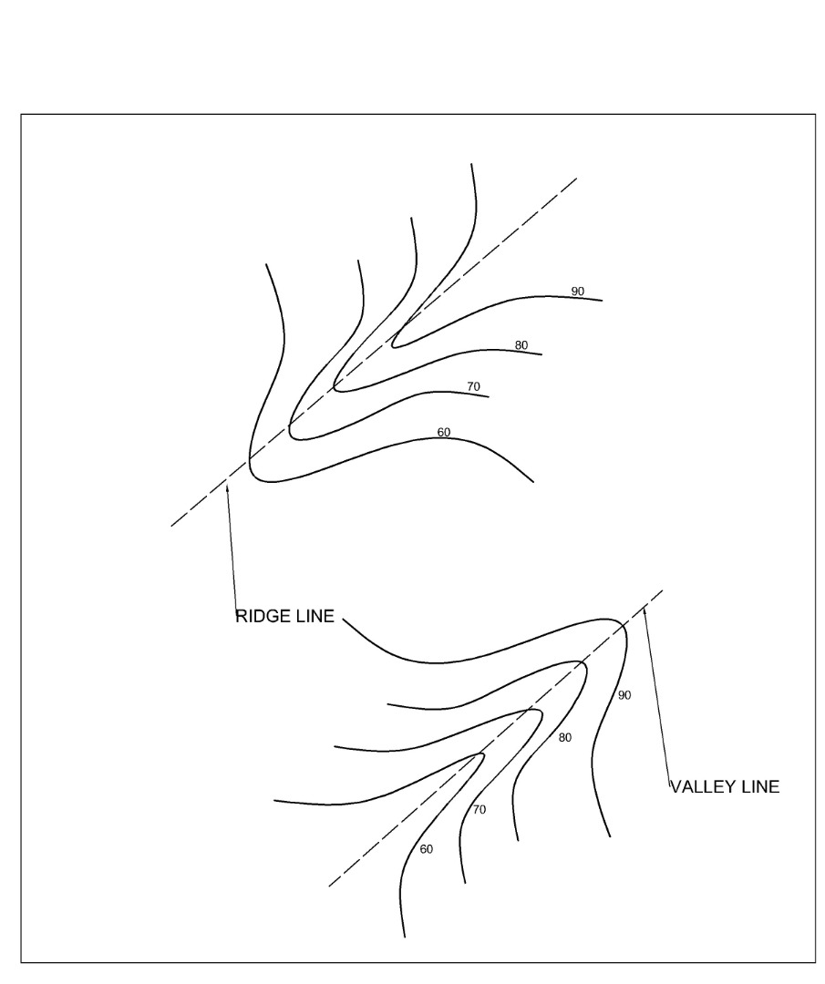
Plate 5. It represent a ridge if the higher values are inside and it represent a. Valley if the higher values are outside.

