NAME : ZIBIRI MIRACLE
MATRIC NUMBER : 17/ENG03/059
ASSIGNMENT TITLE : 1. Levelling, 2. Areas & volume, 3. Contours
COURSE TITLE : Engineering Surveying II
COURSE CODE : CVE 310

1a) Methods of levelling
Height of collimation system
Advantages
- It is rapid as it involves few Calculation
- There are two checks on the accuracy of RL calculation
- This system is suitable for longitudinal leveling where number of intermediate sights
- Visualization is not necessary regarding the nature of the ground
Disadvantages
- There is no check on the RL of the intermediate sight
- Errors in the intermediate RLs cannot be detected.

Rise and fall system
Advantages
- There is a check on the RL of the intermediate points
- Errors in the intermediate RLs can be detected as all the points are correlated
- There are three checks on the accuracy of RL calculation
- This system is suitable where there are no intermediate sights
Disadvantages
- It is laborious involving several calculations.
- Visualization is necessary regarding the nature of the ground

1B.) $H_{of}$C = RL + B.S
RL = $H_{of}$C $–$ F.S (I.S)
RL = 110 + matric No. (59)

B.S | I.S | F.S | H OF C | R.L | DISTANCE
0.771 |  |  |  | 169 | 10
0.802 |  | 1.52 | 168.993 | 168.191 | 20
 | 2.311 |  |  | 166.682 | 30
3.580 |  | 1.990 | 170.583 | 167.003 | 40
 | 1.220 |  |  | 169.363 | 50
 | 3.675 |  |  | 166.908 | 60
2.408 |  | 4.020 | 168.971 | 166.563 | 70
 | 0.339 |  |  | 168.632 | 80
0.780 |  | 0.157 | 169.594 | 168.814 | 90
 | 1.535 |  |  | 168.059 | 100
 | 1.955 |  |  | 167.639 | 110
 | 2.430 |  |  | 167.164 | 120
 | 2.985 |  |  | 166.609 | 130
1.155 |  | 3.480 | 167.269 | 166.114 | 140
 | 1.960 |  |  | 165.309 | 150
 | 2.365 |  |  | 164.904 | 160
0.935 |  | 3.640 | 164.564 | 163.629 | 170
 | 1.045 |  |  | 163.519 | 180
 | 1.630 |  |  | 162.934 | 190
 |  | 2.545 |  | 162.019 | 200
$Σ$=10.431 |  | $Σ$=17.352

Check =$ΣF.S-ΣB.S$= R.L at first point - R.L at last point
= 6.921 = 6.921
Solution

${RL}_{1}$ = 110 + 59 = 169m

$H_{of}$C (1) = 169 + 0.711 = 169.711

${RL}_{2}$ = 169.11 – 1.52 = 168.191m

$H_{of}$C (2) = 168.191 + 0.802 = 168.993

${RL}_{3}$ = 168.993 – 2.311 = 166.682m

${RL}_{4}$ = 168.993 – 1.990 = 167.003m

$H_{of}$C (3) = 167.003 + 3.580 = 170.583

${RL}_{5}$ = 170.583 – 1.220 = 169.363m

${RL}_{6}$ = 170.583 – 3.675 = 166.908m

${RL}_{7}$ = 170.583 – 4.020 = 166.563m

$H_{of}$C (4) = 166.563 + 2.408 = 168.971m

${RL}_{8}$ = 168.971 – 0.339 = 168.632m

${RL}_{9}$ = 168.971 – 0.157 = 168.814m

$H_{of}$C (5) = 168.814 + 0.780 = 169.594

${RL}_{10}$ = 169.594 – 1.535 = 168.059m

${RL}_{11}$ = 169.594 – 1.955 = 167.639m

${RL}_{12}$ = 169.594 – 2.430 = 167.164m

${RL}_{13}$ = 169.594 – 2.985 = 166.609m

${RL}_{14}$ = 169.594 – 3.480 = 166.114m

$H_{of}$C (6) = 166.114 + 1.155 = 167.269

${RL}_{15}$ = 167.269 – 1.960 = 165.309m

${RL}_{16}$ = 167.269 – 2.365 = 164.904m

${RL}_{17}$ = 167.269 – 3.640 = 163.629m

$H_{of}$C (7) = 163.629 + 0.935 = 164.564

${RL}_{18}$ = 164.564 – 1.045 = 163.519m

${RL}_{19}$ = 164.564 – 1.630 = 162.934m

${RL}_{20}$ = 164.564 – 2.545 = 162.019m

QUESTION 2

Chainage(m) | 0 | 30 | 60 | 90 | 120 | 150 | 180 | 210 | 240 | 270
Offset length(m) | 0 | 2.65 | 3.80 | 3.75 | 4.65 | 3.60 | 5.00 | 5.80 | 6.10 | 5.85

Using Mid-ordinate rule:
A=$Σ$hd

h1= $\frac{0+2.65}{2}$=1.325m

h2= $\frac{2.65+3.80}{2}$=3.225m

h3= $\frac{3.80+3.75}{2}$=3.775m

h4= $\frac{3.75+4.65}{2}$=4.2m

h5= $\frac{4.65+3.60}{2}$=4.125m

h6= $\frac{3.60+5.00}{2}$=4.3m

h7= $\frac{5.00+5.80}{2}$=5.4m

h8= $\frac{5.80+6.00}{2}$=5.9m

h9= $\frac{6.00+5.85}{2}$=5.925m

$$Σh=1.325+3.225+3.775+4.2+4.125+4.3+5.4+5.9+5.925$$
$Σh=$38.175m

d=30m
A=$Σhd$
= $38.175×30$
A= $1145.25m^{2}$

Using average ordinate rule

A=$\frac{ndΣO}{n+1}$

n=9

d=30
$$ΣO=0+2.65+3.80+3.75+4.65+3.60+5.00+5.80+6.10+5.85$$
$ΣO=$41.2m

A=$\frac{9×30×41.2}{9+1}$

A=$112.4m^{2}$

Using trapezoidal rule

A=$d(\frac{0_{1}+0_{n }}{2}+0_{2}+0_{3}+0_{4}............0_{n-1})$

$d=30$

A=$30(\frac{0+5.85}{2}+2.65+3.80+3.75+4.65+3.60+5.00+5.80+6.10)$

A=$30(38.275)$
A=$1148.25m^{2}$

Using Simpson's rule

$A=\frac{d }{3 }\left[\left(0_{1}+0_{n}\right)+4\left(0_{2}+0_{4}+.........0_{n-1}\right)+2\left(0_{3}+0_{5}........0_{n-1}\right)\right]$

$d=30$

Note: Last offset was removed because number of offsets were even

$A=\frac{30}{3 }\left[\left(0+6.10\right)+4\left(2.65+3.75+3.60+5,80\right)+2\left(3.80+4.65+5.00\right)\right]$

$A=962m^{2}$

Calculating for last offset using trapezoidal rule

A=$d(\frac{0_{1}+0_{n }}{2}+0_{2}+0{}_{3}+0{}_{4}............0{}_{n-1})$

$A=30\left[\frac{6.40+5.85}{2}\right]$

$A=183.75m^{2}$

Therefore $ΣA=962+183.75$

$A=1145.75m^{2}$

2B.)
CHARACTERISTICS OF CONTOURS

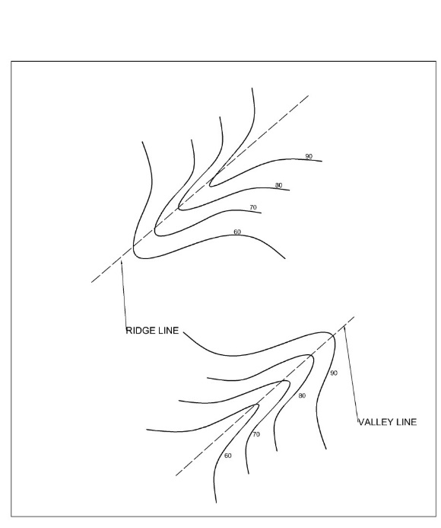
- Contour lines crosses a ridge or valley at right angle. If the higher values are inside the bend or loop in the contour. It represents a ridge and if the higher values are outside the bend it represents the value.

- Contour lines cannot merge or cross one another on a map except in the case of an overhanging cliff.

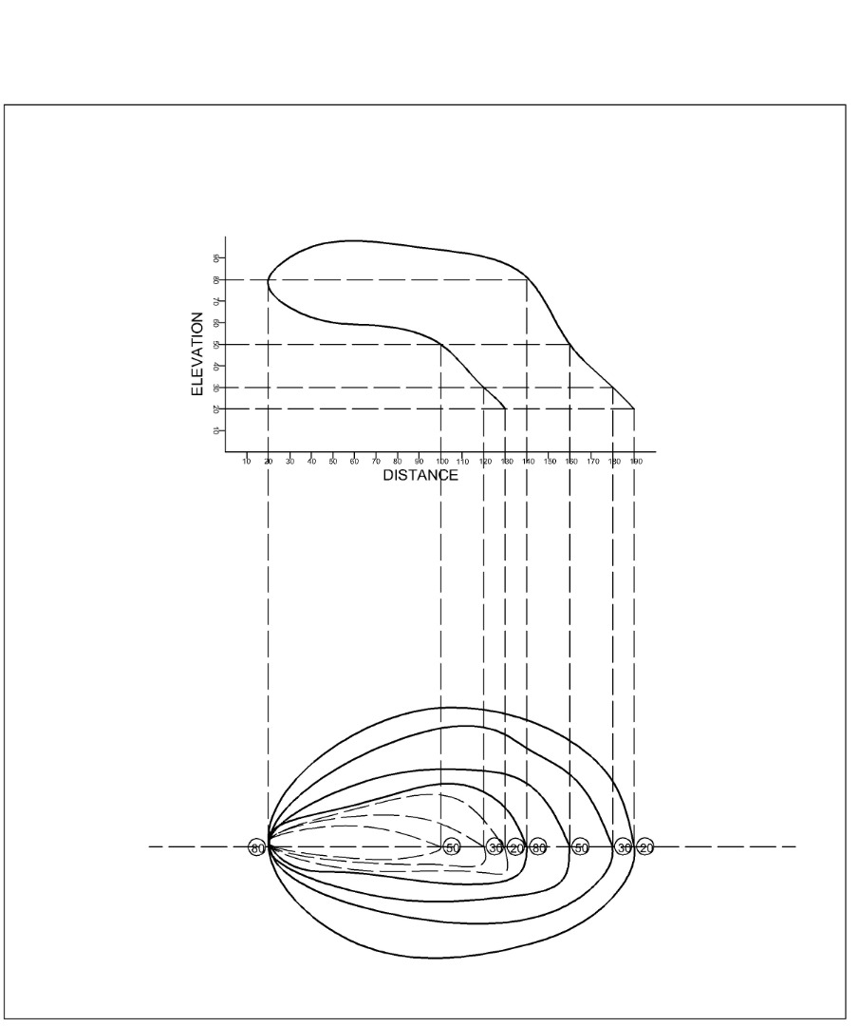

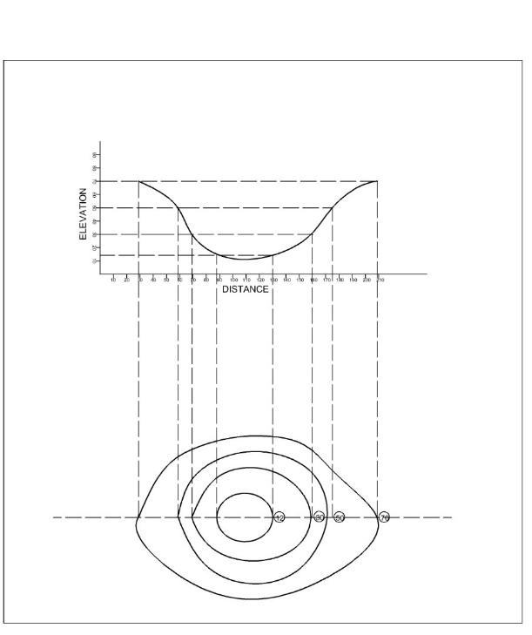
- A series of closed contour on a map indicates a depression if the higher values are outside.

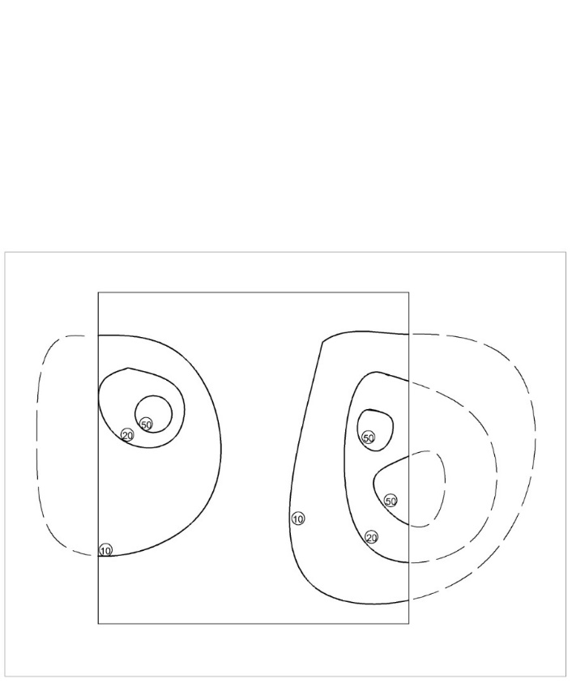
- Contour line cannot end anywhere but close on themselves either within or outside the limit of the map.

- A series of close contour lines, represent a hill if the higher valves are inside.

