NAME: Abu Owoicho-Oche Oneh

MATRIC NO: 18/ENG04/001

DEPARTMENT: ELECTRICAL/ELECTRONICS
A Zener diode is a type of diode that allows current to flow in the conventional manner - from its anode to its cathode i.e. when the anode is positive with respect to the cathode. When the voltage across the terminals is reversed and the potential reaches the Zener voltage (or "knee"), thejunction will break down and current will flow in the reverse direction - a desired characteristic. This effect is known as the Zener effect, after Clarence Zener, who first described the phenomenon. Zener diodes are manufactured with a great variety of Zener voltages (Vz) and some are even variable.
Zener diodes have a highly doped p-njunction. A similar break down is observed in general purpose diodes (which might be quite high)but the voltage and sharpness of the knee is not clearly defined as in Zener diodes. Normal diodes are not designed to operate in the breakdown region and it can cause permanent failure of the device. Zener diodes are manufactured to operate reliably and quite precisely in this region, recovering fully from thejunction breakdown and not being harmed in proper use.
Zener reverse breakdown is due to electron quantum tunnelling caused by a high-strength electric field. However, many diodes described as "Zener" diodes rely instead on avalanche breakdown. Both breakdown types are used in Zener diodes with the Zener effect predominating at lower voltages and avalanche breakdown at higher voltages.
Zener diodes are widely used in electronic equipment of all kinds and are one of the basic building blocks of electronic circuits. They are used to generate low-power stabilized supply rails from a higher voltage and to provide reference voltages for circuits, especially stabilized power supplies. They are also used to protect circuits from overvoltage, especially electrostatic discharge (ESD).
Zener Diode is a general purpose diode, which behaves like a normal diode when forward biased. But when it is reverse biased above a certain voltage known as zener breakdown voltage or zener voltage or avalanche pointor zener knee voltage the voltage remains constant for a wide range of current.
Clarence Zener is the scientist who discovered this electrical property and the device is named after him.
Zener Diode
Ordinary diodes will not have any significant current (only leakage current) when reverse biased below its reverse breakdown voltage. When the reverse bias is increased beyond reverse breakdown voltage its potential barrier breaks down. This may damage the diode due to excess heat produced by the high current flow through the diode unless the current is limited. Zener diode also exhibits similar properties except that it is designed to have lower breakdown voltage. Ordinary diodes have breakdown voltages in the order of 100 or above.

I(a) zener diode regulator symbol
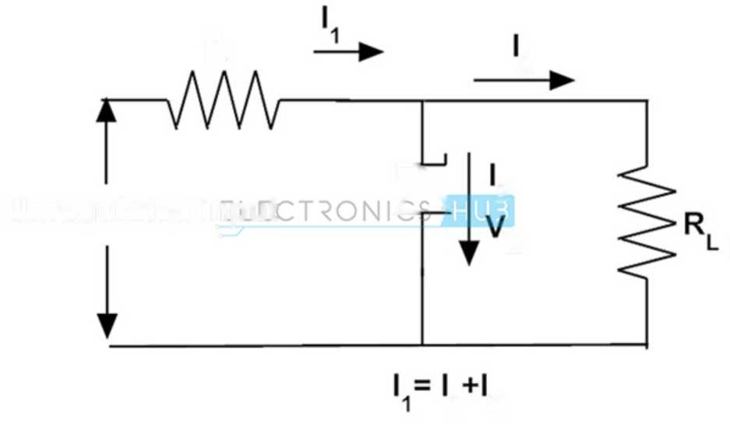
R
2
z\
Z
z
2 Z
Unregulated input

Rl Regulated

Output
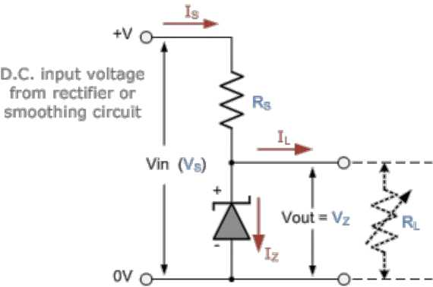
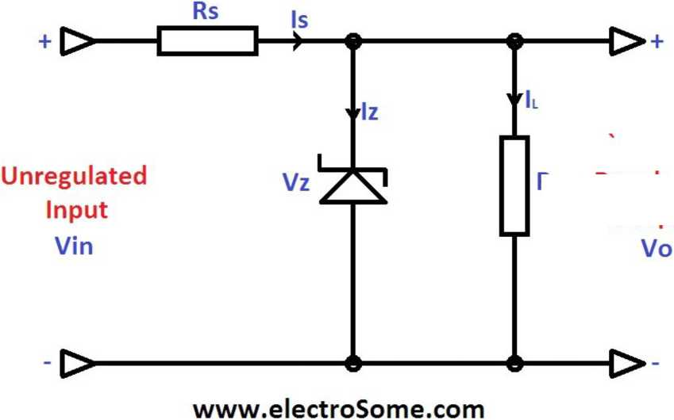

1(b) I-V Characteristic curve
Forward
Current
“Zener” Breakdown
Region
► +w
Forward Bias
i f Reverse ;Current =Ir
Symbol
Forward
Bias Region
I
Reverse Bias " [^{z}
Constant
Zene r Voltage
Cathode
(K)
Anode

ii. CIRCUIT DIAGRAM
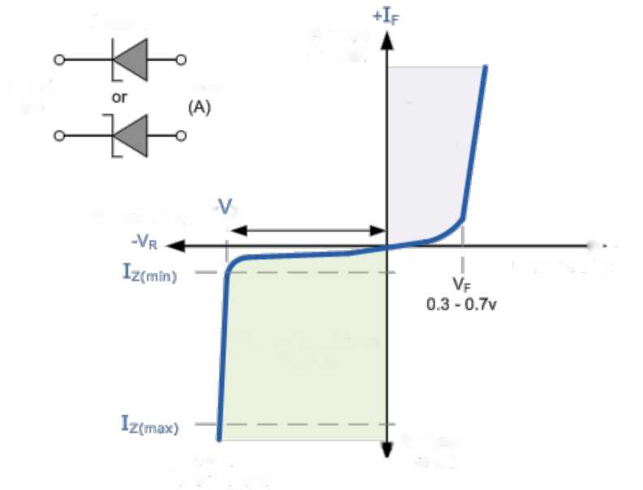
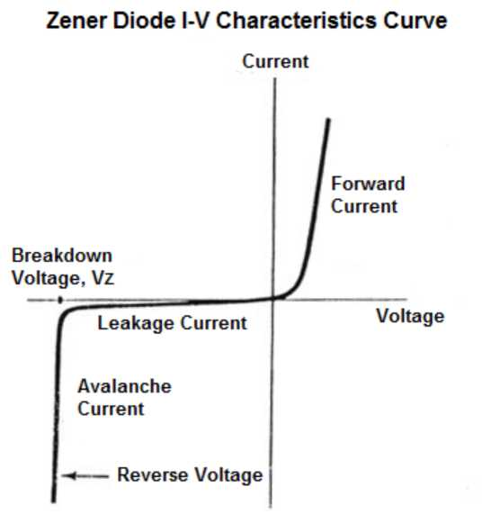

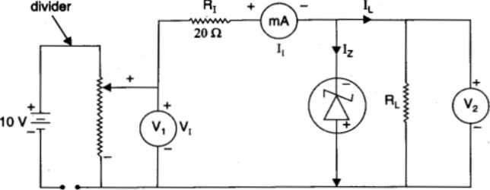
Potential
Vo
