NAME: INEGBEDION IKPEHOSA ANGEL
MATRIC NUMBER: 18/MSH01/185
DEPARTMENT: MEDICINE AND SURGERY
ASSIGNMENT

SECOND WEEEK OF DEVELOPMENT
Three events take place:
- Completion of implantation
- Formation of bilaminar germ disc
- Formation of extra embryonic structures
Day 8
- The blastocyst is partially embedded in the endometrium.
- The syncytiotrophoblast will continue to enrode the endometrium with other vessels and other organs there, the cytotrophoblast will divide and migrate into the region of the syncytiotrophoblast.
- The embryoblast will divide into
- a layer of cuboidal cell=hypoblast
- a layer of columnar cells=epiblast
The cells of the epiblast adjacent to the cytotrophoblast is the Aminoblast and inside the Amniotic cavity.
The cells of the epiblast and hypoblast join together to give rise to Bilaminar embryonic disc.
Day 9
- The blastocyst is deeply embedded in the endometrium and due to this the surface of the epithelium is covered with a fibrin coagulum.
- The membrane lying adjacent to the cytotrophoblast is called the exocoelomic membrane/ heuser’s membrane.
- The exocoelomic/ heuser’s membrane together with the hypoblast will form the exocoelomic cavity or primitive yolk sac or primary umblical vesicle.
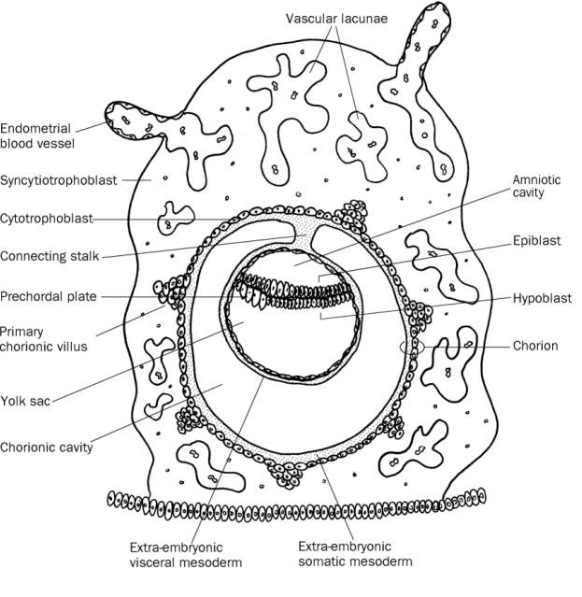
Day 10-12
- Blastocyst is completely embedded in the endometrium
- Presence of vacule called lacunae at the region of the syncytiotrophoblast.
- Cells of syncytiotrophoblast will enter and erode the endometrium deeper and the blastocyst will rupture the capillaries.
- Ruptured capillarie are called sinusoids, the sinusoids will communicate with the lacunae and will establish the primordial uteroplancental circulation.
- Some cells derived from yolk sac cells from a loose connective tissue called extrambryonic mesoderm.
- Soon, large cavity develop in the extraembryonic mesoderm which is the extraembryonic cavity then a connecting stalk is fomed between the amniotic cavity and trophoblast.
- The extraembryonic cavity divides the extraembyonic mesoderm into 2 parts: extraembryonic somatic mesoderm and extraembryonic splanchic membrane.
- As the conceptus implants, the endometrial connective tissue cells undergo a transformation, called decidual reaction
- During this transformation, the cells of the endometrium swell because of the accumulation of glycogen and lipid in their cytoplasm, and they are known as decidual cells
- The primary function of the decidual reaction is to provide nutrition for the early embryo and an immunologically privileged site for the conceptus. 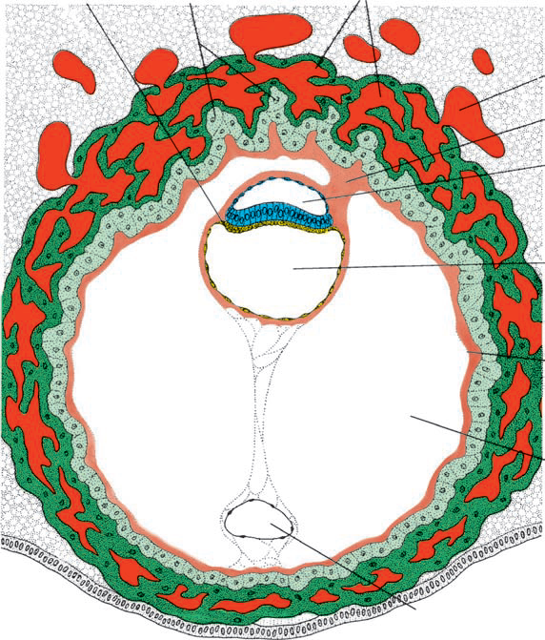

Day 13
- The surface defect in the endothelium is covered completely by surface epithelium.
- The primary yolk sac becomes reduced in size and it will be called secondary yolk sac or definitive yolk sac or secondary umblical vesicle
- Large portion of the exocoelomic cavity are pinched off to form the exocoelomic cyst.
- The extraembryonic cavity expand to form a larger cavity called chorionic cavity and the extrembryonic membrane tranverse the chorionic cavity is in the connecting stalk and with development it becomes the umblical cord.
Clinical correlates
The syncytiotrophoblast produces the human chorionic gonadotrophin at the end of the 2nd week to give a positive pregnancy test.
The HCG keeps the corpus luteum secreting progesterone and estrogen.
Extrauterine implantation:
Implantation outside the uterus leading to etopic pregnancy

