LADAN FIDALEH
17/ENG03/046
CIVIL ENGINEERING
1a) Methods of levelling
Height of collimation system
Advantages
- It is rapid as it involves few Calculation
- There are two checks on the accuracy of RL calculation
- This system is suitable for longitudinal leveling where number of intermediate sights
- Visualization is not necessary regarding the nature of the ground
Disadvantages
- There is no check on the RL of the intermediate sight
- Errors in the intermediate RLs cannot be detected.

Rise and fall system
Advantages
- There is a check on the RL of the intermediate points
- Errors in the intermediate RLs can be detected as all the points are correlated
- There are three checks on the accuracy of RL calculation
- This system is suitable where there are no intermediate sights
Disadvantages
- It is laborious involving several calculations.
- Visualization is necessary regarding the nature of the ground

1b)
RL=110+matric No.=110+33=143
B.S | I.S | F.S | H OF C | R.L | DISTANCE | REMARKS
0.771 |  |  | 143.771 | 143 | 0 | OBM
0.802 |  | 1.52 | 143.053 | 142.251 | 10 | CP
 | 2.311 |  |  | 140.742 | 20
3.580 |  | 1.990 | 144.643 | 141.063 | 30 | CP
 | 1.220 |  |  | 143.423 | 40
 | 3.675 |  |  | 140.968 | 50
2.408 |  | 4.020 | 143.031 | 140.623 | 60 | CP
 | 0.339 |  |  | 142.692 | 80
0.780 |  | 0.157 | 143.654 | 142.874 | 90 | CP
 | 1.535 |  |  | 142.119 | 100
 | 1.955 |  |  | 141.699 | 110
 | 2.430 |  |  | 141.224 | 120
 | 2.985 |  |  | 140.669 | 130
1.155 |  | 3.480 | 141.329 | 140.174 | 140 | CP
 | 1.960 |  |  | 140.369 | 150
 | 2.365 |  |  | 139.964 | 160
0.935 |  | 3.640 | 138.624 | 138.689 | 170 | CP
 | 1.045 |  |  | 138.579 | 180
 | 1.630 |  |  | 137.994 | 190
 |  | 2.545 |  | 137.079 | 200
$Σ$=10.431 |  | $Σ$=17.352

HC=RL+BS
HC(1)=143+0.711=143.771
RL=HC-FS
RL(1)=143.771-1.52=142.251
HC(2)=155.251+0.802=143.053
RL(2)=143.053-2.311=140.742
RL(3)=143.053-1.990=141.063
HC(3)=141.063+3.580=144.643
RL(4)=144.643-1.220=143.423
RL(5)=144.643-3.675=140.968
RL(6)=144.643-4.020=140.623
HC(4)=140.623+2.408=143.031
RL(7)= 143.031-0.339=142.692
RL(8)= 143.031-0.157=142.874
HC(5)=143.654+0.780=156.654
RL(9)= 143.654-1.535=142.119
RL(10)= 143.654-1.955=141.699
RL(11)= 143.654-2.430=141.224
RL(12)= 143.654-2.985=140.669
RL(13)= 143.654-3.480=140.174
HC(6)=141.329+1.155=142.329
RL(14)= 142.329-1.960=140.369
RL(15)= 142.329-2.365=139.964
RL(16)= 142.329-3.640=138.689
HC(7)=138.689+0.935=139.624
RL(17)= 139.624-1.045=138.579
RL(17)= 139.624-1.630=137.994
RL(17)= 139.624-2.545=137.079

Check=$ΣF.S-ΣB.S$=R.L at first point-R.L at last point
=6.921=6.921

QUESTION 2

Chainage(m) | 0 | 30 | 60 | 90 | 120 | 150 | 180 | 210 | 240 | 270
Offset length(m) | 0 | 2.65 | 3.80 | 3.75 | 4.65 | 3.60 | 5.00 | 5.80 | 6.10 | 5.85

Using Mid-ordinate rule:
A=$Σ$hd

h1= $\frac{0+2.65}{2}$=1.325m

h2= $\frac{2.65+3.80}{2}$=3.225m

h3= $\frac{3.80+3.75}{2}$=3.775m

h4= $\frac{3.75+4.65}{2}$=4.2m

h5= $\frac{4.65+3.60}{2}$=4.125m

h6= $\frac{3.60+5.00}{2}$=4.3m

h7= $\frac{5.00+5.80}{2}$=5.4m

h8= $\frac{5.80+6.00}{2}$=5.9m

h9= $\frac{6.00+5.85}{2}$=5.925m

$$Σh=1.325+3.225+3.775+4.2+4.125+4.3+5.4+5.9+5.925$$
$Σh=$38.175m

d=30m
A=$Σhd$
= $38.175×30$
A= $1145.25m{}^{2}$

Using average ordinate rule

A=$\frac{ndΣO}{n+1}$

n=9

d=30
$$ΣO=0+2.65+3.80+3.75+4.65+3.60+5.00+5.80+6.10+5.85$$
$ΣO=$41.2m

A=$\frac{9×30×41.2}{9+1}$

A=$112.4m{}^{2}$

Using trapezoidal rule

A=$d(\frac{0{}_{1}+0{}_{n }}{2}+0{}_{2}+0{}_{3}+0{}_{4}............0{}_{n-1})$

$$d=30$$

A=$30(\frac{0+5.85}{2}+2.65+3.80+3.75+4.65+3.60+5.00+5.80+6.10)$

A=$30(38.275)$
A=$1148.25m{}^{2}$

Using Simpson's rule
$$A=\frac{d }{3 }\left[\left(0{}_{1}+0{}_{n}\right)+4\left(0{}_{2}+0{}_{4}+.........0{}_{n-1}\right)+2\left(0{}_{3}+0{}_{5}........0{}_{n-1}\right)\right]$$

$$d=30$$

Note: Last offset was removed because number of offsets were even

$$A=\frac{30}{3 }\left[\left(0+6.10\right)+4\left(2.65+3.75+3.60+5,80\right)+2\left(3.80+4.65+5.00\right)\right]$$
$$A=962m{}^{2}$$

Calculating for last offset using trapezoidal rule

A=$d(\frac{0{}_{1}+0{}_{n }}{2}+0{}_{2}+0{}_{3}+0{}_{4}............0{}_{n-1})$

$$A=30\left[\frac{6.40+5.85}{2}\right]$$
$$A=183.75m{}^{2}$$

Therefore $ΣA=962+183.75$

$$A=1145.75m{}^{2}$$

- CHARACTERISTICS OF CONTOURS

- On a contour map, A Uniform slope is indicated where the contour lines are uniformly spaced and a plain surface is indicated when the contour lines are straight parallel and equally spaced
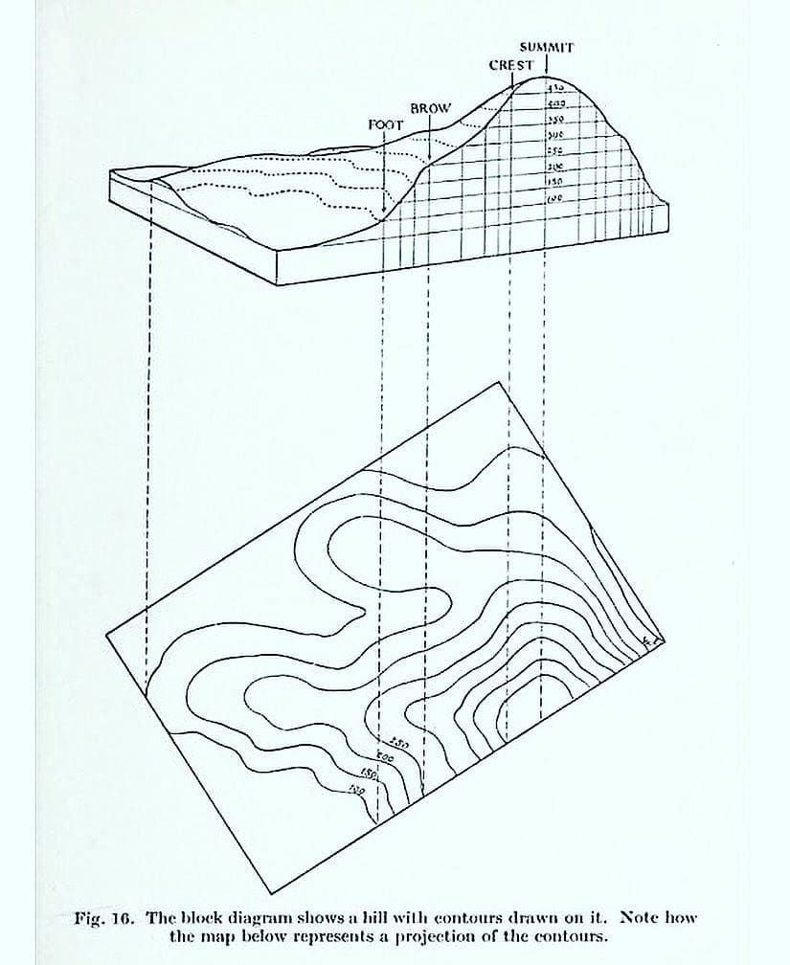
- Contour lines crosses a ridge or a valley at approximate right angles. If the higher values are inwards to the bend or loop in the contour map it represents a ridge and if the higher values are outwards to the bend it represents a valley.
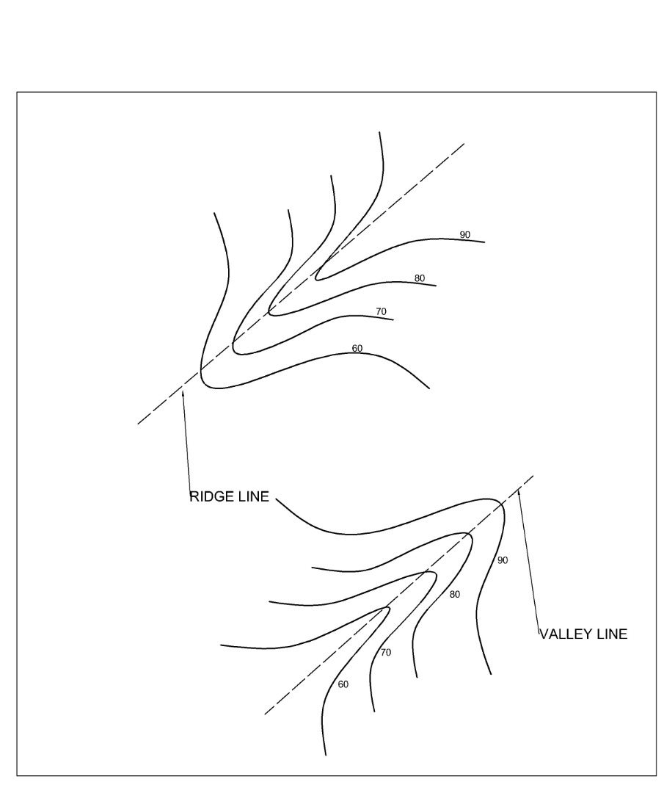
- Contour lines can not merge or cross one-another on a contour map except in the case of an overhanging cliff where the full perimeter of the base is only partially visible from the top.
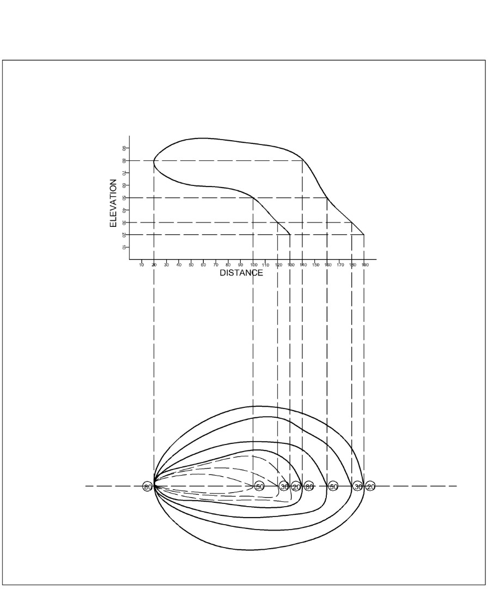
- A series of closed contours on a map indicates a depression if the higher values are outwards as shown. 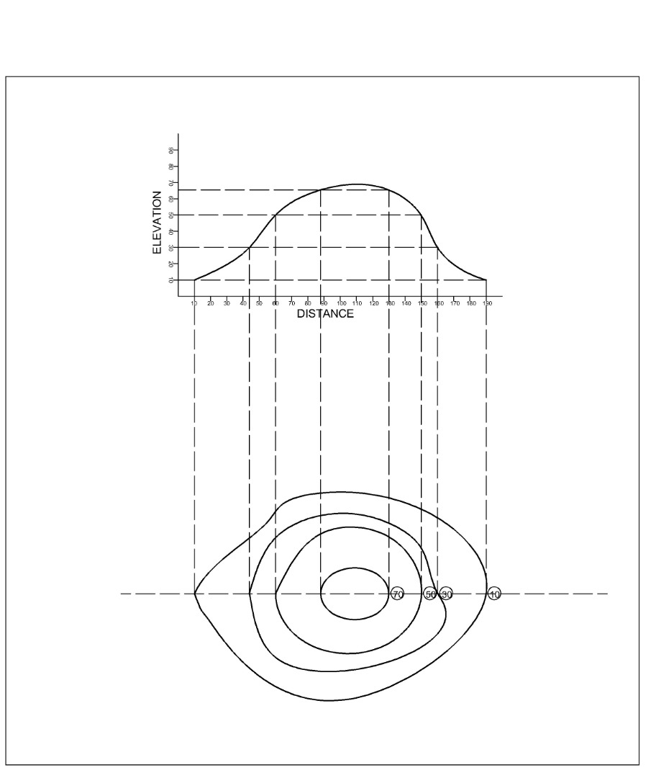
- A series of closed contours on a map indicates a hill if the higher values are inwards as shown.
