NAME: ALAWA PORBARI BERNICE
DEPARTMENT: MEDICINE AND SURGERY
MATRIC NUMBER: 19/MHS01/084
- ORGANIC SUBSTANCE | FUNCTIONAL GROUPS PRESENT
CH2=C(OH)HCHO | -OH, -CHO
C6H5CH(NH2)COCH3 | -NH2, -CO
CH3C=CHCH(OH)CHO | -OH, -CHO
- α_{λ}^{T} =α÷c.l
α_{λ}^{T} =1/100
α_{λ}^{T} =00.1⁰
3.a. 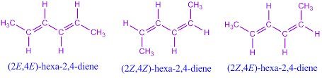
b. 