NAMES: JAMES ONYEKACHI NATHANIEL
MATRIC NO: 19/ENG05/031
COURSE CODE: CHE 102
1. Give the IUPAC names of the following compounds
HCOOH - METHANOIC ACID HOOCCH2CH2CH2COOH – PENT-1,5 DIOIC ACID
CH3CH2CH2COOH - BUTANOIC ACID HO2C-CO2H – HEPTANEDIOC ACID
CH3(CH2)4COOH – HEXANOIC ACID CH3CH=CHCH2CH2COOH– HEX-4-ENOIC ACID
2. Discuss briefly the physical properties of carboxylic acids under the following headings
i. Physical appearance:
- Litmus Test: Carboxylic acids turn blue litmus red.
- Sodium Bicarbonate Test: To a small portion of the organic compound taken in a test tube, a pinch of solid sodium bicarbonate is added. Evolution of carbon dioxide with brisk effervescence shows the presence of carboxylic acid. Alcohols do not give this test.
- Ester Test: In this test, the compound to be tested is warmed with small quantity of ethyl alcohol and 2-3 drops of concentrated sulphuric acid. The formation of sweet smelling vapours indicates the presences of some carboxylic acid. The sweet smelling vapours are due to the formation of some ester by reaction between the acid and ethyl alcohol.
ii. Boiling point: Carboxylic acids tend to have higher boiling points than water, because of their greater surface areas and their tendency to form stabilized dimers through hydrogen bonds. For boiling to occur, either the dimer bonds must be broken or the entire dimer arrangement must be vaporized, increasing the enthalpy of vaporization requirements significantly.
iii. Solubility: Carboxylic acids are polar. Because they are both hydrogen-bond acceptors (the carbonyl –C=O) and hydrogen-bond donors (the hydroxyl –OH), they also participate in hydrogen bonding. Together, the hydroxyl and carbonyl group form the functional group carboxyl. Carboxylic acids usually exist as dimers in nonpolar media due to their tendency to "self-associate". Smaller carboxylic acids (1 to 5 carbons) are soluble in water, whereas higher carboxylic acids have limited solubility due to the increasing hydrophobic nature of the alkyl chain. These longer chain acids tend to be soluble in less-polar solvents such as ethers and alcohols.[3] Aqueous sodium hydroxide and carboxylic acids, even hydrophobic ones, react to yield water-soluble sodium salts. For example, enathic acid has a low solubility in water (0.2 g/L), but its sodium salt is very soluble in water.
3. Write two industrial preparations of carboxylic acids
- Carbonylation coupled to the addition of water. This method is effective and versatile for alkenes that generate secondary and tertiary carbocations, e.g. isobutylene to pivalic acid. In the Koch reaction, the addition of water and carbon monoxide to alkenes is catalyzed by strong acids. Hydrocarboxylations involve the simultaneous addition of water and CO. Such reactions are sometimes called "Reppe chemistry."
HCCH + CO + H2O → CH2=CHCO2H
- Oxidation of hydrocarbons using air. For simple alkanes, this method is inexpensive but not selective enough to be useful. Allylic and benzylic compounds undergo more selective oxidations. Alkyl groups on a benzene ring are oxidized to the carboxylic acid, regardless of its chain length. Benzoic acid from toluene, terephthalic acid from para-xylene, and phthalic acid from ortho-xylene are illustrative large-scale conversions. Acrylic acid is generated from propene.
4. With equations and brief explanation discuss the synthetic preparation of carboxylic acid
- Carbonation of a Grignard reagent and organolithium reagents:
RLi + CO2 → RCO2Li
RCO2Li + HCl → RCO2H + LiCl
- Base-catalyzed cleavage of non-enolizable ketones, especially aryl ketones:[6]
- RC(O)Ar + H2O → RCO2H + ArH

5. With chemical equation only, outline the reduction, decarboxylation and esterification of carboxylic acid
- REDUCTION:
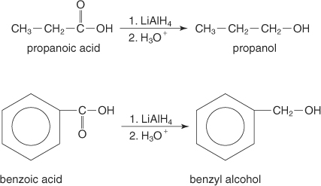
- DECARBOXYLATION:
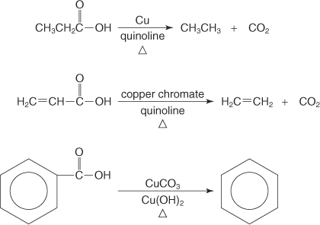
- ESTERIFICATION:

