NAME: NWAOLISA CHIOMA SUCCESS
MATRIC NUMBER: 17/MHS01/207
DEPARTMENT: MEDICINE AND SURGERY
COURSE CODE: ANA 301
ASSIGNMENT QUESTIONS
- Write an essay on the cavernous sinus
- Discuss the walls of the nose
Answer 1
The cavernous sinus is a paired dural venous sinus located within the cranial cavity. It is divided by septa into small ‘caves’ – from which it gets its name.
Each cavernous sinus has a close anatomical relationship with several key structures in the head, and is arguably the most clinically important venous sinus.

Anatomical Location and Borders
The cavernous sinuses are located within the middle cranial fossa, on either side of the sella turcica of the sphenoid bone (which contains the pituitary gland). They are enclosed by the endosteal and meningeal layers of the dura mater.
The borders of the cavernous sinus are as follows:
- Anterior – superior orbital fissure.
- Posterior – petrous part of the temporal bone.
- Medial – body of the sphenoid bone.
- Lateral – meningeal layer of the dura mater running from the roof to the floor of the middle cranial fossa.
- Roof – meningeal layer of the dura mater that attaches to the anterior and middle clinoid processes of the sphenoid bone.
- Floor – endosteal layer of dura mater that overlies the base of the greater wing of the sphenoid bone.

Contents
Several important structures pass through the cavernous sinus to enter the orbit. They can be sub-classified by whether they travel through the sinus itself, or through its lateral wall:
Travels through cavernous sinus: | Travels through lateral wall of cavernous sinus:
- Abducens nerve (CN VI)  - Carotid plexus (post-ganglionic sympathetic nerve fibres)  - Internal carotid artery (cavernous portion) | - Oculomotor nerve (CN III)  - Trochlear nerve (CN IV)  - Ophthalmic (V1) and maxillary (V2) branches of the trigeminal nerve
The cavernous sinus is the only site in the body where an artery (internal carotid) passes completely through a venous structure. This is thought to allow for heat exchange between the warm arterial blood and cooler venous circulation.
Each cavernous sinus receives venous drainage from:
- Ophthalmic veins (superior and inferior) – these enter the cavernous sinus via the superior orbital fissure.
- Central vein of the retina – drains into the superior ophthalmic vein, or directly into the cavernous sinus.
- Sphenoparietal sinus – empties into the anterior aspect of the cavernous sinus.
- Superficial middle cerebral vein – contributes to the venous drainage of the cerebrum
- Pterygoid plexus – located within the infratemporal fossa.
It is important to note that the superior ophthalmic vein forms an anastomosis with thefacial vein. Therefore, the ophthalmic veins represent a potential route by which infection can spread from an extracranial to an intracranial site.
The cavernous sinuses empty into the superior and inferior petrosal sinuses, and ultimately, into the internal jugular vein. The left and right cavernous sinuses are connected in the midline by the anterior and posterior intercavernous sinuses. They travel through the sella turcica of the sphenoid bone.

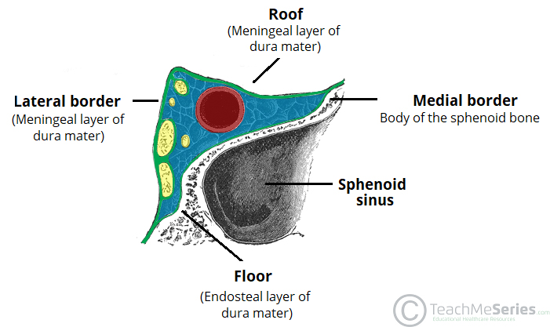
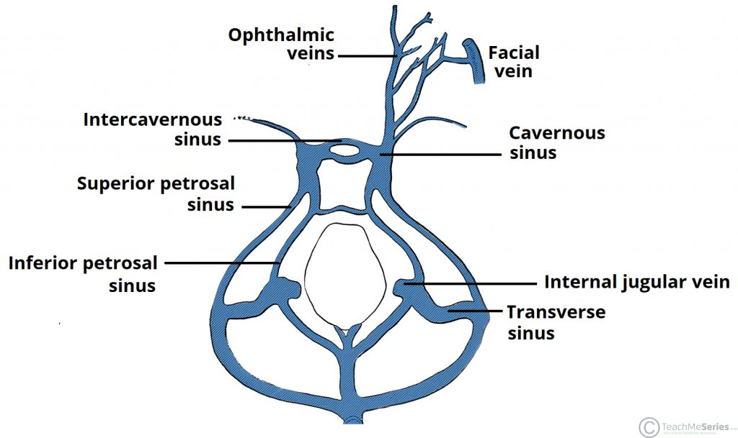
CLINICAL SIGNIFICANCE
CAVERNOUS SINUS THROMBOSIS (CST): refers to the formation of a clot within the cavernous sinus. The most cause of CST is infection which typically spreads from extracranial location such as the orbit, paranasal sinuses, infection is able to swpread in this manner due to the anastomosis between the facial vein and superior ophthalmic veins. thrombosis of cavernous sinus can rapidly progress to meningitis.
ANSWER 2
Medial wall (nasal septum)
Is formed primarily by the perpendicular plate of the ethmoid bone, vomer, and septal cartilage.Is also formed by processes of the palatine, maxillary, frontal, sphenoid, and nasal bones. The nasal septum divides the chamber of the nose into two nasal cavities. The septum has a bony part and a soft mobile cartilaginous part.
Lateral wall
Is formed by the superior and middle conchae of the ethmoid bone and the inferior concha.
Is also formed by the nasal bone, frontal process and nasal surface of the maxilla, lacrimal bone,
perpendicular plate of the palatine bone, and medial pterygoid plate of the sphenoid bone.
Contains the following structures and their openings:
Sphenoethmoidal recess : opening of the sphenoid sinus.
Superior meatus : opening of the posterior ethmoidal air cells.
Middle meatus : opening of the frontal sinus into the infundibulum, openings of the middle
ethmoidal air cells on the ethmoidal bulla , and openings of the anterior ethmoidal air cells
and maxillary sinus in the hiatus semilunaris.
Inferior meatus : opening of the nasolacrimal duct.
Sphenopalatine foramen : opening into the pterygopalatine fossa; transmits the
sphenopalatine artery and nasopalatine nerve.

