OVBUDE IRENOISE DEBORAH

16/MHS03/026

INTRODUCTION TO HISTOPATHOLOGY
ANA 404

MR EDEM. E. EDEM

ASSIGNMENT
- WRITE ON CYTOKINE SIGNALLING AND ITS ROLE IN WOUND HEALING.
- WHEN IS WOUND HEALING REFERRED TO AS “IMPAIRED? AND WHY?
- EXAMINE THE ROLE OF OXIDATIVE STRESS IN THE DEVELOPMENT AND PROGRESSION OF IMPAIRED WOUND HEALING?

WHAT ARE CYTOKINES?
The word cytokine is derived from the greek words “cyto”, meaning cell, and “kinos” meaning movement (Mandal, 2008). Cytokines are a large group of cell signaling molecules that are responsible for cell to cell communication, or signaling, in order to generate an immune response. Cytokines have documented roles in developmental processes such as cell differentiation and cell migration, but the immune system depends on cytokine signaling to keep the human body healthy (Murray, 2011).
They are also peptides and cannot cross the lipid bilayer of cells to enter the cytoplasm. Cytokines have been shown to be involved in autocrine, paracrine and endocrine signaling as immunomodulating agents. Their definite distinction from hormones is still part of ongoing research (Isaacs, 1957).
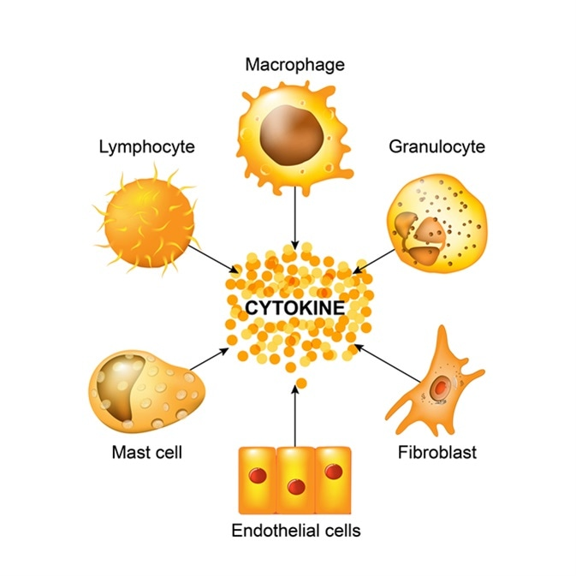
Fig.1. Cytokines

Cytokine Signalling
When cytokines are released from a cell they bind to a receptor on the cell surface of a target cell. This binding triggers a chemical signal that is sent into the target cell which in turn, causes a change in function or phenotype (Mclnnes, 2017). The effect of cytokines can frequently be visible on the very cells that secreted them, which is referred to as autocrine action. Nearby cells can also be affected by cytokine release, which is referred to as paracrine action. Occasionally, cytokine secretion can even affect distant cells that are far away which is referred to as endocrine action.
Many studies have documented that mutations in cytokines themselves and receptors contribute to autoimmune diseases such as multiple sclerosis, diabetes, and inflammatory bowel disease (O’shea and Murray, 2008). In fact, cytokines and cytokine antagonists have recently become some of the most successful new drugs. Bethyl manufactures many antibodies to proteins involved in cytokine signaling that may aid in advancing breakthroughs in future therapeutics (O’shea et.al, 2011).
Cytokins include chemokines, interferons, interleukins, lymphokines, and tumour necrosis factors, but generally not hormones or growth factors (despite some overlap in the terminology). Cytokines are produced by a broad range of cells, including immune cells like macrophages, B lymphocytes, T lymphocytes and mast cells, as well as endothelial cells, fibroblasts, and various stromal cells; a given cytokine may be produced by more than one type of cell (Wolters, 2006). They act through cell surface receptors and are especially important in the immune system; cytokines modulate the balance between humoral and cell-based immune responses, and they regulate the maturation, growth, and responsiveness of particular cell populations. Some cytokines enhance or inhibit the action of other cytokines in complex ways. They are different from hormones, which are also important cell signaling molecules. Hormones circulate in higher concentrations, and tend to be made by specific kinds of cells (Liekens, et.al., 2001). Cytokines are important in health and disease, specifically in host immune responses to infection, inflammation, trauma, sepsis, cancer, and reproduction.

CYTOKINE SIGNALLING AND ITS ROLE IN WOUND HEALING
The response to injury is a phylogenetically primitive, yet essential innate host immune response for restoration of tissue integrity. Tissue disruption in higher vertebrates, unlike lower vertebrates, results not in tissue regeneration, but in a rapid repair process leading to a fibrotic scar (Singer et.al., 1999). Wound healing, whether initiated by trauma, microbes or foreign materials, proceeds via an overlapping pattern of events including coagulation, inflammation, epithelialization, formation of granulation tissue, matrix and tissue remodeling. The process of repair is mediated in large part by interacting molecular signals, primarily cytokines, that motivate and orchestrate the manifold cellular activities which underscore inflammation and healing (Singer, 1999).
Wound healing is an integrated and complex process involving a large number of regulatory molecules, including proinflammatory cytokines and growth factors, and an orchestrated tissue response. Dysregulation in cytokine or growth factor expression dramatically alters the normal wound healing process, and blocking the inappropriate production of specific proinflammatory cytokines or supplementing the milieu with increased quantities of growth factors has demonstrated the central role played by these mediators (Andrew, 2004).
Wound healing is an evolutionarily conserved, complex, multicellular process that, in skin, aims at barrier restoration. This process involves the coordinated efforts of several cell types including keratinocytes, fibroblasts, endothelial cells, macrophages, and platelets (Stojadinovic, 2008). The migration, infiltration, proliferation, and differentiation of these cells will culminate in an inflammatory response, the formation of new tissue and ultimately wound closure. This complex process is executed and regulated by an equally complex signaling network involving numerous growth factors, cytokines and chemokines (Barrientos et.al., 2008). Of particular importance is the epidermal growth factor family, transforming growth factor beta family, fibroblast growth factor family, vascular endothelial growth factor, granulocyte macrophage colony stimulating factor, platelet-derived growth factor, connective tissue growth factor, interleukin family, and tumor necrosis factor-alpha family (Golinko,2008). With gene therapy now in clinical trial and the discovery of biodegradable polymers, fibrin mesh, and human collagen serving as potential delivery systems other growth factors may soon be available to patients. This review will focus on the specific roles of these growth factors and cytokines during the wound healing process (Barrientos et.al., 2008).

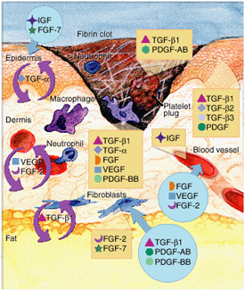

Fig. 2. Cytokines in Wound Healing

IMPAIRED WOUND HEALING

A wound is a disruption of the normal structure and function of the skin and underlying soft tissue. Impaired wound healing often occurs in the setting of multiple, smaller contributing issues to stall the healing process; however, infection or ischemia alone can impair wound healing. When the healing process is stalled, a chronic wound may develop, and this is more likely to occur in patients with underlying medical disorders (Orr et,al., 2003).
Nonhealing wounds represent a significant cause of morbidity and mortality for a large portion of the population. One of the underlying mechanisms responsible for the failure of chronic wounds to heal is an out-of-control inflammatory response that is self-sustaining. Underappreciation of the inherent complexity of the healing wound has led to the failure of monotherapies, with no significant reduction in wound healing times Menke et,al. 2007) . A model of the inflammatory profile of a nonhealing wound is one in which the equilibrium between synthesis and degradation has been shifted toward degradation. This review summarizes the current information regarding acute wound healing responses as contrasted to the delayed response characteristic of chronic wounds. In addition, some initial complexity theoretical models are proposed to define and explain the underlying pathophysiology (Menke et,al. 2007).

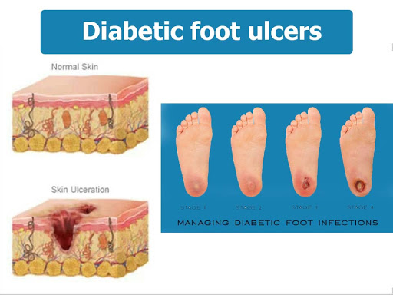

Fig. 2. Impaired Wound Healing in a Diabetic Foot

EFFECTS OF OXIDATIVE STRESS ON THE DEVELOPMENT AND PROGRESSION OF IMPAIRED WOUND HEALING

Oxidative stress is a condition which os the imbalance of prooxidant and antioxidants, abnormally high levels of free radicals and/or the decline of antioxidant defense mechanisms. Excessive oxidative stress could lead to damage of tissue, which played an important role in the development of many kinds of diseases (Yang et.al., 2007).
Free radical relatively increased during oxidative stress. Normally free radical was necessary for defense of organism and there was a balance between its produce and scavenge. Oxidative stress was closely associated with reactive oxygen species. Reactive oxygen species could play an important role in physiology in some extent, also it led to damage of tissue or cells when organism could not defend excessive reactive oxygen species (Yonghe, 2007). Excessive reactive oxygen species and its degradation product generated during the healing of cutaneous wound. Oxidation increased in acute and chronic wound. After wound oxidative stress generates, antioxidation increased in chronic wound (impaired wound healing), which indirectly reflected the increasing of oxidative stress and compensation and defense of tissue to oxidative stress (Wang, 2007).
The generation of oxidative stress in wound maybe closely relate to inflammatory reaction. In the inflammatory stage of wound healing, oxidative stress induced the damage of tissue because of the imbalance of prooxidant and antioxidant. Conclusion: Oxidative stress should be considered in the inflammatory processes of wound healing and treatment of impaired wound (Yang, 2007).

REFERENCE

- Isaacs A, Lindenmann J (September 1957). "Virus interference. I. The interferon". Proc. R. Soc. Lond. B Biol. Sci. 147 (927): 258–67.
- McInnes I. Kelley and Firestein’s Textbook of Reumatology. Elsevier Inc. 2017. Vol 1. 396-407.
- O’Shea J. and Murray P. 2008. Cytokine Signaling Modules in Inflammatory Responces. Immunity. 28(4): 477-487.
- O’Shea J, Gadina M, Kanno Y. 2011. Cytokine Signaling: Birth of a Pathway. J Immunol. 187(11): 5475-5478.
- Singer. 2002. Cytokines in Wound Healing. First printed in R&D Systems' 2002 catalog. R and D System a biotechne brand.https://www.rndsystems.com/resources/articles/cytokines-wound-healing.
- "Cytokine" in Stedman’s Medical Dictionary, 28th ed. Wolters Kluwer Health, Lippincott, Williams & Wilkins (2006)
- Singer, A.J. & R.A. Clark (1999) New Engl. J. Med. 341:738.
- Barrientos S, Stojadinovic O, Golinko MS, Brem H, Tomic-Canic M.
- 2008. Growth factors and cytokines in wound healing.
- Sep-Oct;16(5):585-601. doi: 10.1111/j.1524-475X.2008.00410.x.
- Andrew. J. Sanders. 2004. Cytokines and Wound Healing: The Role of Cytokine and Anticytokine Therapy in the Repair Response. Journal of Burn Care & Rehabilitation. 25(2):149-60. DOI: 10.1097/01.BCR.0000111766.97335.34 ·
- Victor W. Wong,Jeffrey D. Crawfor.2013. Vasculogenic Cytokines in Wound Healing. BioMed Research International. Volume 2013 |Article ID 190486. https://doi.org/10.1155/2013/190486.
- Liekens, S. et al. (2001) Biochem. Pharmacol. 61:253.
- Orr JW, Taylor PT. (2003). Wound healing. In: Complications in gynecological surgery: Prevention, recognition, and management, JB Lippincott, Philadelphia p.167.
- Menke NB, Ward KR, Witten TM, Bonchev DG, Diegelmann RF. (2007). Impaired Wound Healing. PubMed. Pg. 25(1):19-25. DOI:10.1016/j.clindermatol.2006.12.005
- Yang G. Z, Wang R. X, Yonghe Lin. (2007). Oxidative Stress and Wound Healing. Journal of Clinical Rehabilitative Tissue Engineering Research. P.g. 11(2):355-358

