Okereke Chidinma Blessing
18/MHS04/004
BCH 208- Human Nutrition and Biochemistry 2
Assignment
Department of Human Nutrition and Dietetics
College of Medicine and Health Sciences

Describe the glycolytic pathway

Glycolysis
In glycolysis , a molecule of glucose is degraded in a series of enzyme molecules of the three catalyzed reactions to yield two carbon compound, pyruvate. During the sequential reactions of glycolysis, some of the free energy released from glucose is conserved in the form of ATP and NADH. An Overview: Glycolysis has two phases:

Preparatory phase (1): The breakdown of the six the three-- carbon glucose into two molecules of carbon pyruvate, which occurs in ten steps, the first five of which constitute the preparatory phase.

- Glucose is first phosphorylated at the hydroxyl group on C6
- The D-glucose 6-- phosphate thus formed is converted to D-fructose 6-phosphate.
- D-fructose 6-phosphate is again phosphorylated, this time at C1, to yield D-fructose 1, 6-bisphosphate. For both phosphorylations, ATP is the phosphoryl group donor.
- Fructose 1,6- phosphate is split to yield two three-carbon molecules, dihydroxyacetone phosphate and glyceraldehyde 3-phosphate.
- The dihydroxyacetone phosphate is isomerized to a second molecule of glyceraldehyde 3-phosphate

To summarize: in the preparatory phase of glycolysis, the energy of ATP is invested, raising the free-energy content of the intermediates, and the carbon chains of all the metabolized hexoses are converted into a common product, glyceraldehyde 3-phosphate.

The energy gain comes in the pay off phase of glycolysis.
- Each molecule of glyceraldehyde 3-phosphorylated is oxidized and phosphorylated by inorganic phosphate (not by ATP) to form 1,3-biphosphoglycerate.
- Energy is then released as the two molecules of 1,3-bisphosphoglycerate are converted to two molecules of pyruvate.
- Much of this energy is conserved by the coupled phosphorylation of four molecules of ADP to ATP.
- The net yield is two molecules of ATP per molecule of glucose used, because two molecules of ATP were invested in the preparatory phase.
- Energy is also conserved in the payoff phase in the formation of two molecules of NADH per molecule of glucose.

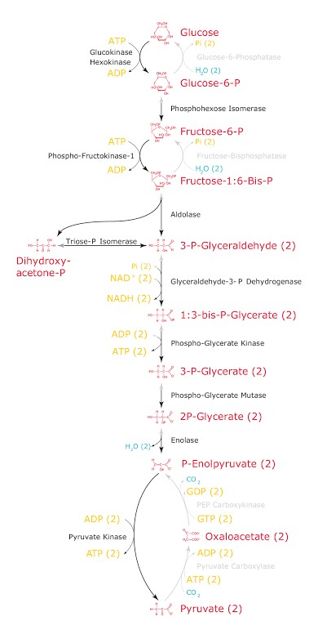

Stoichiometry of Coenzyme Reduction and ATP Formation in the Aerobic Oxidation of Glucose via Glycolysis, the Pyruvate Dehydrogenase Complex Reaction, the Citric Acid Cycle, and Oxidative Phosphorylation using 1 NADH= 3ATP and 1 FADH₂= 2ATP

Reaction | Number Of ATP/Reduction Coenzyme | Number Of ATP
Glucose→Glucose 6-Phosphate | -1 ATP | -1
Fructose 6-Phosphate →Fructose 1,6-Biphosphate | -1 ATP | -1
2 Glyceraldehyde 3-Phosphate→2 1,3-Biphosphoglycerate | 2 NADH | 6
2 1,3 Biphosphoglycerate→2 3-Phosphoglycerate | 2 ATP | 2
2 Phosphoenolpyruvate →2 Pyruvate | 2 ATP | 2
2 Pyruvate→2 Acetyl-CoA | 2 NADH | 6
2 Isocitrate→2 Α-Ketoglutarate | 2 NADH | 6
2 Α-Ketoglutarate→2 Succinyl-CoA | 2 NADH | 6
2 Succinyl-CoA→2 Succinate | 2 ATP or 2 GTP | 2
2 Succinate→2 Fumerate | 2 FADH₂ | 4
2 Malate→2 Oxaloacetate | 2 NADH | 6
TOTAL |  | 38

