NAME: ALLEN-OKEREAFOR CHIAMAKA SONIA

MATRIC NO: 18/MHS01/070

COLLEGE: MEDICINE AND HEALTH SCIENCES

DEPT: MEDICINE AND SURGERY

COURSE: ANATOMY

ASSIGNMENT
Discuss the second week of development

SECOND WEEK OF DEVELOPMENT
There are three (3) major events that will take place during the second (2nd) week of development. These include:
- Completion of implantation of the blastocyst
- Formation of a bilaminar embryonic disc (epiblast and hypoblast)
- Development of extra embryonic structures e.g. amniotic cavity, amnion, etc.

Day 8
- The blastocyst is partially embedded in the endometrium
- The syncytiotrophoblast will continue to evade the region of the endometrium thereby eroding endometrial blood vessels and endometrial glands
- The cytotrophoblast will continue to divide and migrate to the region of the syntiotrophoblast where they fuse and lose their individual cell membranes
- The embryoblast will differentiate into two (2) types of cells
- Hypoblast that is made up of small cuboidal cells and it is adjacent to the blastocyst cavity
- Epiblast that is made up of high columnar cells and it is adjacent to the amniotic cavity
The cells of the epiblast that are adjacent to the cytotrophoblast are called amnioblast.
- These cells (epiblast and amnioblast) surround a cavity called amniotic cavity.
- The epiblast and hypoblast give rise to the bilaminar germ disc.
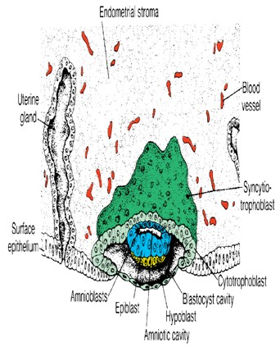

Day 9
- The blastocyst is deeply embedded in the endometrium
- The surface epithelium is closed by a coagulum called fibrin coagulum
- Vacuoles appear at the region of the trophoblast and they fuse to form larger lacunae. This phase of trophoblast development is called the lacunar stage
- The cells that lie adjacent to the cytotrophoblast called exocoelomic membrane/Heuser’s membrane
- The cavity that is developed is called exocoelomic cavity/primary yolk sac/primary umbilical vesicle
- The synciotrophoblast will continue to erode the endometrium

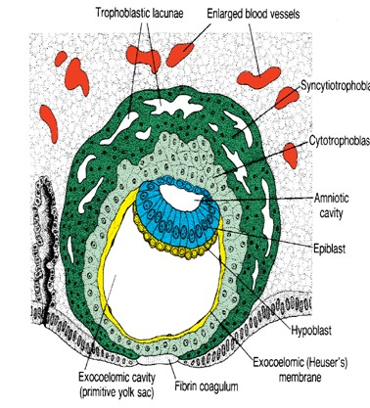

Day 11-12
- The blastocyst is completely embedded in the endometrium
- And the surface epithelium almost entirely covers the original defect in the uterine wall
- Cells of the syncytiotrophoblast penetrate deeper into the stroma (tissue) and erode the endothelial lining of the endometrial capillaries. These ruptured endometrial capillaries are called sinusoids
- The lacunae then begin to communicate with sinusoids and maternal blood enters the lacunar system
- The communication of the eroded endometrial capillaries with the lacunae establishes the primordial uteroplacental circulation
- A new population of cells appears between the inner surface of the cytotrophoblast and the outer surface of the exocoelomic cavity
- These cells which are derived from yolk sac cells form a fine, loose connective tissue called the extraembryonic mesoderm
- Soon, large cavities develop in the extraembryonic mesoderm, and when these become confluent, they form a new space known as the extraembryonic cavity/chorionic cavity/extraembryonic coelom
- This space surrounds the primitive yolk sac and amniotic cavity, except where the germ disc is connected to the trophoblast by the connecting stalk
- The extraembryonic mesoderm lining the cytotrophoblast and amnion is called the extraembryonic somatic mesoderm
- The lining covering the yolk sac is known as the extraembryonic splanchnic mesoderm.
- As the conceptus implants, the endometrial connective tissue cells undergo a transformation, called decidual reaction. During this transformation, the cells of the endometrium swell because of the accumulation of glycogen and lipid in their cytoplasm and they are known as decidual cells. The primary function of the decidual reaction is to provide nutrition for the early embryo and an immunologically privileged site for the conceptus
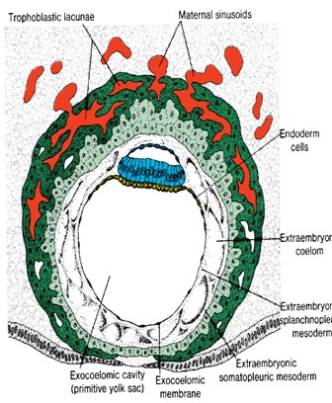

Day 13
- The surface defect in the endometrium has been completely covered by the surface epithelium
- Occasionally bleeding occurs at the implantation site as a result of increased blood flow into the lacunar spaces
- Cells of the cytotrophoblast proliferate locally and penetrate into the syncytiotrophoblast, forming cellular columns surrounded by syncytium
- Cellular columns with the syncytial covering are known as primary villi
- The primary yolk sac becomes reduced in size and is known as the secondary yolk sac
- This new cavity is known as the secondary yolk sac/definitive yolk sac/secondary umbilical vesicle
- In humans the yolk sac contains no yolk but is important for the transfer of nutrients between the fetus and mother.
- This yolk sac is much smaller than the original exocoelomic cavity or primitive yolk sac
- During its formation, large portions of the exocoelomic cavity are pinched off to form exocoelomic cysts
- Exocoelomic cysts are often found in the extraembryonic cavity/chorionic cavity/extraembryonic coelom
- The extraembryonic coelom expands and forms a large cavity called the chorionic cavity
- The extraembryonic mesoderm lining the inside of the cytotrophoblast is then known as the chorionic plate
- The only place where extraembryonic mesoderm traverses the chorionic cavity is in the connecting stalk
- With development of blood vessels, the connecting stalk becomes the umbilical cord.
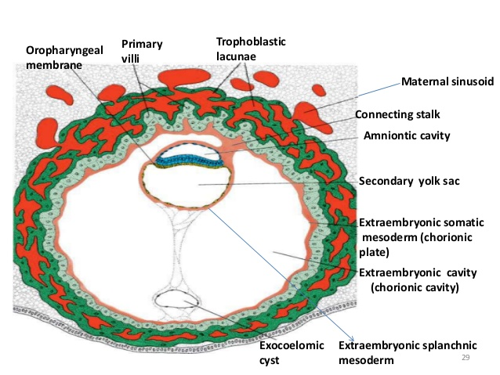

CLINICAL CORRELATIES
- Pregnancy testing
The synciotrophoblast produces a hormone called the human chorionic gonadotrophin (hCG) which enters the maternal blood via lacunae and keeps the corpus luteum secreting estrogen and progesterone. hCG can be detected in maternal blood or urine as early as day 10 of pregnancy and is the basis for pregnancy tests.
- Extrauterine implantation
Blastocysts may implant outside the uterus. These implantations result in ectopic pregnancies.

