Okerewa Alice
17/sci03/007
Bch304 assignment
Question : Give in details the characteristics of genetic codes

Answer :

The genetic code consists of the sequence of nitrogen bases—A, C, G, U—in an mRNA chain. The four bases make up the “letters” of the genetic code. The letters are combined in groups of three to form code “words,” called codons. Each codon stands for (encodes) one amino acid, unless it codes for a start or stop signal.

There are 20 common amino acids in proteins. There are 64 possible codons, more than enough to code for the 20 amino acids.
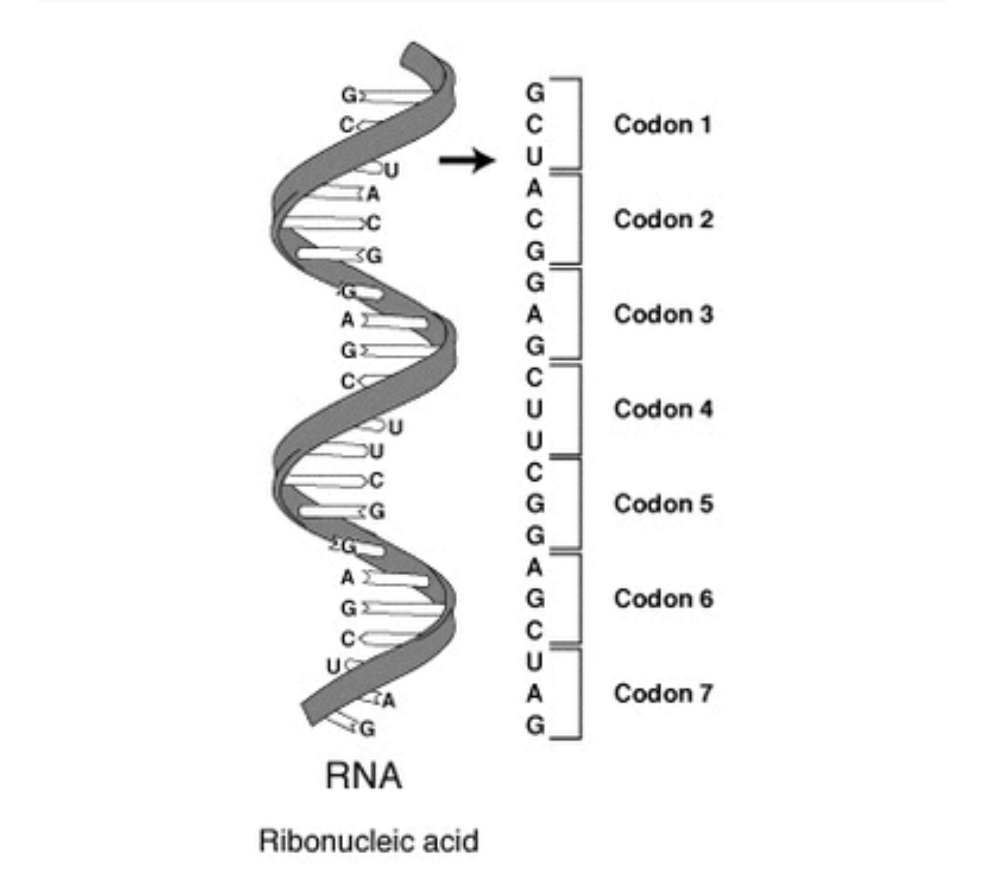
A series of codons in part of a messenger RNA (mRNA) molecule. Each codon consists of three nucleotides, usually corresponding to a single amino acid. The nucleotides are abbreviated with the letters A, U, G and C. This is mRNA, which uses U (uracil). DNA uses T (thymine) instead. This mRNA molecule will instruct a ribosome to synthesize a protein according to this code.
The genetic code is the set of rules used by living cells to translate information encoded within genetic material (DNA or mRNA sequences of nucleotide triplets, or codons) into proteins. Translation is accomplished by the ribosome, which links amino acids in an order specified by messenger RNA (mRNA), using transfer RNA (tRNA) molecules to carry amino acids and to read the mRNA three nucleotides at a time. The genetic code is highly similar among all organisms and can be expressed in a simple table with 64 entries.[1]

The code defines how codons specify which amino acid will be added next during protein synthesis. With some exceptions,[2] a three-nucleotide codon in a nucleic acid sequence specifies a single amino acid. The vast majority of genes are encoded with a single scheme (see the RNA codon table). That scheme is often referred to as the canonical or standard genetic code, or simply the genetic code, though variant codes (such as in human mitochondria) exist.
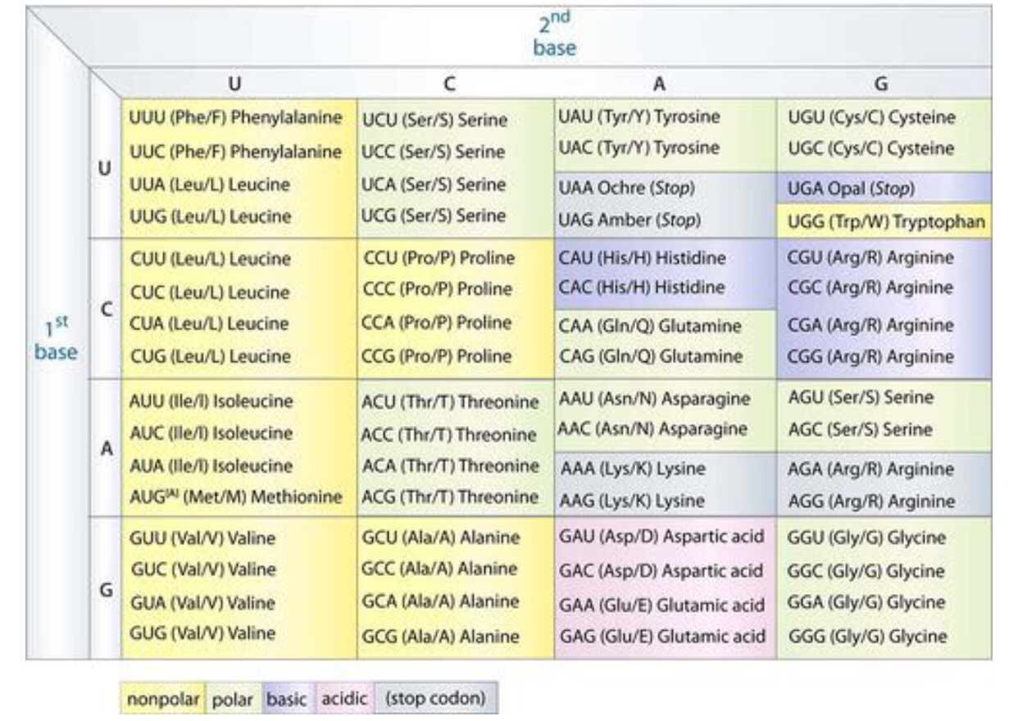

Characteristics of genetic code

- Three nucleotides/bases encode an amino acid, there are 20 different amino acids which are the building blocks for proteins.
- The genetic code is non-overlapping, for example a sequence UGGAUCGAU is read UGG AUC GAU rather than UGG GGA GAU etc.
- The code has no punctuation, so no base serves as a "comma" between groups of bases, therefore the code is read sequencially three bases at a time.
- The code is degenerate, meaning more than one codon encodes for the same amino acid. There are 64 possible triplets yet only 20 amino acids so most amino acids are encoded by 2 or more codons. Triplets that code for the same amino acid are known as synonyms.
- AUG has two functions.It acts as an initiator codon and codes for Methionine(met).[2]
The genetic code is a set of rules for translating information encoded in DNA into proteins through RNA in genes. The code is read 5' to 3' direction in a fixed reading frame beginning from the start codon (AUG) 6Codes for a single amino acid whereby the bases are read in sets or groups of 3s called a TRIPLET CODE or CODON. Example is UUU for Phenylalanine, CGC for Arginine Is non-overlapping meaning that the triplets (group of 3s) are read separately. A deletion or insertion of bases can cause a frameshift mutation.

- Is degenerate- more than one triplet can code for a particular amino acid. This occurs due to redundancy; there are four different bases read in groups of three to give 64 possible combinations but only 20 amino acids (43 = 64). Examples are; serine has the following (UCU, UCC, UCA, UCG, AGU, AGC), glycine which has (GGU, GGC, GGA, GGG). These codons are called synonymous codon .However, some amino acid have only one codon which specifies it on the genetic code, example is tryptophan (UGG) and methionine (AUG), also, the stop codon has three codons which specifies it (UGA, UAA, UAG)
- According Berg et al. (2012), "the code lacks punctuation (comma)" .
- As well as being degenerate, the genetic code is also referred to as 'unambiguous' which means that each possible codon can code for one amino acid only.
- The genetic code is almost universal (i.e. it is the same for all living organisms and in all types of DNA/RNA) however there are some exceptions. An example is in human mitochondrial genomes whereby UGA codes for tryptophan, AGA and; AGG code for stop codon; this occurs because mitochondrial DNA encodes a distinct set of tRNAs.

