NAME: IKECHUKWU JOY NMESOMA
MATRIC NO: 18/MHS05/008
DEPARTMENT: PHYSIOLOGY
ANA 202 ASSIGNMENTS
03-05-2020
QUESTION: 1.Using the video in slide 53, explain the heart
2. Write on 5 common congenital diseases of the heart.
ANSWER.
- The heart is a muscle about the size of your fist. It lies behind the breast bone or sternum; it is for pumping blood to all the vessels of the body. It is divided into four chambers;
- Right and left atrium
- Right and left ventricles
The chambers are separated by valves, there are 4 valves in the heart which are; Tricuspid, mitral, aortic and pulmonary. Circulation begins at the right side of the heart, where blood from the body comes into the right atrium; it passes through the right ventricle where it pumps blood to the lungs for oxygenation. Once it receives oxygen it flows to the left atrium and to the left ventricle where it is pumped to the aorta, then the rest of the body. On the right side of the heart the tricuspid valves separates the right atrium from the right ventricle to avoid backflow of blood. On the left side of the heart, the mitral valve separates the left atrium from the left ventricle. Blood flows from the left ventricle to the aorta through the aortic valves and then to the rest part of the body. Arteries carry blood with oxygen throughout the body while veins take blood back to the heart, then to the lungs to get oxygenated. The heart arteries, coronary arteries provide oxygen and nutrients to the heart muscle. The right coronary arteries supplies blood to the bottom and back of the heart. The left coronary artery splits into two vessels; one part supplies blood to the front of the heart while the other supplies blood to the left side of the heart.
The electric system transmits signal round the heart to control its pumping. The electric signal starts from the sino atrial node (SA node) which is located on the upper portion of the right ventricle. It is known as the natural pace maker of the heart, the electrical signal passes down to the lower portion the heart by the atrio ventricular node which controls signal so the atrium contracts before the ventricles. In the ventricles pathway wrap the muscle so they contract at the same time to pump blood to the lungs and through the body.

- a. Dextrocardia: this is the bending of the heart tube to the left instead of the right. It can also be defined as the condition in which the heart( four chambered heart) is pointed towards the right side instead of normally pointing to the left. It is present at birth. 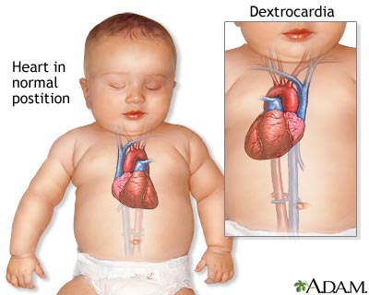

b .Atrial Septal defects: An ASD is a hole between the upper chambers, or the right and left atria of the heart. A hole here lets blood from the left atrium mix with blood in the right atrium.
- Ventricular Septal Defects: A VSD is a hole in the part of your septum that separates your heart’s lower chambers, or ventricles. If you have a VSD, blood gets pumped back to your lungs instead of your body.
- Tetralogy of fallot: it is combination of four defects, including:
- A large ventricular septal defect
- Thickened wall around your right ventricle, or lower chamber.
- Your aorta is located above the hole in your ventricular wall
- Stiff pulmonary valve that prevents blood from flowing easily from the heart to the lungs.
- Aorticopulmonary septal defect: it is a condition in which there is an opening (aortic window) between the aorta and pulmonary trunk near the aortic valve. The aorticopulmonary defect results from localised defect in the formation of the aorticopulmonary septum. The presence of pulmonary and aortic valves and an intact IV septum distinguishes this anomaly from the persistent truncus arteriosus defect.

