Name: Guwor-Niki Bolouere Michelle
Matric Number: 17/MHS03/018
Course Code: BCH 308

Answer:
Neurotransmitters:
A Neurotransmitter is a chemical substance which is released at the end of a nerve fibre by the arrival of a nerve impulse and, by diffusing across the synapse or junction, affects the transfer of the impulse to another nerve fibre, a muscle fibre, or some other structure.
Neurotransmitters include:
- Acetylcholine,
- Dopamine,
- Gamma-aminobutyric acid ( GABA ),
- Glutamate,
- Histamine,
- Norepinephrine, and
- Serotonin.

Synthesis of Histamine:
Histamine is an organic nitrogenous compound involved in local immune responses, as well as regulating physiological function in the gut and acting as a neurotransmitter for the brain, spinal cord, and uterus. Histamine is involved in the inflammatory response and has a central role as a mediator of itching
Histamine is derived from the decarboxylation of the amino acid histidine, a reaction catalyzed by the enzyme L-histidine decarboxylase. It is a hydrophilic vasoactive amine.
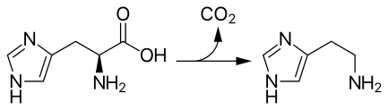
Conversion of histidine to histamine by histidine decarboxylase

Once formed, histamine is either stored or rapidly inactivated by its primary degradative enzymes, histamine-N-methyltransferase or diamine oxidase. In the central nervous system, histamine released into the synapses is primarily broken down by histamine-N-methyltransferase, while in other tissues both enzymes may play a role. Several other enzymes, including MAO-B and ALDH2, further process the immediate metabolites of histamine for excretion or recycling.
Bacteria also are capable of producing histamine using histidine decarboxylase enzymes unrelated to those found in animals. A non-infectious form of foodborne disease, scombroid poisoning, is due to histamine production by bacteria in spoiled food, particularly fish. Fermented foods and beverages naturally contain small quantities of histamine due to a similar conversion performed by fermenting bacteria or yeasts. Sake contains histamine in the 20–40 mg/L range; wines contain it in the 2–10 mg/L range.
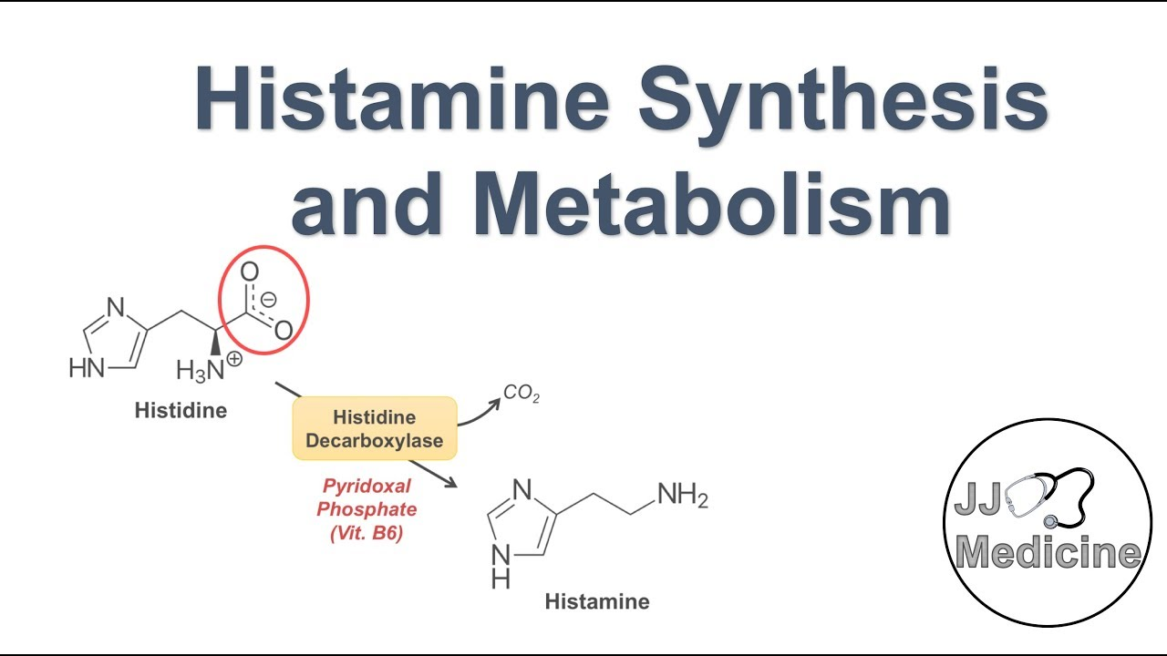

Synthesis of Glutamate:
Glutamate refers to the anion of glutamic acid in its role as a neurotransmitter: a chemical that nerve cells use to send signals to other cells. It is by a wide margin the most abundant excitatory neurotransmitter in the vertebrate nervous system. It is used by every major excitatory function in the vertebrate brain, accounting in total for well over 90% of the synaptic connections in the human brain. It also serves as the primary neurotransmitter for some localized brain regions, such as cerebellum granule cells.
Glutamate is a major constituent of a wide variety of proteins; consequently it is one of the most abundant amino acids in the human body. Under ordinary conditions enough is obtained from the diet that there is no need for any to be synthesized. Nevertheless, glutamate is formally classified as a non-essential amino acid, because it can be synthesized from alpha-Ketoglutaric acid, which is produced as part of the citric acid cycle by a series of reactions whose starting point is citrate. Glutamate cannot cross the blood-brain barrier unassisted, but it is actively transported out of the nervous system by a high affinity transport system, which maintains its concentration in brain fluids at a fairly constant level.
Glutamate is synthesized in the central nervous system from glutamine as part of the glutamate–glutamine cycle by the enzyme glutaminase. This can occur in the presynaptic neuron or in neighboring glial cells.
Glutamate itself serves as metabolic precursor for the neurotransmitter GABA, via the action of the enzyme glutamate decarboxylase.
