NAME: IDARA MENDIE
DEPARTMENT: PHYSIOLOGY
MATRIC NO. : 17/MHS01/189
BCH 308 ASSIGNMENT

- Describe in details the synthesis of two named neurotransmitters
ANSWER:
- Dopamine Synthesis:

Dopamine is synthesized from the amino acid tyrosine; the majority of circulating tyrosine originates from dietary sources, but small amounts are derived from hydroxylation of phenylalanine by the liver enzyme phenylalanine hydroxylase .
Blood-borne tyrosine is taken up into the brain by a low-affinity amino acid transport system and subsequently from brain extracellular fluid into dopaminergic neurons by high- and low-affinity amino acid transporters.
Tyrosine is converted to dopamine by the enzymes tyrosine hydroxylase (TH) and l-amino acid decarboxylase (AADC) also called dihydroxyphenylalanine (DOPA) decarboxylase (DDC).
TH is the rate-limiting step in their biosynthetic pathway; the TH gene is localized to chromosome 11p in humans and encodes a single form of TH that can be alternatively spliced. The mRNA expression of the TH is abundant throughout the human mesencephalon.
The mature enzyme is a soluble cytosolic protein composed of four subunits of approximately 60 kDa each.
TH activity is the most critical factor that controls dopamine synthesis, and considerable efforts have been devoted to understanding activation/inactivation of this enzyme. As previously said, AADC is the second and terminal enzyme in dopamine biosynthesis. The enzyme uses pyridoxal phosphate as a cofactor and can convert both DOPA to dopamine and 5-hydroxytryptophan to serotonin [5-hydroxytryptamine (5-HT)].

The following is the complete reaction:

L-tyrosine + THFA + O2 + Fe2+ → L-dopa + DHFA + H2O + Fe2+

L-dopa + pyridoxal phosphate → dopamine + pyridoxal phosphate + CO2

So for L-dopa formation, L-tyrosine, THFA (tetrahydrofolic acid), and ferrous iron are essential and for dopamine biosynthesis from L-dopa, pyridoxal phosphate is essential.

The activity of the enzyme rises and falls according to how much pyridoxal phosphate there is. Besides two enzymes being required for the formation of dopamine from L-tyrosine (L-tyrosine >>> L-dopa >>> dopamine), three coenzymes are also required. They are : THFA (for L-tyrosine to L-dopa), pyridoxal phosphate (for L-dopa to dopamine), and NADH (for the formation of THFA and Pyridoxal phosphate). The cofactor tetrahydrobiopterin (BH4) donates the hydrogen atom needed for hydroxylation of tyrosine to DOPA.
Because pterin also serves as a cofactor for other monoxygenases as well as nitric oxide synthase, its availability is a determinino factor in the control of TH activity.
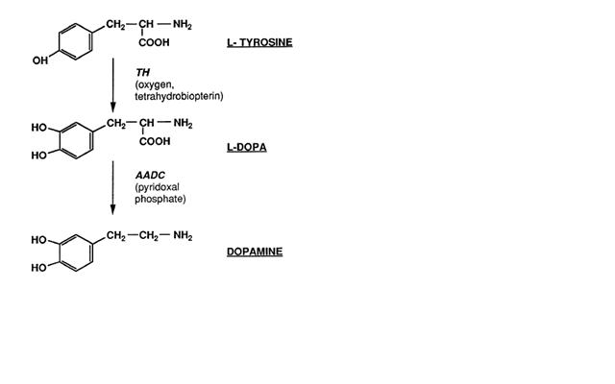
- Acetylcholine Synthesis:

Acetylcholine (Ach) is the neurotransmitter at parasympathetic neuro-effector junctions, all autonomic ganglia, adrenal medulla, somatic neuromuscular junctions, and CNS. Synthesis, Storage and Release of Ach: Ach is synthesized in the cholinergic nerve endings. After a reaction among acetate, coenzyme A and ATP, acetyl CoA is formed within the mitochondria and released into the cytoplasm. Choline enters into the axoplasm by active transport through the axonal membrane.
Choline acetyltransferase or choline acetylase, which is present in the axonal terminal, helps in acetylation of choline with acetyl CoA to form Ach. The transport of choline from the extracellular fluid into neuron is directly proportional to the concentration of extracellular Na+ and is inhibited by hemicholinium.

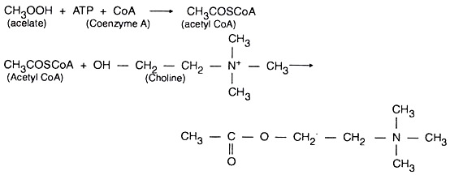
After synthesis, Ach is transported into the synaptic vesicles where it is stored till an action potential (AP) renders its release into the synaptic cleft by exocytosis. Vesamicol inhibits this transport and release systems.

When an action potential arrives at the motor or cholinergic nerve terminal, depo­larization of the area opens the voltage-gated Ca2+ channels on the axonal membrane, through which Ca2+ enters into the axoplasm and helps in fusion of vesicles with axonal membrane, resulting in extrution of a larger quantity of Ach.The release of Ach can be inhibited by excess Mg2+, botulinus toxin, or procaine. Black widow spider venom’ causes release of excessive amounts of Ach followed by blockade of release.

