NAME : SHALDAS USIJU SHALDAS
MATRIC NO. : 17/MHS01/296
LEVEL: 300
DEPARTMENT : HUMAN ANATOMY
COURSE : BCH

QUESTIONS:
- Describe in details the synthesis of two named neurotransmitters

SYNTHESIS OF NEUROTRANSMITTERS
The synthesis of neurotransmitters occurs within the synaptic cleft. The enzymes needed for transmitter synthesis are synthesized in the neuronal cell body and transported to the nerve terminal cytoplasm at 0.5-5 millimeters a day by a mechanism called slow atonal transport . The precursor molecules used by these synthetic enzymes are usually taken into the nerve terminal by transporter proteins found in the plasma membrane of the terminal. The enzymes generates a cytoplasmic pool of neurotransmitter that must then be loaded into synaptic vesicles by transport proteins in the vesicular membrane. For some small molecule neurotransmitters, the final synthetic steps actually occur inside the synaptic vesicles.

MAJOR NEUROTRANSMITTERS:
- Amino acids
- Gasotransmitters
- Monoamines.

MONOAMINES :
Monoamine neurotransmitters are neurotransmitters and neuromodulators that contain one amino group connected to an aromatic ring by a two-carbon chain. Monoamines refers to particular neurotransmitters such as ; Dopamine, noradrenaline and serotonin. These neurotransmitters are involved in mediating a wide range of physiological and homeostatic functions, which vary with the part of the brain being examined.
We’ll be focusing on the synthesis of DOPAMINE and SEROTONIN.

- SYNTHESIS OF DOPAMINE:
Dopamine is synthesized from the amino acid tyrosine; the majority of circulating tyrosine originates from dietary sources, but small amounts are derived from hydroxylation of phenylalanine by the liver enzyme phenylalanine hydroxylase.
Blood-borne tyrosine is taken up into the brain by a low-affinity amino acid transport system and subsequently from brain extra cellular fluid into dopaminergic neurons by high and low affinity amino acid transporters.
Tyrosine is converted to dopamine by the enzyme tyrosine hydroxylase (TH) and 1-amino acid decarboxylase (AADC) also called dihydroxyphenylalanine (DOPA) decarboxylase (DDC).
TH is the rate-limiting step in their bio synthetic pathway; the TH gene is localized to chromosome 11p in humans and encodes a single form of TH that can be alternatively spliced. The mRNA expression of the TH is abundant throughout the human mesencephalon.
The mature enzyme is a soluble cytology protein composed of four subunits of approximately 60 kDa each.
Within catecholaminergic neurons, tyrosine hydroxylase catalyze the addition of a hydroxyl group to the meta position of tyrosine, yielding L-dopa. This rate -limiting step in nthesis is subject to inhibition by high levels of catecholamines. Because tyrosine hydroxylase is normally saturated with substrate, manipulation of tyrosine levels does not readily impact the rate of catecholamine synthesis. Once formed, L-dopa is rapidly converted to dopamine by dopa decarboxylase, which is located in the cytoplasm . It is now recognized that this enzyme acts not only on L-dopa but also on all naturally occurring aromatic L-amino acids, including tryptophan and thus it is more properly termed aromatic amino acid decarboxylase.

STORAGE AND EXOCYTOSIS :
In dopaminergic neurons, the neurotransmitter is transported from the cytoplasm to specialized storage vesicles at extremely high concentrations, 0.5-0.6m. Which is near its limit of solubility. Here the amine is concentrated to approximately at a 100- to 1000- times higher than the level in the cytosol.
It should be noted that dopamine can be synthesized and released from dendrites, in addition to terminal regions; however, in dendrites dopamine appears to be stored both in classical vesicles and in smooth endoplasmic reticulum.
Dopamine is translocated from the cytoplasm into the vesicles by the vesicular monoamine transporter (VMAT)
Dopamine is inactivated by :
- Reputake via the dopamine transporter
- Metabolism
- Monoamine oxidase (MAO)
- Catechol-O-methyl transferase (COMT)

REUPTAKE :
Reuptake of dopamine is mediated by two classes of transporters :
- Dopamine transporter (DAT) : which transports dopamine from the extracellular to the intracellular space .
- VMAT (Vesicular monoamine transporter ) : which reloads dopamine into the vesicles .
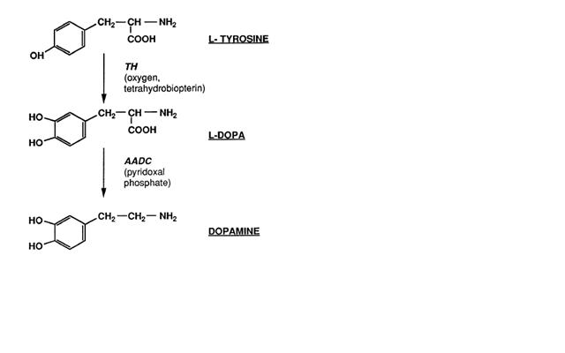

- SYNTHESIS OF SEROTONIN :
Serotonin is an example of a monoamine neurotransmitter, a chemical messenger that is passed between nerve cells. This hormone is mainly found in the gastrointestinal tract, the platelets and the central nervous system of animals and is thought to contribute to a sense of well being and happiness.
Serotonin is synthesized from the amino acid L-tryptophan via a short metabolic pathway that involves two major enzymes. These enzymes are:

- Tryptophan hydroxylase (TPH)
- Amino acid decarboxylase
The reaction in this pathway that is mediated by tryptophan hydroxylase is the rate limiting step, meaning that if this enzyme is blocked, the synthesis of serotonin would be stopped. Tryptophan hydroxylase exists in two forms - TPH1 and TPH2. While TPH1 is found in several tissues, TPH2 is specifically found in the nerves of the brain .

A serotonin transporter protein called SERT or 5HTT is responsible for carrying serotonin from the synaptic cleft to its target nerve. This transporter acts as a regulator of serotonin levels and mutations in the 5HTT gene have been shown to disrupt serotonin uptake. Serotonin regulates many important bodily functions ranging from sleep, mood, appetite and eating habits as well as influencing anxiety levels, suicidal tendencies, and our ability to learn and memorize things.

The 5-HTT protein is an important target of many antidepressant therapies. There are two forms of 5-HTT genes, the long form and the short form. Studies have shown that people with two long forms of the 5-HTT genes are less likely to suffer from depression compared with people who have one short and one long copy of the gene or two short copies.

While serotonin in its primary form cannot reach the brain since it cannot cross the blood–brain barrier, the serotonin precursors tryptophan and its metabolite 5-hydroxytryptophan (5-HTP) do cross this barrier and reach the brain. These agents can be taken as dietary supplements to increase levels of serotonin in the brain.
