NAME: AMUSAN OPEMIPO
DEPT: ANATOMY
MATRIC NUMBER: 17/MHS01/061
COURSE CODE : BCH 308

Dopamine
Dopamine (DA, a contraction of 3,4-dihydroxyphenethylamine) is an organic chemical of the catecholamine and phenethylamine families. It functions both as a hormone and a neurotransmitter, and plays several important roles in the brain and body. It is an amine synthesized by removing a carboxyl group from a molecule of its precursor chemical L-DOPA, which is synthesized in the brain and kidneys. Dopamine is also synthesized in plants and most animals. In the brain, dopamine functions as a neurotransmitter—a chemical released by neurons (nerve cells) to send signals to other nerve cells. The brain includes several distinct dopamine pathways, one of which plays a major role in the motivational component of reward-motivated behaviour. The anticipation of most types of rewards increases the level of dopamine in the brain and many addictive drugs increase dopamine release or block its reuptake into neurons following release. Other brain dopamine pathways are involved in motor control and in controlling the release of various hormones. These pathways and cell groups form a dopamine system which is neuromodulatory.

In popular culture and media, dopamine is usually seen as the main chemical of pleasure, but the current opinion in pharmacology is that dopamine instead confers motivational salience; in other words, dopamine signals the perceived motivational prominence (i.e., the desirability or aversiveness) of an outcome, which in turn propels the organism's behaviour toward or away from achieving that outcome.

Outside the central nervous system, dopamine functions primarily as a local paracrine messenger. In blood vessels, it inhibits norepinephrine release and acts as a vasodilator (at normal concentrations); in the kidneys, it increases sodium excretion and urine output; in the pancreas, it reduces insulin production; in the digestive system, it reduces gastrointestinal motility and protects intestinal mucosa; and in the immune system, it reduces the activity of lymphocytes. With the exception of the blood vessels, dopamine in each of these peripheral systems is synthesized locally and exerts its effects near the cells that release it.
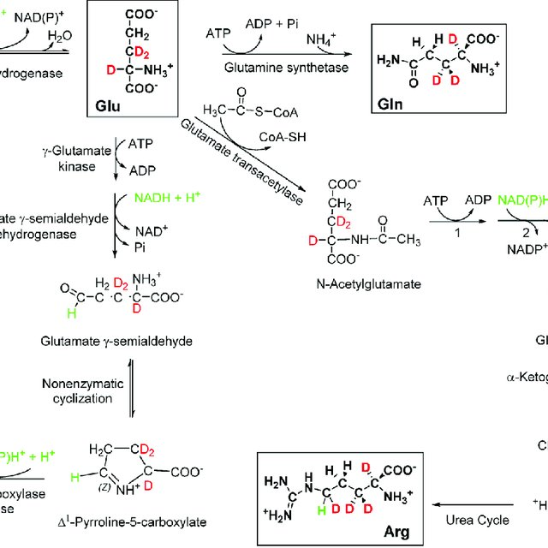
BIOSYNTHESIS OF DOPAMINE
Dopamine is synthesized in a restricted set of cell types, mainly neurons and cells in the medulla of the adrenal glands. The primary and minor metabolic pathways respectively are:
Primary: L-Phenylalanine → L-Tyrosine → L-DOPA → Dopamine
Minor: L-Phenylalanine → L-Tyrosine → p-Tyramine → Dopamine
Minor: L-Phenylalanine → m-Tyrosine → m-Tyramine → Dopamine
The direct precursor of dopamine, L-DOPA, can be synthesized indirectly from the essential amino acid phenylalanine or directly from the non-essential amino acid tyrosine. These amino acids are found in nearly every protein and so are readily available in food, with tyrosine being the most common. Although dopamine is also found in many types of food, it is incapable of crossing the blood–brain barrier that surrounds and protects the brain. It must therefore be synthesized inside the brain to perform its neuronal activity.
L-Phenylalanine is converted into L-tyrosine by the enzyme phenylalanine hydroxylase, with molecular oxygen (O₂) and tetrahydrobiopterin as cofactors. L-Tyrosine is converted into L-DOPA by the enzyme tyrosine hydroxylase, with tetrahydrobiopterin, O₂, and iron (Fe²⁺) as cofactors. L-DOPA is converted into dopamine by the enzyme aromatic L-amino acid decarboxylase (also known as DOPA decarboxylase), with pyridoxal phosphate as the cofactor
Dopamine itself is used as precursor in the synthesis of the neurotransmitter’s norepinephrine and epinephrine. Dopamine is converted into norepinephrine by the enzyme dopamine β-hydroxylase, with O₂ and L-ascorbic acid as cofactors. Norepinephrine is converted into epinephrine by the enzyme phenylethanolamine N-methyltransferase with S-adenosyl-L-methionine as the cofactor.
Some of the cofactors also require their own synthesis.] Deficiency in any required amino acid or cofactor can impair the synthesis of dopamine, norepinephrine, and epinephrine.

Dopamine is synthesized from the amino acid tyrosine, which is taken up into the brain via an active transport mechanism. Tyrosine is produced in the liver from phenylalanine through the action of phenylalanine hydroxylase. Tyrosine is then transported to dopamine containing neurons where a series of reactions convert it to dopamine Within catecholaminergic neurons, tyrosine hydroxylase catalyses the addition of a hydroxyl group to the meta position of tyrosine, yielding L-dopa. This rate-limiting step in catecholamine synthesis is subject to inhibition by high levels of catecholamines (end product inhibition). Because tyrosine hydroxylase is normally saturated with substrate, manipulation of tyrosine levels does not readily impact the rate of catecholamine synthesis. Once formed, L-dopa is rapidly converted to dopamine by dopa decarboxylase, which is located in the cytoplasm. It is now recognized that this enzyme acts not only on L-dopa but also on all naturally occurring aromatic L-amino acids, including tryptophan, and thus it is more properly termed aromatic amino acid decarboxylase

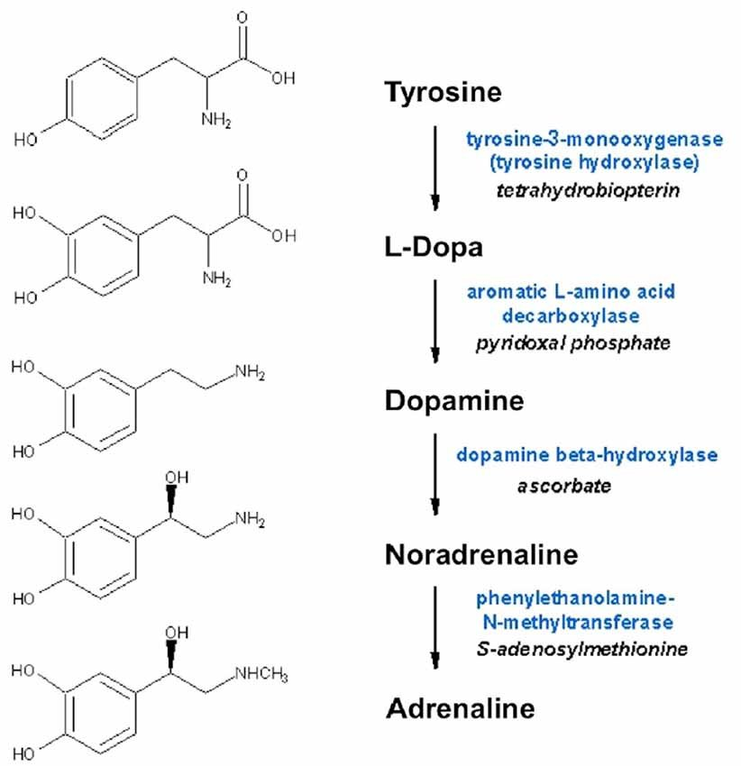

GLUTAMATE
Glutamate refers to the anion of glutamic acid in its role as a neurotransmitter: a chemical that nerve cells use to send signals to other cells

Biosynthesis of Glutamate
Glutamate is a major constituent of a wide variety of proteins; consequently it is one of the most abundant amino acids in the human body. Under ordinary conditions enough is obtained from the diet that there is no need for any to be synthesized. Nevertheless, glutamate is formally classified as a non-essential amino acid, because it can be synthesized from alpha-Ketoglutaric acid, which is produced as part of the citric acid cycle by a series of reactions whose starting point is citrate. Glutamate cannot cross the blood-brain barrier unassisted, but it is actively transported out of the nervous system by a high affinity transport system, which maintains its concentration in brain fluids at a fairly constant level.
Glutamate is synthesized in the central nervous system from glutamine as part of the glutamate–glutamine cycle by the enzyme glutaminase. This can occur in the presynaptic neuron or in neighbouring glial cells.
Glutamate itself serves as metabolic precursor for the neurotransmitter GABA, via the action of the enzyme glutamate decarboxylase  

