IKE DANIELLE
DENTISTRY
19/MHS09/009
CHM 102 ASSINGNMENT ON ESTHERS
1 a) Diethyl ether
b) 4- Methoxyheptene
c) Ethyl propyl ether
2) a) Physical Properies ;The solubility degree of ester in water is less than that of the corresponding acid due to the absence of polar hydroxyl group which has the ability to form hydrogen bonds between molecules and water.
b) Chemical properties : alcohol and acid are produced from the hydrolysis of ester, this reaction reverse to ester formation, Hydrolysis may take place by the use of dilute mineral acids as a catalyst and is called acid hydrolysis.
3) a) Preparation Of Ester By Dehydration Of Alcohols;
In the presence of protic acids, alcohol undergoes dehydration to produce alkynes and esters under different conditions, for example in the presence of sulphuric acid, dehydration of ethanol at 443 k yields ethane whereas it yields exoxythane at 413 k. this is an ideal method of preparation through primary alcohols. c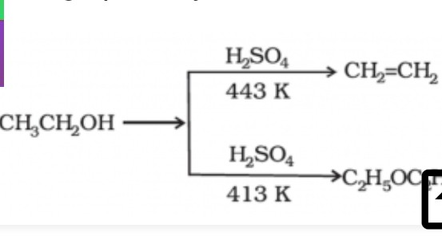

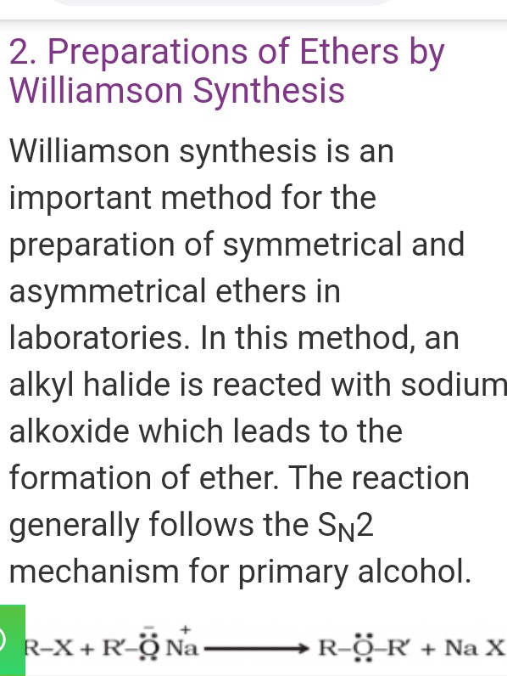

4) Ethylene oxide is used to make detergents
It is used to make fumigants and pesticides
It is used as a sterilization agent or medical equipments

