NAME: Amusan Opemipo
MATRIC NO 17/MHS01/061
DEPT Human Anatomy
COURSE CODE/TITLE ANA 314/Animal Handling & Comparative Ana.
- Relevance of Comparative Anatomy to Evolution?
There are many forms of evidence for evolution. One of the strongest forms of evidence is comparative anatomy; comparing structural similarities of organisms to determine their evolutionary relationships. Organisms with similar anatomical features are assumed to be relatively closely related evolutionarily, and they are assumed to share a common ancestor. As a result of the study of evolutionary relationships, anatomical similarities and differences are important factors in determining and establishing classification of organisms.
The study of comparative anatomy predates the modern study of evolution. Early evolutionary scientists like Buffon and Lamarck used comparative anatomy to determine relationships between species. Organisms with similar structures, they argued, must have acquired these traits from a common ancestor. Today, comparative anatomy can serve as the first line of reasoning in determining the relatedness of species. However, there are many hidden dangers that make it necessary to support evidence from comparative anatomy with evidence from other fields of study.

2.Types of Comparative Anatomy?
We have two types of comparative anatomy namely
- Homologous Comparative Anatomy
- Analogous Comparative Anatomy

Homologous structures are similar structures in related organisms. The most important thing to remember about homologous structures is that they share common ancestry. In other words, only organisms that are somehow related to each other can have homologous structures.
For example, a chimpanzee’s arm and a human’s arm are homologous structures. Both sets of arms have a similar structure and use and chimpanzees and humans share a common ancestor.

What Are Analogous Structures?
Analogous structures are similar structures in unrelated organisms. These structures are similar because they do the same job, not because they share common ancestry.
For example, dolphins and sharks both have fins, even though they aren’t related. Both species developed fins because of how (and where) they live.
What’s the Difference Between Homologous and Analogous Structures?
Homologous Structures | Analogous Structures
- Shared ancestry  - Similar internal structure  - May look different externally | - No shared ancestry  - Similar function  - May look similar externally
Homologous and analogous structures have several key differences. Let’s take a look at them:
Homologous Structures Example
A great example of homologous structures are the wings of a bat and the arms of a human. Bats and humans are both mammals, so they share a common ancestry.
Both a bat’s wing and a human’s arm share a similar internal bone structure, even though they look very different externally. The wing and the arm also perform different functions - wings help bats fly, while arms help humans interact with their world in a very different way.
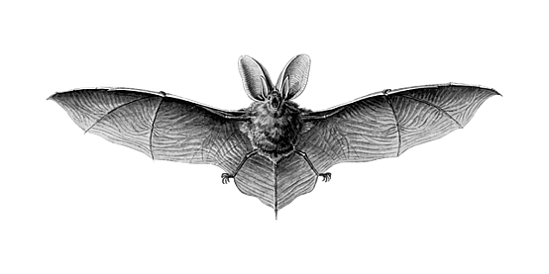
Analogous Structures Example
A great example of analogous structures are a bat’s wing and a bee’s wing. Bats and bees do not share common ancestry, so the structures cannot be homologous.
Both bat wings and bee wings serve a common purpose - helping bats and bees fly! The structures look similar on the outside, too. However, their internal structures are very different - bat wings have a bony structure with muscles, while bee wings are membranous extensions.

Homologous and Analogous Structures -
Many animals have body parts that look similar, even though they don’t share common functionality. Other animals have body parts that look totally different, but have a shared background. Here’s the difference between homologous and analogous structures:
- Homologous structures are structures that may look or function differently from related organisms.
- Analogous structures are structures that look and function similarly from unrelated organisms.

