NAME : HAMZAT KEHINDE ODUSOGA
MATRIC NO : 15/ENG07/022
COURSE : CHE574
QUESTION ONE
A) EXPLANATION OF THE VARIOUS FORMS OF ENERGY
1) Mechanical energy is the sum of potential energy and kinetic energy. It is the macroscopic energy associated with a system. The principle of conservation of mechanical energy states that in an isolated system that is only subject to conservative forces, the mechanical energy is constant. If an object moves in the opposite direction of a conservative net force, the potential energy will increase; and if the speed (not the velocity) of the object changes, the kinetic energy of the object also changes.
E _{mechanical} = U+K
The potential energy, U,
K (KINETIC ENERGY)= 1/2MV²
2.)Electrical energy is energy derived from electric potential energy or kinetic energy. When used loosely, electrical energy refers to energy that has been converted from electric potential energy. This energy is supplied by the combination of electric current and electric potential that is delivered by an electrical circuit (e.g., provided by an electric power utility). At the point that this electric potential energy has been converted to another type of energy, it ceases to be electric potential energy. Thus, all electrical energy is potential energy before it is delivered to the end-use. Once converted from potential energy, electrical energy can always be called another type of energy (heat, light, motion, etc
3.) Magnetic energy and electrostatic potential energy are related by Maxwell's equations. The potential energy of a magnet of magnetic moment in a magnetic field is defined as the mechanical work of the magnetic force (actually magnetic torque) on the re-alignment of the vector of the magnetic dipole moment and is equal to:
while the energy stored in an inductor (of inductance ) when a current flows through it is given by:

4.)Gravitational energy (GPE) is the potential energy a physical object with mass has in relation to another massive object due to gravity. It is potential energy associated with the gravitational field. Gravitational energy is dependent on the masses of two bodies, their distance apart and the gravitational constant (G). In everyday cases (i.e. close to the Earth's surface), the gravitational field is considered to be constant. For such scenarios the Newtonian formula for potential energy can be reduced to:
U = mgh
5.) Chemical energy is the potential of a chemical substance to undergo a chemical reaction to transform into other substances. Examples include batteries, food, gasoline, and etc. Breaking or making of chemical bonds involves energy, which may be either absorbed or evolved from a chemical system.Energy that can be released or absorbed because of a reaction between a set of chemical substances is equal to the difference between the energy content of the products and the reactants, if the initial and final temperatures are the same. This change in energy can be estimated from the bond energies of the various chemical bonds in the reactants and products. Mathematically
6.) Ionization energy denoted E_{i}, is the minimum amount of energy required to remove the most loosely bound electron, the valence electron, of an isolated neutral gaseous atom or molecule. It is quantitatively expressed as
X(g) + energy → X⁺(g) + e⁻
where X is any atom or molecule capable of ionization, X⁺ is that atom or molecule with an electron removed, and e⁻ is the removed electron.^{[1]} This is generally an endothermic process. Generally, the closer the outermost electrons to the nucleus of the atom, the higher the atom's or element's ionization energy.

7.) Nuclear energy is energy that comes from a nucleus, the core of an atom. Atoms are particles that make up every object; and there exists a lot of energy (binding forces) which holds these atoms together. Nuclear energy can be used to make electricity, but for this to happen the energy has to be released from atoms.Nuclear energy harvests the powerful energy in the nucleus, or core, of an atom. Nuclear energy is released through nuclear fission, the process where the nucleus of an atom splits. Nuclear power plants are complex machines that can control nuclear fission to produce electricity. The material most often used in nuclear power plants is the element uranium. Although uranium is found in rocks all over the world, nuclear power plants usually use a very rare type of uranium, U-235. Uranium is a non-renewable resource.

8.) Heat is energy in transfer to or from a thermodynamic system, by mechanisms other than thermodynamic work or transfer of matter. The various mechanisms of energy transfer that define heat are stated in the next section of this article. Like thermodynamic work, heat transfer is a process involving more than one system, not a property of any one system. In thermodynamics, energy transferred as heat (a process function) contributes to change in the system's cardinal energy variable of state, for example its internal energy, or for example its enthalpy. This is to be distinguished from the ordinary language conception of heat as a property of an isolated system.The quantity of energy transferred as heat in a process is the amount of transferred energy excluding any thermodynamic work that was done and any energy contained in matter transferred. For the precise definition of heat, it is necessary that it occur by a path that does not include transfer of matter.
9). Sound energy is a form of energy that can be heard by humans. Sound is a mechanical wave and as such consists physically in oscillatory elastic compression and in oscillatory displacement of a fluid. Therefore, the medium acts as storage for both potential and kinetic energyConsequently, the sound energy in a volume of interest is defined as the sum of the potential and kinetic energy densities integrated over that volume:
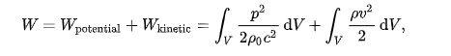
Here:
- V is the volume of interest;
- p is the sound pressure;
- v is the particle velocity;
- ρ₀ is the density of the medium without sound present;
- ρ is the local density of the medium;
- c is the speed of sound.
10)
B) DIFFERENCE BETWEEN SUSTAINABLE ENERGY AND NON SUSTAINABLE ENERGY
I ) Sustainable energy is a form of energy that meet our today’s demand of energy without putting them in danger of getting expired or depleted and can be used over and over again. Sustainable energy should be widely encouraged as it do not cause any harm to the environment and is available widely free of cost. All renewable energy sources like solar, wind, geothermal, hydropower and ocean energy are sustainable as they are stable and available in plenty.
II) Non- Sustainanble Energy is a natural resource that cannot be readily replaced by natural means at a quick enough pace to keep up with consumption. An example is carbon-based fossil fuel. The original organic matter, with the aid of heat and pressure, becomes a fuel such as oil or gas. Earth minerals and metal ores, fossil fuels (coal, petroleum, natural gas) and groundwater in certain aquifers are all considered non-renewable resources, though individual elements are always conserved (except in nuclear reactions).

B) With the aid of a pie chart or bar chart briefly discuss the typical energy resource mix for sustainable energy development and provide your own view the case for Nigeria
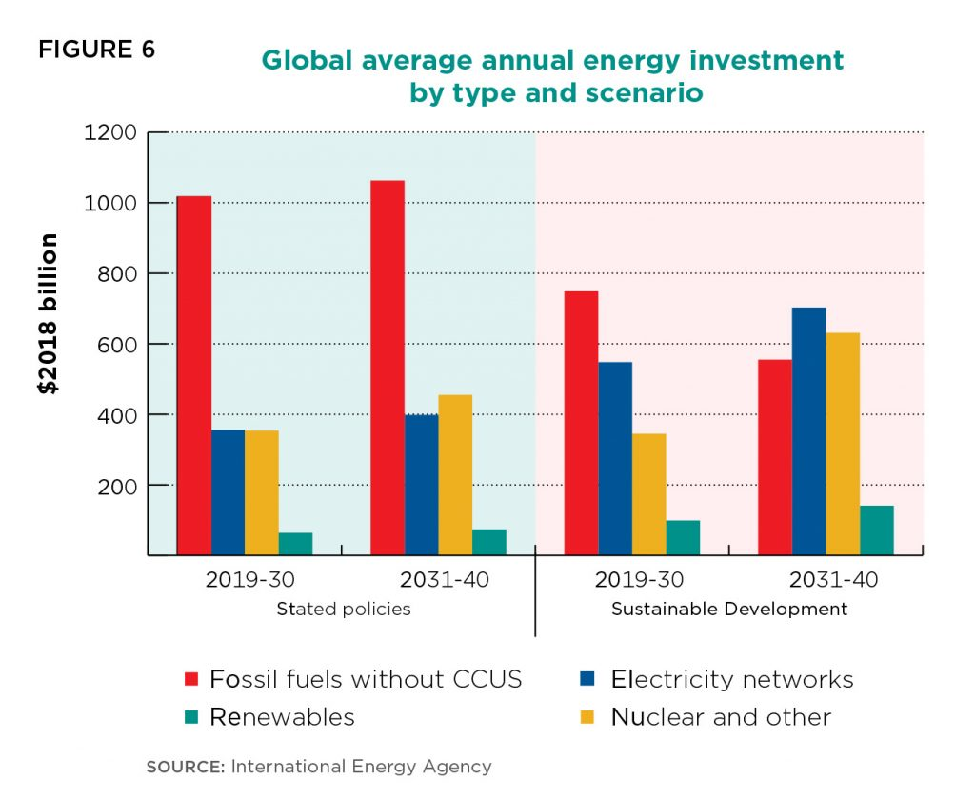
No single energy resource can sustainably meet the energy demands of any country. Integrating all exploitable energy sources is a viable way of achieving stability in energy supply for Nigeria Energy availability, economic growth and sustainable development are grossly inseparable. Generating adequate power has been a major challenge for successive Nigerian governments. Hydro-powers and thermal plants were established between 1960 and 1979. No other successful attempt was made to increase the energy generating capacity till 1999. First, that energy sources should be diversified. Since power failure is a regular occurrence in Nigeria with attendant negative impact on the quality of living and business productivity, a new approach to electricity generation in which a mix of several energy sources including renewable sources is optimally utilized should be vigorously pursued and adopted. Second, the utilization of renewable energy technologies especially solar energy to provide off-grid electricity to remote communities should be intensified. The scenario whereby combustible renewable and waste accounted for 80.2 percent of total energy consumption in Nigeria (fig.1) and mainly utilized by the rural areas to meet off-grid heating and cooking needs is not sustainable as it does not only contribute to green house gas but also portends a threat to health, woodlands and the economy. Third, it is imperative to intensify research and development in the energy sector, especially renewable energy to increase energy sources and improve energy management systems that will promote sustainable development. Last, there should be increased funding in energy sector, which is capital intensive and requires huge amount of investment.
QUESTION 2 :HOW MUCH ENERGY IS BEEN PRODUCED FROM NIGERIA DAMS AND COMPARE WITH THE ONE PRODUCE FROM CRUDE OIL
HYDROPOWER
Hydroelectric power comes from the potential energy of dammed water driving a water turbine and generator. The Niger and Benue Rivers and their tributaries form the core of the Nigerian river system with potential for large-scale (greater than 100MW) hydropower development. Several small rivers and streams also provide opportunities for small-scale (less than 10MW) hydropower projects. Estimate of total exploitable large-scale hydropower potential in Nigeria is over 10,000MW, capable of producing 36,000GWh of electricity annually only about one fifth had been developed as at 2001. Likewise, estimate of exploitable small-scale hydropower potential is at 734MW. Small hydropower plants for electricity provision are suitable in remote areas. By 1999, hydropower represented about 32% of the installed grid-connected electricity generation capacity (FGN, 2003).

CRUDE OIL
Following its discovery at Oloibiri, Delta State in 1956 (MBendi, 2011) oil would eventually become dominant in Nigeria’s energy scenario as the economic mainstay. Presently, oil accounts for over 95% of export earnings and over 65% of government revenue according to the International Monetary Fund- IMF (EIA, 2010). However, according to Odularu (2007) petroleum production and export, which play a dominant role in Nigeria’s economy accounts for about 90% of gross domestic earnings making Nigeria the “13thoil producer in the world” (Nation Master, 2008). Nigeria has an estimated 37.2 billion barrels of proven oil reserve situated
along the Niger River Delta and offshore in Bight of Benin, Gulf of Guinea and Bight of Bonny. Production capacity as at 2009 was over 2.2 million b/d making Nigeria the largest oil producer in Africa (EIA, 2010). An oil boom in the early 1970s drew the country’s attention away from agriculture, which hitherto was the mainstay and contributed an average of 72% of GDP between 1955 and 1969 (Folawewo & Olakojo, 2010). Since then, oil has been dominant in the energy scene of the country at all levels of economic activities.

QUESTION 3
- Diagram Of Anemometer
Anemometer, device for measuring the speed of airflow in the atmosphere, in wind tunnels, and in other gas-flow applications. Most widely used for wind-speed measurements is the revolving-cup electric anemometer, in which the revolving cups drive an electric generator.