NAME: KUJORE MOJOLAOLUWA OLUWASEUN
MATRIC NUMBER: 17/MHS01/173
DEPARTMENT: PHYSIOLOGY
COURSE CODE: BCH 308
COURSE TITLE: CELLULAR BIOCHEMISTRY.

ASSIGNMENT
Describe in details the synthesis of two named neurotransmitters.
- Synthesis of Acetylcholine.

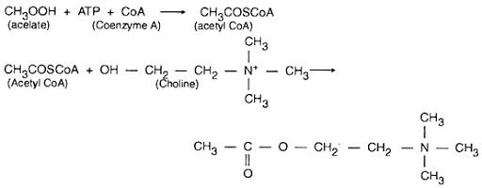
Choline acetyltransferase (CAT): Acetylcholine is synthesized by a single step reaction catalysed by the biosynthetic enzyme choline acetyltransferase. As is the case for all nerve terminal proteins, CAT is produced in the cholinergic cell body and transported down the axon to the nerve endings. Both CAT and Acetylcholine may be found throughout the neuron, but their highest concentration is in axon terminals. The presence of CAT is the "marker" that a neuron is cholinergic, only cholinergic neurons contain CAT.
The rate-limiting steps in Acetylcholine synthesis are the availability of choline and acetyl - CoA. During increased neuronal activity the availability of acetyl - CoA from the mitochondria is upregulated as is the uptake of choline into the nerve ending from the synaptic cleft. Ca²⁺ appears to be involved in both of these regulatory mechanisms. As will be described later, the inactivation of Acetylcholine is converted by metabolism to choline and acetic acid. Consequently, much of the choline used for Acetylcholine synthesis comes from the recycling of choline from metabolized Acetylcholine. Another source is the breakdown of the phospholipid, phosphatidylcholine. One of the strategies to increase Acetylcholine neurotransmission is the administration of choline in the diet. However, this has not been effective, probably because the administration of choline does not increase the availability of choline in the CNS.

- Synthesis of Nitric oxide.
Nitric oxide is produced by a group of enzymes called nitric oxide synthases. These enzymes convert arginine into citrulline, producing NO in the process. Oxygen and NADPH are necessary co-factors. There are three isoforms of nitric oxide synthase (NOS) named according to their activity or the tissue type in which they were first described. The isoforms of NOS are neuronal NOS (or nNOS), endothelial NOS (or eNOS) and inducible NOS (or iNOS). These enzymes are also sometimes referred to by number, so that nNOS is known as NOS1, iNOS is known as NOS2 and eNOS is NOS3. Despite the names of these enzymes, all three isoforms can be found in a variety of tissues and cell types. The general mechanism of NO production from NOS is illustrated below.
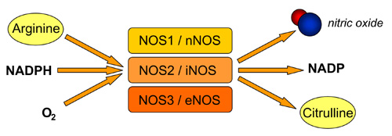
Two of the enzymes (nNOS and eNOS) are constitutively expressed in mammalian cells and synthesise NO in response to increases in intracellular calcium levels. In some cases, however, they are able to increase NO production independently of calcium levels in response to stimuli such as shear stress.
iNOS activity is independent of the level of calcium in the cell, however its activity - like all of the NOS isoforms - is dependent on the binding of calmodulin. Increases in cellular calcium lead to increases in levels of calmodulin and the increased binding of calmodulin to eNOS and nNOS leads to a transient increase in NO production by these enzymes. By contrast iNOS is able to bind tightly to calmodulin even at very low cellular concentration of calcium. Consequently, iNOS activity doesn't respond to changes in calcium levels in the cell. As a result, the production of NO by iNOS lasts much longer than from the other isoforms of NOS, and tends to produce much higher concentrations of NO in the cell.
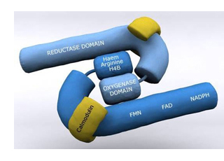
The production of NO by iNOS can, however, be controlled through transcription. In most cell types iNOS protein levels are either very low or undetectable. However, stimulation of these cells with, for example, cytokines or growth factors, can lead to increased transcription of the iNOS gene, with subsequent production of NO.

