NAME: MAWEDO VICTORIA MERCY
MATRIC NUMBER: 18/MHS02/111
COLLEGE: MEDICINE AND HEALTH SCIENCES
DEPARTMENT: PUBLIC HEALTH
COURSE CODE: PUH 202
COURSE TITLE: INTERNATIONAL HEALTH
ASSIGNMENT 2

The 2030 Agenda for Sustainable Development
The agenda is a commitment to eradicate poverty and achieve sustainable development by 2030 world-wide, ensuring that no one is left behind. Realizing gender equality and the empowerment of women and girls is also said to be a contribution to progress across all the goals and targets. The elimination of all forms of discrimination and violence against women and girls, which includes the thorough engagement of men and boys. The reaffirmation of the importance of the universal Declaration of Human Rights.
The empowerment of people who are most vulnerable, provision of inclusive and equitable education at all levels, promotion of physical and mental health and well-being and to extend the life expectancy for all. The Agenda also seeks to build strong economic foundations for all countries, commitment to making fundamental changes in the way the society produce and consume goods and services, recognizing the positive contribution of migrants for inclusive growth and sustainable development, sustainable development cannot be realized without peace and security.

WHO GPW13
The WHO 13th General Programme of Work was adopted by the Member States in May 2018. It has three interconnected strategic priorities {achieving universal health coverage, addressing health emergencies, and promoting healthier populations} to ensure healthy lives and well-being for all ages. The WHO Impact Framework focuses on making focuses on making a measurable impact for people at the country level, with an emphasis on data and accountability.
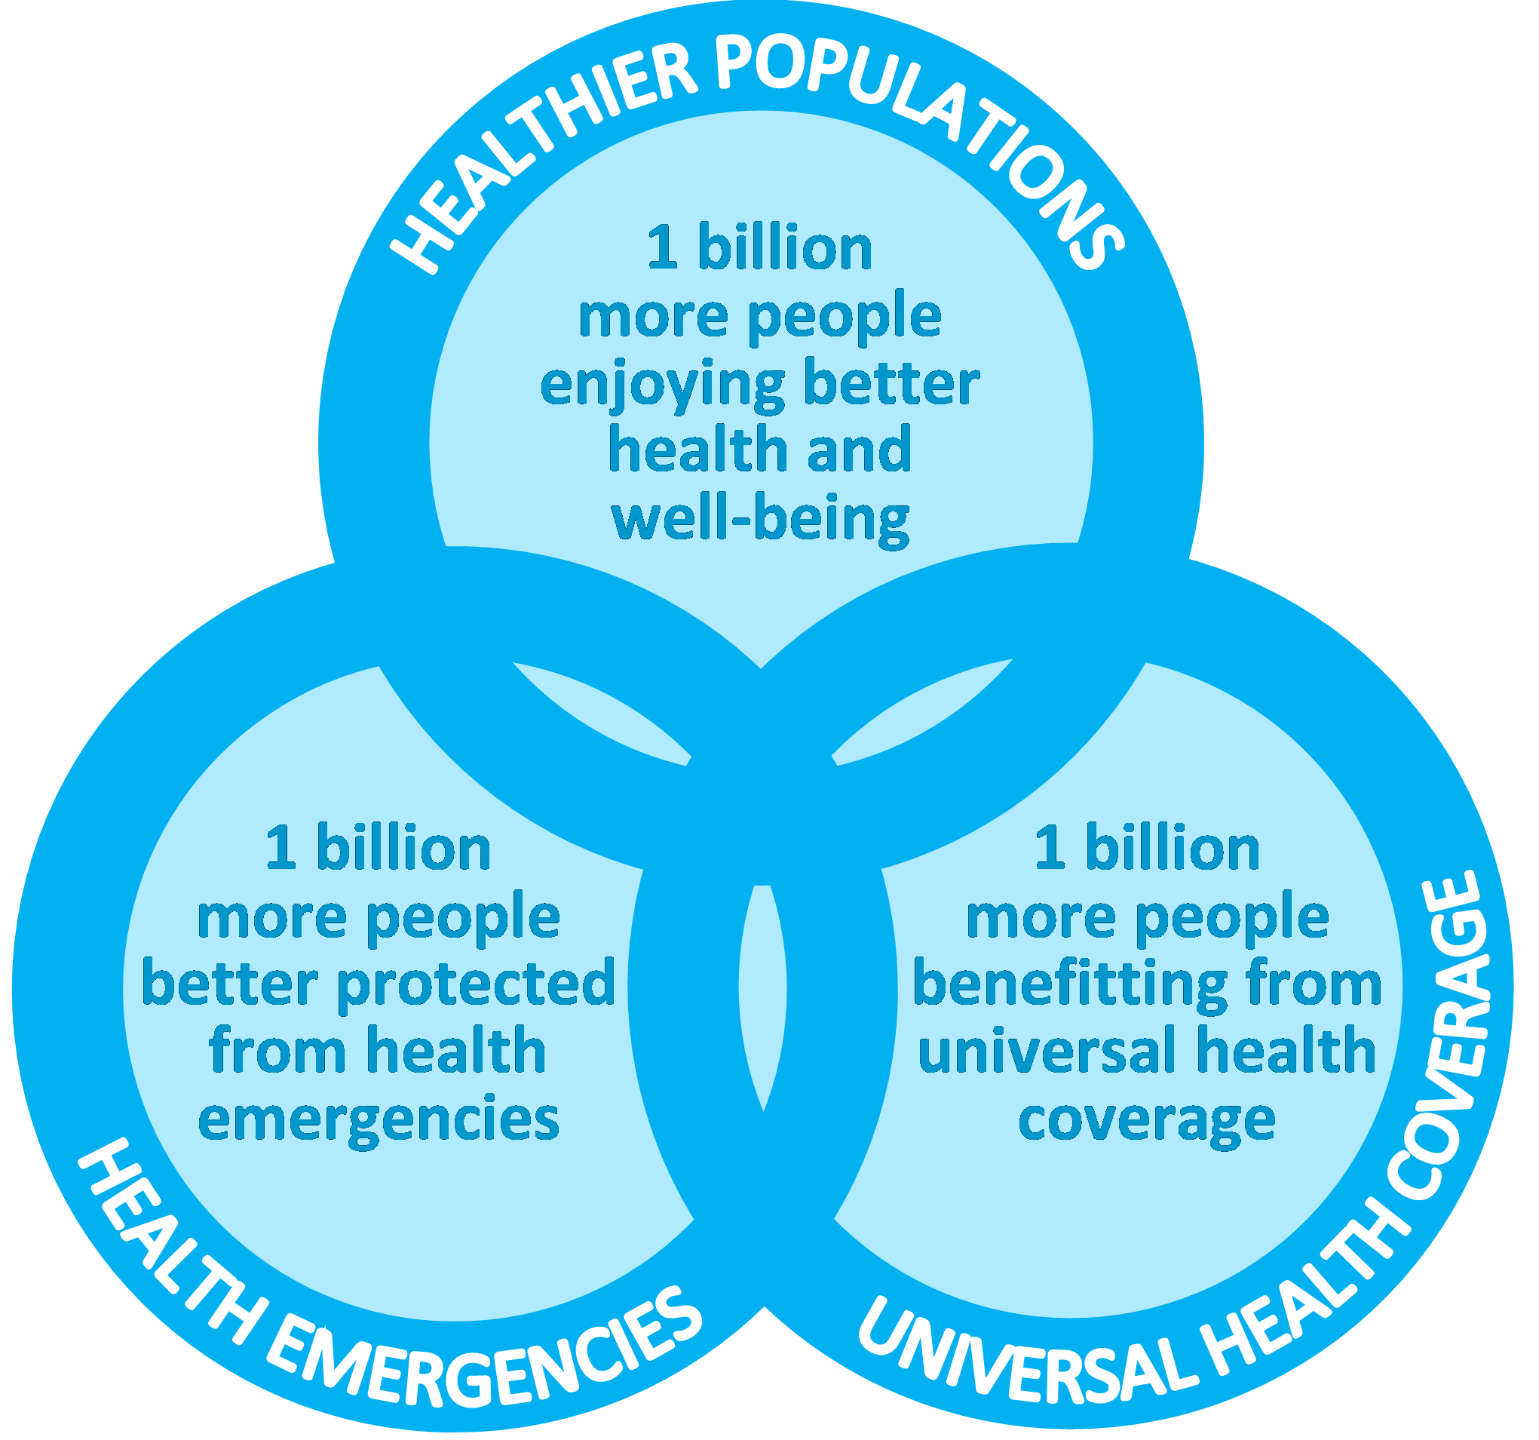
- The Sustainable Development Goals {SDGs} which is also known as the Global Goals were adopted by all United Nations Member States in 2015 as a universal call to action to end poverty, protect the planet and ensure that all people enjoy peace and prosperity by 2030. It is a collection of 17 global goals designed to be a “blueprint to achieve a better and more sustainable future for all”.

The following are some Sustainable Development Goals;
- No poverty
- Zero hunger
- Good health and well-being
- Quality education
- Gender equality
- Clean water and sanitation
- Affordable and clean energy
- Decent work and economic growth
- Industry, innovation and infrastructure
- Reduced inequality
- Sustainable cities and communities
- Responsible consumption and production
- Climate action
- Life below water
- Life on land
- Peace and justice strong institutions
- Partnerships to achieve the goal
- The following are some goals with relation to the current situations at Are-Ekiti;
- Zero hunger
- Responsible production and consumption
- Life below water
- No poverty
- Gender equality
- Strategies on how to implement these goals at local community level includes;
- Health education is very important in achieving Public Health goals i.e in order to achieve these goals, the individual who is a Public Health practitioner is expected to educate the citizens on the causes, significance and side effects of their actions. In areas where there is low quality education, practical

word/actions is advisable as they would have a better understanding. For example, In Are-Ekiti, most of the villagers are unable to understand English but with the use of pictures they might have an idea of what the health practitioner is saying.
- Zero hunger; The aim of this is to end hunger, achieve security and improved nutrition, and promote sustainable agriculture.
- Responsible production and consumption; Ensuring sustainable consumption and production patterns is important i.e they have to substantially reduce waste generation through prevention, reduction, recycling and reuse.
- Life below water; The ability to conserve and the sustainably use of oceans, seas, and marine resources for sustainable development i.e they have to significantly prevent and reduce marine pollutions of all kinds.
- No poverty; Ending poverty in all its forms everywhere. All individuals particularly the poor and the vulnerable, have equal rights to economic resources, as well as the access to basic services, ownership and control over land and other things.

