ORIOLA ENIOLA PRECIOUS 18/MHS01/316
MBBS
EMBRYOLOGY ASSIGNMENT
THE SECOND WEEK OF HUMAN DEVELOPMENT
*The second week of development takes place in three main stages which are;
-Completion of implantation
-Formation of the bilaminal germ disc
-Formation of extra embryonic structures
DAY 8
Completion of implantation
The blastocyst is partly embedded in the endometrium of the uterus.
*The syncytiotropoblast continues to enroll the endometrium while the cytotropoblast divides and migrates towards the syncytiotropoblast.
*A fluid cavity is formed called the amniotic cavity.
*The inner cell mass (embryo blast) differentiates into two layers, one cuboidal layer called hypoblast and one columnar layer called epiblast.
Formation of the bilaminal germ disc
*The hypoblast and the epiblast fuses to form the bilaminal germ disc, the epiblast lies close to the amniotic cavity and the hypoblast lies near the blastocystic cavity. 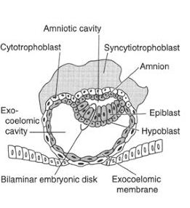

Formation of extra embryonic structures
DAY 9
*The blastocyst is deeply embedded in the endometrium of the uterus.
*The surface epithelium is covered by fibrin coagulum.
*A cavity is formed called the exocoelomic cavity enclosed by an exocoelomic membrane aka primary yolk sac/primary umbilical vesicle.
*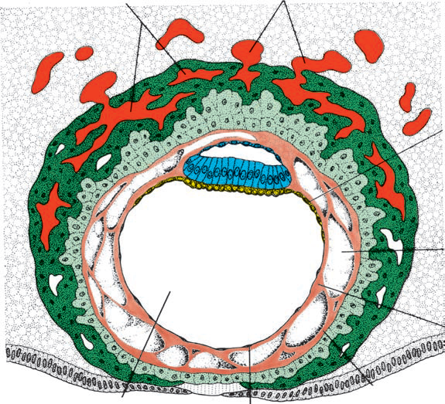A trophoblastic lacunae is formed.
DAY 10-12
*The blastocyst is totally embedded in the endometrium of the uterus.
*Ruptured capillaries called sinusoid locates the lacuna and supplies blood to the lacuna through uteroplacenta circulation.
*There is formation of a mesodermal cavity known as extra embryonic cavity which covers the inner surface except the connecting stalk portion.
*The extra embryonic cavity is divided into two; the embryonic somatic mesoderm located proximally and the extra embryonic splanchnic mesoderm.
*A reaction called the decidual reaction takes place in the embryo called decidual reaction (accumulation of glycogen and lipid in their cytoprotein) to provide nutrition for the embryo for immunity.
DAY 13
*A syncytium is formed (a covering formed by a cellular column called primary villi)
*The primary yolk sack reduces to form the secondary yolk sack
*The portion of the exocoelomic cavity form a cyst called the exocoelomic cyst 