NAME: OYEBOADE Rukayah Kiitan
MATRIC NO: 17/ENG08/004
DEPARTMENT: Biomedical Engineering
COURSE CODE: BME312
COURSE TITLE: Biological System of Control and Modelling

EXERCISE 4.8

Question
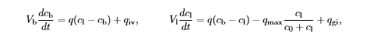
(Drug administration) The metabolism of alcohol in the body can be modelled by the nonlinear compartment model

where Vb = 48 L and Vl = 0.6 L are the apparent volumes of distribution of body water and liver water, cb and cl are the concentrations of alcohol in the compartments, qiv and qgi are the injection rates for intravenous and gastrointestinal intake, q = 1.5 L/min is the total hepatic blood ﬂow, qmax = 2.75 mmol/min and c0 = 0.1 mmol/L. Simulate the system and compute the concentration in the blood for oral and intravenous doses of 12 g and 50 g of alcohol.

Codes
commandwindow
clear
clc
syms cb(t)
syms ci(t)
q=1.5
vb=48
vi=0.6
c0=0.1
ci= 50 %tried converting it to mmol/L but there is nothing like that
cb= 12
qmax=2.75
qiv=50 %do not know the value to put for it
qgi=12 %do not know the value to put for it
ode=diff(cb,t)==(q*ci)/vb-(q*cb)/vb+(qiv/vb)
ode1=diff(cb,t)==(q*cb)/vi- (ci*((q/vi)+((qmax*vi)/(c0-ci)))+(qgi/vi))
plot(ode, ode1) %seriously do not know what to plot against what

Result
q =
1.5000

vb =
48

vi =
0.6000

c0 =
0.1000

ci =
50

cb =
12

qmax =
2.7500

qiv =
50

qgi =
12

ode =
0 == 107/48

ode1 =
0 == -56560/499

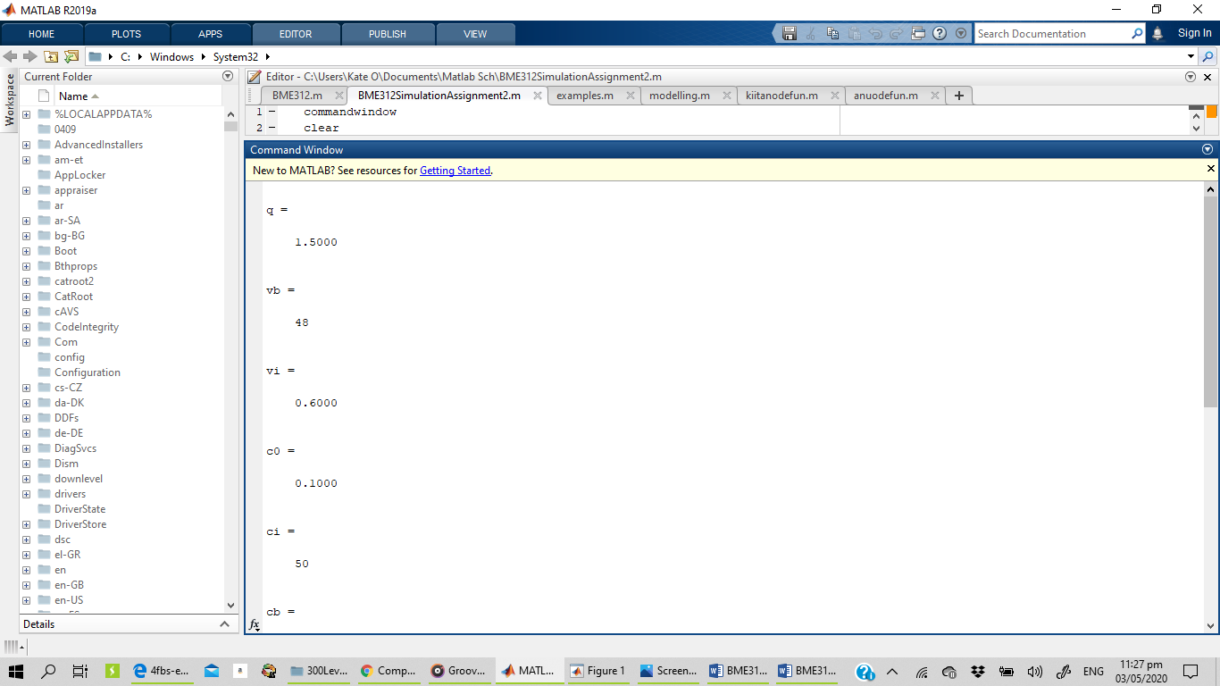
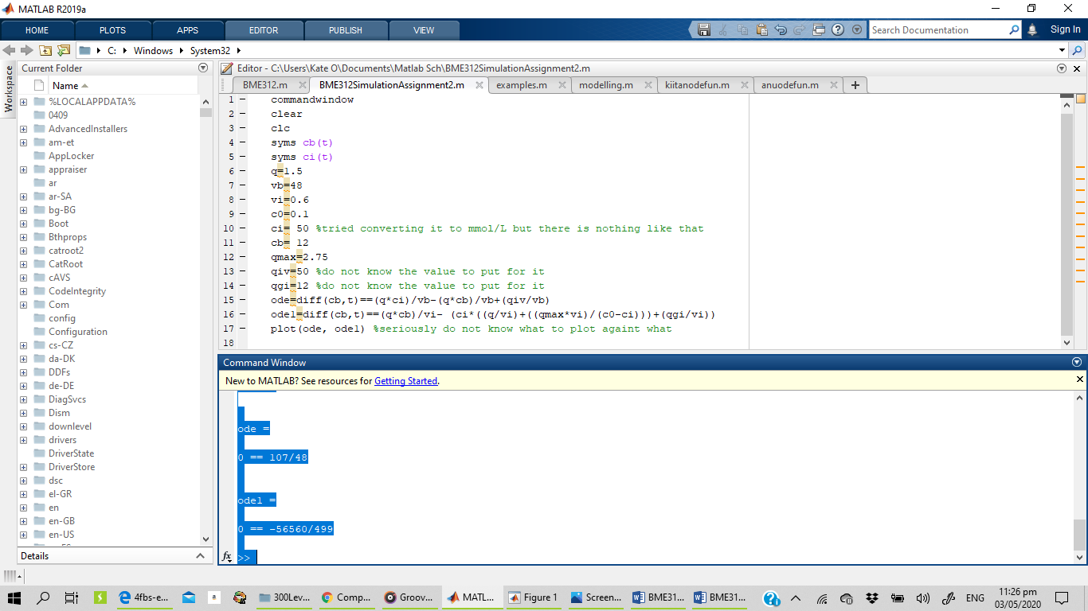

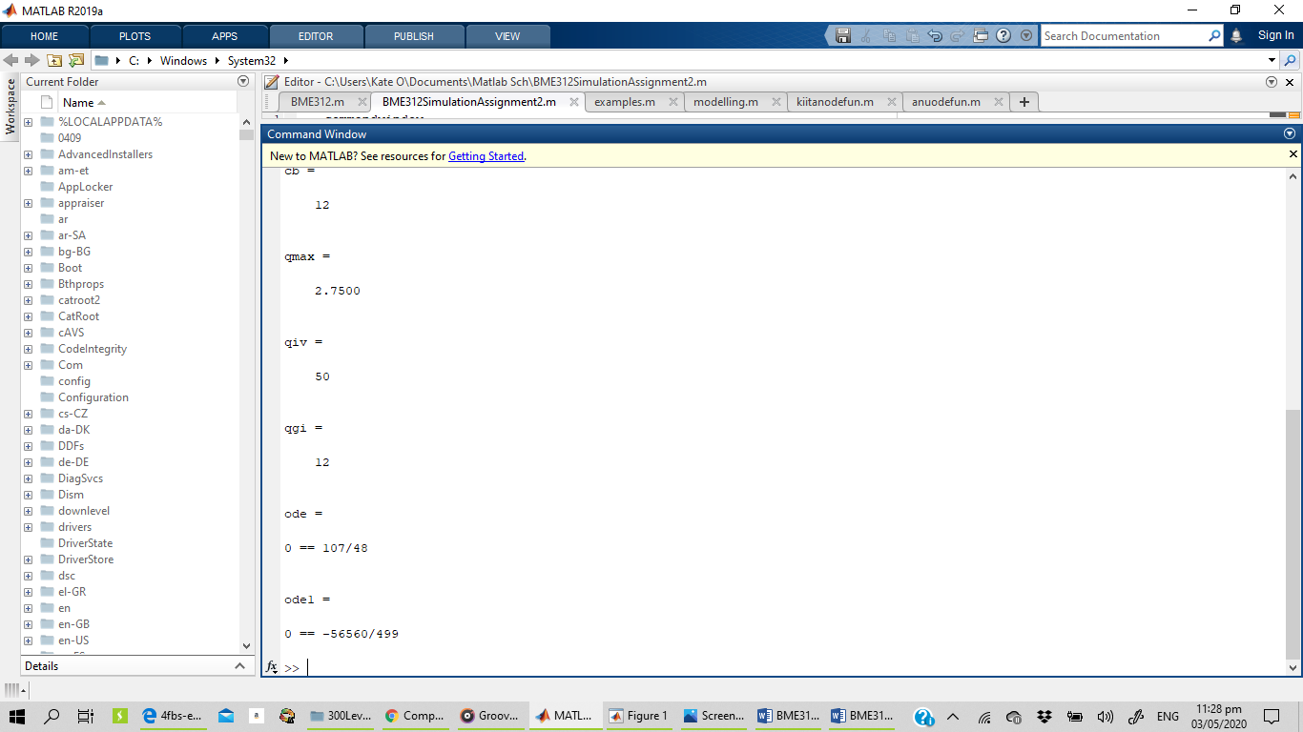
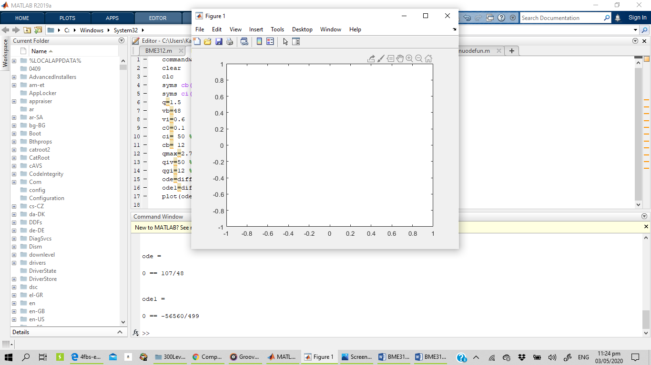

Exercise 4.9
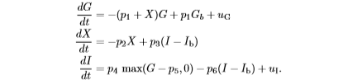
(Insulin-glucose dynamics) The following model for insulin glucose dynamics by Gaetano and colleagues [GMGM05] has three states: glucose concentration in the blood plasma G [mg/dL], insulin concentration in the interstitial ﬂuid I [µUI/ml], and X [min−1] that represents the increased removal rate of glucose due to insulin. The state X is proportional to the concentration of interstitial insulin. The dynamics are: dG dt =−(p1 + X)G + p1Gb + uG dX dt =−p2X + p3(I −Ib) dI dt = p4 max(G−p5,0)−p6(I −Ib)+uI. Use the parameters
Simulate the system with the initial conditions G(0) = 300, I(0) = 100 and X(0) = 0. This corresponds to a person having taken a large initial dose of glucose.

Codes
commandwindow
clear
clc
syms G(t)
syms X(t)
syms I(t)
Gb=87;
Ib=37.9
P1=0.05
P2=0.5
P3=10^(-4)
P4=10^(-5)
P5=150
P6=0.05
P7=199
G=300
I=100
X=0
Ug=diff(G,t)+((P1+X)*G)-(P1*Gb)
ode2=diff(X,t)==(-P2*X)+(P3*(I-Ib))
Ui=diff(I,t)-(P4*(G-P5))-(P6*(I-Ib))

Result
Ib =
37.9000

P1 =
0.0500

P2 =
0.5000

P3 =
1.0000e-04

P4 =
1.0000e-05

P5 =
150

P6 =
0.0500

P7 =
199

G =
300

I =
100

X =
0

Ug =
213/20

ode2 =
0 == 621/100000

Ui =
-6213/2000

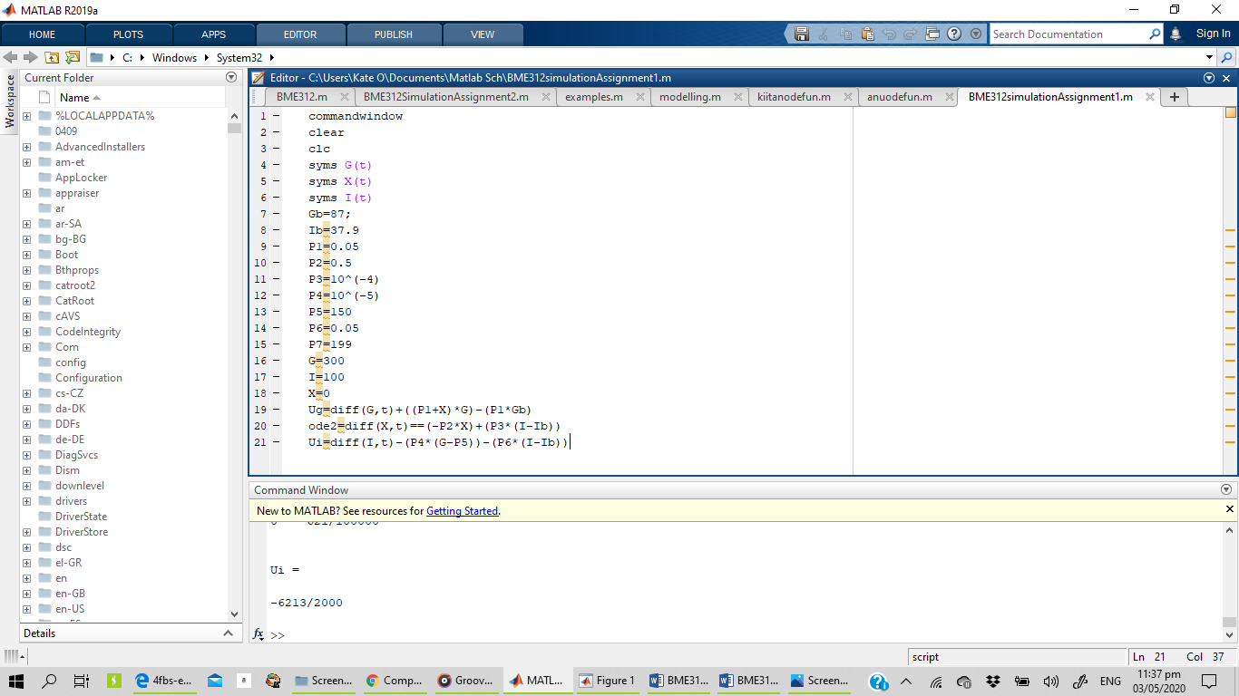
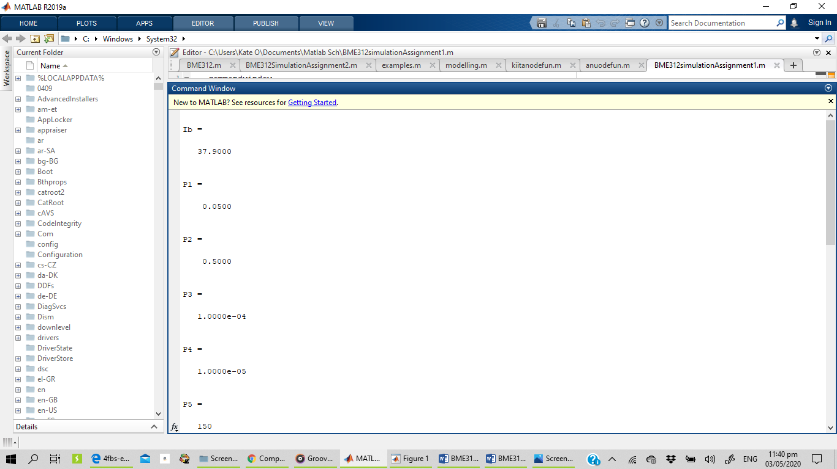
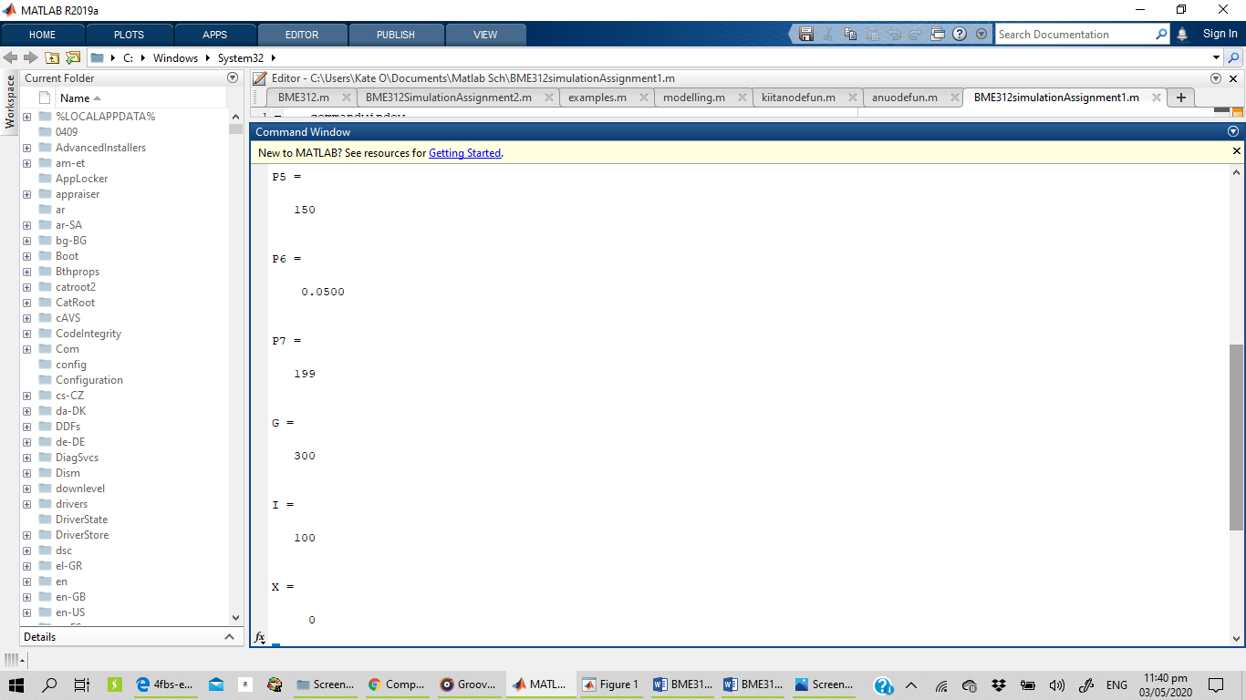
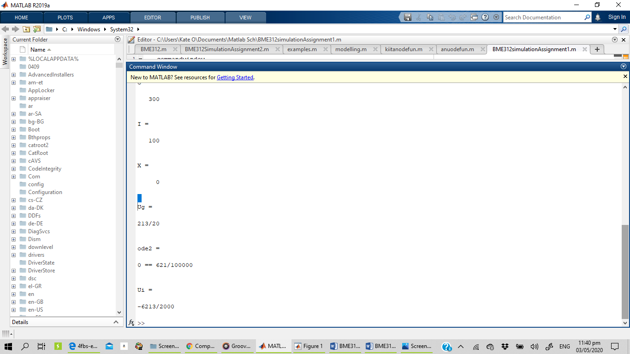

OR USING ODE FUNCTION
Codes
function f = anuodefun(c,x)
vb=48
vi=0.6
c0=0.1
ci= 50
cb= 12
qmax=2.75
qiv=50
qgi=12
q=1.5
f(1)= (q*ci)/vb-(q*cb)/vb+(qiv/vb);
f(2)= (q*cb)/vi- (ci*((q/vi)+((qmax*vi)/(c0-ci)))+(qgi/vi));
end

Other code
close all
clear
clc

c=[0.1 50 12]
tspan= [0:0.25:1]
[t,c]=ode45(@anuodefun, tspan, c);

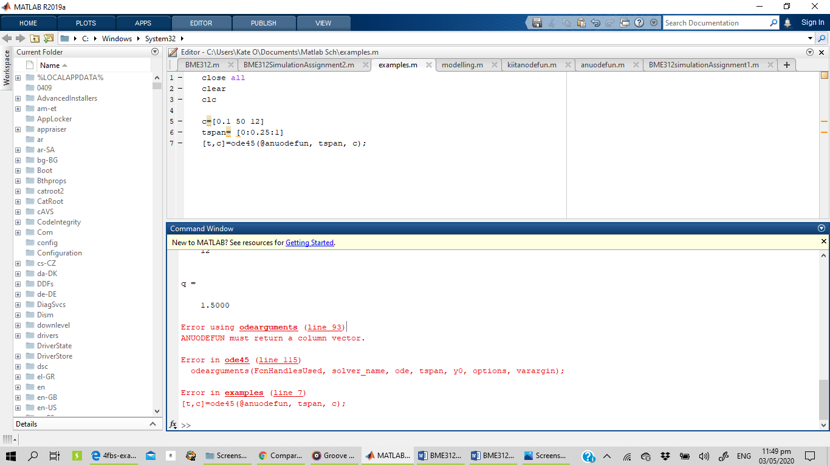

%did not run

Result
>> anuodefun
vb =
48

vi =
0.6000

c0 =
0.1000

ci =
50

cb =
12

qmax =
2.7500

qiv =
50

qgi =
12

q =
1.5000

ans =
2.2292 -113.3467

