NAME; UZOSIKE FAITH AMARACHI
MATRIC NUMBER; 18/MHS03/019
DEPARTMENT; ANATOMY
COURSE; CELLULAR BIOCHEMISTRY
COURSE CODE; BCH 308
ASSIGNMENT TITLE; NEUROCHEMISTRY

Question;
Describe in details the synthesis of two named neurotransmitters.

Answers;

- ACETYLCHOLINE

Acetylcholine is synthesized from its two immediate precursors, choline and acetyl coenzyme A.
The synthesis reaction is a single step catalyzed by the enzyme ChAT
(EC 2.3.1.6):
Choline + Acetyl coenzyme A⇌Acetylcoline + Coenzyme A
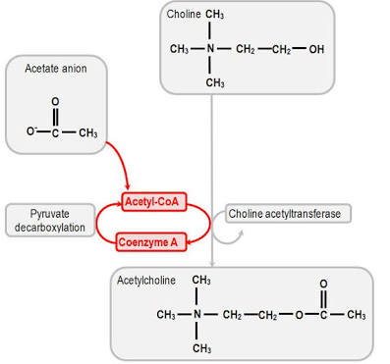

ChAT, first assayed in a cell-free preparation in 1943, subsequently has been purified and cloned from several sources . The purification of ChAT has allowed production of specific antibodies. Whereas acetylcholinesterase (AChE), the enzyme responsible for degradation of ACh, is produced by cells containing cholinoreceptive sites as well as in cholinergic neurons, ChAT is found in the nervous system specifically at sites where ACh synthesis takes place. Within cholinergic neurons, ChAT is concentrated in nerve terminals, although it is also present in axons, where it is transported from its site of synthesis in the soma. When subcellular fractionation studies are carried out, ChAT is recovered in the synaptosomal fraction, and within synaptosomes it is primarily cytoplasmic. It has been suggested that ChAT also binds to the outside of the storage vesicle under physiological conditions and that ACh synthesized in that location may be situated favorably to enter the vesicle.

Brain ChAT has a K D for choline of approximately 1 mm and for acetyl coenzyme A (CoA) of approximately 10 μm. The activity of the isolated enzyme, assayed in the presence of optimal concentrations of cofactors and substrates, appears far greater than the rate at which choline is converted to ACh in vivo. This suggests that the activity of ChAT is repressed in vivo. Inhibitors of ChAT do not decrease ACh synthesis when used in vivo; this may reflect a failure to achieve a sufficient local concentration of inhibitor but also suggests that this step is not rate-limiting in the synthesis of ACh.
The acetyl CoA used for ACh synthesis in mammalian brain comes from pyruvate formed from glucose. It is uncertain how the acetyl CoA, generally thought to be formed at the inner membrane of the mitochondria, accesses the cytoplasmic ChAT, and it is possible that this is a rate-limiting step.

Acetylcholine formation is limited by the intracellular concentration of choline, which is determined by uptake of choline into the nerve ending
Choline is present in the plasma at a concentration of about 10 μm. A “low-affinity” choline uptake system with a K m of 10 to 100 μm is present in all tissues, but cholinergic neurons also have an Na+-dependent “high-affinity” choline uptake system, with a K m for choline of 1 to 5 μm. The high-affinity uptake mechanisms should be saturated at 10 μm choline, so the plasma choline concentration is probably adequate for sustained ACh synthesis even under conditions of high demand, as observed in ganglia. Since the plasma concentration of choline is above the K m of the high-affinity choline-transport system, it is not expected that choline concentrations in the nerve ending would be increased by increasing the plasma concentration of choline or by changing the K m of the uptake system. However, neuronal choline content might be changed by altering the capacity of the high-affinity choline-uptake mechanism, such as changing the maximum velocity (V max) for transport, and this has been reported to occur in some brain regions in response to increased or decreased neuronal activity. There is some dispute about whether the capacity of the uptake system is increased or whether choline influx is regulated by changes in the intraterminal concentration of choline; it is agreed, however, that some event associated with neuronal activity enhances choline entry into neurons. If the K m of ChAT for choline in vivo is as high as that seen with the purified enzyme, one would expect ACh synthesis to increase in proportion to the greater availability of choline. Conversely, ACh synthesis should be diminished when high-affinity choline uptake is blocked. Hemicholinium-3 is a potent inhibitor of the high-affinity choline-uptake system, with a K i in the submicromolar range . Treatment with this drug decreases ACh synthesis and leads to a reduction in ACh release during prolonged stimulation; these findings lend support to the notion that choline uptake is the rate-limiting factor in the biosynthesis of ACh. To date, the high-affinity choline-uptake system has not been cloned successfully.

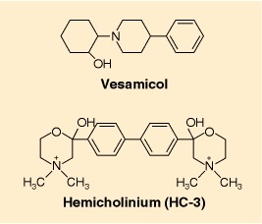
Structures of hemicholinium (HC-3) and vesamicol

- DOPAMINE

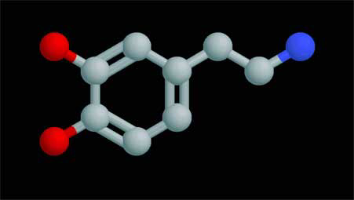
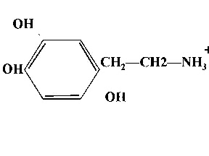
DOPAMINE belong to a class of neurotransmitters known as catecholamines, which are structurally defined by a catechol ring and an amine side chain.

Catecholamines are referred to as monoamines.
Monoamines are small, water-soluble molecules that are the decarboxylated derivatives of amino acids.
Production from their respective amino acids is catalyzed by several enzymes that act in sequence, the first of which serves as the rate limiting step.
Dysfunction of dopaminergic systems is associated with a number of diseases. For example, deficiency of dopamine in midbrain nigrostriatal neurons has long been recognized in the pathogenesis of Parkinson’s disease .
Within the brain, catecholamines function as classical neurotransmitters, i.e., they communicate between neurons and act within the anatomically confined space of the synapse.
However, by virtue of their presence in the circulation and action on distant target organs, catecholamines from the adrenal medulla were among the first compounds classified as hormones in the early 1900s. Not until the 1970s, however, did the role of dopamine as an inhibitor of the pituitary lactotrophs become recognized. Since then, dopamine has been clearly established as the primary regulator of PRL (releasing factor) gene expression and release. Dopamine as a Prolactin (PRL) Inhibitor 2002

DOPAMINE SYNTHESIS

Dopamine is synthesized from the amino acid tyrosine; the majority of circulating tyrosine originates from dietary sources, but small amounts are derived from hydroxylation of phenylalanine by the liver enzyme phenylalanine hydroxylase .
Blood-borne tyrosine is taken up into the brain by a low-affinity amino acid transport system and subsequently from brain extracellular fluid into dopaminergic neurons by high- and low-affinity amino acid transporters.
Tyrosine is converted to dopamine by the enzymes tyrosine hydroxylase (TH) and l-amino acid decarboxylase (AADC) also called dihydroxyphenylalanine (DOPA) decarboxylase (DDC). The aromatic amino acid hydroxylases 2000
TH is the rate-limiting step in their biosynthetic pathway; the TH gene is localized to chromosome 11p in humans and encodes a single form of TH that can be alternatively spliced. The mRNA expression of the TH is abundant throughout the human mesencephalon.
The mature enzyme is a soluble cytosolic protein composed of four subunits of approximately 60 kDa each.
TH activity is the most critical factor that controls dopamine synthesis, and considerable efforts have been devoted to understanding activation/inactivation of this enzyme. Assignment of the human tyrosine hydroxylase gene to chromosome 1984
As previously say, AADC is the second and terminal enzyme in dopamine biosynthesis. The enzyme uses pyridoxal phosphate as a cofactor and can convert both DOPA to dopamine and 5-hydroxytryptophan to serotonin
[5-hydroxytryptamine (5-HT)]. Aromatic L-amino acid decarboxylase modulation and Parkinson's disease 1995
The following is the complete reaction:

L-tyrosine + THFA + O2 + Fe2+ → L-dopa + DHFA + H2O + Fe2+

L-dopa + pyridoxal phosphate → dopamine + pyridoxal phosphate + CO2

So for L-dopa formation, L-tyrosine, THFA (tetrahydrofolic acid), and ferrous iron are essential and for dopamine biosynthesis from L-dopa, pyridoxal phosphate is essential.
The activity of the enzyme rises and falls according to how much pyridoxal phosphate there is. Besides two enzymes being required for the formation of dopamine from L-tyrosine (L-tyrosine >>> L-dopa >>> dopamine), three coenzymes are also required. They are : THFA (for L-tyrosine to L-dopa), pyridoxal phosphate (for L-dopa to dopamine), and NADH (for the formation of THFA and Pyridoxal phosphate). The cofactor tetrahydrobiopterin (BH4) donates the hydrogen atom needed for hydroxylation of tyrosine to DOPA.
Because pterin also serves as a cofactor for other monoxygenases as well as nitric oxide synthase, its availability is a determinino factor in the control of TH activity. Regulation of pteridine-requiring enzymes by the cofactor tetrahydrobiopterin 1999

