National Institute for Pharmaceutical Research and Development,
P.M.B 21, Idu Old Garki, Abuja

Student Industrial Training Experience

Report by
Aso Oghenero Cuthbert,
16/MHS01/049

Submitted to:

Afe Babalola University Ado-Ekiti, Ekiti State,

College of Medicine and Health Sciences,

Department of Pharmacology and Therapeutics.

May, 2020

Table of Contents
- Introduction
  - Functions of the Institution
  - Mission Statement
- Students Industrial Work Experience Scheme (Siwes)
  - Summary of Training Experience
  - Dispensation of Drugs
  - Stock Keeping and Recording
  - Anti-retroviral Drugs
  - Classes of Anti-retroviral drugs
  - Dispensation of Antiretroviral Drugs
  - Important things to note
  - Filling of Log Book
- Conclusion

1.0 Introduction
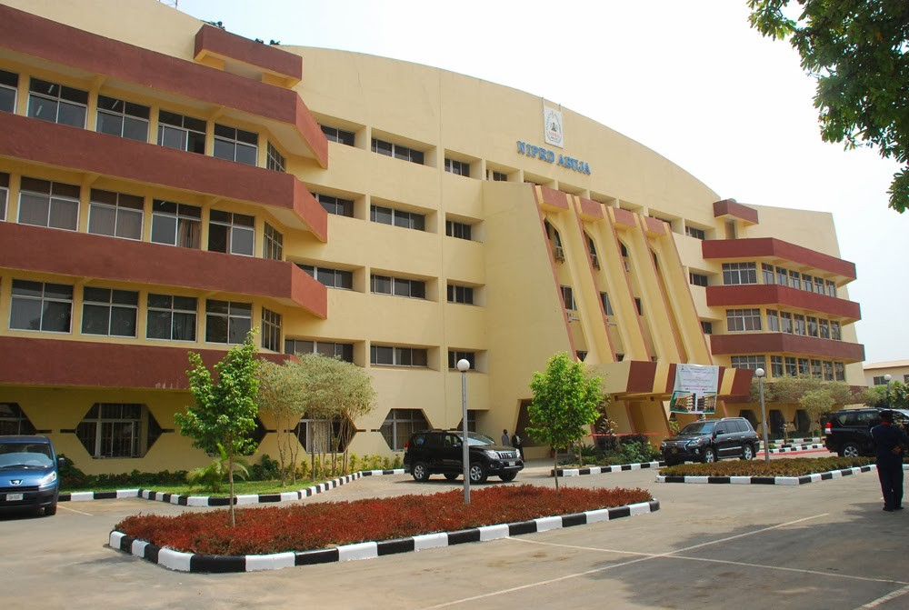

The National Institute for Pharmaceutical Research and Development (NIPRD) is a Federal Government Parastatal under the Federal Ministry of Health. The Agency was established by Government Order No. 33 Vol. 74 of 11th June 1987 Part B under the Science and Technology Act Cap 276. It became functional in the year 1989. In 2001 following a Federal Executive Council decision, NIPRD was moved to the Federal Ministry of Health (FMOH), with a huge investment in scientific equipment and human resources.
​NIPRD is the only one of its kind in the Region, and is statutorily charged with the responsibility for research and development of drugs, vaccines, phyto-medicines, commodities, and diagnostics aimed at improving sustainable access to safe, affordable and high-quality healthcare. NIPRD also undertakes activities relating to capacity building, policymaking, data collation, drug distribution and the development of contextual partnerships that can expedite access to healthcare.
​NIPRD was designated a Center of Excellence (CoE) in the African Sub-region in research and development of drugs, vaccines, phyto-medicines, and diagnostics towards improving the health and well-being of Nigerians and mankind by the African Network for Drugs and Diagnostics Innovation (ANDi) in 2011. NIPRD is ISO 9001:2015 certified by the Standards Organization of Nigeria, and recently got its laboratory accredited by the ANSI-ASQ National Accreditation Board (ANAB) for ISO 17025:2017 in the field of technical competence in testing.
The institute is located at P.M.B 21, Idu Old Garki , Abuja which lies at the North central part of the country. Its surrounded by well-developed and renounced industries such as NASENI(National Agency for Science and Engineering Infrasrtucture), Marshall Paints, Geonel Holdings limited and a host of many more.
NIPRD is currently headed by a DG in person of Dr. Obi Peter Adigwe who is on political appointment under the Ministry of Health with approval from the President, Federal Republic of Nigeria.
The DG’s Office has ten (10) Units. The Units are
- Audit
- (ii) Legal
- (iii) Planning, Monitoring & Evaluation
- (iv) Protocol/Public Relation
- (v) Library, Information & Documentation Services
- (vi) Procurement, (vii) Information & Communication Technology
- (viii) NIPRD Research Clinic
- (ix) SERVICOM
- (x) Consultancy Services.
The institute comprises of several technical departments which furthermore has different subdivisions/ units
- Dept. of Microbiology & Biotechnology
- Dept. of Medicinal Chemistry & Quality Control
- Dept. of Medicinal Plant Research & Traditional Medicine
- Dept. of Pharmacology & Toxicology
- Dept. of Pharmaceutical Technology & Raw Materials Development
1.1. The Institute, which formally took off in January 1989, has the following functions:
1.1.1. Undertake research and development work on drugs, biological products including vaccines and pharmaceutical raw materials from indigenous natural resources and by synthesis using appropriate science and technology methodologies
1.1.2. Conduct appropriate investigations and consequent applications in the areas of evaluation, preservation, purification, standardization, safety and rational utilization of traditional medicine.
1.1.3. Develop methodologies for quality assessment of biological products, orthodox and herbal medicines including their raw materials.
1.1.4. Serve as reference Centre for research work on the biopharmaceutics, pharmacokinetics, storage and stability of imported and locally manufactured drugs and biological products.
1.1.5. Conduct research and development work into pharmaceutical biotechnology, nutrition, cosmetics and environmental science for improved quality of life and the conservation of medicinal and aromatic plants.
1.1.6. Establish and operate a quality assurance laboratory for pharmaceutical raw materials and products.
1.1.7. Promote and sponsor staff development; through training courses, workshops, and fellowship within and outside Nigeria.
1.2 Mission Statement
1.2.1. To apply appropriate modern science and technological resources to stimulate local production of drugs through effective collaboration with the industry and experts within and outside Nigeria;
1.2.2. Develop herbal and phyto-medicines to pilot state of commercialization;
1.2.3. Develop quality standards for phyto-medicine;
1.2.4. Drugs and diagnostics for the purpose of control and regulation;
1.2.5. Provide quality assurance services on all drugs used in healthcare delivery; and
1.2.6. Provide safety data and essential information on herbal and other towards achieving self-sufficiency in the production and control of essential drugs in such a way that would guarantee the overall health of Nigerians and mankind in general

2.0 STUDENTS INDUSTRIAL WORK EXPERIENCE SCHEME (SIWES)
The Students industrial work experience scheme (Siwes) also known as Industrial Training is a compulsory skill programme designed to expose and prepare students of Nigerian Universities, Polytechnics, Colleges of Education, Colleges of Technology and Colleges of Agriculture for the industrial work situation they are likely to meet after graduation
The scheme also affords the students the opportunity of familiarizing and exposing themselves to the needed experience in handling equipment and machinery that are usually not available in their institution
SIWES Introduction, initiation and design was done by the Industrial Training Fund (I.T.F) in 1993 to acquaint students with the skills of handling employer’s equipment and machinery
Objectives and Scopes of SIWES in Nigeria
- SIWES provides avenue for students in institutions of higher learning to acquire industrial skills and experiences in their course of study.
- Prepare the students for industrial work situation they are likely to meet after graduation.
- Make the transition of school to the world of work easier and enhance students contact for later job placement
- SIWES provides students an opportunity to apply their knowledge in real work situations thereby bridging the gap between theory and practice
- Enlists and strengthens employers’ involvement in the entire educational process and prepare students for employment after graduation
2.1 Summary of Training Experience
I began my 3 months Industrial training experience on the 27th of May and I was posted to the pharmacy unit which falls as a sub unit under the clinical department.
The clinical department consists of 16 staffs who have been posted to various functional departments and has a Chief Medical Director as the overall head
I was supervised by a professionally trained pharmacist in person of Pharm. Adegoke Valentine who was the Head of the pharmacy unit. I was also assigned to various co pharmacists such as Pharm Nembam, Pharm. Chioma whom also assisted in helping me obtain the necessary information required for the training
Under the 3 months training, I attended subsequent seminars and classes which were held to teach us some of the prevailing medical issues in the country with solutions. Also, assignments were given to test and expand our Knowledge on the topics taught. I was also exposed to various drugs both basic and complex which are needed daily for health improvement. Some of these drugs include: the anti-malarial (e.g. lonart, coatem), antibiotics (e.g. ampidox,), Pain relievers (e.g. paracetamol, ibuprofen), worm infestation such as albendazole, anti-tuberculosis such as isoniazid, anti-respiratory (e.g. cetirizine), etc.
2.2 Dispensation of Drugs
I was also taught the procedure on how to dispense drugs to patients appropriately and the procedure goes as follows:
- Firstly, you collect the drug prescription from the patient already prescribed by the doctor
- Then you give a total cost of the drug(s) and ask it to be sent to the cashier for payments and a receipt will be issued after payment has been done
- After it has been costed, you dispense the required drug with fixed doses as required
O.D: Once daily dosage
B.D; Twice daily dosage
T.D.S: Three times daily dosage
- Then you collect the receipt as evidence of payment before the patient leaves and store it in the receipt book

2.3 Stock Keeping and Recording
After the end of every week, I recorded the drugs sold for the week inside a record book with the aid of the receipts being collected. This book had various fractions for recording consisting of the receipt number, date of payment, name(s) of drug(s) with quantities and cost of the drug(s).

Also at the ending of every 2 weeks, I took stock keeping on the quantity of drugs available in the store room so as to know the drugs which are still available and low in stock

2.4 Anti-retroviral Drugs
Anti-retroviral Drugs can help lower your viral load, fight infections, and improve your quality of life. They can lower your chances of transmitting HIV, but if you take them incorrectly, you can still give HIV to others. They are not a cure for HIV

The goals for these medicines are to:
- Control the growth of the virus
- Improve how well your immune system works
- Slow or stop symptoms
- Prevent transmission of HIV to others

The FDA has approved more than two dozen antiretroviral drugs to treat HIV infection. They're often broken into six groups because they work in different ways. Doctors recommend taking a combination or "cocktail" of at least two of them. This is called antiretroviral therapy, or ART
Some other medicines and supplements don't mix well with HIV drugs, so the doctor needs to know all that you are taking.

2.5 Classes of Antiretroviral drugs
2.5.1. Nucleoside/Nucleotide Reverse Transcriptase Inhibitors (NRTIs)
NRTIs force the HIV virus to use faulty versions of building blocks so infected cells can't make more HIV. Examples include Abacavir, or ABC (Ziagen), Didanosine or ddl (Videx), Emtricitabine or FTC (Emtriva), Lamivudine, or 3TC (Epivir), Stavudine or d4T (Zerit), Tenofovir alafenamide or TAF (Vemlidy), Tenofovir disoproxil fumarate or TDF (Viread),

2.5.2. Non-nucleoside Reverse Transcriptase Inhibitors (NNRTIs)
These are also called "non-nukes." NNRTIs bind to a specific protein so the HIV virus can't make copies of itself, similar to jamming a zipper. Examples include: Delavirdine, Efavirenz or EFV (Sustiva), Etravirine or ETR (Intelence), Nevirapine or NVP (Viramune), Rilpivirine or RPV (Edurant)

2.5.3. Protease Inhibitors (PIs)
These drugs block a protein that infected cells need to put together new HIV virus particles. Examples include: Atazanavir or ATV (Reyataz), Darunavir or DRV (Prezista), Indinavir or IDV (Crixivan), Lopinavir + ritonavir, or LPV/r (Kaletra)

2.5.4. Integrase Inhibitors
These stop HIV from making copies of itself by blocking a key protein that allows the virus to put its DNA into the healthy cell's DNA. They're also called integrase strand transfer inhibitors (INSTIs). Examples include: Bictegravir or BIC (combined with other drugs as Biktarvy), Dolutegravir or DTG (Tivicay)
2.5.5. Fusion Inhibitors
Unlike NRTIs, NNRTIs, PIs, and INSTIs -- which work on infected cells -- these drugs help block HIV from getting inside healthy cells in the first place. Examples include: Enfuvirtide, or ENF or T-20 (Fuzeon)

2.5.6. CCR5 Antagonist
Maraviroc, or MVC (Selzentry), also stops HIV before it gets inside a healthy cell, but in a different way than fusion inhibitors. It blocks a specific kind of "hook" on the outside of certain cells so the virus can't plug in.

2.6. Dispensation of ARV drugs

Every Monday and Wednesday were days set aside by the institution as days for antiretroviral treatment. On these days, I was on seat at the ARV pharmacy for dispensation of these drugs and this was done with due process which goes as follows

- Firstly, the patients take their assigned cards to the viral unit where their viral loads and other vital information was taken.
- Then the patient proceeds to see the doctor afterwards for treatment in which the doctor prescribes his/her treatment in accordance to severity of the virus and other factors such as age, pregnancy etc. and sends it via web to the ARV pharmacy unit.
- The patient then proceeds to the ARV pharmacy unit with their custom assigned cards held in their hands for dispensation of drugs.
- I proceed to collect the cards from them at the ARV pharmacy unit and input their card numbers into the system to access the doctor’s prescription.
- The prescription entails the drug to be dispensed, the dosage and quantity of the drug after which they are permitted to leave.
- Septrin was also administered as a cocktail alongside the ARV drugs to enhance performance of the ARV drugs.
- Isoniazid served as a prescribed drug for patients with tuberculosis and it’s to be taken in combination with the ARV drugs to manage the virus
2.7. Some important things to note:
The dispensation of these ARV drugs was done via an online platform called “Open MRS”. This Open MRS was done in collaboration with the institute. The platform contained each registered patient’s personal information and status.
Some of the ARV drugs were advised to be taken at different time intervals. For example, the Dolutegravir(DTG) was advised to be taken in the morning because of a high number of complaints from the patients that the drug makes them have nightmares while drug like efavirenz was advised to be taken at night as a result of the patients complaining that it makes them feel dizzy and destabilizes their day
Also, pregnant mothers and weaning mothers were advised to take nevirapine suspension so as to prevent or minimize the infection in their children
Aside the physical training given, I also went through training on Work ethics which entails Good code of Conduct such as decent dressing, punctuality to work, good manners and other pharmaceutical rules.
2.8. Filling of Log book
At the end of every week, I submitted my log book alongside my fellow IT colleagues to our supervisor for cross- checking and signing
3.0 Conclusion
The 3 months Industrial training I went through was really a beneficial one to my academic process and it really expanded my Knowledge about the medical field.
It also served as a great recipe for a better work experience/ service for undergraduates when they finally becoming working class individuals

