TECHNICAL REPORT
ON
STUDENTS INDUSTIAL WORKEXPERIENCE SCHEME (SIWES)
AT
NIGERIAN NATIONAL PERTROLEUM CORPORATION MEDICAL SERVICES PORT HARCOURT
(A Subsidiary of NIGERIAN NATIONAL PERTROLEUM CORPORATION)
P.O.B 585 PORT HARCOURT
PRESENTED BY
EYO BEATRICE OBO
17/MHS07/009
DEPARTMENT OF PHARMACOLOGY ND THERAPEUTY
COLLEGE OF MEDICINE AND HEALTH SCIENCE
AFE BABALOLA UNIVERSITY KM 8, 5 AFE BABALOLA WAY
ADO-EKITI NIGERIA.

DEDICATION
I dedicate this report to almighty GOD without whom I could do nothing. To my parents who constantly encourage and push me towards all I can potentially achieve. And to those who helped me along the way during the period of my industrial training.

ACKNOWLEDGEMENT
I deeply appreciate those who put in extra effort to teaching and training me during the period of my industrial training program, Pharm. Princess, Pharm. Blessing, Pharm. Ogulo , pharm. Femi ,Pharm. Chu Pharm. CJ , Pharm Patience .They never got tired of answering my endless questions and they never held back knowledge that was worth sharing. Pharm. Patient Pharm. Femi and pharm Chu whose constant lectures shall forever stay with me.Pharmacist Cj assignments kept me up till the late hours of the night. Thank you all.

TABLE OF CONTENT
Cover Page i
Certification ii
Acknowledgement iii
Table of Content iv
- INTRODUCTION………………………………………………...5
1.1. PURPOSE OF TRAINING
1.2. BRIEF OVERVIEW OF NNPC MEDICAL SERVICES
1.3. PHARMACY DEPARTMENT

- TRAINING PROGRAMME………………………………… 11
2.1. OVERVIEW OF TRAINING EXPERIENCES

- OBSERVATIONS AND CONTRIBUTIONS
3.1. OBSERVATION
3.2. CONTRIBUTIONS

- CONCLUSION ……………….
4.1. CONCLUSION

- REFERENCES……………………………………………………

1.0 INTRODUCTION

1.1 PURPOSE OF TRAINING
The Student Industrial Work Experience Scheme (SIWES) was initiated in 1973 by the Industrial Training Fund (ITF). This was to update practical knowledge of students in the Universities, Polytechnics and Colleges of Technology.
It was aimed at bridging the gap between the theoretical knowledge acquired in classes and technical knowledge in the industry by providing students with the opportunities to apply their educational knowledge in real work situations. Over the years, SIWES has contributed immensely to building the common pool of technical and allied skills available in the Nigeria economy which are needed for the nation’s industrial development.
Furthermore, the place and relevance of SIWES is underscored by the fact that the scheme contributes to improving the quality of technical skills generally available in the pool from which employer’s source technical manpower Its gives student the opportunity to blend the theoretical knowledge acquired in the classroom and with practical hands-on application of knowledge required to perform work in the industry. Also, it prepares students for employment and makes the transition from school to the world of work easier after graduation.
I undertook my SIWES at NNPC medical (Pharmacy Department) which is located at Aleto Eleme (Akpajo) Port Harcourt river state Nigeria from May to August 2019.
Pharmacy is the science and technique of preparing and dispensing drugs. It is a health profession that links health sciences with chemical sciences and aims to ensure the safe and effective use of pharmaceutical drugs.
The scope of pharmacy practice includes more traditional roles such as compounding and dispensing medications, and it also includes more modern services related to health care, including clinical services, reviewing medications for safety and efficacy, and providing drug information. Pharmacists, therefore, are the experts on drug therapy and are the primary health professionals who optimize the use of medication for the benefit of the patients.

BRIEF OVERVIEW OF NNPC MEDICAL SERVICES
NNPC was established on 1 April 1977 as a merger of the Nigerian National Oil Corporation and the Federal Ministry of Mines and Steel. NNPC by law manages the joint venture between the Nigerian federal government and a number of foreign multinational corporations, which include Royal Dutch Shell, Agip, ExxonMobil, Total S.A, Chevron, and Texaco (now merged with Chevron). Through collaboration with these companies, the Nigerian government conducts petroleum exploration and production. In 2007, the head of the Nigerian wing of Transparency International said salaries for NNPC workers were too low to prevent graft.

ABOUT THE MEDICAL SERVICES

Vision
To be the best healthcare provider in Nigeria
Mission
To engage in business across the entire health value chain using platform such as HMO, strategic alliances, joint ventures partnership etc., aimed at improving skills delivery, generating revenue and reversing medical tourism in Nigeria.
Mandate:
To provide comprehensive quality healthcare to NNPC staff and other defined beneficiaries; and to transit from being a cost center to a profitable healthcare services organization.
Activities
Provision of Comprehensive Diagnostic and Curative Healthcare services to staff and dependents.
Management of 3rd Party healthcare facility relationships
Provision of Occupational Services to staff in compliance with regulations through Health surveillance, Fitness to Work, Medical Emergency preparedness and Response, Periodic Medical Examination, etc.
Provision of health promotion and preventive healthcare to staff.
Provision of counseling services to staff as need arises.​
Achievements
Incorporation of NNPC Medical Services Ltd (NMSL) to do business across the entire healthcare value chain
Incorporation of NNPC HMO Ltd with CAC and appointed Consultant to midwife Medical’s transition to full operations
Enhanced essential drugs availability across zones.

1.3 PHARMACY UNIT IN NNPC MEDICAL

o In-Patient Pharmacy Unit
o Out-Patient Pharmacy Unit

2.1 OVERVIEW OF TRAINING EXPERIENCES
OUT-PATIENT UNIT
I resumed work at the out-patient unit on the 15th of May 2019.
On the first day, I was introduced to the operations and activities in the Unit. Before the end of the day, I got familiarized with the Unit and the pharmacists on duty. As time went on I got familiarized with the classes of Drugs present in the Unit day by day. During my work period I was made to read up, do some findings and present.
Every Moring we carry out requisition from the store to the outpatient unit, this daily requisition help to keep check of drugs and also make dispensing easier.
I learnt about the proper routine of attending to Prescriptions (Interpretation, Assessment and Dispensing and Counseling), I went through most of the Prescriptions to Check for its completeness and accuracy. Learning extensively about the component of a prescription. As I was allowed to Assess, Dispense and counsel some patients, all under the supervision of the pharmacist-in-charge.
During my training period I learnt how to calculate the required number of tablets and volume of syrup and also the various abbreviation, terminology, labelling and interpretation of prescription.
On resumption, every Tuesday I do attend the Health Talk meeting where Health Practitioners alongside Pharmacists educate and counsel Patients on recent trends of Diseases. Health talk on hypertension, diabetes, low back pain, blood donation, etc.

IN-PATIENT PHARMACY
The experience in the In-patient pharmacy is slightly different. The pharmacist does not interact with the patients directly rather; a ward attendant comes to collect the drugs to be administered to the patients on admission. The in-patient pharmacy deals majorly with infusions and injections but also dispense drugs in some cases.

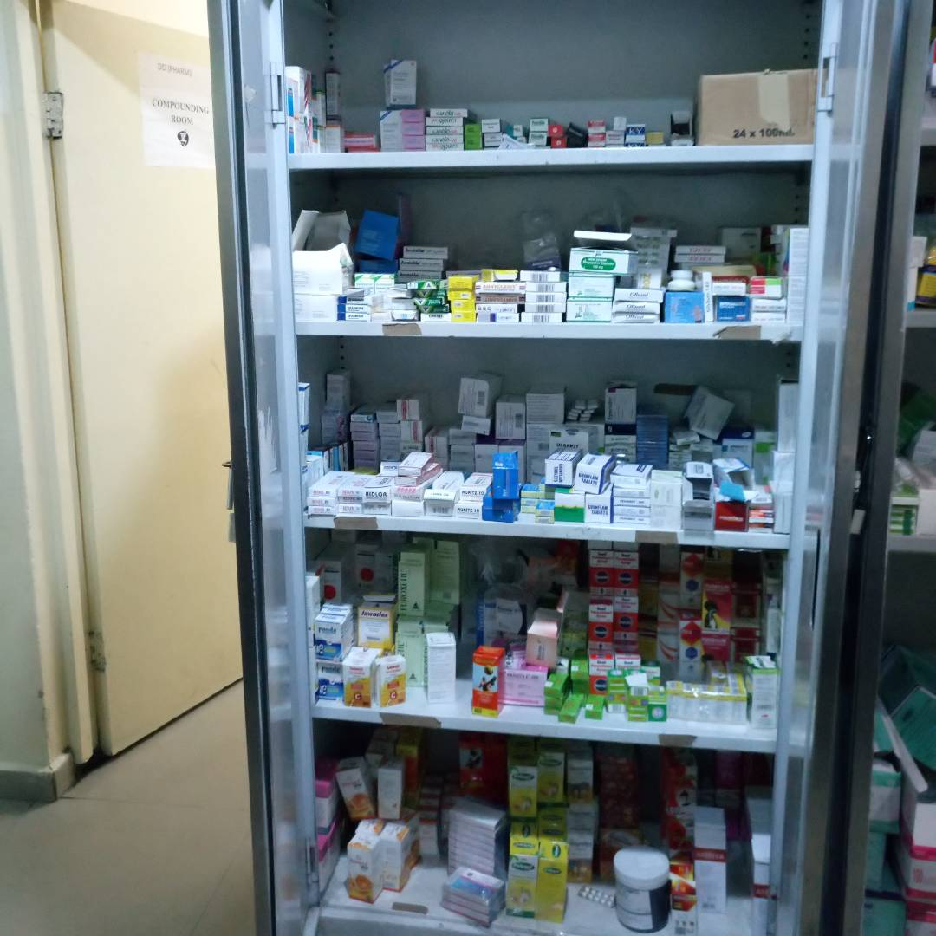
INFUSIONS AND INJECTIONS

THE ACTIVE STORE
In the active store, daily requisitions are carried out for both the In-patient and Out-patient, the active store supply drugs to all. The drugs on the shelves are arranged according to formulations.
At the store, the poison cupboard was also made available here, where drugs like diazepam diabetes treatment. Nitrazepam, tramadol, bromazepam and other control drugs are kept. Cold chain was also made available for d Vaccines, Glaucoma eye drops, which are temperature sensitive, Aerosol spray, Insulin for diabetes treatment.

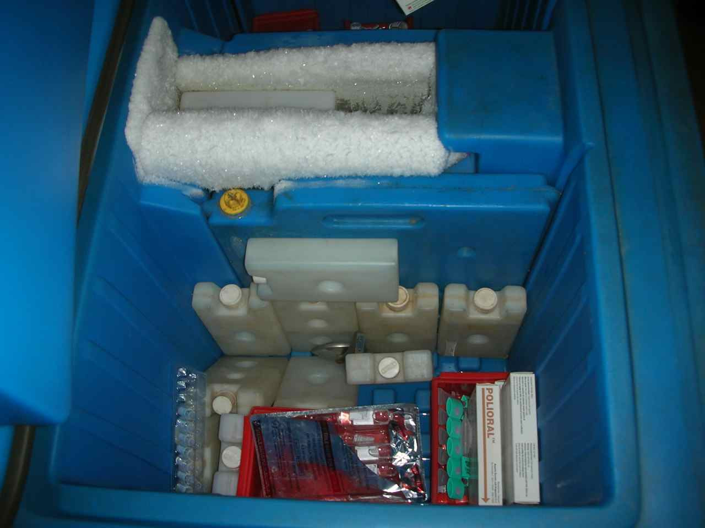
COLD CHAIN

3.1 EXPERIENCE GAINED
During my training experience. I learnt how to interpret prescriptions, dispense drugs and also how to counsel patients on drug administration. I learnt the act of drug selection and substitution and also how to provide drug alternatives when necessary. I got myself acquainted with the basic managerial skills that are required to manage a pharmacy. I’m now familiar with different brands of drugs and also on the ethics behind the use of poison book. Learnt how to make requisition of drugs from the store to the pharmacy and also learnt how to carry out some activities in line with my career using specific software's. I was able to learn more about drug-drug interaction and drug-food interactions and side effects of drugs based on what I learnt in Pharmacology.

3.2 OBSERVATIONS
As a student, my first observation was the cognition of the difference between the school environment and its activities and the Work Environment and Activities”. I observed that a Hospital Pharmacy does not look like a classroom environment where lectures are being taught. It’s also a Place where you have the Opportunity to learn while you delivering services to the patients in relation to unusual Clinical problems, uncommon Drug interactions and side effects. Also, Drug companies come around to present on their new development of drugs and indication of their products, their interactions, side effects and superiority over other products which helps to improve Learning and awareness of their products.

4.1 CONCLUSION
My experience during this period of industrial training has been of the utmost importance. I have learnt so much discipline and fully understand the importance of the pharmaceutical practice .It has given me an insight on the practical aspect of all I have learnt in the classroom and more. It is an experience that has shaped my attitude towards the profession.

