NAME; SOLOMON OKON REJOICE
DEPARTMENT; PHARMACOLOGY
COLLEGE; MEDICINE AND EALTH SCIENCES
MATRIC NUMBER; 16/MHS07/032
SIWES REPORT

TABLE OF CONTENT
Title page
Dedication
Acknowledgement
Departments of Sewell pharmaceuticals limited
Report overview
Summary SIWES training activities
Problems encountered during training.

SIWES REPORT ON; The production of vitamin c syrup in SEWELL Pharmaceuticals Ogun Housing Estate, Ogun State Nigeria

DEDICATION
This report is dedicated to God Almighty, my Family, friends and my Department.

ACKONWNLEDGEMENT
I say a big thank you to the Department of Pharmacology ABUAD and SEWELL Pharmaceuticals for sparing their precious time and resources to teach and impact knowledge in me.

Sewell Pharmaceuticals limited
The company is located at Ogun housing estate Ogun state. They produce blood tonics, vitamin c syrups, cough syrups and stimulants. Drugs they produce include
- Seprowell
- Exyln
- Careon
- Hey baby vitamin c syrup
- Albendazole syrup
- Weltonic
- Welvita 12
- Hey baby Exyln
Departments in SEWELL include the chemistry department, the microbiology department, the compounding department, water department, filling department, packing department.

During my three months training all the drugs stated above were produced .daily routines included environmental monitoring (i.e. humidity and temperature check, the average humidity is 65 while the average temperature is 25).water regeneration was done every Monday and Tuesdays, water analysis was done every morning after environmental monitoring this includes hardness test, residual chlorine test, pH etc. Microbial analysis was done to check microbial.
VITAMIN C SYRUP
Vitamin C also known as ascorbic acid and ascrobate, it is found in food and sold as dietary supplement.

USES OF VITAMIN C SYRUP
It is used to prevent scurvy.
It is essential in tissue repair.
It is essential in the enzymatic production of certain neurotransmitters.

WEIGHING OF RAW MATERIALS FOR COMPOUNDING OF VITAMIN C SYRUP
1. purified Water
2. Orange citrus
3. Ascrobic acid
4. Citric acid
5. Sodium citrate
6. Sodium metabisulphate
7. Propyl paraben
8. Methyl paraben
9. Sugar
NOTE; the materials are weighed according to the volume of product desired
The water used to reconstitute the product is gotten from strict water regeneration (passed through the calcium chloride tank, activated charcoal tank where the excess Calcium Chloride reacts with the charcoal, the UVlight tank, ion exchanger tank(anion and cation exchanger).
PRECAUTIONS WHILE WEIGHING
1. It was ensured that while weighing particles of the raw material being weighed didn’t fall on the weighing balance in order to avoid false weight reading of the content of the raw material in the weighing tank
2. it was ensured that gloves were worn to avoid accidental burns caused by any raw material.

COMPOUNDING OF VITAMIN C SYRUP
Purified water was transferred to a boiling tank in the boiling room, granulated sugar was turned into the tank and allowed to boil till the sugar is completely dissolved and a sugar syrup is formed .the sugar syrup is allowed to cool then transferred using the transfer line into a compounding tank in the compounding room ,methyl paraben and propyl paraben is added to the sugar syrup and it is thoroughly stirred till a thick whitish paste is created .citric acid is added and sodium citrate are also added and stirred .Sodium metabisulphate and ascorbic acid are added and stirred ,orange citrus and purified water is added and thoroughly stirred using the stirrer .The raw materials mixed in the tank

is thoroughly stirred using the stirrer and the homogenizer. Samples of the drug is collected and taken to the laboratory for chemical (P^{H} analysis, weight/ml analysis, HPlC analysis) and microbiological analysis (bacteria count analysis, fungi count analysis), the tank was then sealed and a yellow under test label was placed on it. If the analysis result is accurate a green label is placed on the tank for production to proceed.
NOTE; Methyl paraben and propyl paraben were combined and dissolved under heat in water because they do not easily dissolve in water at room temperature, it was instantly poured into the compounding tank and thoroughly stirred with the sugar syrup to avoid crystallization.

Significance
- Methyl paraben and propyl paraben aid in maintaining the acid stability of the drug.
- Sodium metabisulphate serves as a preservative in the product
- Sodium citrate is used to thicken the product
FILLING OF VITAMIN C SYRUP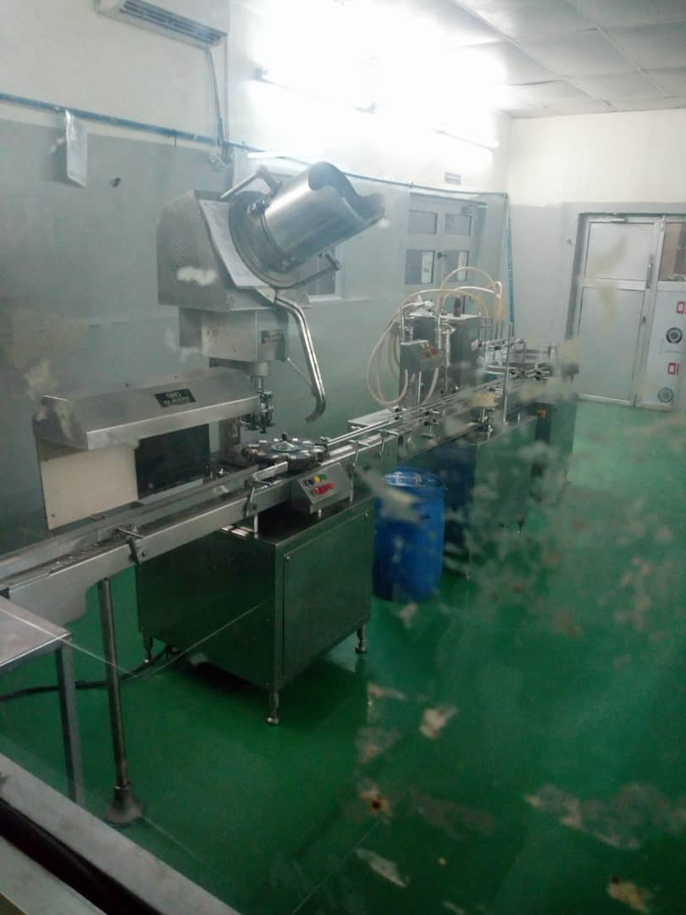
MICRO AUTOMATIC FILLING MACHINE
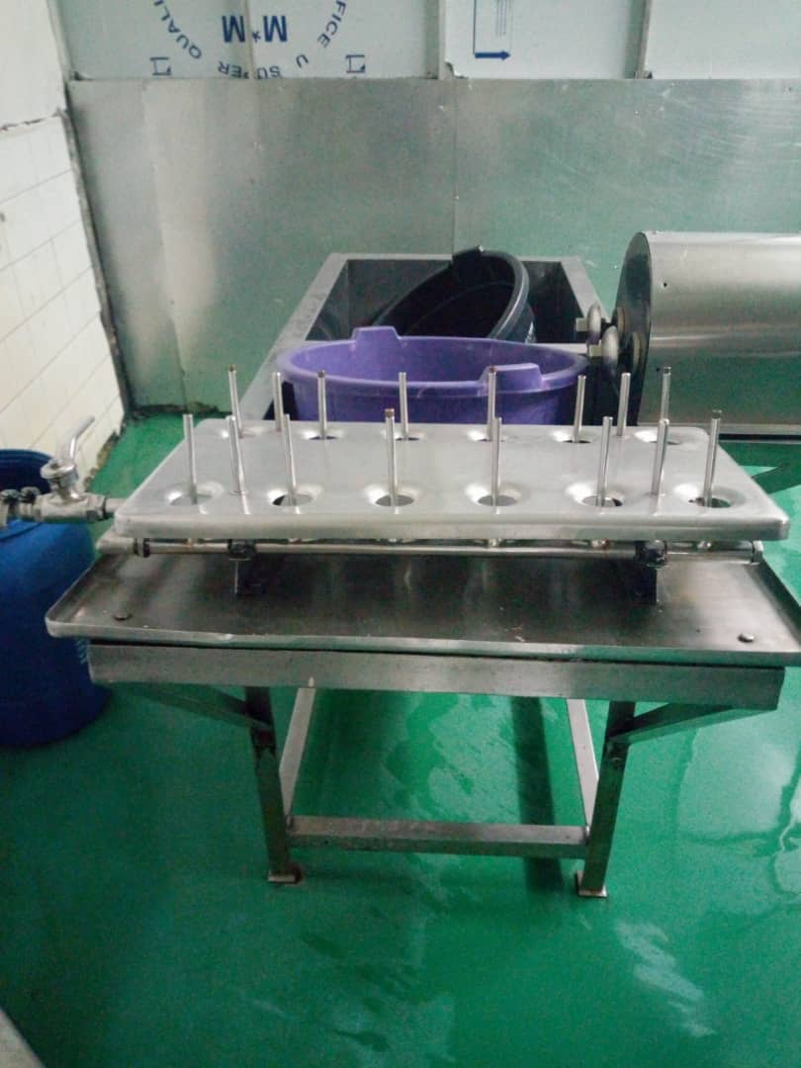
BOTTLE WASH MACHINE
Bottles are wash at the bottle wash room and sterilized, twelve bottles are taken at random to the microbiology lab for microbial analysis ,the transfer line is inserted in the tank containing the syrup and passed to the filling room ,the homogenizer is also used to stir while filling commences .the micro automatic filling machine is used in filling the syrup due to it ability to fill the 100ml bottles .immediately each bottle is filled it is cap by the automatic capping machine. Samples of each batches filed to taken for chemical and biological analysis, it is then moved to the labeling and packing halls.
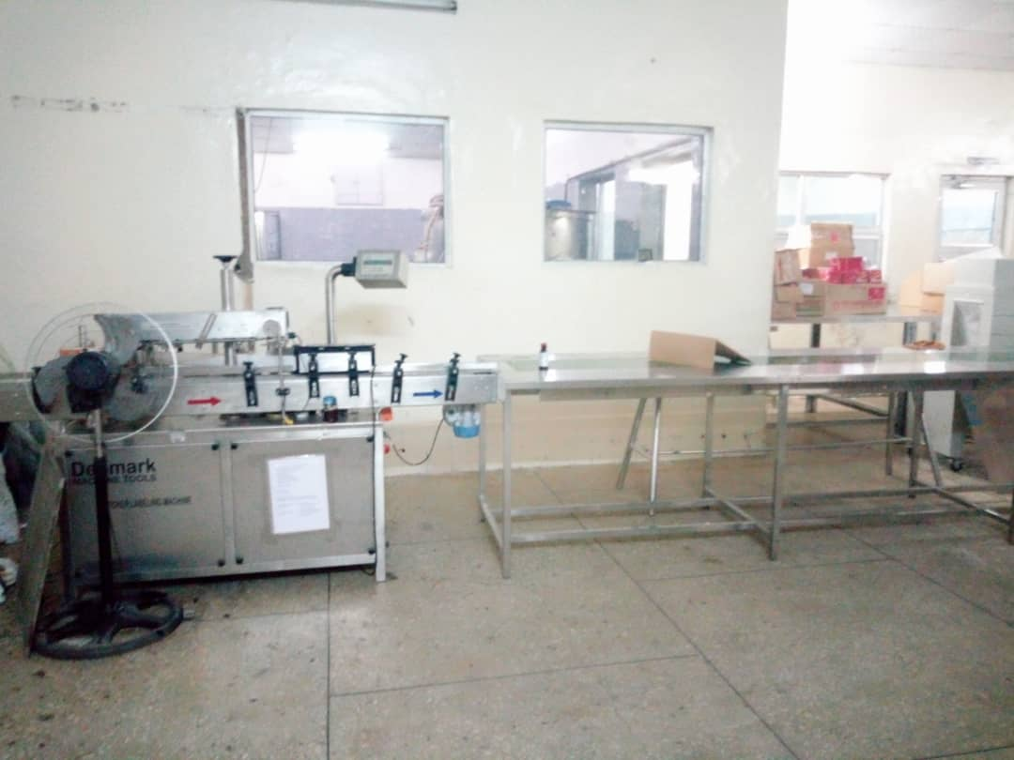

PACKAGING MACHINE
After packing is done it is stored in the observation room for a month to ensure there is no instability either in acidity level ,basicity level ,chemical changes or physical changes these includes ; color change or bacteria or fungi growth.
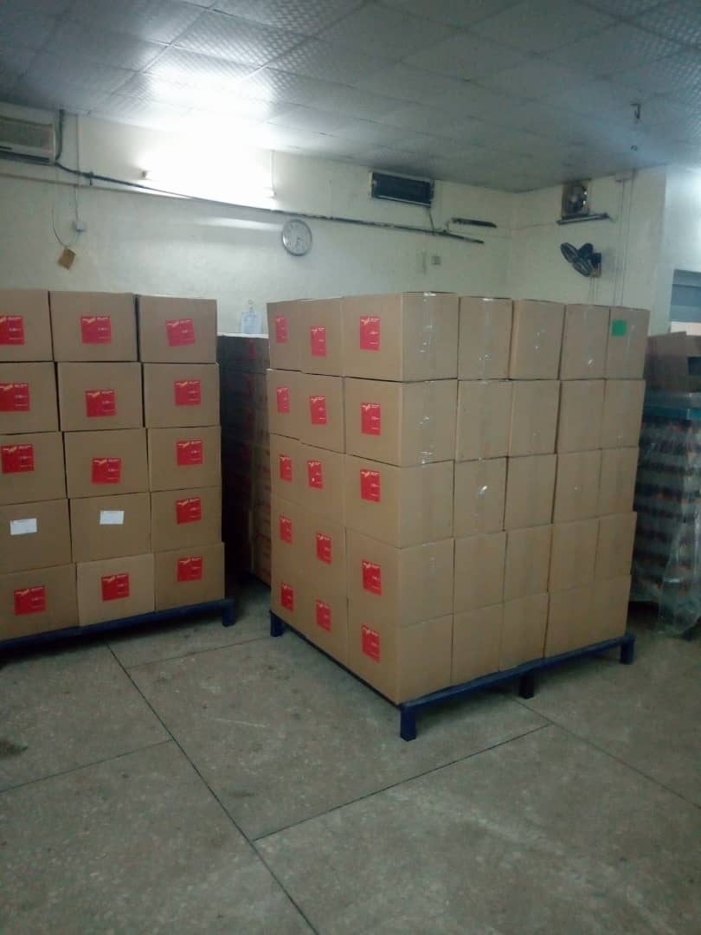

PRECAUTIONS WHILE FILLING
- It was ensured that line clearance was observed before the new product was brought to the filling room i.e. removal of any previous product that was filled and left to avoid any mix up.
- It was ensured that the grading of the micro automatic machine was 100ml precisely ,the content the machine dispenses was checked using a 100ml measuring cylinder after every 30 minutes
3. While filling every staff wore a PPE (the manufacturing boots, gloves, head wear, laboratory coat etc).
4. It was ensured that any spillage of the product that occurred during filling was immediately cleaned to avoid accidents and contamination.
PROBLEMS ENCOUNTERED DURING TRAINING
The time frame for the training was little and the numbers of students being trained were much so there was no intense concentration on a specific student.
REFERENCE
Rang and Dales pharmacology
Standard operational procedures (SOP).

THANK YOU….

