A TECHINCAL REPORT ON
STUDENT INDUSTRIAL WORK EXPERIENCE SCHEME (SIWES) JUNE – AUGUST 2019
DONE AT
PHAMATEX INDUSTRIES LIMITED
NO 1, CRYSTAL GLASS CLOSE, AMUWO ODOFIN INDUSTRIAL ESTATE
LAGOS, NIGERIA.
WRITTEN BY:
IQUO PAMELA INYANGABIA
MATRIC NUMBER: 16/MHS07/015
DEPARTMENT OF PHARMACOLOGY AND THERAPEUTICS
COLLEGE OF MEDICINE AND HEALTH SCIENCES
SUBMITTED TO THE SIWES CO-ORDINATOR
4TH MAY, 2020

DEDICATION
This Student Industrial Work Experience Scheme (SIWES) report is dedicated to God Almighty.

ACKNOWLEDGEMENTS
Special appreciation to God Almighty for his unconditional love, grace and protection throughout the period of my industrial training program.
My sincere thanks go to my parents Prof and Dr. (Mrs.) Moses Inyangabia for their extreme support throughout the period of my SIWES program, and I will also appreciate Mr. and Mrs. Matthew Nnamdi for accommodating me throughout the period of the attachment. May God bless them all.
I am grateful to the entire staff and mostly to my supervisors of Quality Assurance, Production and Quality Control Departments. Starting with the Manager of Quality Assurance Mr. Ayo Okegbenle, the head of department of Production Pharmacist Onyeka Okenu and the manager of quality control Mr. Ariyo Olusegun. I will like to appreciate you for your support and encouragement during my SIWES program also to my fellow colleagues, I appreciate you all.
I also want to appreciate the Head of Department of Pharmacology and Therapeutics, Dr. Adeoluwa, my level adviser, Mrs. Obiesan and all the lecturers in the department for giving me this amazing opportunity to go for this SIWES program and explore more diverse areas in my course of study.

TABLE OF CONTENTS

DEDICATION
ACKNOWLEDGMENT

CHAPTER 1: Good Manufacturing Practices (GMP)
  - Quality Assurance
  - Quality Control
  - Basic principles of Good Manufacturing Practices (GMP)
CHAPTER 2: Apparatus used out in the Quality Control Laboratory
CHAPTER 3: Tests carried out in the Quality Control Laboratory
CHAPTER 4: Drugs produced in Phamatex Industry and their mode of action
CONCLUSION

CHAPTER ONE:
GOOD MANUFACTURING PRACTICES (GMP)
These are practices required in order to conform to guidelines recommended by agencies that control the authorization and licensing of the manufacture and sale of food, medical devices, cosmetics and pharmaceutical products.
The guidelines provide the minimum requirements that a manufacturer must to assure that their products are of good quality. Therefore, the main aim of Gmp is to deliver quality product from contamination and prevent harm from occurring to end users.
Gmp starts from you, before we could go down to the processes involved in manufacturing. Gmp is ensured through this dept, quality assurance department.
QUALITY ASSURANCE:
Quality assurance is a way of preventing mistakes or defects in manufactured products and avoiding problems when delivering services to customers. It involves management of quality of raw materials, assembles i.e. production processes and service related to inspection processes.
QUALITY CONTROL:
Quality control are procedures intended to ensure that manufactured product or performed services adhere to a defined set of quality criteria or meet the requirement of the client or customer. It includes testing of products to uncover defects and reporting to management for further instructions.
BASIC PRINCIPLES OF GMP
- Manufacturing facilities must maintain a clean and contamination-free manufacturing are
- Manufacturing facilities must maintain a controlled environment so and to avoid gross contamination that may render the product unsafe.
- All processed must be clearly defined and controlled, it there is a change or deviation it must be validated (investigated and documented).
- Instructions are written in clear and no ambiguous languages using good documentation practices.
- Operators must be highly to carry out procedure and document them.
- Samples taken at different stages of production for checks.

GMP is not instruction on how to manufacture drugs but they are series of principles that must be observed when manufacturing.
CHAPTER TWO:
APPARATUS USED IN THE QUALITY CONTROL LABORATORY
There are different apparatus used in the quality control laboratory some are used to carry out test on the physical parameters on the drugs as already discussed earlier and the others are for chemical analysis.
- SONICATOR: this is an instrument used in applying sound energy to agitate particles in a sample, for various purposes. 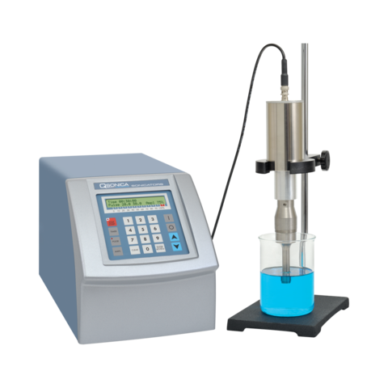

- UV SPECTROPHOTOMETER: this is an apparatus used for measuring the intensity of light or wavelength in a part of the spectrum, especially as transmitted or emitted by particular substance.

- DISSOLUTION: it is an apparatus used in the laboratory to carry out dissolution test.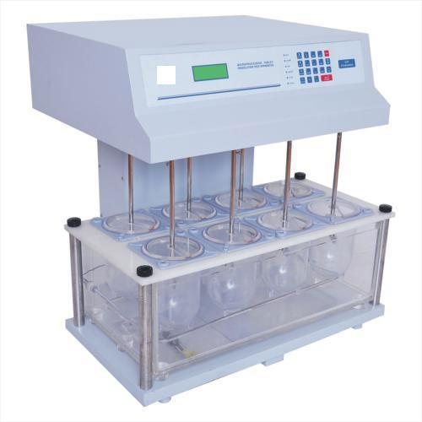
- HPLC: it is known as high performance liquid chromatography. It is used to separate, identify and quantify each component in a mixture. They are used in situations where the UV spectrophotometer cannot be used.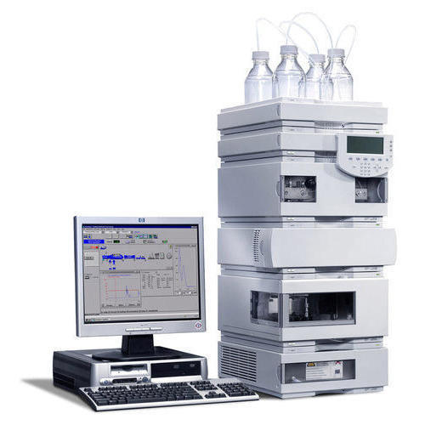
- PH METER; it is a design used for potentiometrically measuring the PH which is either the concentration or the activity of hydrogen ions of an aqueous solution.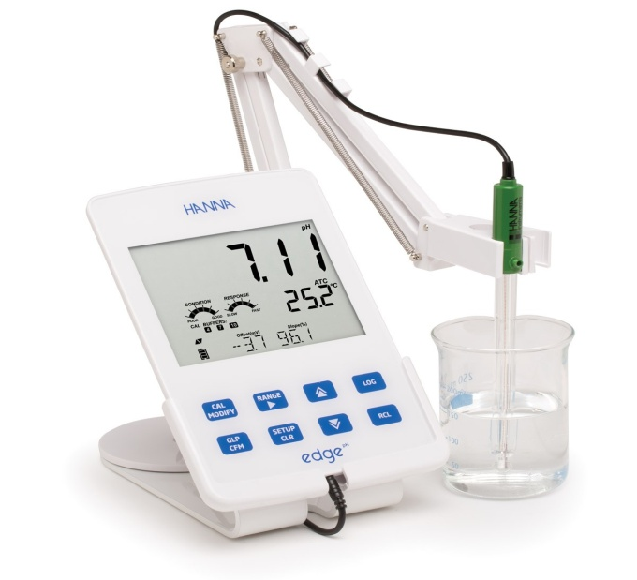

- CONDUCTIVITY METER: it is an apparatus that measures the electrical conductivity in a solution

.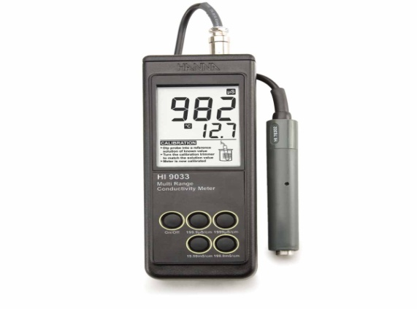
- FUME CUPBOARD: it is a type of local ventilation device that is designed to limit exposure to hazardous or toxic fumes, vapors or dust.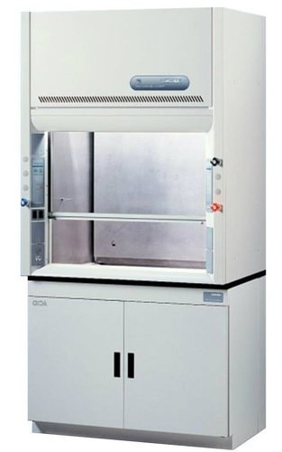
- WATER BATH: it is a container of water heated to a given temperature, used for heating substances placed in a smaller container.
.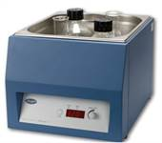

CHAPTER THREE:
TEST CARRIED OUT IN THE QUALITY CONTROL LABORATORY
WATER ANALYSIS:
This refers to the chemical, physical, biological and radiological characteristics of water. It is a measure of the condition of water. It is a measure of the condition of water relative to the requirements of biotic species or to any human need or purpose. There are different test carried out on water and they are discussed below. These different tests are carried out on raw, portable and purified water.
- Analysis of Raw Water
- PH: this is a numeric scale used in specify the acidity or alkalinity of an aqueous solution. Solutions with a PH less than 7 are acidic and solution with a PH greater than 7 are alkaline or basic
In the quality control laboratory, the PH of water is measured by an apparatus called the PH meter.
The PH of raw water must be within the range of 5.5 - 8.5.
- CONDUCTIVITY: it is a measure of a materials ability to conduct an electric current. This test is carried out by an apparatus called the conductivity meter.
The conductivity of raw mater must not be more than 1000 5_{cm}²
- TOTAL DISSOLVED SOLID: it is a measure of the combined content of all inorganic and organic substance contained in a liquid in molecular, ionized or micro-granular suspended from.
This is calculated in the quality control laboratory using values gotten from the conductivity meter.
If the conductivity value is less than 1000 cm⁻¹, it is multiplied by a factor of 0.5048 and if the conductivity value is more than 1000uscm⁻¹ or less than 500uscm⁻¹ it is multiplied by a factor of 0.5407.

- Analysis of Portable Water
- PH: conducted using the ph meter. The normal range of ph of portable water is between 6.0 – 8.5.
- CONDUCTIVITY: this test is conducted using the conductivity meter. The conductivity of portable water should not be more than 1000 3scm⁻¹.
- TOTAL DISSOLVED SOLID: some as raw water but it must not be more than 500ppm.
- Analysis Of Purified Water:
- PH; conducted using of ph meter. The normal range of ph meter of purified water is between 5.0 and 7.0
- CONDUCTIVITY; The conductivity of purified water should not be more than 4.0
- NITRATE TEST; the procedure is as follows;
- Pour 5ml of water in a test tube
- Add 0.4ml of potassium chloride
- Add 0.1ml of diphenylamine solution
- Add 5ml of nitrogen free sulphuric acid.
- Transfer the tube to a water bath at 50ºc for 15mins
- A light blue coloration indicates that nitrate is absent.
- ACIDITY AND ALKANLITY TEST:
For acidity
- To 10ml of water add 0.05ml of methyl red solution
- No red coloration indicates that the water samples is not acidic
For alkalinity
- To 10ml of water add 0.1ml of bromothymol blue solution
No blue coloration indicates that the water sample is not basic.
- CHLORIDE TEST:
To 10ml of water add for chloride free water, the solution shows no change in appearance for at least 15minutes. Some indicators used in the laboratory;
- Methyl red
- Methyl blue
- Crystal violet
- Bromocresol green
- Bromothymol blue

RINSE WATER ANALYSIS

It is a cleaning validation that involves testing for acceptable residues on pharmaceutical manufacturing surfaces. The Validation may involve residue identification, residue detection method selection sampling method etc.
In phamatex industries limited, rinse water analysis is carried out on machines where there is a change in product manufacture or when a machine or equipment previously used for the manufacture of a different product. This analysis is done to check it there are any time or traces of the previous product in the sample of water .collected from the machine after washing thoroughly so as to avoid contamination.
Rinse water analysis is carried out in the quality control laboratory using the UV spectrophotometer. This is done by reading its absorption set at a particular wavelength of the previous product; a deviation shows that they are still traces or the product in the sampled water.
CHAPTER FOUR:
DRUGS PRODUCED IN PHAMATEX INDUSTRY AND THEIR MODE OF ACTION

PILPROFEN;

The active ingredient in the pharmaceutical drug is ibuprofen.
It is a non-steroidal, anti-flammatory drug (NSAID) that has analgesic and anti-pyretic properties.

MODE OF ACTION: Pilprofen works by inhibiting enzyme cycloxygenase which converts arachidonic acid to prostaglandin H₂
Prostaglandin H2 is converted by other enzymes to several other prostaglandin (which are mediators of pair, inflammation and fever) and thromaboxance (stimulates platelet aggregation)
Pilprofen is used to relieve neither pain, headaches, toothaches e.t.c. the drug is not good for pregnant women and nursing mothers because it is excreted into human breast milk.
FLULOX:
The active ingredient in this drug is fluxonazole.
It is primarily fungi static, but it can be fungicidal against contain organism in a dose-dependent manner. It has a potent and specific inhibition for fungal sterol synthesis.
MODE OF ACTION: it inhibits fungal cytochrome p450 dependent enzymes. This inhibition prevents the conversion of lanosterol to ergo sterol which is an essential component o the fungal cytoplasm membrane. This ultimately leads to loss in accumulation of essential sterol.
Flulox is used for the treatment, prophylaxis (prevention) fungal infections like:
- Mucosal candidacies: onchomycosis
- Gential candidiasis: vaginal candidiasis
They could be used as first-line therapy for coccidiodomycosis, cryptococcosis and histoplasmosis. Over dosage leads to hallucination and it cannot be taken by nursing mothers or pregnant women.
PILOTRIM:
The active in these pharmaceutical drugs are trimethoprin and sulphamethoxazole.
Trimethoprin, a chromo therapeutic agent is a dihydrofilate reducase inhibitor in a 1:5 combination with sulphamethoxazole.
Sulphonamide is an antibiotic which inhibits an earlier step in the folate synthesis pathways of certain bacteria. The combination therefore inhibits successive steps in folate synthesis of the bacteria.
MODE OF ACTION: pilotrim reduces the ability of some bacteria to utilize folic acid for growing. Sulphamethoxazole disrupts the production of dihydrofolate. These are forms of folic acids that bacteria and human calls use for producing proteins. Trimethroprim inhibits the enzyme responsible for making tetrahyde folate from dihydrofolate.
By the combination of both drugs, two important steps required in the production of bacterial proteins are interrupted.
Pilotrim is used for treating infections like;
- Urinary tract infections e.g. urethritis
- Respiratory tract infections e.g. pneumonia, chronic bronchitis.
- Skin and soft tissues infections: infected wounds
- Gastrointestinal tract injections e.g. Typhoid, paratyphoid fever cholera, bacillary dysentery, shigellosis e.t.c.
Others are osteomylitis, brucellosis e.t.c.
Dosage depends on the types of injection, over dosage could result to dizziness, drowsiness, rash, nausea, headache.
Side Effects: the side effects of this drug are gastrointestinal; they include loss of appetite, vomiting, abnormal pain and abnormal taste.
FAMAGYL:
The active pharmaceutical ingredients in this drug is metronidazole
The drugs is a nitroimidazole antibiotics (isomer of imidozale) need cation used particularly for anaerobic bacteria, it is the drug of choice for first episodes of mild to moderate clostridium difficult infection (inflammation of the large intestine).
MODE OF ACTION: metronidazole or flagyl is selectively absorbed by anaerobic bacteria and sensitive protozoa. Once taken up by anaerobes.
It is non-enzymatic ally reduced by reacting with reduced ferredoxin which is generated by pyruvate oxido-reductase. Many of the reduced intermediates will form sulfonamides and thioether linkages with cysteine bearing enzymes thereby deactivating these critical enzymes.
FLAGYL: conjunction with other antibiotics can be used in the treatment of bacterial infections like:
- Bacterial vaginosis; pelvic inflammatory diseases
Anaerobic infections caused by clostridium spp, fusobacterium spp e.t.c.
- Protozoa infections like
- Amoebiasis: infection caused by entamoeba bistolytica
- Giardiasis: infections of the small intestine caused by ingestion infective cyst of Giardia lamblia
- Trichonomiasis: caused by trichonomiasis vaginalis, it is the most frequently presenting new infection of common STDs.
Flagyl is also taking by women to prevent bacterial vaginalis, associated with preterm birth (premature birth).
Side effects: it side effects are nausea, metallic taste in the mouth, headache, vomiting e.t.c.
- Contradiction: these sensitive or allergic to metronidazole, people with liver and kidney disease should avoid flagyl.
- Pregnant women should not use unless considered absolutely necessary
- Lactating women should not use because small amount may pass into the mother’s milk.
PARATEX:
The active pharmaceutical ingredient is paracetamol.
PROPERTIES;
- It is classified as a mild analgesic
- It is part of the class of drugs known as aniline analgesics (simplest aromatic amine).
- It is not considered a non-steroidal anti inflammatory drug because it does not exhibits significant anti-inflammatory activity due to its weak cycloxygenase inhibition.
- In contrast to aspirin, it is not an anti-thrombotic drug and does not cause gastric irritation.

MODE OF ACTION:
The proposed mechanism of action of paracetamol is the inhibition of cycloxygenase as it is highly sensitive for cycloxygenase. It has anti-pyretic and analgesics properties comparable to these of aspirin or other NSAIDS.
Its peripheral anti-inflammatory activity is usually limited by several factors, one of which is the high level of peroxides in inflammatory
In some cases, peripheral anti-inflammatory activity comparable to NSAIDs can be observed.
Paracetamol reduces the oxidized form of cycloxygenase, preventing it from forming anti-inflammatory compounds leading to a reduced amount of prostaglandin in the CNS.
Paracetamol is used for;
- Reducing fever in people of all ages.
- Relief of pain associated with many part of the body
- Relief of pain in mild arthritis but has no affect on the underlying inflammation, redness and swelling of the joint.
Paraceutamol is better tolerated than aspirin in patients whom excessive gastric acid secretion or prolongation of bleeding time maybe concern. It has in recent years become a common household drug.
SIDE EFFECT:
Paracetamol is metabolized by the liver and is hepatoxic, side effects are likely occurring in chronic alcoholics or patients with liver damage. They are stomach bleeding which may cause liver or kidney damage.
Chronic users of paracetamol may have high risk of developing blood cancer.
CONTRADICTIONS;
- Paracetamol should not be used when taking other drugs containing paracetamol.
- Patient suffering from liver or kidney diseases should not use.
- Patients hypersensitive or allergic to paracetamol should not use.
- Paracetamol is not known to be harmful to pregnant women, through small amount maybe secreted into mother’s milk.
CONCLUSION
The Student Industrial Work Experience Scheme (SIWES) is an accepted acquisition and training programmed set up by the Nigerian university commission (NUC) in collaboration with Industrial Training Fund (ITF) for student to acquire practical skills and knowledge in their different field of study.

