NAME: KWAME-OKPU E.A OGHENEOVU
MAT NO: 17/MHS01/174
COURSE TITLE: CELLULAR BIOCHEMISTRY
COURSE CODE: BCH 308
Question
- Describe in details the synthesis of two named neurotransmitters
ANSWER
Neurotransmitters are endogenous chemicals that enable neurotransmission. They are a type of chemical messenger which transmits signals across a chemical synapse from one neuron (nerve cell) to another 'target' neuron, muscle cell, or gland cell. Neurotransmitters are released from synaptic vesicles in synapses into the synaptic cleft, where they are received by neurotransmitter receptors on the target cell. Many neurotransmitters are synthesized from simple and plentiful precursors such as amino acids, which are readily available and only require a small number of biosynthetic steps for conversion. Neurotransmitters are essential to the function of complex neural systems. The exact number of unique neurotransmitters in humans is unknown, but more than 200 have been identified.

Types of Neurotransmitters

There are many different ways to classify neurotransmitters. Dividing them into amino acids, peptides, and monoamines is sufficient for some classification purposes. Major neurotransmitters:
- Amino acids: glutamate, aspartate, D-serine, γ-aminobutyric acid (GABA), glycine
- Gasotransmitters: nitric oxide (NO), carbon monoxide (CO), hydrogen sulfide (H₂S)
- Monoamines: dopamine (DA), norepinephrine (noradrenaline; NE, NA), epinephrine (adrenaline), histamine, serotonin (SER, 5-HT)
- Trace amines: phenethylamine, N-methylphenethylamine, tyramine, 3-iodothyronamine, octopamine, tryptamine, etc.
- Peptides: oxytocin, somatostatin, substance P, cocaine and amphetamine regulated transcript, opioid peptides
- Purines: adenosine triphosphate (ATP), adenosine

- Catecholamines: dopamine, norepinephrine (noradrenaline), epinephrine (adrenaline)
- Others: acetylcholine (ACh), anandamide, etc.

SYNTHESIS OF ACETYLCHOLINE
Acetylcholine is synthesized from acetyl coenzyme A and choline by the enzyme choline acetyltransferase. In the nervous system, this enzyme is thought to exist primarily in the nerve terminal cytoplasm. Coenzyme A is synthesized in mitochondria and accesses choline acetyltransferase following transport across the mitochondrial membrane into the cytoplasm. In addition to its synthesis in the liver, choline employed in acetylcholine production is derived from dietary sources. There is a carrier system in capillary endothelial cells that is responsible for transport of choline, in its free and phospholipid forms, into the brain. Hydrolysis of choline-containing phospholipids may also liberate choline that is used in acetylcholine synthesis. As choline acetyltransferase is not saturated by concentrations of acetyl coenzyme A and choline that are estimated to be present in the nerve terminal, it appears that the rate of acetylcholine synthesis is dependent on precursor availability. Enzyme activity is also regulated by product inhibition; by binding at an allosteric site on choline acetyltransferase, acetylcholine inhibits its activity. In addition, mass action and neuronal activity influence the rate of acetylcholine formation. Short-term regulation of enzyme activity is partly achieved by phosphorylation induced by protein kinases. There are no very specific and potent inhibitors of the enzyme and it should be noted that pharmacological blockade of this step (e.g. with naphthylvinylpyridine) in the life-cycle of acetylcholine produces a less profound effect on the transmitter than does inhibition of choline transport.

A specific low-affinity acetylcholine transporter is responsible for uptake of the transmitter from the cytoplasm into vesicles. The genes for choline acetyltransferase and the vesicular acetylcholine transporter are organized in a single gene locus, and transcription of the two genes is typically co-regulated. (±)-Vesamicol is a selective inhibitor of this transporter, with L-(–)-vesamicol being more potent than D-(+)-vesamicol. Once packaged in vesicles, acetylcholine is subject to stimulus-induced release by exocytosis. Several powerful toxins impact on acetylcholine release, notably botulinum toxin which inhibits its release.

Neuronal acetylcholinesterase very rapidly inactivates the majority of acetylcholine released in brain, although butyrylcholinesterase contained in glial cells may hydrolyze a small proportion of acetylcholine in the synapse. In the periphery, acetylcholinesterase is present in muscle that receives cholinergic innervation, while butyryl-cholinesterase is more widely distributed. A number of reversible (e.g. physostigmine, BW284C51) and irreversible (e.g. iso-OMPA) inhibitors of acetylcholinesterase are known, and these drugs have the effect of prolonging the synaptic effects of acetylcholine. Second generation reversible anticholinesterases such as donepezil, rivastigmine (ENA 713), eptastigmine, and galantamine (galanthamine) are being employed as treatments for Alzheimer’s disease. Some second generation cholinesterases have been withdrawn from clinical use because of unacceptable side effects (e.g, tacrine, metrifonate). Irreversible acetylcholinesterase inhibitors are used as insecticides and chemical warfare agents. Choline, which is liberated from acetylcholine by acetylcholinesterase, is taken back up into cholinergic terminals by a high-affinity transporter, and reused in transmitter synthesis. Hemicholinium-3 potently and reversibly inhibits choline transport, and this results in a profound decrease in acetylcholine formation. Unlike hemicholinium-3, A-4 (a bis 4-methylpiperidine analog of HC-3), is active following peripheral administration. Nitrogen mustard analogs of choline are potent irreversible inhibitors of high-affinity choline uptake.
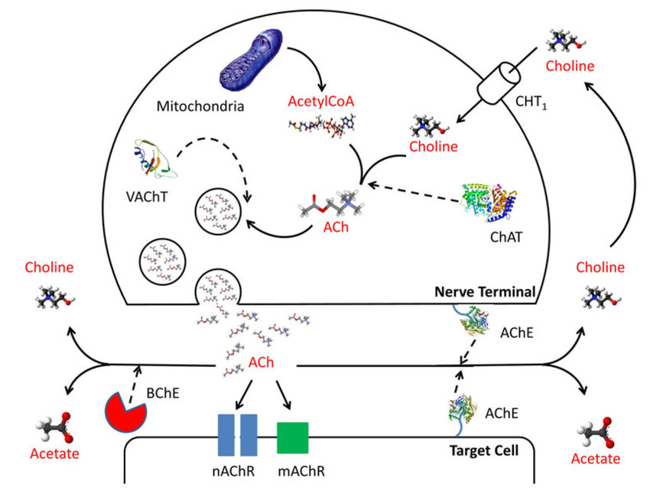
DIAGRAM DEMONSTRATING THE-MECHANISM OF ACETYLCHOLINE SYNTHESIS RELEASE ACTIO
SYNTHESIS OF DOPAMINE
Dopamine is monoamine neurotransmitter. Dopamine is produced in the dopaminergic neurons in the ventral tegmental area of the substantia nigra, midbrain and the arcuate nucleus of the hypothalamus. In the periphery, dopamine is found in the kidney where it functions to produce renal vasodilation, diuresis, and natriuresis. Dopamine neurons are more widely distributed than those of other monamines and it is found in hypothalamus, olfactory bulb, the midbrain substantia nigra and ventral tegmental area and in the periaqueductal gray and retina.
Dopamine synthesis begins with the amino acid, phenylalanine, and proceeds sequentially through tyrosine, DOPA, and then dopamine.Tyrosine hydroxylase is the rate-limiting enzyme in this pathway. Another important enzyme is DOPA decarboxylase, which decarboxylates DOPA to form dopamine. That same enzymatic acts on both naturally occurring DOPA and L-dopa (levodopa), the Parkinson’s disease medicine. Several different processes terminate dopamine activity at the synapse. The primary one consists of dopamine reuptake into the presynaptic neuron. In another termination process, two different enzymes metabolize dopamine. Catechol-O-methyltransferase (COMT), mostly an extracellular enzyme, and monoamine oxidase (MAO), mostly an intracellular enzyme, both metabolize dopamine. Some medicines for Parkinson’s disease and other conditions defined by dopamine deficiency preserve dopamine by inhibiting these enzymes (see later). When these enzymes metabolize dopamine, the main product consists of homovanillic acid (HVA). Some studies indicate that the concentration of this metabolite in the cerebrospinal fluid (CSF) roughly corresponds to dopaminergic activity in the brain.
Dopamine is synthesized from the amino acid tyrosine, which is taken up into the brain via an active transport mechanism. Tyrosine is produced in the liver from phenylalanine through the action of phenylalanine hydroxylase. Tyrosine is then transported to dopamine containing neurons where a series of reactions convert it to dopamine Within catecholaminergic neurons, tyrosine hydroxylase catalyzes the addition of a hydroxyl group to the meta position of tyrosine, yielding L-dopa. This rate-limiting step in catecholamine synthesis is subject to inhibition by high levels of catecholamines (endproduct inhibition). Because tyrosine hydroxylase is normally saturated with substrate, manipulation of tyrosine levels does not readily impact the rate of catecholamine synthesis. Once formed, L-dopa is rapidly converted to dopamine by dopa decarboxylase, which is located in the cytoplasm. It is now recognized that this enzyme acts not only on L-dopa but also on all naturally occurring aromatic L-amino acids, including tryptophan, and thus it is more properly termed aromatic amino acid decarboxylase.

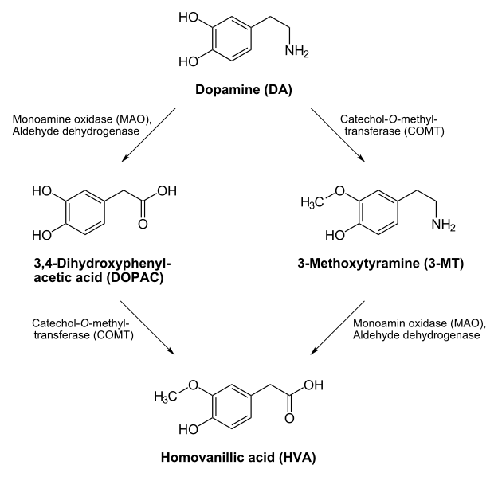
DIAGRAM SHOWING THE SYNTHESIS OF DOPAMINE

