Name: Voke Afeno- Eboh
Matric no : 17/mhs01/026
Dept: Anatomy
Level: 300
Course title : biochemistry
Question
- Describe in details the synthesis of two named neurotransmitters

Neurotransmitters:
A Neurotransmitter is a chemical substance which is released at the end of a nerve fibre by the arrival of a nerve impulse and, by diffusing across the synapse or junction, affects the transfer of the impulse to another nerve fibre, a muscle fibre, or some other structure.
Neurotransmitters include:
- Acetylcholine,
- Dopamine,
- Gamma-aminobutyric acid ( GABA ),
- Glutamate,
- Histamine,
- Norepinephrine, and
- Serotonin.
SYNTHESIS OF NEUROTRANSMITTERS
The synthesis of neurotransmitters occurs within the synaptic cleft. The enzymes needed for transmitter synthesis are synthesized in the neuronal cell body and transported to the nerve terminal cytoplasm at 0.5-5 millimeters a day by a mechanism called slow atonal transport . The precursor molecules used by these synthetic enzymes are usually taken into the nerve terminal by transporter proteins found in the plasma membrane of the terminal. The enzymes generates a cytoplasmic pool of neurotransmitter that must then be loaded into synaptic vesicles by transport proteins in the vesicular membrane. For some small molecule neurotransmitters, the final synthetic steps actually occur inside the synaptic vesicles.

MAJOR NEUROTRANSMITTERS:
- Amino acids
- Gasotransmitters
- Monoamines.

MONOAMINES :
Monoamine neurotransmitters are neurotransmitters and neuromodulators that contain one amino group connected to an aromatic ring by a two-carbon chain. Monoamines refers to particular neurotransmitters such as ; Dopamine, noradrenaline and serotonin. These neurotransmitters are involved in mediating a wide range of physiological and homeostatic functions, which vary with the part of the brain being examined.
We’ll be focusing on the synthesis of DOPAMINE and SEROTONIN.

- SYNTHESIS OF DOPAMINE:
Dopamine is synthesized from the amino acid tyrosine; the majority of circulating tyrosine originates from dietary sources, but small amounts are derived from hydroxylation of phenylalanine by the liver enzyme phenylalanine hydroxylase.
Blood-borne tyrosine is taken up into the brain by a low-affinity amino acid transport system and subsequently from brain extra cellular fluid into dopaminergic neurons by high and low affinity amino acid transporters.
Tyrosine is converted to dopamine by the enzyme tyrosine hydroxylase (TH) and 1-amino acid decarboxylase (AADC) also called dihydroxyphenylalanine (DOPA) decarboxylase (DDC).
TH is the rate-limiting step in their bio synthetic pathway; the TH gene is localized to chromosome 11p in humans and encodes a single form of TH that can be alternatively spliced. The mRNA expression of the TH is abundant throughout the human mesencephalon.
The mature enzyme is a soluble cytology protein composed of four subunits of approximately 60 kDa each.
Within catecholaminergic neurons, tyrosine hydroxylase catalyze the addition of a hydroxyl group to the meta position of tyrosine, yielding L-dopa. This rate -limiting step in nthesis is subject to inhibition by high levels of catecholamines. Because tyrosine hydroxylase is normally saturated with substrate, manipulation of tyrosine levels does not readily impact the rate of catecholamine synthesis. Once formed, L-dopa is rapidly converted to dopamine by dopa decarboxylase, which is located in the cytoplasm . It is now recognized that this enzyme acts not only on L-dopa but also on all naturally occurring aromatic L-amino acids, including tryptophan and thus it is more properly termed aromatic amino acid decarboxylase.

STORAGE AND EXOCYTOSIS :
In dopaminergic neurons, the neurotransmitter is transported from the cytoplasm to specialized storage vesicles at extremely high concentrations, 0.5-0.6m. Which is near its limit of solubility. Here the amine is concentrated to approximately at a 100- to 1000- times higher than the level in the cytosol.
It should be noted that dopamine can be synthesized and released from dendrites, in addition to terminal regions; however, in dendrites dopamine appears to be stored both in classical vesicles and in smooth endoplasmic reticulum.
Dopamine is translocated from the cytoplasm into the vesicles by the vesicular monoamine transporter (VMAT)
Dopamine is inactivated by :
- Reputake via the dopamine transporter
- Metabolism
- Monoamine oxidase (MAO)
- Catechol-O-methyl transferase (COMT)

REUPTAKE :
Reuptake of dopamine is mediated by two classes of transporters :
- Dopamine transporter (DAT) : which transports dopamine from the extracellular to the intracellular space .
- VMAT (Vesicular monoamine transporter ) : which reloads dopamine into the
- vesicles .
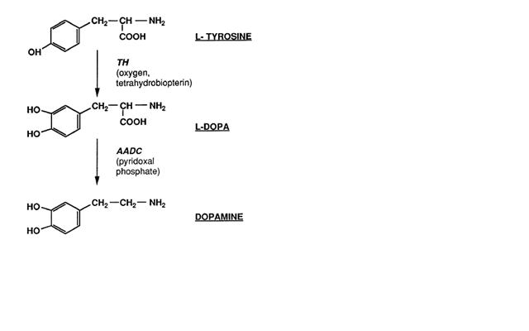

Synthesis of Histamine:
Histamine is an organic nitrogenous compound involved in local immune responses, as well as regulating physiological function in the gut and acting as a neurotransmitter for the brain, spinal cord, and uterus. Histamine is involved in the inflammatory response and has a central role as a mediator of itching
Histamine is derived from the decarboxylation of the amino acid histidine, a reaction catalyzed by the enzyme L-histidine decarboxylase. It is a hydrophilic vasoactive amine.
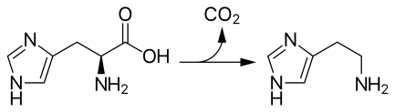
Conversion of histidine to histamine by histidine decarboxylase

Once formed, histamine is either stored or rapidly inactivated by its primary degradative enzymes, histamine-N-methyltransferase or diamine oxidase. In the central nervous system, histamine released into the synapses is primarily broken down by histamine-N-methyltransferase, while in other tissues both enzymes may play a role. Several other enzymes, including MAO-B and ALDH2, further process the immediate metabolites of histamine for excretion or recycling.
Bacteria also are capable of producing histamine using histidine decarboxylase enzymes unrelated to those found in animals. A non-infectious form of foodborne disease, scombroid poisoning, is due to histamine production by bacteria in spoiled food, particularly fish. Fermented foods and beverages naturally contain small quantities of histamine due to a similar conversion performed by fermenting bacteria or yeasts. Sake contains histamine in the 20–40 mg/L range; wines contain it in the 2–10 mg/L range.
