NAME: AFOLABI AJIBOLA ADUKE
MATRIC NO: 17/MHS03/003
DEPARTMENT : ANATOMY
COLLEGE: MEDICINE AND HEALTH SCIENCES
LEVEL : 300
COURSE TITLE : CELLULAR BIOCHEMISTRY
COURSE CODE :BCH 308
ASSIGNMENT TITLE : NEUROCHEMISTRY
QUESTION
- Describe in details the synthesis of two named neurotransmitters

SYNTHESIS OF NEUROTRANSMITTERS

The synthesis of neurotransmitters occurs within the synaptic cleft. The enzymes needed for transmitter synthesis are synthesized in the neuronal cell body and transported to the nerve terminal cytoplasm at 0.5-5 millimeters a day by a mechanism called slow atonal transport . The precursor molecules used by these synthetic enzymes are usually taken into the nerve terminal by transporter proteins found in the plasma membrane of the terminal. The enzymes generates a cytoplasmic pool of neurotransmitter that must then be loaded into synaptic vesicles by transport proteins in the vesicular membrane. For some small molecule neurotransmitters, the final synthetic steps actually occur inside the synaptic vesicles.

MAJOR NEUROTRANSMITTERS:
- Amino acids
- Gasotransmitters
- Monoamines

MONOAMINES
Monoamine neurotransmitters are neurotransmitters and neuromodulators that contain one amino group connected to an aromatic ring by a two-carbon chain (such as -CH₂-CH₂-). Examples are dopamine, serotonin and epinephrine.
SYNTHESIS OF SEROTONIN
Serotonin (5-hydroxytryptamine) is principally found stored in three main cell types
- i) serotonergic neurons in the CNS and in the intestinal myenteric plexus
ii) enterochromaffin cells in the mucosa of the gastrointestinal tract, and
iii) in blood platelets.
Serotonergic neurons and enterochromaffin cells can synthesize serotonin from its precursor amino acid L-tryptophan, whereas platelets rely upon uptake of serotonin for their stores. Likewise, serotonergic neurons also have the capacity for amine uptake via serotonin transporters. Serotonin is also synthesized in the pineal gland as a precursor for the subsequent enzymatic formation of the pineal hormone melatonin (N-acetyl-5-methoxytryptamine).
Serotonin is synthesized from the amino acid L-tryptophan via a short metabolic pathway that involves two major enzymes. These enzymes are:

- Tryptophan hydroxylase (TPH)
- Amino acid decarboxylase
The reaction in this pathway that is mediated by tryptophan hydroxylase is the rate limiting step, meaning that if this enzyme is blocked, the synthesis of serotonin would be stopped. Tryptophan hydroxylase exists in two forms - TPH1 and TPH2. While TPH1 is found in several tissues, TPH2 is specifically found in the nerves of the brain .

A serotonin transporter protein called SERT or 5HTT is responsible for carrying serotonin from the synaptic cleft to its target nerve. This transporter acts as a regulator of serotonin levels and mutations in the 5HTT gene have been shown to disrupt serotonin uptake. Serotonin regulates many important bodily functions ranging from sleep, mood, appetite and eating habits as well as influencing anxiety levels, suicidal tendencies, and our ability to learn and memorize things.

The 5-HTT protein is an important target of many antidepressant therapies. There are two forms of 5-HTT genes, the long form and the short form. Studies have shown that people with two long forms of the 5- HTT genes are less likely to suffer from depression compared with people who have one short and one long copy of the gene or two short copies.

While serotonin in its primary form cannot reach the brain since it cannot cross the blood–brain barrier, the serotonin precursors tryptophan and its metabolite 5-hydroxytryptophan (5-HTP) do cross this barrier and reach the brain. These agents can be taken as dietary supplements to increase levels of serotonin in the brain.

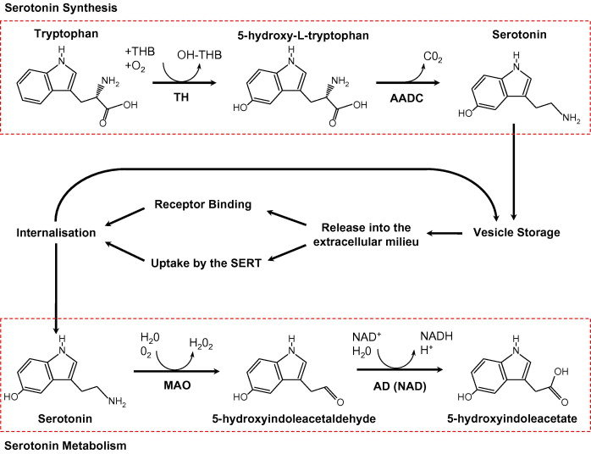

SYNTHESIS OF DOPAMINE
Dopamine is synthesized from the amino acid tyrosine; the majority of circulating tyrosine originates from dietary sources, but small amounts are derived from hydroxylation of phenylalanine by the liver enzyme phenylalanine hydroxylase .
Blood-borne tyrosine is taken up into the brain by a low-affinity amino acid transport system and subsequently from brain extracellular fluid into dopaminergic neurons by high- and low-affinity amino acid transporters.
Tyrosine is converted to dopamine by the enzymes tyrosine hydroxylase (TH) and l-amino acid decarboxylase (AADC) also called dihydroxyphenylalanine (DOPA) decarboxylase (DDC). The aromatic amino acid hydroxylases 2000
TH is the rate-limiting step in their biosynthetic pathway; the TH gene is localized to chromosome 11p in humans and encodes a single form of TH that can be alternatively spliced. The mRNA expression of the TH is abundant throughout the human mesencephalon.
The mature enzyme is a soluble cytosolic protein composed of four subunits of approximately 60 kDa each.
TH activity is the most critical factor that controls dopamine synthesis, and considerable efforts have been devoted to understanding activation/inactivation of this enzyme.
The following is the complete reaction:
L-tyrosine + THFA + O2 + Fe2+ → L-dopa + DHFA + H2O + Fe2+
L-dopa + pyridoxal phosphate → dopamine + pyridoxal phosphate + CO2
So for L-dopa formation, L-tyrosine, THFA (tetrahydrofolic acid), and ferrous iron are essential and for dopamine biosynthesis from L-dopa, pyridoxal phosphate is essential.
The activity of the enzyme rises and falls according to how much pyridoxal phosphate there is. Besides two enzymes being required for the formation of dopamine from L-tyrosine (L-tyrosine >>> L-dopa >>> dopamine), three coenzymes are also required. They are : THFA (for L-tyrosine to L-dopa), pyridoxal phosphate (for L-dopa to dopamine), and NADH (for the formation of THFA and Pyridoxal phosphate). The cofactor tetrahydrobiopterin (BH4) donates the hydrogen atom needed for hydroxylation of tyrosine to DOPA.
Because pterin also serves as a cofactor for other monoxygenases as well as nitric oxide synthase, its availability is a determinino factor in the control of TH activity.
