Name: Michael Effiong Ekpo
Reg No: 18/ENG04/079
Dept: Elect/Elect

Question 1: Discuss the effects of harmonics on synchronous machines (hint” identify the harmonics, state how they affect synchronous motors; state how they affect synchronous generators)
Answer:
Armature Reaction in Synchronous Generator", there is distortion of Resultant Flux when Resistive Load is connected to Synchronous Generator. Flux is also distorted due to other reasons e.g. Slot Harmonics. Distortion in Flux distorts EMF induced and creates Harmonics in EMF Wave.
Harmonics mean EMF has higher Frequency components. Harmonics increase Losses in Transmission Line due to Skin Effect and Iron Loss in Transformers connected to Generator. 5_{th} Harmonic produces retarding Torque in Induction Motor. 7_{th} Harmonics may produce Crawling in Induction Motor i.e. Induction Motor may start running at 1/7_{th} Speed.
Causes of Distortion In EMF induced
Distortion in EMF generated is due to distortion in Flux. There are various causes of Distortion in Flux and some are given below.

Armature Reaction due to Resistive Load
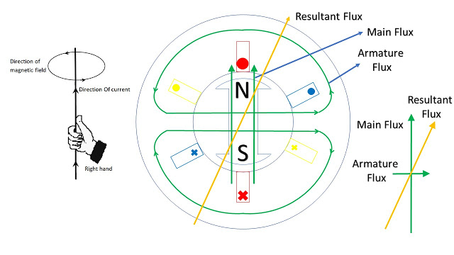
Direction of Flux obtained from Right Hand Thumb Rule

When a Resistive Load is connected to Generator, Armature Current flows which produces Armature Flux. In case of Resistive Load, Armature Flux is at 90⁰ to the Main Flux as shown above.

Resultant Flux increases on Right side of North Pole and decreases on Left side. At South Pole, Armature Flux increases on Left side and decreases on Right side. Resultant Flux is distorted as shown below in developed view.

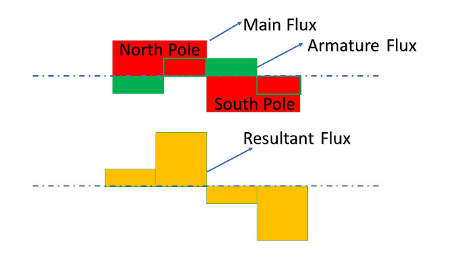
Main Flux and Armature Flux combine to form Resultant Flux
Main Flux and Armature Flux is shown as square wave for ease of understanding. These are actually Sine Waves as shown below.
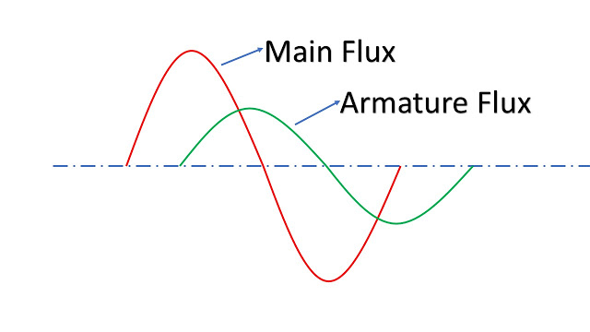
Slot Harmonics
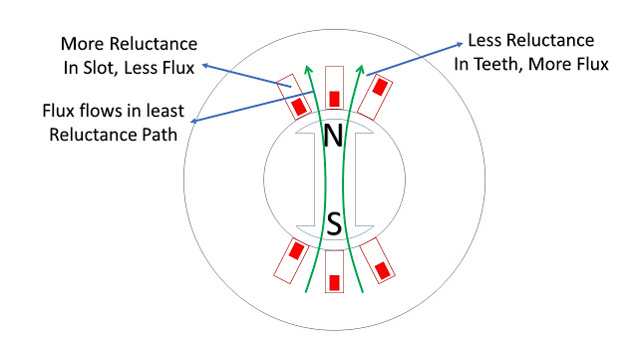
Effect of Slots on Flux
There are number of Slots around the periphery of Stator to accommodate Conductors.
In the slot portion, there is more Reluctance due to Air and hence less Flux. In the teeth portion, there is less Reluctance due to presence of Silicon Iron and hence more Flux. Silicon Iron offers more permeability to Flux than Air. This causes distortion of Flux as shown below. This is called Slot Harmonics.
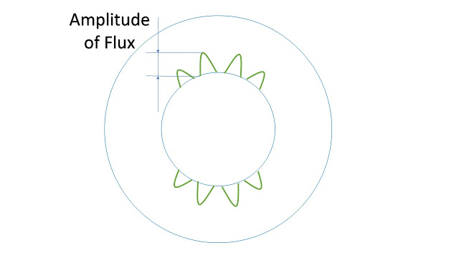
Flux is more in teeth than in Slot

Distortion of Flux due to non Linear Load
Earlier Load Current used to be Linear i.e. Sinusoidal. Resistive, Inductive and Capacitive Loads were all Linear Loads.
Now a days, Power Electronic Devices have come. Variable Frequency AC Drives are replacing DC Motor. In HVDC, Converter is used at transmission end to convert AC into DC and Invertor is used at receiving end to convert DC into AC. These devices use Thyristors. Current flows in Thyristors after it is triggered and thus there is non Linear Load as shown below. This distorts Flux.
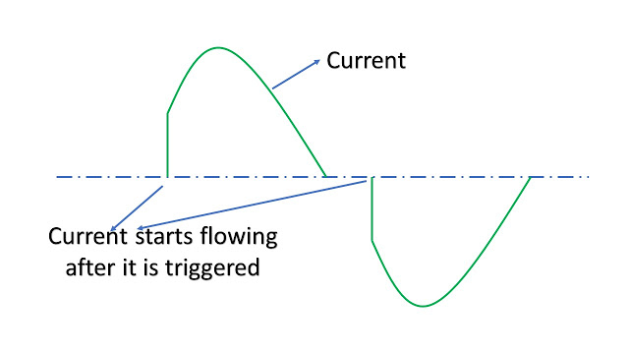
Non Linear Load

Fourier Series

As seen above, Flux is distorted due to various reasons. Since EMF induced is due to rotating Flux, EMF induced is also distorted. Typical EMF Wave is shown below. This is called Complex Wave. It depends on type of Load and amount of Load connected to Generator.

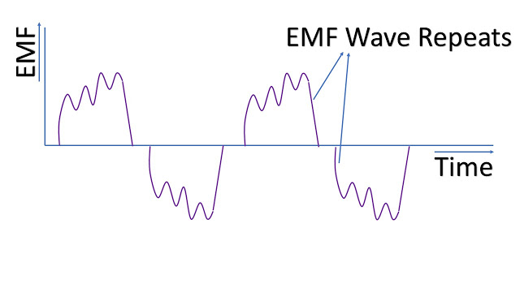
EMF Wave is non Sinusoidal but Periodic
Any non Sinusoidal Periodic Wave can be expressed as sum of Fundamental Frequency and Harmonics by Fourier Transform.
EMF = a₁sin(ωt) + a₂sin(2ωt) + a₃sin(3ωt) and so on.
First term is called Fundamental Component or 1_{st} Harmonic having Amplitude a₁ and Frequency 50 Hz.
Second term is called 2_{nd} Harmonic having Amplitude a₂ and Frequency 100 Hz.
Third term is called 3_{rd} Harmonic having Amplitude a₃ and Frequency 150 Hz and so on.
i.e. Frequency of Harmonics is an integral multiple of Fundamental Frequency.
Fundamental Wave and Harmonics are shown below.
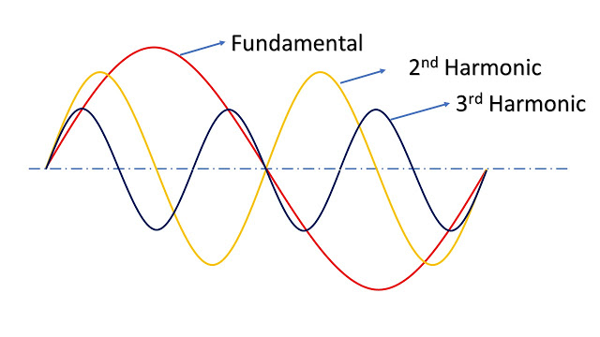
Fundamental and Harmonics

Even Harmonics are absent

First consider Fundamental Frequency. EMF induced in Top Conductor is outward and Bottom Conductor is inward. EMF induced in both Conductors aid each other.

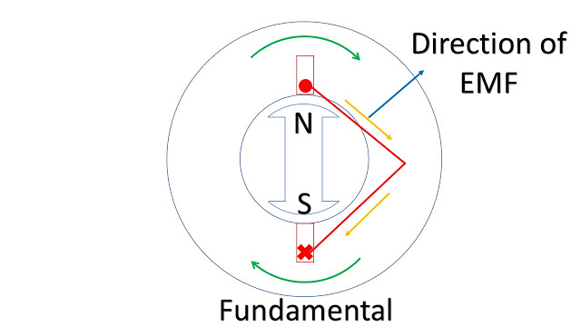
Fundamental EMF aid each other
In case of 2_{nd} Harmonic, effectively 4 Poles are created and superimposed on Main Poles as shown below. 4 Poles complete 2 Electrical Cycles by the time 2 Poles complete one Electrical cycle.
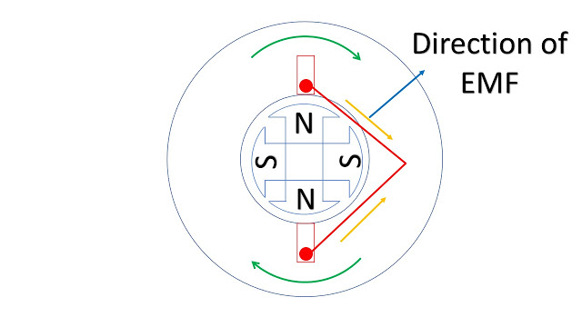
2nd Harmonic EMF oppose each other

EMF induced in both Top and Bottom Conductor is outward by Fleming's Right Hand Rule. These EMF cancel each other. This is applicable for all even Harmonics.
Thus even Harmonics 2nd, 4th, 6th etc are absent.

In Star Connected Winding Triplen Harmonics are absent
Triplen Harmonic means Harmonics having multiple of 3 i.e. 3_{rd}, 6_{th,} 9_{th}, 12_{th} Harmonics etc. High Voltage Synchronous Machine is Star Connected to reduce Phase Voltage. V_{Ph} = 1/∛ V_{L}
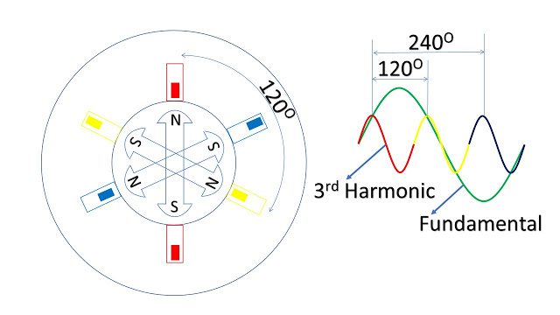
3rd Harmonic has same EMF in all 3 Phases
3_{rd H}armonic is equivalent to saying that 6 Poles are rotating at 3000 RPM.
As seen above, Voltage induced in all 3 Phases is same in 3_{rd} Harmonic. Line Voltage i.e. difference between R Phase and Y Phase and Y Phase and B Phase is zero. Thus 3_{rd} Harmonic is absent. This is applicable for all Triple Harmonics.
Remaining Harmonics
Since even and triple Harmonics are absent, we need to concentrate on following Harmonics.
5_{th}, 7_{th}, 11_{th}, 13_{th} etc.
11_{th}, 13_{th} and higher Harmonics are very less and may be ignored.
Effect of Harmonics
Since Harmonic Voltage means Voltage at higher Frequency, it has following effects
Skin Effect
In case of AC Current, Current flows in Periphery or Skin of Transmission Lines due to Self-Inductance in Conductors. At higher Frequency Skin Effect increases. Due to Skin Effect, Effective Resistance increases. This increases Loss and increase in Temperature.
Increase in Iron Loss in Transformers connected to Generator
Iron Loss consists of Hysteresis Loss and Eddy Current Loss. Hysteresis Loss ∝ f and Eddy Current Loss ∝ f². Thus Iron Loss increases resulting in Higher Loss in Core of Transformer and Temperature is increased.
Retarding Torque in Induction Motor
5_{th} Harmonic produces flux rotating in opposite direction to Main Flux in Induction Motor. This Flux produces Retarding Torque in Induction Motor.
Crawling in Induction Motor
7_{th} Harmonic creates dip in Torque Speed Curve of Induction Motor at 1/7_{th} the Synchronous Speed. This may result in Induction Motor running at 1/7_{th} the Synchronous Speed. This is called Crawling.
Methods of reducing Harmonics in Synchronous Generator
There are various methods of reducing Harmonics but each method has got limitation as shown below.
Using Salient Pole Rotor
In Salient Pole Rotor, Flux produced is more Sinusoidal as compared to Cylindrical Rotor. However, in large Turbo Generator, outside Diameter of Rotor is large and it runs at 3000 RPM. Salient Poles are unable to withstand large Centrifugal Forces. Hence Cylindrical Rotor is used. It is a single Forging in which Slots are cut to accommodate Rotor Winding.
Large Air Gap between Stator and Rotor
Reluctance increases with large air gap. Ripple due to slot Harmonics decreases. But large air gap requires more MMF for maintaining Flux. Current in Rotor increases. This may lead to sparking between Brushes and Slip Rings. There will be higher temperature in Rotor.
Skewing in Slots of Stator Core by one Slot Pitch
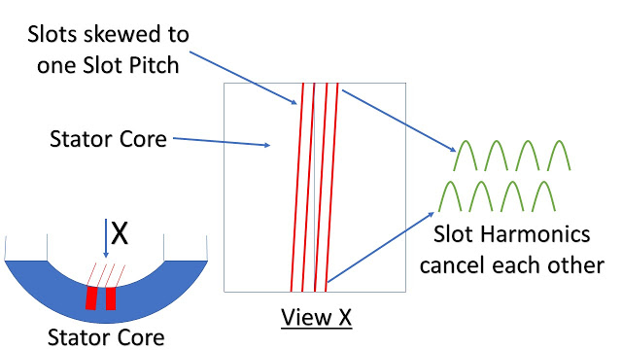
Stator Slots skewed to one Slot Pitch
Skewing means that at the other end of Stator Core, in place of Slot, Teeth will come and in place of Teeth, Slot will come. Slot Harmonics at both ends cancel each other. However manufacturing of Stamping used in Stator Core becomes very cumbersome.
Distribution of Winding in Stator
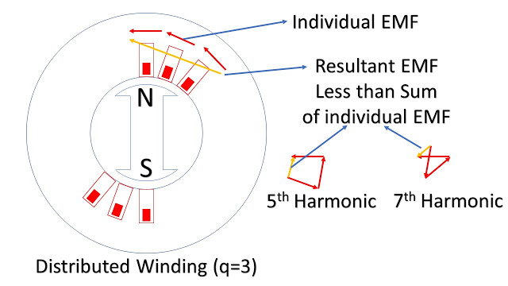
Distributed Winding reduces Harmonics

In place of concentrated Winding, distributed Winding is used.

EMF induced in Phase is given by 4.44K_{d}K_{p}fnØ
K_{d} is Distribution Factor
K_{p} is Pitch Factor
In case of Number of Slots / Pole / Phase (q) = 3
Distribution Factor for Fundamental Frequency is 0.96
For 5th Harmonics, it is 0.22
For 7th Harmonics, it is 0.18
Hence in Distributed Winding, Harmonics are reduced though EMF of Fundamental Frequency is also reduced slightly. Distributed Winding also helps in equal distribution of Temperature around Stator Core. Stator Core is fully utilized.
Please note that Phasors of 5_{th} and 7_{th} Harmonics are running at 5 times and 7 times faster than Fundamental.
Short Pitch Coil
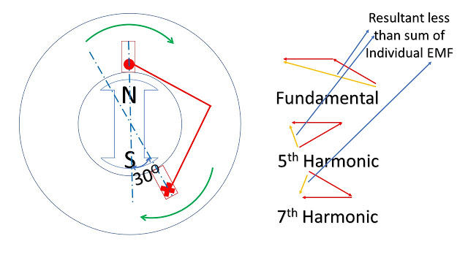
Short Pitch Winding reduces Harmonics

By Short Pitch Coil, Harmonics are reduced.
30⁰ is most suitable for reducing 5_{th} and 7_{th} Harmonics.
At 30º Pitch, Pitch Factor
for Fundamental Frequency is 0.96
for 5th Harmonics, it is 0.26
for 7th Harmonics, it is also 0.26
Pitch is also decided by length of overhang of winding. Overhang is less with less Pitch.
Magnetic Wedge
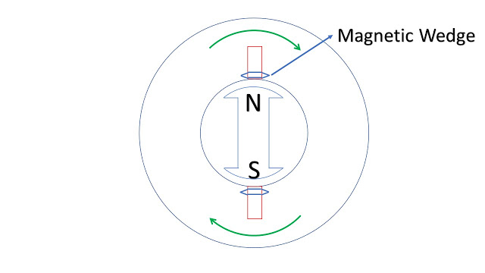
Magnetic Wedge reduces Reluctance

By use of Magnetic Wedge, Reluctance in Slots reduce and more Flux will pass through Slots. This reduces Slot Harmonics.
Harmonic Filter
5_{th} and 7_{th} Harmonics have major contribution. 11_{th} and 13_{th} Harmonics may also come though there amplitude is less. At the Load end Harmonic Analyser are used to find out Harmonics and Harmonic Filters are installed to reduce these Harmonics.

1.(b) Generators and motors are adversely affected by harmonics in the networks to which they are connected. Typical effects are:
Increased heating due to iron and copper losses at the harmonic frequencies
Higher audible noise emission as compared with sinusoidal excitation
Harmonic currents in the rotor
The harmonic currents noted above are caused by harmonics in the stator winding, which will produce harmonic currents in the rotor, e.g., 5th- and 7th-order stator harmonics will produce 6th-order rotor harmonics, while 11th- and 13th-order stator harmonics will produce 12th-order rotor harmonics. These rotor harmonic currents will result in increased rotor heating and pulsating or reduced torque.
Generators can also produce harmonics and, in particular, tripled harmonics that can circulate through adjacent Wye-grounded transformers when generators are directly connected to a load bus. The use of the Delta-connected generator transformers can control this.
Question 2: Justify technically why the stator windings of large generators are star connected
Answer:
Lesser stress on insulation and Copper saving: Voltage per phase is less for a given line voltage which reduces insulation requirement and this also reduces the number of turns hence copper is also saved.
Easy protection: Neutral grounding is necessary to allow zero sequence currents to flow to the ground in case of a fault.
Elimination of harmonics: Star connection facilitates a neutral connection which is instrumental in eliminating triple harmonics.
No circulating currents: In star connection we don’t have circulating parasitic current on like in delta which leads to heating loss.
Question 3: Why is it that the armature for large machines is stationary?
Answer:
It is easier to insulate stationary winding for high voltages for which the alternators are usually designed. It is because they are not subjected to centrifugal forces and also extra space is available due to the stationary arrangement of the armature.
The stationary 3-phase armature can be directly connected to load without going through large, unreliable slip rings and brushes.
Only two slip rings are required for d.c. supply to the field winding on the rotor. Since the exciting current is small, the slip rings and brush gear required are of light construction.
Due to the simple and robust construction of the rotor, the higher speed of rotating DC field is possible. This increases the output obtainable from a machine of given dimensions.

Question 4: Why do brushless generators undergo less maintenance?
Answer: Brushless generators are better suited for more long-term, constant usage because there are no brushes to replace or fix, and have fewer internal parts that can be damaged. You may be asking yourself, “How do they move the electrical current then?” A brushless alternator has two sets of rotors that spin together to generate and transfer the electrical current. But how does it accomplish moving the current without brushes? A brushless alternator has a second, smaller generator on the end of the equipment instead of brushes, which it uses to transfer any electrical current. This is an immediate advantage over a brushed alternator because there are no brushes to replace or repair, saving you long term money and time. A disadvantage of a brushless alternator, however, is the much higher initial cost, as opposed to a brushed alternator. This is mostly because of the higher amount of materials used in a brushless alternator. Brushless alternators, however, are also more suited to be your primary alternator/generator and are more capable of long-term use. In the long run, you will save money by buying a brushless alternator, but keep in mind that it’s an investment because of the higher cost when compared to a brushed alternator.
Whether you’re looking for a quick and cheap short-term brushed alternator, or a more advanced and expensive long-term solution brushless alternator, always keep in mind how much power you need to generate as well as your budget. You shouldn’t feel pressured into spending more money just for a long-term alternator, but the worst-case scenario is underestimating just how much power your job requires. Use our power calculator to determine your power needs, or contact a trained Absolute Generators specialist to determine if a brushed or a brushless generator is right for your operation.

