OMOJOLA Temiloluwa Oluwatomisin
17/ENG04/058
Electrical/Electronics Engineering

Assignment on Synchronous Machines
QUESTION 1
Harmonic currents are caused by non-linear loads connected to the distribution system. A load is said to be non-linear when the current it draws does not have the same waveform as the supply voltage. The flow of harmonic currents through system impedances in turn creates voltage harmonics, which distort the supply voltage.
Effect on Motors
There is an increasing use of variable frequency drives (VFDs) that power electric motors. The voltages and currents emanating from a VFD that goes to a motor are rich in harmonic frequency components. Voltage supplied to a motor sets up magnetic fields in the core, which create iron losses in the magnetic frame of the motor. Hysteresis and eddy current losses are part of iron losses that are produced in the core due to the alternating magnetic field. Hysteresis losses are proportional to frequency, and eddy current losses vary as the square of the frequency. Therefore, higher frequency voltage components produce additional losses in the core of AC motors, which in turn, increase the operating temperature of the core and the windings surrounding in the core. Application of non-sinusoidal voltages to motors results in harmonic current circulation in the windings of motors. The net rms current is
I_{rms} = √[(I₁)² + (I₂)² + (I₃)² + …], where the subscripts 1, 2, 3, etc. represent the different harmonic currents. The I²R losses in the motor windings vary as the square of the rms current. Due to skin effect, actual losses would be slightly higher than calculated values. Stray motor losses, which include winding eddy current losses, high frequency rotor and stator surface losses, and tooth pulsation losses, also increase due to harmonic voltages and currents.
The phenomenon of torsional oscillation of the motor shaft due to harmonics is not clearly understood, and this condition is often disregarded by plant personnel. Torque in AC motors is produced by the interaction between the air gap magnetic field and the rotor-induced currents. When a motor is supplied non-sinusoidal voltages and currents, the air gap magnetic fields and the rotor currents contain harmonic frequency components.
The harmonics are grouped into positive (+), negative (-) and zero (0) sequence components. Positive sequence harmonics (harmonic numbers 1, 4, 7, 10, 13, etc.) produce magnetic fields and currents rotating in the same direction as the fundamental frequency harmonic. Negative sequence harmonics (harmonic numbers 2, 5, 8, 11, 14, etc.) develop magnetic fields and currents that rotate in a direction opposite to the positive frequency set. Zero sequence harmonics (harmonic numbers 3, 9, 15, 21, etc.) do not develop usable torque, but produce additional losses in the machine. The interaction between the positive and negative sequence magnetic fields and currents produces torsional oscillations of the motor shaft. These oscillations result in shaft vibrations. If the frequency of oscillations coincides with the natural mechanical frequency of the shaft, the vibrations are amplified and severe damage to the motor shaft may occur. It is important that for large VFD motor installations, harmonic analyses be performed to determine the levels of harmonic distortions and assess their impact on the motor.
Effect on Generators
The flux density distribution around the air gap in all well-designed alternators symmetrical with respect to the abscissa and also to polar axes.Thus it can be expressed with the help of a Fourier series which do not contain any even harmonics.
So flux density at an angle θ from the interpolar axis is given by,
B = Bm1 sin θ + Bm3 sin 3θ +……….. + Bmx sin xθ
where x = Order of the harmonic component which is odd
Bm1 = Amplitude of fundamental component of flux density
Bm3 = Amplitude of 3rd harmonic component of flux density
Bmx = Amplitude of Xth (odd) harmonic component of flux density
The EMF generated in a conductor on the armature of a rotating machine is given by
ec = B.l.v
Substituting value of B,
ec = [Bm1 sin θ + Bm3 sin 3θ +……….. + Bmx sin xθ].l.v
l = Active length of conductor in metre
d = Diameter of the armature at the air gap
v = Linear velocity = π d ns
where ns = Synchronous speed in r.p.s.
Now NS = 120f/P
ns = 120f/60P = 2f/P
v = π d 2f/P
Substituting in the expression for ec ,
ec = [Bm1 sin θ + Bm3 sin 3θ +……….. + Bmx sin xθ].l.(2πdf/P)
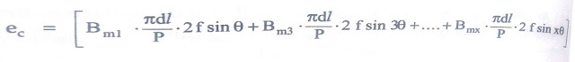
Area of each fundamental pole,
A1 = πdl/P
ec = [Bm1 A1 2f sin θ + Bm3 A1 2f sin 3θ +……….. + Bmx A1 2f sin xθ]
Area of xth harmonic pole, Ax = πdl/xP = A1/x
This is because there are xP poles for the xth order harmonic.
ec = 2f [Bm1 A1 sin θ + Bm3 3A3 sin 3θ +……….. + Bmx xAx sin xθ]
Bm1 A1 = Φ1m = Maximum value of fundamental flux per pole
Φ1= (2/π)Φ1m = Average value of fundamental flux per pole
Similarly, the average value of xth harmonic flux per pole can be obtained as,
Φx = (2/π)Ax Bmx
Effect of Harmonic Components on EMF of Synchronous Generator
Substituting the values of flux in ec we get the expression for e.m.f. induced per conductor as
ec = πf (Φ1 sin θ + 3Φ3 sin 3θ +……….. + xΦx sin xθ)
Instantaneous value of fundamental frequency EMF generated in a conductor is,
ec1 = πfΦ1 sin θ V
Hence the R.M.S. value of fundamental frequency EMF generated in a conductor is,
ec1 = πfΦ1/√2 = 2.22 fΦ1
Hence RMS value of xth harmonic frequency emf generated in a conductor is,
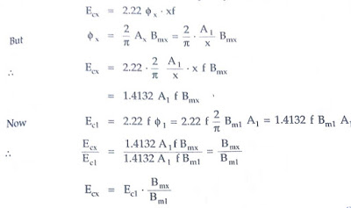
It can be observed that the magnitude of harmonic e.m.f.s is directly proportional to their corresponding flux densities.
The RMS value of resultant EMF of a conductor is,
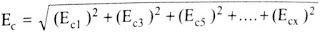
- Effect of Harmonic Components on Pitch Factor in Synchronous Generator:
We know that,
α = Angle of the short pitch for fundamental flux wave then it changes for the various harmonic component of flux as,
3α = For 3rd harmonic component
5α = For 5th harmonic component
xα = For xth harmonic component
Hence the pitch factor is expressed as,
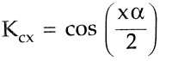
x = Order of the harmonic component
- Effect of Harmonic Components on Distribution Factor in Alternators:
Similar to the pitch factor, the distribution factor is also different for various halt components.
The general expression to obtain distribution factor is,
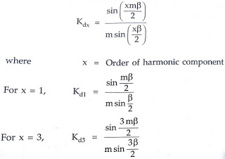
- Total EMF Generated due to Harmonics in synchronous Generator:
Consider the windings to short pitch and distributed, the e.m.f. of a fundamental frequency is given by,
E1ph = 4.44 Kc1 Kd1 Φ1 f Tph V
where Tph = Turns per phase series
Φ1 = Fundamental flux component
While the phase e.m.f. of Xth order harmonic component of frequency is given by,
Exph = 4.44 Kcx Kdx Φx (xf) Tph V
The total phase EMF is given by,
Line EMF: For star connected, the line or terminal induced EMF is √3 times the total phase EMF.But it should be noted that with star connection, the 3rd harmonic voltages do not appear across line terminals though present in phase voltage.
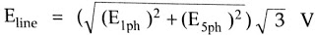
Key Point: In delta connection also, 3rd,9th,15th….. harmonic voltages do not appear at the line terminals.
Taking the ratio of fundamental frequency EMF and Xth order harmonic frequency EMF we can write,
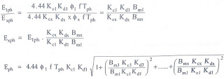
From the ratio in above equation, we can write
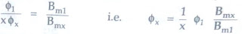
Thus if the third harmonic is given to be 10% of fundamental
Φ3 = 1/3*(10% of Φ1) = 0.0333Φ1

QUESTION 2
The armature winding of the alternator is generally connected in star because of two main reasons:
- The phase voltage is 0.577 times the line voltage which results in lesser voltage stress and hence lesser insulation cost.
- The stator winding of an alternator is generally connected in star so as to obtain neutral which is properly earthed at the generating station. At the sub-stations, the neutral point of the star-connected winding of transformer is also earthed. Thus neutral completes its path through the earth.

QUESTION 3
The armature winding is stationary because of some advantages listed below:
- It is easier to collect current through brushes from stationary armature in case of generators.
- When armature winding is stationary and field winding rotates we get more output as field winding is quite lighter than armature winding.
- There is less chances of sparking in stationary arm winding comparatively to stationary rotor.
- Commutation is a problem in rotatory armature.
- As armature winding is stationary the natural cooling is more effective as rotating winding is field winding which is comparatively light so chances of wear and tear is less.

QUESTION 4
They undergo less maintenance mainly because there’s no brush. As a result of this there’s low noise, low interference, low friction causing the brushless generator to be an almost maintenance-free motor.

