NAME: MOTAJO OLAKUNLE OLUWATOSIN
MATRIC NO: 17/MHS01/190
DEPARTMENT: MEDICINE AND SURGERY
COURSE: GROSS ANATOMY OF HEAD AND NECK
COURSE CODE: ANA 301

1) Discuss the anatomy of the tongue and comment on its applied anatomy
ANSWER:
Definition:
The tongue is a muscular organ partly located in the oral cavity and partly in the oropharynx. The tongue facilitates perception of gustatory stimuli and also plays important roles in mastication, deglutition, taste and oral cleansing. Additionally, the tongue is an integral component of the speech pathway, as it helps with articulation.
Parts and Surfaces of the tongue:
1) The apex of the tongue: The tip or apex of the tongue is the most anterior and most mobile aspect of the organ. It rests against the incisor teeth.
2) The body of the tongue: is the anterior two-third of the tongue. The body is also mobile. 3) The root of the tongue: is referred to as the posterior third of the tongue and it rests on the floor of the mouth. It is populated by numerous lymphoid aggregates known as the lingual tonsils along with foliate papillae along the posterolateral surface.
4) The Dorsal surface of the tongue: is the posterosuperior surface, which is located both in the oral cavity and oropharynx. The dorsal surface has a V- shaped groove called the terminal groove or sulcus ( sulcus basilaris). The terminal sulcus divides the dorsum of the tongue into an anterior part in the oral cavity and a posterior part in the oropharynx. At the apex of the V-shaped groove is a small depression (the foramen cecum of the tongue), which marks the site in the embryo where the epithelium invaginates to form the thyroid gland. In some people a thyroglossal duct persists and connects the foramen cecum on the tongue with the thyroid gland in the neck. The mucous membrane over the anterior part of the dorsum of the tongue is thin and closely attached to the underlying muscle. The mucous membrane of the posterior part of the tongue is thick and freely movable.
5) The inferior surface of the tongue: The inferior surface of the tongue is covered with a thin, transparent mucous membrane through which one can see the underlying veins. A single median fold (the frenulum of the tongue) connects the inferior surface with the floor of the mouth, and overlies the lower margin of a midline sagittal septum, which internally separates the right and left sides of the tongue. On each side of the frenulum is a lingual vein, and lateral to each vein is a rough fimbriated fold.
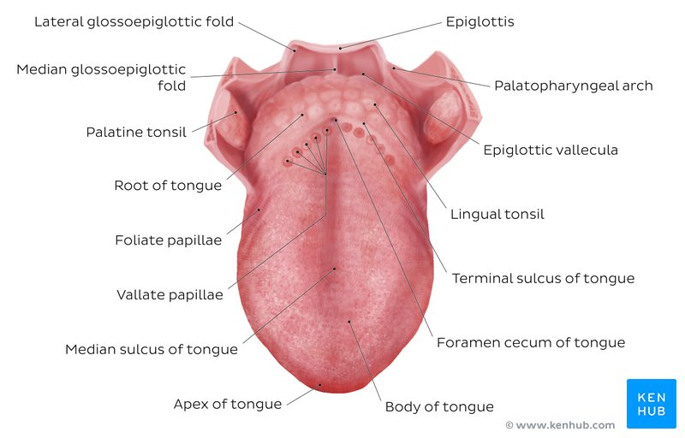
Papillae
The mucous membrane seen on the anterior part of the tongue is rough because of the presence of numerous small papillae. They are i) Vallate papillae: are the largest papillae. There are about 8 to 12 vallate papillae in a single V-shaped line immediately anterior to the terminal sulcus of the tongue.
ii) Filiform papillae: are small cone-shaped projections of the mucosa that end in one or more points. They are long and numerous and they contain afferent nerve endings that are sensitive to touch.
iii) Fungiform papillae: are rounder in shape and larger than the filiform papillae. They are scattered among the filiform papillae and tend to be concentrated along the margin and apex of the tongue.
iv) Foliate papillae: are linear folds of mucosa on the sides of the tongue near the terminal sulcus. They are poorly developed in humans.
Note: The vallate, foliate, and most of the fungiform papillae contain taste receptors in the taste buds.
Muscles of the Tongue
The tongue is essentially a mass of muscles that is mostly covered by mucous membrane. The tongue is completely divided into left and right halves by a median sagittal septum composed of connective tissue. This means that all muscles of the tongue are paired. There are intrinsic and extrinsic lingual muscles. Except for the palatoglossus, which is innervated by the vagus nerve, all muscles of the tongue are innervated by the hypoglossal nerve.
Intrinsic muscles

The intrinsic muscles of the tongue originate and insert within the substance of the tongue. They work in pairs and aid the movement of the tongue required for speech, eating and swallowing. They alter the shape of the tongue by:
i) Lengthening and shortening it.
ii) Curling and uncurling its apex and edges. iii) Flattening and rounding its surface.

The intrinsic muscles are:
a) Superior longitudinal muscle: it originates from the submucosal connective tissue at the back of the tongue and its muscle fibers pass forward and obliquely to the mucosa at the margins of the tongue. It shortens the tongue and curls apex and sides of the tongue.

b) Inferior longitudinal muscle: it originates from the root of the tongue and inserts on the apex of the tongue. It uncurls the apex of the tongue.

c) Tranverse muscle: it arises from the median septum of the tongue and inserts on the submucosal connective tissue on lateral margins of the tongue. It narrows and enlongates the tongue.
d) Vertical muscle: Arises from the submucosal connective tissue on dorsum of the tongue and attaches to the connective tissue in more ventral region of the tongue. Note: all the intrinsic and extrinsic muscles are innervated by the hypoglossal nerve except the palatoglossus supplied by the vagus nerve.
Extrinsic muscles:
Extrinsic muscles originate from structures outside the tongue and insert into the tongue. There are four major extrinsic muscles on each side, the genioglossus, hyoglossus, styloglossus, and palatoglossus. These muscles protrude, retract, depress, and elevate the tongue.
a) Genioglossus: originates from the superior mental spines and inserts to the body of hyoid (entire length of the tongue). It protrudes the tongue and depresses the center of the tongue. b) Hyoglossus: originates from the greater horn and adjacent part of the body of the hyoid bone and attaches to the lateral surface of the tongue. It depresses the tongue.
c) Styloglossus: arises from the styloid process and attaches to the lateral surface of the tongue. It elevates and retracts the tongue.
d) Palatoglossus: originates from the inferior surface of the palatine aponeurosis and it attaches to the lateral margin of the tongue. It depresses the palate and moves the palatoglossal fold toward midline. It also elevates the back of the tongue.
Vasulature of the tongue
Arterial supply: the arteries of the tongue are derived from the lingual artery, which arises from the external carotid artery. On entering the tongue, the lingual artery passes deep to the hyoglossus muscle and give rise to the:
i) The dorsal lingual arteries which supply the posterior part (root). ii) The deep lingual arteries which supply the anterior part. The deep lingual arteries communicate with each other near the apex of the tongue, while the dorsal lingual arteries are prevented from communicating by the lingual septum.
Venous drainage: The veins of the tongue are:
i) The deep lingual veins which are visible through the mucosa on the undersurface of the tongue. Although they accompany the lingual arteries in anterior parts of the tongue, they become separated from the arteries posteriorly by the hyoglossus muscles. On each side, the deep lingual vein travels with the hypoglossal nerve on the external surface of the hyoglossus muscle and passes out of the floor of the oral cavity through the aperture (oropharyngeal triangle) formed by the margins of the mylohyoid, superior constrictor, and middle constrictor muscles. It joins the internal jugular vein in the neck.
ii) The dorsal lingual vein follows the lingual artery between the hyoglossus and genioglossus muscles and, like the deep lingual vein, drains into the internal jugular vein in the neck.
iii) The sublingual veins in elderly people are often varicose (enlarged and tortuous)
Lymphatic drainage: lymph from the tongue takes four routes:
i) Lymph from the posterior third drains into the superior deep cervical lymph nodes. ii) Lymph from the medial part of the anterior two thirds drains directly to the inferior deep cervical lymph nodes. iii) Lymph from the lateral parts of the anterior two thirds drains to the submandibular lymph nodes. iv) The apex and frenulum drain to the submental lymph nodes Note: The posterior third and the medial part of the anterior two thirds drain bilaterally
Innervation of the Tongue:
Motor innervation: All muscles of the tongue, receive motor innervation from the
hypoglossal nerve (CN XII), except the palatoglossus (actually a palatine muscle supplied by the vagus nerve of the pharyngeal plexus). Some of the tongue musculature is derived from myoblast originating in occipital somites hence tongue musculature is innervated by hypoglossal nerve.
Sensory innervation:
The anterior two thirds of the tongue are supplied by: the lingual nerve (CN V₃) for general sensation and the chorda tympani, a branch of the facial nerve (CN VII) which transfers nerve fibers to the lingual nerve, for taste The posterior third of the tongue and the vallate papillae are supplied by: the lingual branch of the glossopharyngeal nerve (CN IX) for both general sensation and taste. Another contribution is made by the internal laryngeal branch of the vagus (CN X) for general sensation and taste.
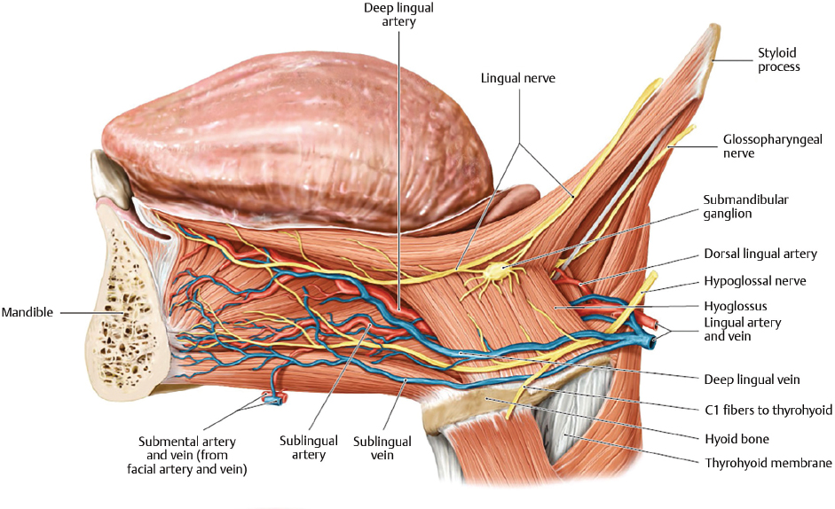
Clinical anatomy: i) Lingual carcinoma
A lingual carcinoma in the posterior part of the tongue metastasizes to the superior deep cervical lymph nodes on both sides, whereas a tumor in the anterior part usually does not metastasize to the inferior deep cervical lymph nodes until late in the disease. Because these nodes are closely related to the Internal jugular vein, metastases from the tongue may be widely distributed through the submental and submandibular regions and along the Internal jugular vein in the neck.
ii) Thyroglossal Duct Cyst
A cystic remnant of the thyroglossal duct, associated with development of the thyroid gland, may be found in the root of the tongue and it is connected to a sinus that opens at the foramen cecum. Surgical excision of the cyst may be necessary. Most thyroglossal duct cysts are in the neck, close or just inferior to the body of the hyoid bone.
2) Write an essay on the air sinuses
Answer:
The paranasal air sinuses are spaces present in the substance of bones related to the nasal cavities. Each sinus opens into the nasal cavity, and is lined by mucous membrane. There are four paranasal air sinuses which includes the ethmoidal cells, the sphenoidal, maxillary and frontal sinuses. Each is named according to the bone in which it is found.
1) Frontal sinuses: The frontal sinuses, one on each side, are variable in size and are the most superior of the sinuses. Each is triangular in shape and is in the part of the frontal bone under the forehead. The base of each frontal sinus is oriented vertically in the bone at the midline above the bridge of the nose and the apex is laterally approximately one-third of the way along the upper margin of the orbit.
Each frontal sinus drains onto the lateral wall of the middle meatus via the frontonasal duct, which penetrates the ethmoidal labyrinth and continues as the ethmoidal infundibulum at the front end of the semilunar hiatus.
The frontal sinuses are innervated by branches of the supra-orbital nerve from the ophthalmic nerve. Their blood supply is from branches of the anterior ethmoidal arteries.
2) Ethmoidal cells air sinuses: The ethmoidal cells on each side fill the ethmoidal labyrinth. Each cluster of cells is separated from the orbit by the thin orbital plate of the ethmoidal labyrinth, and from the nasal cavity by the medial wall of the ethmoidal labyrinth.
The ethmoidal cells are formed by a variable number of individual air chambers, which are divided into anterior, middle, and posterior ethmoidal cells based on the location of their apertures on the lateral wall of the nasal cavity:
i) The anterior ethmoidal cells open into the ethmoidal infundibulum or the frontonasal duct.
ii) The middle ethmoidal cells open onto the ethmoidal bulla, or onto the lateral wall just above this structure.
iii)The posterior ethmoidal cells open onto the lateral wall of the superior nasal meatus.
Because the ethmoidal cells often erode into bones beyond the boundaries of the ethmoidal labyrinth, their walls may be completed by the frontal, maxillary, lacrimal, sphenoid, and palatine bones.
The ethmoidal cells are innervated by the anterior and posterior ethmoidal branches of the nasociliary nerve from the ophthalmic nerve, and the maxillary nerve via orbital branches from the pterygopalatine ganglion.
The ethmoidal cells receive their blood supply through branches of the anterior and posterior ethmoidal arteries.

3) Maxillary sinuses: The maxillary sinuses, one on each side, are the largest of the paranasal sinuses and completely fill the bodies of the maxillae. Each is pyramidal in shape with the apex directed laterally and the base deep to the lateral wall of the adjacent nasal cavity. The medial wall or base of the maxillary sinus is formed by the maxilla, and by parts of the inferior concha and palatine bone that overlie the maxillary hiatus.
The opening of the maxillary sinus is near the top of the base, in the center of the semilunar hiatus, which grooves the lateral wall of the middle nasal meatus.
Relationships of the maxillary sinus are as follows:
i) The superolateral surface (roof) is related above to the orbit.
ii) The anterolateral surface is related below to the roots of the upper molar and premolar teeth and in front to the face.
iii) The posterior wall is related behind to the infratemporal fossa.
The maxillary sinuses are innervated by infra-orbital and alveolar branches of the maxillary nerve, and receive their blood through branches from the infra-orbital and superior alveolar branches of the maxillary arteries.
4) Sphenoidal sinuses: The sphenoidal sinuses, one on either side within the body of the sphenoid, open into the roof of the nasal cavity via apertures on the posterior wall of the spheno-ethmoidal recess. The apertures are high on the anterior walls of the sphenoid sinuses.
The sphenoidal sinuses are related:
■ above to the cranial cavity, particularly to the pituitary gland and to the optic chiasm,
■ laterally, to the cranial cavity, particularly to the cavernous sinuses, and
■ below and in front, to the nasal cavities.
Because only thin shelves of bone separate the sphenoidal sinuses from the nasal cavities below and hypophyseal fossa above, the pituitary gland can be surgically approached through the roof of the nasal cavities by passing first through the anteroinferior aspect of the sphenoid bone

