NAME : Imoyin-Omene Emuobonuvie
MATRIC NO. : 17/MHS01/159
LEVEL: 300
DEPARTMENT : HUMAN ANATOMY
COURSE : BCH308

QUESTIONS:
- Describe in details the synthesis of two named neurotransmitters

Neurotransmitters:
Neurotransmitters ,also called chemical transmitters or chemical messenger,any of a group of chemical agents released by neurons(nerve cells) to stimulate neighbouring neurons or muscle or gland cells,this allowing impulses to be passed from one cell to the next throughout the nervous system.They are synthesized in and released from nerve endings into the synaptic cleft.The neurotransmitters as a diverse group of chemicals,are over a hundred in number.Based on chemical and molecular properties,the major classes of neurotransmitters include amino acids,such as glutamate and glycine,monoamines,such as dopamine and norepinephrine;peptides such as somastostatin and opoids;and purines,such as ATP(adenosine triphosphate).

Neurotransmitters are synthesized in the cell body and are transported to the terminal synaptic buttons of the axon where they are encapsulated into vesicles and stay close to the synaptic region of the button.

Neurotransmitters | Function | Synthesis by (enzymes)
Dopamine | Excitatory and inhibitory | Tyrosine hydroxilaese
Glutamate | Excitatory | Metabolic amino acid

This,the presynaptic neurons should contain both the transmitter and the appropriate enzymes needed to synthesize that neurotransmitters.
Many neurotransmitters are synthesized from simple and plentiful precursors such as amino acids,which are readily available and only require a small number of biosynthesic steps for conversion.

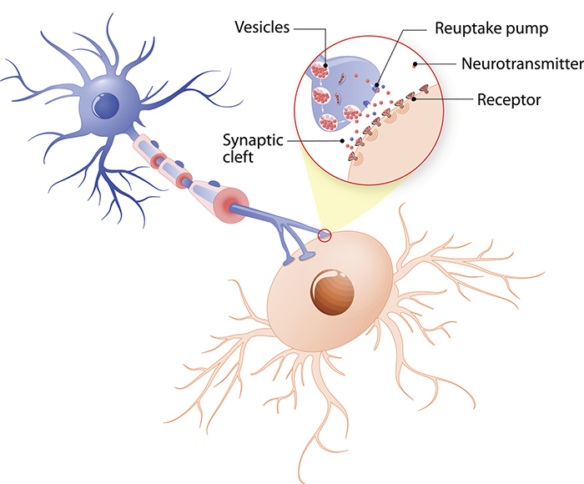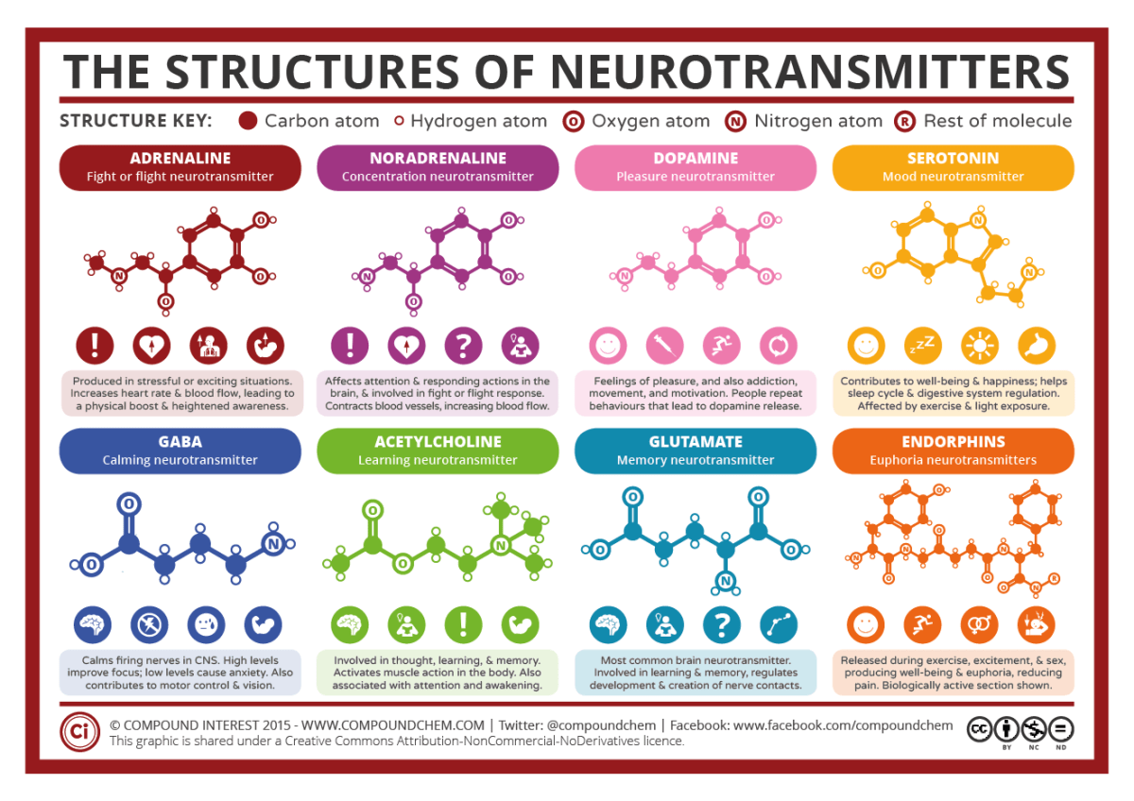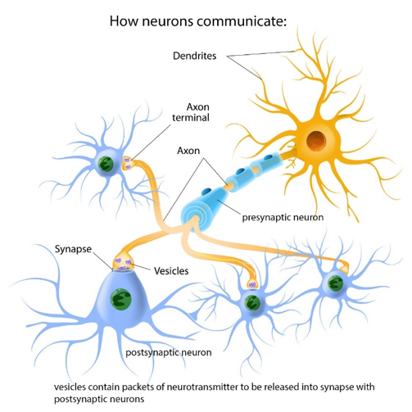

SYNTHESIS OF NEUROTRANSMITTERS
The synthesis of neurotransmitters occurs within the synaptic cleft. The enzymes needed for transmitter synthesis are synthesized in the neuronal cell body and transported to the nerve terminal cytoplasm at 0.5-5 millimeters a day by a mechanism called slow atonal transport . The precursor molecules used by these synthetic enzymes are usually taken into the nerve terminal by transporter proteins found in the plasma membrane of the terminal. The enzymes generates a cytoplasmic pool of neurotransmitter that must then be loaded into synaptic vesicles by transport proteins in the vesicular membrane. For some small molecule neurotransmitters, the final synthetic steps actually occur inside the synaptic vesicles.

MAJOR NEUROTRANSMITTERS:
- Amino acids
- Gasotransmitters
- Monoamines.

We'll be focusing on the synthesis of Dopamine and glutamate.

DOPAMINE:
They are neurotransmitters and neuromodulators that contain one amino group connected to an aromatic ring by a two-carbon chain. These neurotransmitters are involved in mediating a wide range of physiological and homeostatic functions, which vary with the part of the brain being examined.The chemical is found naturally in the human body.It comes from the families of catecholamine and phenethylamine.It is particularly referred to as "Happy hormones" -It is responsible for experiencing our happiness.It affects our mood, movement,memory and focus.
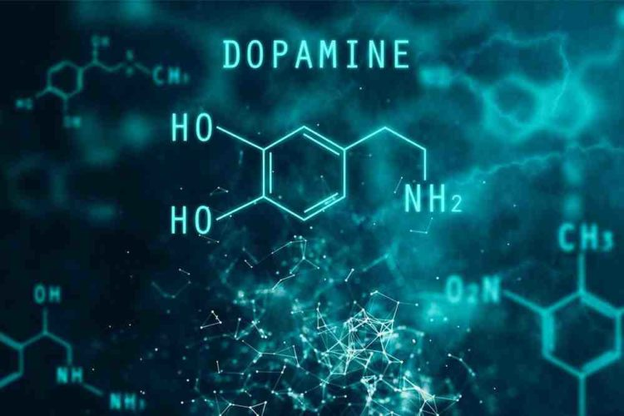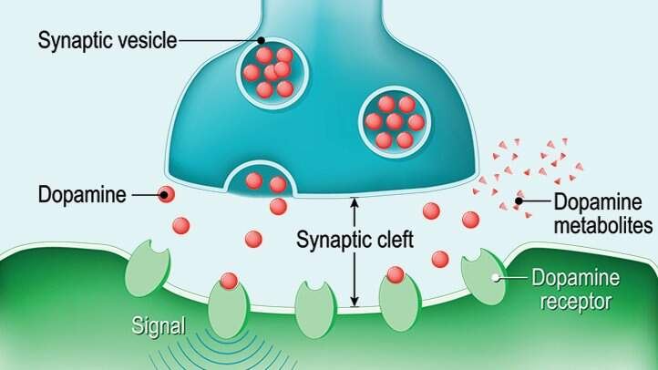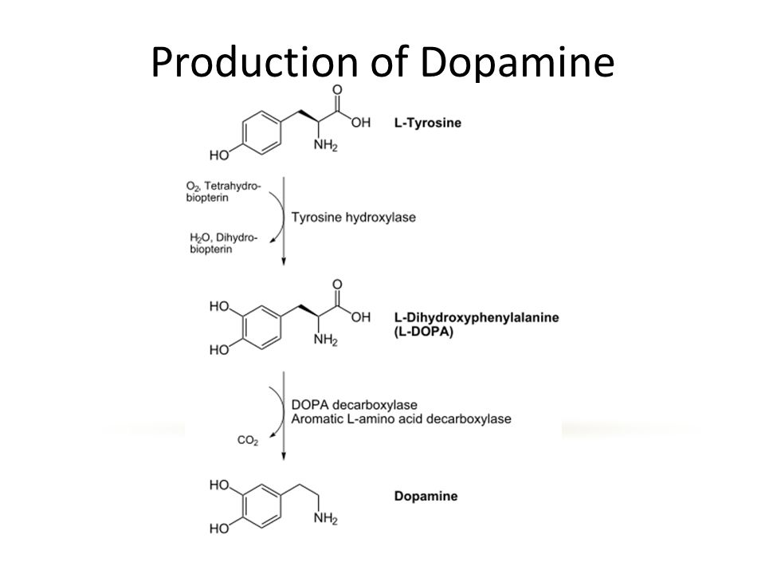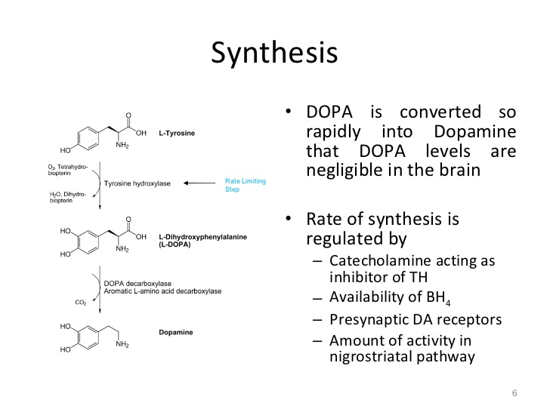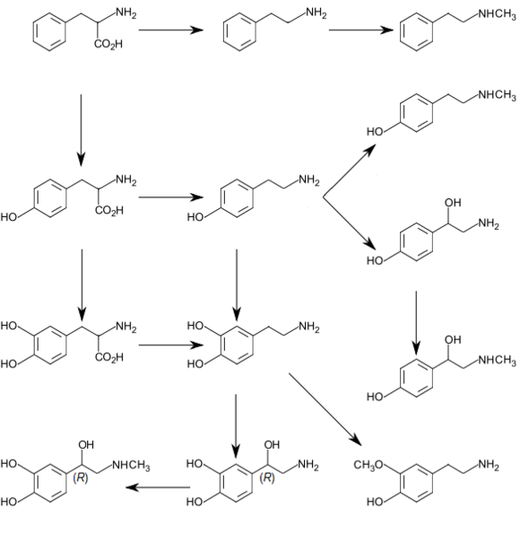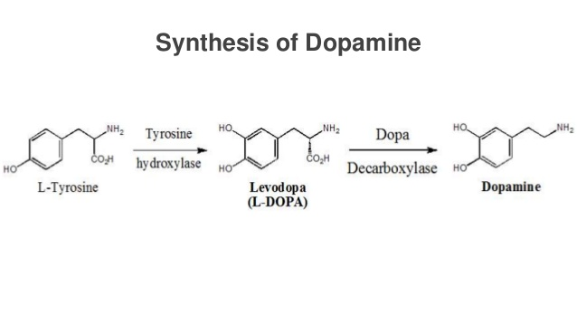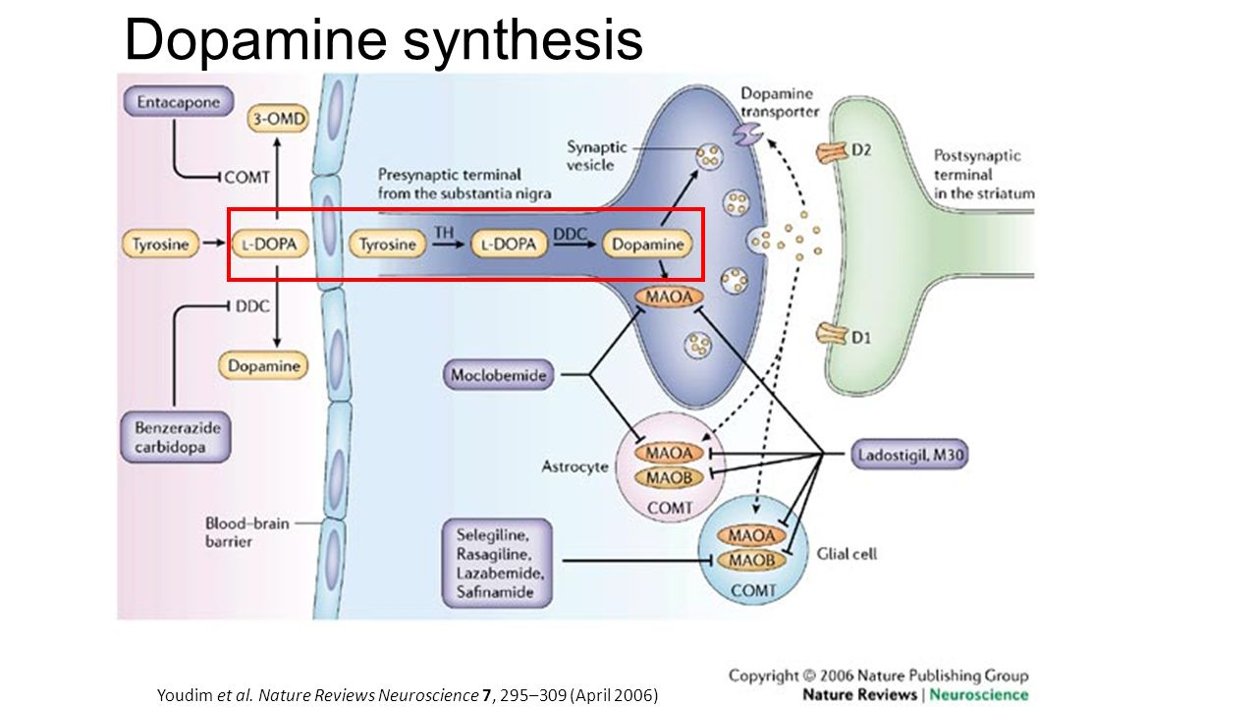

- SYNTHESIS OF DOPAMINE: It is synthesized in plants and most animals.
Dopamine is synthesized in a restricted set of cell types,mainly neurons and cells in the medulla of the adrenal glands.The primary and minor metabolic pathways respectively are:
Primary:L-phenylalanine >L--tyrosine>L-DOPA>Dopamine
Minor:L-phenyalanine>L--tyrosine>P-Tyramine>Dopamine.
Minor: L-phenylalanine >m-tyrosine>m-tyramine>Dopamine
The direct precursor of dopamine,L-DOPA, can be synthesized indirectly from the essential amino acid phenylalanine or directly from the non-essential amino acid tyrosine.These amino acids are found in nearly every protein and so are readily available in food,with tyrosine being the most common.Although dopamine is also found in many types of food,it is incapable of crossing the blood -brain barrier that surrounds and protects the brain.It must therefore be synthesized inside the brain to perform it's neuronal activity. L-phenylalanine is converted into L--tyrosine by the enzyme phenylalanine hydroxylase,with molecular oxygen (O2) and tetrahydrobiopterin as cofactors.L-tyrosine is converted into L-DOPA by the enzyme aromatic L-amino acid decarboxylase (also known as DOPA decarboxylase),with pyroidal phosphate as the cofactor.
Dopamine itself is used as precursor in the synthesis of the neurotransmitters norepinephrine and epinephrine.Dopamine is converted into norepinephrine by the enzyme dopamine beta- hydroxylase,with O2 and L- ascorbic acid as cofactors.Norepinephrine is converted into epinephrine by the enzyme phenyl ethanolamine N-methyl transferase with S-adenosyl-L- methionine as the cofactor.
Some of the cofactors also require their own synthesis.Deficiency in any required amino acid or cofactor can impair the synthesis of dopamine, norepinephrine,and epinephrine

Dopamine is synthesized from the amino acid tyrosine; the majority of circulating tyrosine originates from dietary sources, but small amounts are derived from hydroxylation of phenylalanine by the liver enzyme phenylalanine hydroxylase.
Blood-borne tyrosine is taken up into the brain by a low-affinity amino acid transport system and subsequently from brain extra cellular fluid into dopaminergic neurons by high and low affinity amino acid transporters.
Tyrosine is converted to dopamine by the enzyme tyrosine hydroxylase (TH) and 1-amino acid decarboxylase (AADC) also called dihydroxyphenylalanine (DOPA) decarboxylase (DDC).
TH is the rate-limiting step in their bio synthetic pathway; the TH gene is localized to chromosome 11p in humans and encodes a single form of TH that can be alternatively spliced. The mRNA expression of the TH is abundant throughout the human mesencephalon.
The mature enzyme is a soluble cytology protein composed of four subunits of approximately 60 kDa each.
Within catecholaminergic neurons, tyrosine hydroxylase catalyze the addition of a hydroxyl group to the meta position of tyrosine, yielding L-dopa. This rate -limiting step in nthesis is subject to inhibition by high levels of catecholamines. Because tyrosine hydroxylase is normally saturated with substrate, manipulation of tyrosine levels does not readily impact the rate of catecholamine synthesis. Once formed, L-dopa is rapidly converted to dopamine by dopa decarboxylase, which is located in the cytoplasm . It is now recognized that this enzyme acts not only on L-dopa but also on all naturally occurring aromatic L-amino acids, including tryptophan and thus it is more properly termed aromatic amino acid decarboxylase.

STORAGE AND EXOCYTOSIS :
In dopaminergic neurons, the neurotransmitter is transported from the cytoplasm to specialized storage vesicles at extremely high concentrations, 0.5-0.6m. Which is near its limit of solubility. Here the amine is concentrated to approximately at a 100- to 1000- times higher than the level in the cytosol.
It should be noted that dopamine can be synthesized and released from dendrites, in addition to terminal regions; however, in dendrites dopamine appears to be stored both in classical vesicles and in smooth endoplasmic reticulum.
Dopamine is translocated from the cytoplasm into the vesicles by the vesicular monoamine transporter (VMAT)
Dopamine is inactivated by :
- Reputake via the dopamine transporter
- Metabolism
- Monoamine oxidase (MAO)
- Catechol-O-methyl transferase (COMT)

REUPTAKE :
Reuptake of dopamine is mediated by two classes of transporters :
- Dopamine transporter (DAT) : which transports dopamine from the extracellular to the intracellular space .
- VMAT (Vesicular monoamine transporter ) : which reloads dopamine into the vesicles .
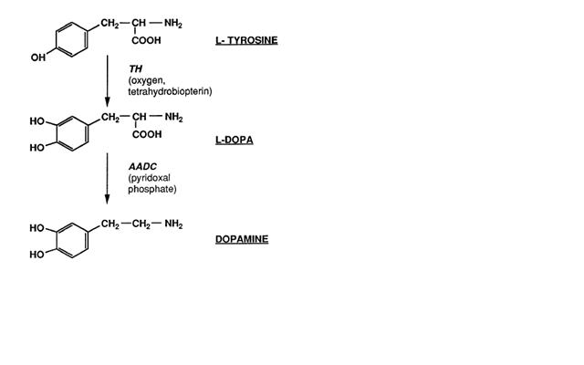

Glutamate:It is the most abundant free amino acid in the brain and a very powerful excitatory neurotransmitters.It is generally acknowledged to be the most important transmitter for normal brain functions.It is responsible for sending signals between nerve cells,and under normal conditions it plays an important role in learning and memory.Tge highest concentration Ms of glutamate are found in synaptic vesi kes in nerve terminals from where it can be released by exocytosis.

Synthesis of glutamate: Glutamate cannot cross the blood -brain barrier unassisted,but it is actively transported out of the nervous system by a high affinity transport system,which maintains it's concentration in brain fluids at a fairly constant level Glutamate is synthesized in the central nervous system from glutamine as part of the glutamate-glutamine cycle by the enzyme glutaminase.This can occur in the presynaptic neuron or in the neighbouring glial cells.Glutamatwme itself serves as metabolic precursor for the neurotransmitter GABA,via the action of the enzyme Glutamate decarboxylase.

