Name: Oladimeji Oluwaseun Oreoluwa
Department: Anatomy
Matric no: 17/MHS01/253
Course Code: BCH 308

Question
- Describe in details the synthesis of two named neurotransmitters

Answer
1. Dopamine

DOPAMINE SYNTHESIS
Dopamine is synthesized from the amino acid tyrosine; the majority of circulating tyrosine originates from dietary sources, but small amounts are derived from hydroxylation of phenylalanine by the liver enzyme phenylalanine hydroxylase .
Blood-borne tyrosine is taken up into the brain by a low-affinity amino acid transport system and subsequently from brain extracellular fluid into dopaminergic neurons by high- and low-affinity amino acid transporters.
Tyrosine is converted to dopamine by the enzymes tyrosine hydroxylase (TH) and l-amino acid decarboxylase (AADC) also called dihydroxyphenylalanine (DOPA) decarboxylase (DDC).
TH is the rate-limiting step in their biosynthetic pathway; the TH gene is localized to chromosome 11p in humans and encodes a single form of TH that can be alternatively spliced. The mRNA expression of the TH is abundant throughout the human mesencephalon.
The mature enzyme is a soluble cytosolic protein composed of four subunits of approximately 60 kDa each.
TH activity is the most critical factor that controls dopamine synthesis, and considerable efforts have been devoted to understanding activation/inactivation of this enzyme. As previously say, AADC is the second and terminal enzyme in dopamine biosynthesis. The enzyme uses pyridoxal phosphate as a cofactor and can convert both DOPA to dopamine and 5-hydroxytryptophan to serotonin [5-hydroxytryptamine (5-HT)]. The following is the complete reaction:
L-tyrosine + THFA + O2 + Fe2+ → L-dopa + DHFA + H2O + Fe2+
L-dopa + pyridoxal phosphate → dopamine + pyridoxal phosphate + CO2
So for L-dopa formation, L-tyrosine, THFA (tetrahydrofolic acid), and ferrous iron are essential and for dopamine biosynthesis from L-dopa, pyridoxal phosphate is essential.
The activity of the enzyme rises and falls according to how much pyridoxal phosphate there is. Besides two enzymes being required for the formation of dopamine from L-tyrosine (L-tyrosine >>> L-dopa >>> dopamine), three coenzymes are also required. They are : THFA (for L-tyrosine to L-dopa), pyridoxal phosphate (for L-dopa to dopamine), and NADH (for the formation of THFA and Pyridoxal phosphate). The cofactor tetrahydrobiopterin (BH4) donates the hydrogen atom needed for hydroxylation of tyrosine to DOPA.
Because pterin also serves as a cofactor for other monoxygenases as well as nitric oxide synthase, its availability is a determinino factor in the control of TH activity.
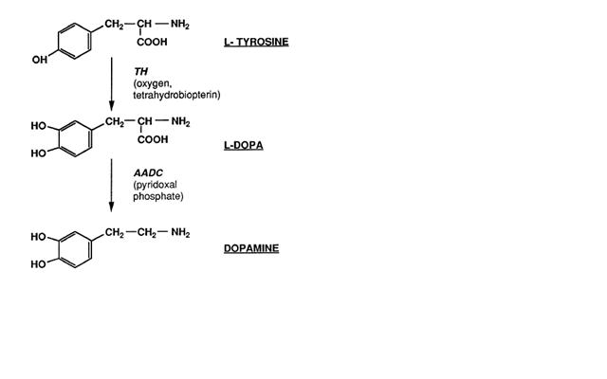

2 Adenosine Triphosphate (ATP)

Glycolysis
Glycolysis is a process by which glucose is partially converted through a series of enzyme-catalyzed reactions into two molecules of pyruvate. Some mammalian cell types (erythrocytes, sperm) and tissues (brain, renal medulla) are able to survive only (or mostly) on the energy derived from glycolysis. The steps comprising the processes leading to the breakdown of the six-carbon glucose into two three-carbon pyruvate molecules can be divided into two phases: the preparatory phase and the so-called “payoff” phase (Fig. 1).
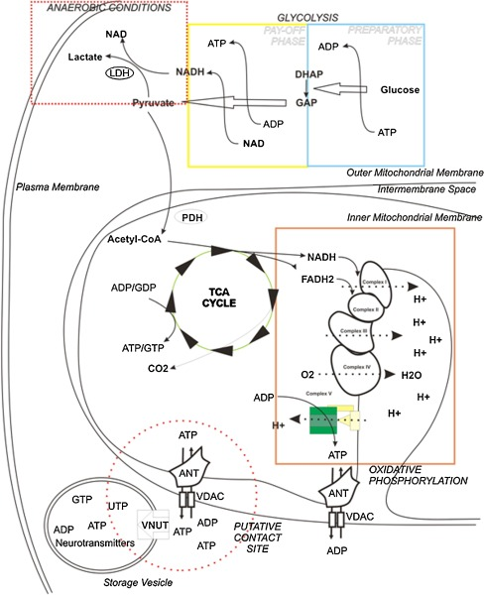
Fig. 1
ATP management within the cell. Schematic representation of mechanisms of ATP synthesis and storage inside the cell. Glycolysis is represented in the yellow and blue boxes, the TCA cycle by the green circle, and oxidative phosphorylation in the orange box. Reduction of pyruvate to lactate is represented inside the red dotted rectangle. Hypothetical contacts between ATP storage vesicles and mitochondria, with preferential ATP transfer, are shown within the red dotted circle
In the first phase, glucose is phosphorylated at the hydroxyl group on C-6 by hexokinase (HK) generating glucose 6-phosphate. This event is fundamental to “trap” the hexose within the cell. In fact, the existence of a transporter of phosphorylated hexose has not been reported in mammalian cells. In this way, the phosphorylation of glucose shifts the equilibrium of glucose concentration, preventing its escape. Several types of HKs have been found, each with specific features. In the case of HK IV (glucokinase), known to be liver-specific, it is the insensitivity to glucose 6-phosphate inhibition that allows its direct regulation by the levels of glucose in the blood. Recently, there has been increased interest in the mitochondria-associated HK (mtHK). mtHK is able to promote cell survival through an AKT-mediated pathway. This was one of the first mechanisms suggested to couple metabolism to cell fate because of its ability to participate in mitochondrial dynamics during apoptosis and especially due to its involvement in the formation of the mitochondrial permeability transition pore.
Subsequently, glucose 6-phosphate is converted to fructose 6-phosphate by glucose 6-phosphate isomerase. This isomerization is fundamental for the subsequent step in which C-1 is once again phosphorylated, resulting in the formation of fructose 1,6-bisphosphate. Aldolase is then able to split fructose 1,6-bisphosphate into two three-carbon molecules: dihydroxyacetone phosphate (DHAP) and glyceraldehyde 3-phosphate (GAP). This step represents the real “lysis” phase.
Until now, the glycolytic pathway consumed ATP instead of producing it. This should be interpreted as an investment raising the free-energy content of the intermediates, and the real yield of the process starts from here, with the beginning of the second phase.
DHAP is isomerized by triosephosphate isomerase to form a second molecule of GAP. The carbon chain of the entire glucose is thus converted into two molecules of GAP. Each of these molecules is oxidized and phosphorylated by inorganic phosphate to form 1,3-bisphosphoglycerate. During this process, glyceraldehyde-3-phosphate dehydrogenase (GAPDH) uses nicotinamide adenine dinucleotide (NAD+) as cofactor and releases NADH for each molecule of GAP. The resulting NADH will directly feed into the respiratory chain to propel mitochondrial ATP synthesis. It is noteworthy that GAPDH is also able to regulate several processes which are not part of the glycolytic pathway. These include the regulation of apoptosis, membrane fusion, microtubule bundling, RNA export, DNA replication, and repair.
Some energy is released through the conversion of 1,3-bisphosphoglycerate into two molecules of pyruvate by the sequential steps performed by phosphoglycerate kinase (PGK), phosphoglicerate mutase, enolase, and pyruvate kinase. The conversions of 1,3-bisphosphoglycerate to 3-phosphoglycerate (by PGK) and phosphoenolpyruvate to pyruvate (by pyruvate kinase) are the steps that promote ATP synthesis from ADP in glycolysis. The last step is also a fundamental regulator of the whole process. Pyruvate kinase (PK) undergoes allosteric regulation by fructose 1,6-bisphosphate that promotes PK activity and boosts the rate of glycolysis . Allosteric regulation and tissue expression characterize several isoforms of the PK enzyme, i.e., the isoform M2, usually expressed during embryogenesis, has been found as a special promoter of tumorigenesis. This isoform is characterized by a high affinity to phosphoenolpyruvate, and it has been associated with favoring the conversion of pyruvate to lactate instead of its entry in the TCA cycle.
Thus, the second phase of glycolysis provides four molecules of ATP and two of NADH per molecule of glucose, paying the investment of the preparatory phase. The final balance of this process is then: two molecules of ATP, two of NADH (that could directly feed into the respiratory chain), and two of pyruvate. The latter enters the TCA cycle and undergoes complete oxidation in aerobic conditions.
During anaerobic conditions (such as what occurs in muscles during a burst of extreme activity, when oxygen is not obtained fast enough from the blood), the low oxygen amounts do not allow the complete and efficient oxidation of pyruvate. During these conditions, NADH (produced in large amounts from the citric acid cycle; see next section) cannot be reoxidized to NAD, thus limiting the activity of GAPDH and glucose consumption. Pyruvate is then reduced to lactate with the consumption of one NADH in a process called lactic fermentation catalyzed by lactate dehydrogenase. In this way, the two molecules of NADH produced in glycolysis are consumed in lactic fermentation to restore the NAD reservoir, and the final balance of one glucose degradation is two molecules of ATP. This condition occurs also in aerobic conditions in erythrocytes (that have no mitochondria) or in many cancer cells as was originally observed by doctor Otto Warburg in 1930, and which led to the widely accepted Warburg effect theory .

Citric acid cycle
The TCA, also known as the citric acid cycle, was elucidated by Sir Hans Krebs in 1940 when he concluded, “the oxidation of a triose equivalent involves one complete citric acid cycle”. The “triose” deriving from glycolysis is completely oxidized into three molecules of CO₂ during a sequence of reactions that allow the reduction of cofactors NAD and flavin adenine nucleotide (FAD), providing energy for the respiratory chain in the form of electrons. In 1949, it was demonstrated by Kennedy and Lehningher that the entire cycle occurs inside mitochondria
The starting material for the citric acid cycle is directly provided by the pyruvate coming from glycolysis through the activity of the pyruvate dehydrogenase complex. This enzymatic complex, composed of multiple copies of the three enzymes pyruvate dehydrogenase (E1), dihydrolipoyl transacetylase (E2), and dihydrolipoyl dehydrogenase (E3), oxidizes pyruvate to acetyl-CoA and CO₂ in an irreversible reaction in which the carboxyl group is removed from pyruvate as a molecule of CO₂. This reaction is strictly related to the cycle, even if is not comprised in it. The acetyl group introduces two carbons in each turn of the cycle; these carbons will then leave the cycle as CO₂.
The first reaction of the citric acid cycle is the condensation of one acetyl-CoA and a molecule of citrate to generate oxaloacetate and is catalyzed by citrate synthase. Citrate is then transformed into isocitrate by aconitase through the formation of cis-aconitate. This step is reversible and could lead to the formation of both citrate and isocitrate. Only the fast consumption of isocitrate by its dehydrogenase can force the reaction to the proper direction. Isocitrate dehydrogenase catalyzes the first irreversible oxidation leading to the decarboxylation of isocitrate, generating CO₂ and α-ketoglutarate. The second carbon leaves the cycle in the following step, when the newly generated α-ketoglutarate is immediately decarboxylated by the α-ketoglutarate dehydrogenase complex in a reaction similar to the pyruvate decarboxylation. In fact, both these complexes share high similarities in enzyme amino acid composition and in the organization of the different subunits. Energy released from both oxidations is used to generate NADH from NAD that directly feeds into the respiratory chain.
The following step is catalyzed by succinyl–Coa synthetase and utilizes the energy derived from the CoA removal to phosphorylate GDP (or ADP) to GTP (or ATP). Selectivity for the nucleotide is determined by the isozyme involved. It has been well established that at least two isozymes of succinyl–CoA synthetase are expressed in animal tissues, and the proportion between them seems to be tissue-specific.
The succinate generated in the previous step is the four-carbon compound that is then converted, by three sequential reactions, to oxaloacetate to conclude the cycle. The first of these steps is the oxidation of succinate to fumarate by succinate dehydrogenase. This enzyme, tightly bound to the inner mitochondrial membrane (IMM), catalyzes FAD reduction to FADH₂ that provides electrons for the respiratory chain. Fumarate is then hydrated by fumarate hydratase to l-malate. It is particularly interesting that both succinate dehydrogenase and fumarate hydratase are oncosuppressor genes. It has been demonstrated that inactivation of these oncosuppressors leads to the accumulation of succinate and fumarate that spread in the cytosol and promote hypoxia-inducible factor 1α (HIF1α) accumulation by inactivating prolyl hydroxylase enzymes (promoter of HIF1α degradation); HIF1α in turn promotes a pseudo-hypoxic condition that favors tumor development. The last event that completes the citric acid cycle is the oxidation of l-malate to oxaloacetate. This reaction is performed by l-malate dehydrogenase which induces the reduction of another molecule of NAD to NADH. The resulting molecule of oxaloacetate is suitable for starting another cycle through condensation with an acetyl group.
During all these processes, only one molecule of ATP (or GTP) is produced, but three molecules of NADH and one of FADH2 (plus one molecule of NADH from pyruvate dehydrogenase), which provide electrons for respiratory chain, are also generated and subsequently result in the production of large amounts of ATP .

