NAME: NATASHA GIMBIYA DANIEL
MATRIC NO: 17/MHS01/094
DEPARTMENT: ANATOMY
DESCRIBE IN DETAIL THE SYNTHESIS OF TWO NEUROTRANSMITTERS
SEROTONIN
Serotonin, or 5-hydroxytryptamine (5-HT), was initially thought to increase vascular tone by virtue of its presence in serum (hence the name serotonin). 5-HT is synthesized from the amino acid tryptophan, which is an essential dietary requirement. Tryptophan is taken up into neurons by a plasma membrane transporter and hydroxylated in a reaction catalyzed by the enzyme tryptophan-5-hydroxylase, the rate-limiting step for 5-HT synthesis. As in the case of other biogenic amines, the synaptic effects of serotonin are terminated by transport back into serotonergic nerve terminals. The primary catabolic pathway is mediated by MAO. Serotonin is located in groups of neurons in the raphe region of the pons and upper brainstem, which have widespread projections to the forebrain and have been implicated in the regulation of sleep and wakefulness. A number of antipsychotic drugs used in the treatment of depression and anxiety are thought to act specifically on serotonergic neurons.
Serotonin is an example of a monoamine neurotransmitter, a chemical messenger that is passed between nerve cells. This hormone is mainly found in the gastrointestinal tract, the platelets and the central nervous system of animals and is thought to contribute to a sense of well being and happiness.
Serotonin is synthesized from the amino acid L-tryptophan via a short metabolic pathway that involves two major enzymes. These enzymes are:
- Tryptophan hydroxylase (TPH)
- Amino acid decarboxylase
The reaction in this pathway that is mediated by tryptophan hydroxylase is the rate limiting step, meaning that if this enzyme is blocked, the synthesis of serotonin would be stopped. Tryptophan hydroxylase exists in two forms - TPH1 and TPH2. While TPH1 is found in several tissues, TPH2 is specifically found in nerves of the brain.
A serotonin transporter protein called SERT or 5HTT is responsible for carrying serotonin from the synaptic cleft to its target nerve. This transporter acts as a regulator of serotonin levels and mutations in the 5HTT gene have been shown to disrupt serotonin uptake. Serotonin regulates many important bodily functions ranging from sleep, mood, appetite and eating habits as well as influencing anxiety levels, suicidal tendencies, and our ability to learn and memorize things.
The 5-HTT protein is an important target of many antidepressant therapies. There are two forms of 5-HTT genes, the long form and the short form. Studies have shown that people with two long forms of the 5-HTT genes are less likely to suffer from depression compared with people who have one short and one long copy of the gene or two short copies.
While serotonin in its primary form cannot reach the brain since it cannot cross the blood–brain barrier, the serotonin precursor’s tryptophan and its metabolite 5-hydroxytryptophan (5-HTP) do cross this barrier and reach the brain. These agents can be taken as dietary supplements to increase levels of serotonin in the brain. 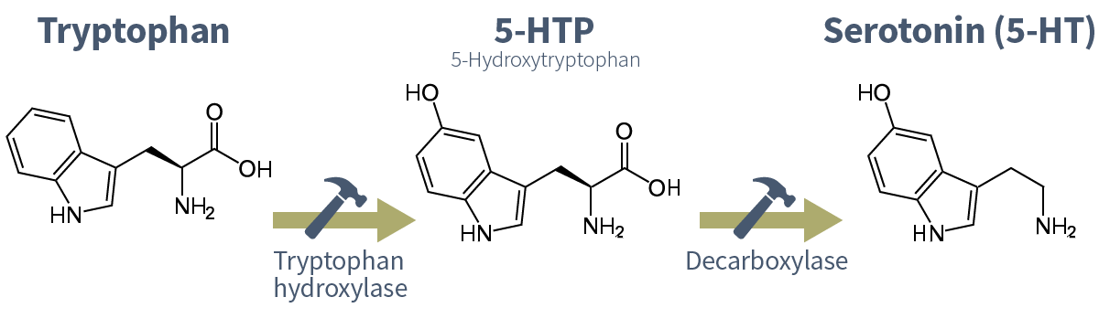
2. HISTAMINE
Histamine is produced from the amino acid histidine by a histidine decarboxylase and is metabolized by the combined actions of histamine methyltransferase and MAO. High concentrations of histamine and histamine decarboxylase are found in neurons in the hypothalamus that send sparse but widespread projections to almost all regions of the brain and spinal cord . The central histamine projections mediate arousal and attention, similar to central ACh and norepinephrine projections. This partly explains why antihistamines that cross the blood-brain barrier, such as diphenhydramine (Benadryl®), act as sedatives. Histamine also is released from mast cells in response to allergic reactions or tissue damage. The close proximity of mast cells to blood vessels, together with the potent actions of histamine on blood vessels, raises the possibility that histamine may influence brain blood flow.
Histamine is a biogenic amine that stimulates multiple histamine receptor types. In mammals, histamine is found within granules of basophils and mast cells (>90% of body stores) and within tuberomammillary neurons of the CNS. When released, histamine induces complex physiological and pathological effects, including allergic reactions, gastric acid secretion, multiple CNS-regulated effects, smooth muscle contraction and profound vasodilation that can lead to cardiovascular collapse.
In mammals, physiological levels of L-histidine are converted to histamine by specific L-histidine decarboxylase (HD), which differs from the nonspecific DOPA decarboxylase. α-Fluoromethylhistidine (α-FMH) has been shown to be an irreversible, highly selective "suicide" inhibitor of HD, although this mode of inhibition often has little or no immediate effect on histamine stores or transmission. Once released, histamine is metabolized almost exclusively by methylation or oxidation, the propensity of which varies between species and between tissues and organs within species. For example, in brain relatively small amounts of histamine are oxidized with most being methylated. As a survival mechanism, only traces of histamine escape metabolism, particularly following systemic injection or release, with inhibition of one metabolic route resulting in histamine being shunted to another.
Histamine is methylated at the imidazole nitrogen furthest from the ethylamine side chain (termed tele-N or N^{t}) by the enzyme histamine-N-methyltransferase (HMT) through a ping-pong mechanism using S-adenosyl-L-methionine as cofactor. The tele-methylhistamine (t-MH) produced is a substrate for monoamine oxidase-B (MAO-B) and semicarbazide-sensitive amine oxidases (SSAOs), such as diamine oxidase (DAO) and benzylamine oxidase (Bz.SSAO). The aldehyde intermediate is further oxidized by aldehyde dehydrogenase (ALD-DH) to tele-methylimidazoleacetic acid (t-MIAA). In rats, histamine possesses a K_{m} value of ~10 mM for HMT yet shows substrate inhibition at 30-60 mM. Several substances inhibit HMT, of which tacrine (K_{i} <50 nM) and metoprine are among the most potent. t-MH also induces product inhibition.
In the oxidative pathway, histamine is oxidized by the SSAOs, particularly DAO and Bz.SSAO, but is a poor substrate for the MAOs. The resultant imidazolacetaldehyde is rapidly converted by ALD-DH to imidazole-4-acetic acid (IAA). IAA induces numerous effects in the CNS where it has been shown to act as both a GABA_{A} receptor agonist and a GABA_{C} receptor partial agonist. IAA is conjugated with phosphoribosyl-pyrophosphate by the action of imidazoleacetic acid 5Â´-phosphoribosyl transferase (IPRT) to produce imidazoleacetic acid-ribotide (IAA-RP), a compound that has been shown to behave as a potent ligand at multiple imidazoline binding sites (EC₅₀~50 nM), in addition to displacing clonidine from its non α-adrenoceptor binding sites. Immunohistochemical studies have shown that IAA-RP is present in neurons throughout the brain. Both phosphatases and 5´-ecto-nucleotidases can convert IAA-RP to IAA-riboside (IAA-R); preliminary findings suggest a rank order of in vitro enzyme activities of alkaline-phosphatase> acid-phosphatase> 5´-ecto-nucleotidase.
Histamine's oxidative products can also be derived from pathways independent of histamine. Thus, L-histidine-pyruvate aminotransferase (HPAT), recently termed kyneuramine aminotransferase (KAT) and glutamine transaminase-K (GTK), also leads to IAA production and appears to generate most of the IAA found in brain. In contrast, t-MH and t-MIAA are unique products of histamine metabolism. For example, in plasma and urine of patients with mastocytosis, a state of constant excessive systemic histamine release, levels of histamine may increase only slightly, while levels of t-MH and t-MIAA may increase by as much as 20-fold. Furthermore, because HMT is distal to sites of histamine release, levels of t-MH and t-MIAA together have been used as indices of general histaminergic activity.

