MY FEEDBACK FORM

S/N | PARAMETER | RESPONSE LEVEL
 |  | YES  (5 points) | NO  (0 points) | NOTSURE  (3points)
1 | Are you learning valuable information? | YES
2 | Are the explanations of concepts clear? | YES
3 | Is the Instructor’s delivery engaging? |  |  | NOTSURE
4 | Are there enough helpful practice activities? |  |  | NOTSURE
5 | Was the course description accurate? | YES
6 | Is the instructor knowledgeable about the topic? | YES
TOTAL SCORE |  | 26
FINAL REMARKS |  | I was flowing with the class
EXCELLENT (5POINTS)
FAIR (3 POINT) |  | FAIR
POOR (0 POINTS)

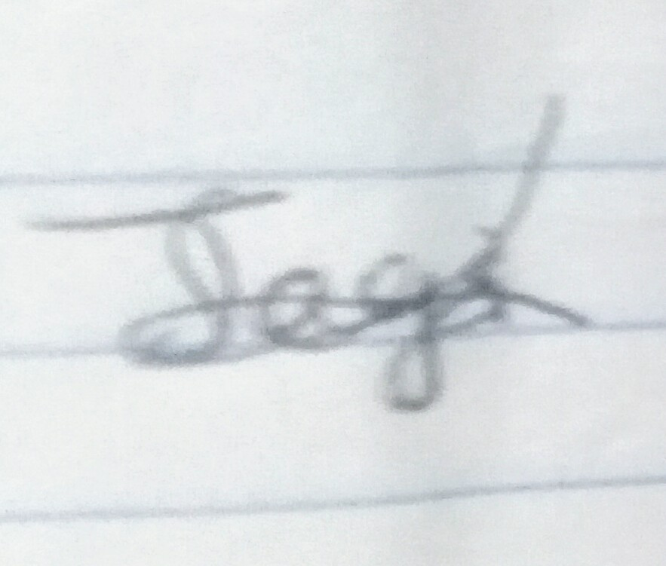
NAME/SIGNATURE/DATE: …JAGUN Oluwaseyi Oladimeji……; …………………………………….; ……3/4/2020……….8

