MATRIC NUMBER: 18/MHS01/160
NAME: FASIPE BLESSING OLUWAFUNKE
COURSE CODE: BCH 204
ASSIGNMENT:
1.HIGHLIGHT THE STEPS OF DNA REPLICATION

INITIATION:
The initiation of DNA replication occurs in two steps. First, a so-called initiator protein unwinds a short stretch of the DNA double helix. Then, a protein known as helicase attaches to and breaks apart the hydrogen bonds between the bases on the DNA strands, thereby pulling apart the two strands. As the helicase moves along the DNA molecule, it continues breaking these hydrogen bonds and separating the two polynucleotide chains.
Meanwhile, as the helicase separates the strands, another enzyme called primase briefly attaches to each strand and assembles a foundation at which replication can begin. This foundation is a short stretch of nucleotides called a primer.
The leading strand is the simplest to replicate. Once the DNA strands have been separated, a short piece of RNA called a primer binds to the 3' end of the strand. The primer always binds as the starting point for replication. Primers are generated by the enzyme DNA primase.

Elongation

Enzymes known as DNA polymerases are responsible creating the new strand by a process called elongation. There are five different known types of DNA polymerases in bacteria and human cells. In bacteria such as E. coli, polymerase III is the main replication enzyme, while polymerase I, II, IV and V are responsible for error checking and repair. DNA polymerase III binds to the strand at the site of the primer and begins adding new base pairs complementary to the strand during replication. In eukaryotic cells, polymerases alpha, delta, and epsilon are the primary polymerases involved in DNA replication. Because replication proceeds in the 5' to 3' direction on the leading strand, the newly formed strand is continuous.

The lagging strand begins replication by binding with multiple primers. Each primer is only several bases apart. DNA polymerase then adds pieces of DNA, called Okazaki fragments, to the strand between primers. This process of replication is discontinuous as the newly created fragments are disjointed

Termination

Once both the continuous and discontinuous strands are formed, an enzyme called exonuclease removes all RNA primers from the original strands. These primers are then replaced with appropriate bases. Another exonuclease “proofreads” the newly formed DNA to check, remove and replace any errors. Another enzyme called DNA ligase joins Okazaki fragments together forming a single unified strand. The ends of the linear DNA present a problem as DNA polymerase can only add nucleotides in the 5′ to 3′ direction. The ends of the parent strands consist of repeated DNA sequences called telomeres. Telomeres act as protective caps at the end of chromosomes to prevent nearby chromosomes from fusing. A special type of DNA polymerase enzyme called telomerase catalyzes the synthesis of telomere sequences at the ends of the DNA. Once completed, the parent strand and its complementary DNA strand coils into the familiar double helix shape. In the end, replication produces two DNA molecules, each with one strand from the parent molecule and one new strand.

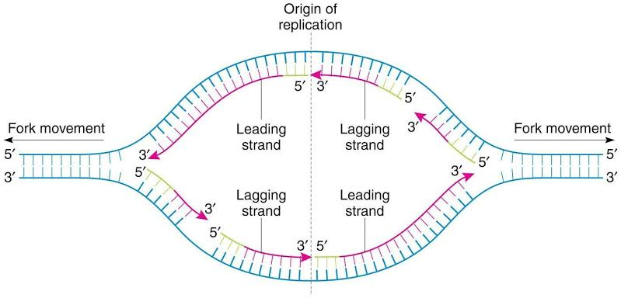

2. OUTLINE THE FUNCTIONS OF DNA REPLICATION ENZYMES.
1. TOPOISOMERASE: Relaxes the super-coiled DNA.
2. DNA HELICASE: Also known as helicopter destabilizing enzyme.
Unwinds the double helix at the replication fork. They separate double-stranded DNA into single strands allowing each strand to be copied.

3. PRIMASE: Provides the starting point for DNA polymerase to begin synthesis of the new strand.
4. DNA POLYMERASE I: Exonuclease activity removes RNA primer and replaces with newly synthesized DNA.
5. DNA POLYMERASE II: It helps to repair. Performs proofreading and error correction.
6. DNA POLYMERASE III: Builds a new duplex DNA strand by adding nucleotides in the 5`-3` direction.
7. DNA LIGASE: Re-joins the two DNA strands into a double helix and joins Okazaki fragments of the lagging strands.
8. DNA CLAMP: A protein which prevents DNA Polymerase III from dissociating from the DBA parent strand.
9. SINGLE STRAND BINDING(SSB) PROTEIN: Bind to single strand DNA and prevents the DNA double helix from re-annealing after DNA helicase unwinds it, thus maintaining the strand separation.
10. DNA GYRASE: Relieves strain of unwinding by DNA helicase. It is a specific type of topoisomerase.
11. TELOMERASE: Lengthens telomeric DNA by adding repetitive nucleotide sequences to the end of eukaryotic chromosomes.

