ADEBARA FAITH INUMIDUN
17/SCI05/001
MEDICINE AND SURGERY
300 LEVEL
2019/2020

ASSIGNMENT:
- Discuss the anatomy of the tongue and comment on its applied anatomy.
- Write an essay on the air sinuses

QUESTION 1
ANATOMY OF THE TONGUE
The tongue is a mobile muscular organ that can assume a variety of shapes and positions. It lies partly in the oral cavity and partly in the oropharynx. It is a mass of tissue that is almost completely covered by a mucous membrane. It is attached via muscles to the hyoid bone, mandible, styloid process, palate, and pharynx.
The tongue is involved with taste, mastication(chewing), deglutition (swallowing), articulation(speech), and oral cleansing.

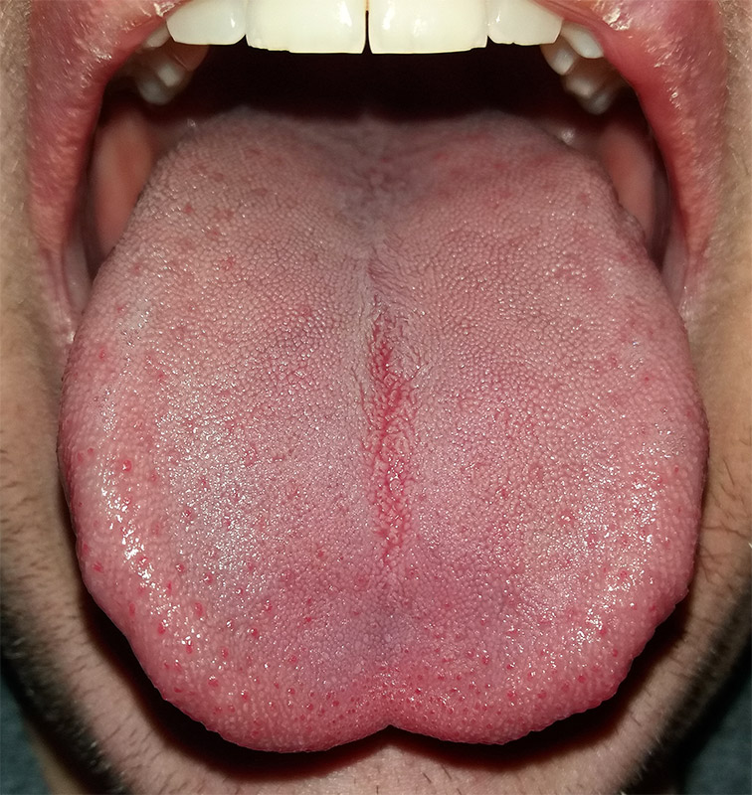
THE HUMAN TONGUE
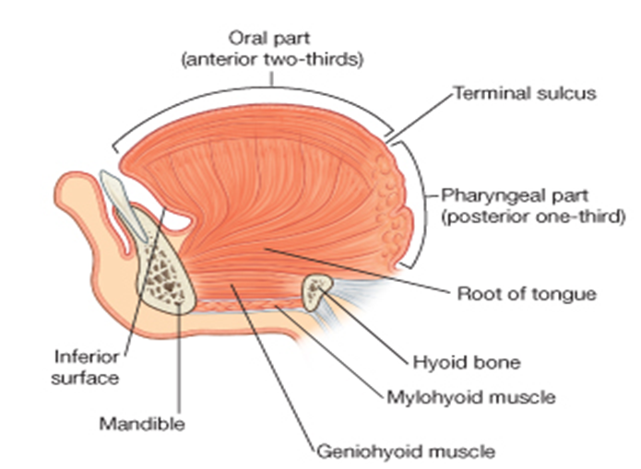
- EMBRYOLOGY OF THE TONGUE
Embryologically, the tongue is divided into an anterior and a posterior part. The anterior part of the tongue is also called the oral or presulcal part of the tongue and the posterior part is also called the pharyngeal or postsulcal part of the tongue.
The pharyngeal apparatus has been identified as the main embryological structure that gives rise to numerous components of the head and neck. The tongue is one of the structures derived from the pharyngeal apparatus.

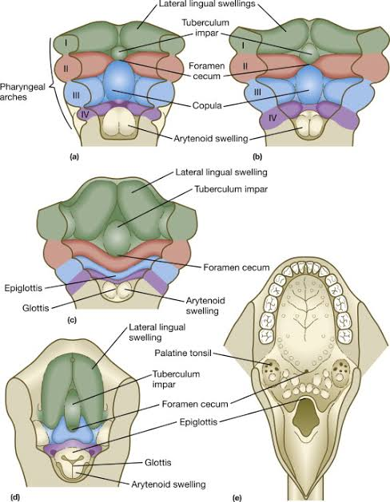

- Development of the anterior two-thirds of the tongue
It is formed by fusion of 2 lateral lingual swellings and a tuberculum impar (median lingual swelling).
Towards the end of the 4th gestational week, the mesenchyme of the ventromedial aspect of the first pharyngeal arches begins to proliferate in the floor of the primitive pharynx to form median lingual swelling (also known as tuberculum impar). This triangular opening is located cranial to the foramen cecum (opening to the thyroglossal duct) and is later joined by the two distal tongue buds, the lateral lingual swellings. The lateral lingual swellings are oval enlargements arising on either side of the median lingual swelling. The rate of growth of the lateral lingual swellings exceeds that of the median lingual swelling.
By the 5th and 6th gestational week, they outgrow the median lingual swelling and fuse in the median lingual swelling and fuse in the midline to form the oral part (the anterior two-third) of the tongue. The fibrous lingual septum represents the point of fusion of the two lateral lingual swellings, which lies deep to the midline groove (a central groove along the longitudinal axis) of the tongue. The mucosa overlying this part of the tongue originates from the first arch; thus, the sensory innervation to this area is from the mandibular branch of the trigeminal nerve (CN III).

- Development of the posterior third of the tongue
Caudal to the foramen cecum, two mesenchymal derivatives arise from the ventromedial part of the 2nd – 4th pharyngeal arches. The copula linguae (also called hypobranchial eminence) are the product of the 2nd pharyngeal arches, while the hypopharyngeal eminence, which develops below the copula, arises from the 3rd and 4th pharyngeal arches. Like the lateral lingual swellings, the hypopharyngeal eminences grow at a faster rate than the copula. As a result, the copula regresses between the 4th and 5th week of development and the hypopharyngeal eminence become the pharyngeal part of the tongue. The mucosa overlying the pharyngeal part of the tongue has sensory innervation from the glossopharyngeal nerve (CN XI).
This means that neither the tuberculum impar or the copula contributes to structures of the adult tongue.
The oral and pharyngeal part of the tongue eventually fuses, forming a V- shaped junction known as the sulcus terminalis. While the connective tissue and vascular supply of the tongue mostly originate from the preceding pharyngeal arches, the intrinsic and extrinsic muscles are myoblast derivatives originating for the occipital myotomes and thus are innervated by the hypoglossal nerve (CN XII).
Also, the tongue and the hard palate develops simultaneously. It contributes to molding the palate int arched structured that it eventually becomes during post-natal life.
Most of the morphological changes of the tongue occurs during the first trimester of pregnancy. By the second trimester of extrauterine life, the rest of the changes are related to elongation and repositioning of the tongue. Both the presulcal and postsulcal parts of the tongue are within the cavity proper at birth. Caudal migration if the posterior third of the tongue is not completed until the age of 4.
- Development of taste buds and papillae
The coarse texture of the dorsal surface of the tongue are attributed to the numerous lingual papillae that are found on its surface. Towards the end of the 8th gestational week, foliate and vallate papillae are the first of the four to develop. Followed by the appearance of fungiform papillae. By the 10th – 11th week of gestation, the thread like filiform papillae can be observed on the dorsal surface of the tongue.
The development of taste buds begins as the last of the papillae are formed in the 11th week of gestation and is concluded around the 13th gestational week.

- GROSS ANATOMY OF THE TONGUE
Under normal circumstances, the tongue is a pink, muscular organ located within the oral cavity proper, that can assume a variety of shapes and positions. On average, the tongue is roughly 10cm long anteroposterior.

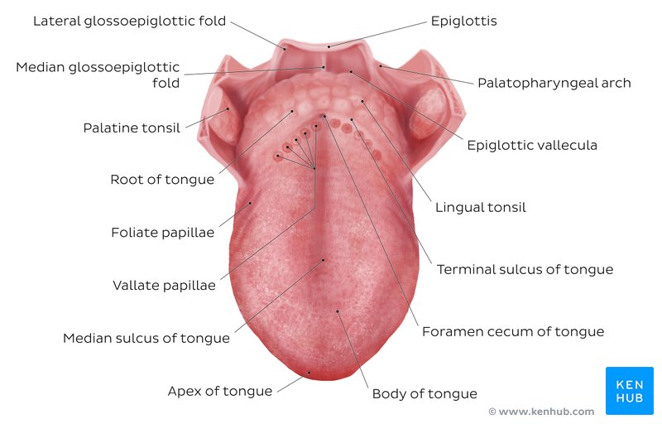

PARTS OF THE TONGUE

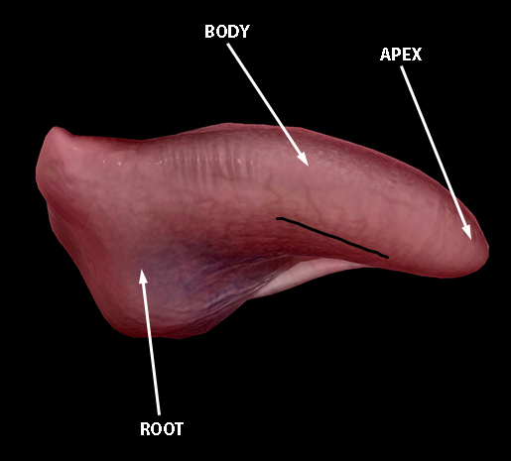
The tongue has 3 main parts:
- The apex or tip
- The body
- The base
- The apex or tip: it is the most anterior and most mobile aspect of the tongue. It is the anterior end of the body, which at rest lies behind the incisor teeth.
- The body: the tip is followed by the body of the tongue. It has a rough dorsal(superior) surface and a smooth (ventral) surface.
- note: The body and apex of the tongue are extremely mobile.
- The base: it is the most posterior part of the tongue. It is populated by numerous lymphoid aggregates known as the lingual tonsils along with foliate papillae along the posterolateral surface.
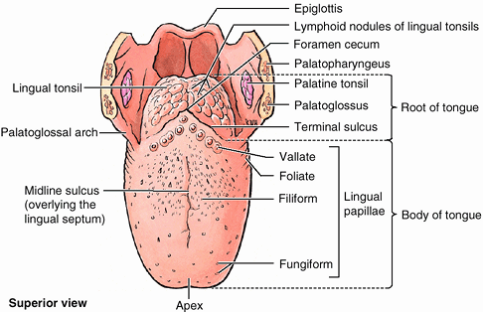
The dorsum (dorsal surface) of the tongue:
The dorsum of the tongue is convex. It is characterized by a V-shaped groove called the terminal sulcus or groove (sulcus terminalis). Posterior to this groove is foramen cecum. This foramen cecum, a small pit which is frequently absent, is the non-functional remnant of the proximal part of the embryonic thyroglossal duct from which the thyroid gland developed
The terminal sulcus divides the dorsum of the tongue into the:
- anterior (oral) part in the oral cavity proper
- posterior (pharyngeal) part in the oropharynx

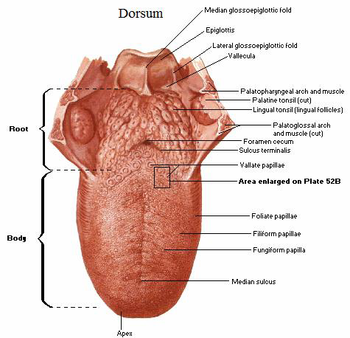

Oral part
The anterior part of the tongue includes the apex and body of the organ. It terminates at the sulcus terminalis.
The mucous membrane on the anterior part of the tongue is rough because of the presence of numerous small lingual papillae (small nipple like process). The four types of papillae include:
- Vallate papillae: Large and flat topped, they lie directly anterior to the terminal sulcus and are arranged in V-shape. It is the largest among papillae.
- Foliate papillae: Small lateral folds of the lingual mucosa. They are poorly developed in humans
- Filiform papillae: Long and numerous. They make up the majority of the papillae and covers the anterior part of the tongue. They contain afferent nerve endings that are sensitive to touch and facilitate mastication.
- Fungiform papillae: Mushroom shaped pink or red spots, they are scattered among the filiform papillae but are most numerous at the apex and margins of the tongue.
Vallate, foliate, and most of the fungiform papillae contain taste receptors in the taste buds.
A shallow midline groove of the tongue divides the tongue into right and left halves called the median sulcus.

Pharyngeal part
The remainder of the tongue that lies posterior to the sulcus terminalis is made up by the base of the tongue.
The mucous membrane of the posterior part of the tongue is thick and freely movable
It has no lingual papillae, rather the mucous membrane has many lymphoid nodules or follicles that give this part of the tongue an irregular, cobblestone appearance. The lymphoid nodules are known collectively as the lingual tonsils.
The pharyngeal part of the tongue constitutes the anterior wall of the oropharynx.

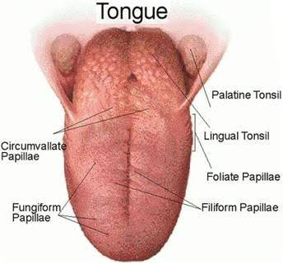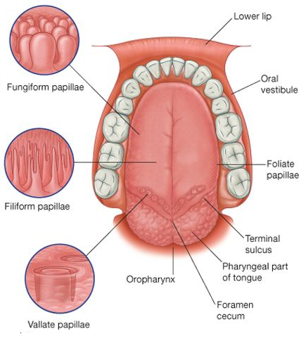

The ventral surface of the tongue
The inferior surface of the tongue is covered with a thin, transparent smooth mucous membrane through which one can see the underlying veins.
This surface is connected to the floor of the mouth by a midline fold called the frenulum of the tongue. The lingual frenulum is a thin strip of tissue that runs vertically from the floor of the mouth to the undersurface of the tongue. It allows the anterior part of the tongue to move freely but tends to limit the movement of the whole tongue.
On each side of the frenulum, there is a prominence produced by deep lingual vein, which is visible through the thin mucous membrane and more laterally there are pleated folds called plica fimbriata.

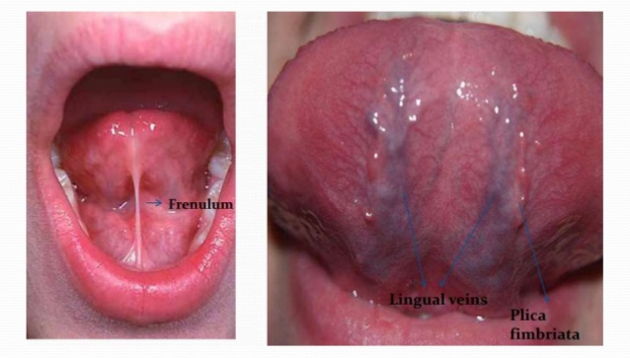
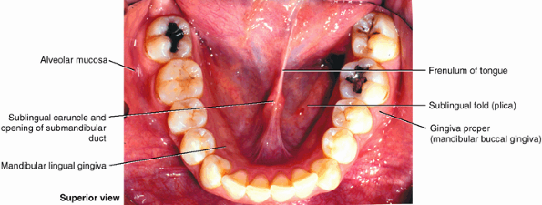

RELATIONS OF THE TONGUE
There are numerous important structures surrounding the tongue. The margin of the tongue is related on each side to the lingual gingivae and lateral teeth.
- It is limited anteriorly and laterally by the upper and lower rows of teeth
- Superiorly, it is bordered by the hard (anterior part) and soft (posterior part) palates.
- Inferiorly, by the mucosa of the floor of the oral cavity, the sublingual salivary glands and vascular bundles being located below the mucosa of the floor of the oral cavity, and the posterior wall of the oropharynx.
- Posterior to the base of the tongue is the dorsal surface of the epiglottis and pharyngeal inlet,
- The palatoglossal and palatopharyngeal arches (along with the palatine tonsils) have lateral relations to the posterior third of the tongue.

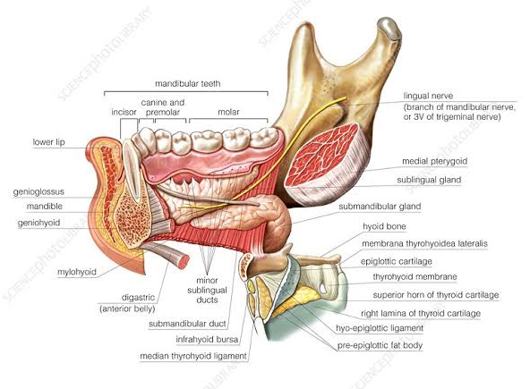

MUSCLES OF THE TONGUE
The tongue is chiefly a muscular organ with some amount of fatty and fibrous tissue distributed throughout its substance. It is mostly covered by mucous membrane.
All the muscles of the tongue are paired structures, with each copy being found on either side of the median fibrous lingual septum, which merges posteriorly with the lingual aponeurosis.
There are muscles that originate outside of the tongue and attach to it to anchor it to surrounding bony structures and alter the position of the tongue, known as extrinsic muscles. The other set of muscles are confined to each half of the organ and contribute to altering the shape of the organ; these are the intrinsic muscles. They have their attachments entirely within the tongue and are not attached to bone.
Extrinsic Muscles of the Tongue
These include:
- genioglossus
- Hyoglossus
- styloglossus
- palatoglossus

Intrinsic Muscles of the Tongue
They include:
- superior longitudinal muscle
- inferior longitudinal muscle
- transverse muscle
- vertical muscles

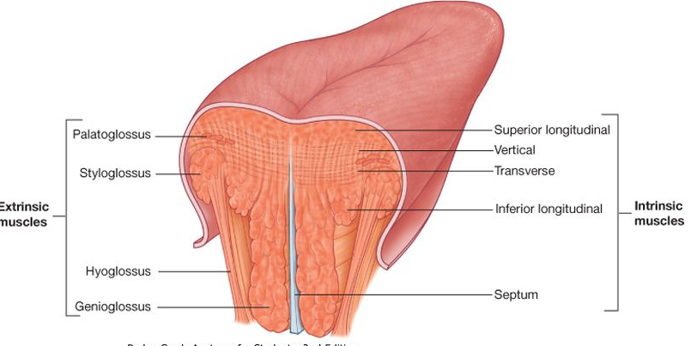

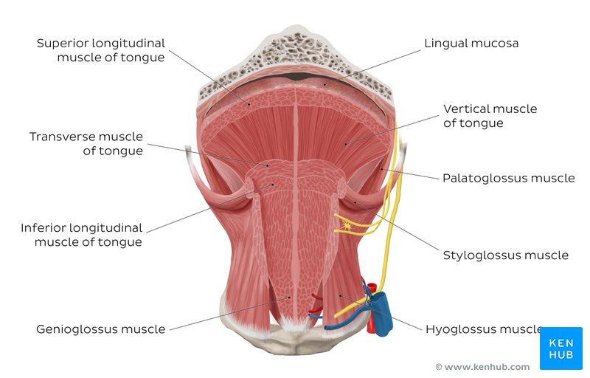

Intrinsic tongue muscles
The intrinsic tongue muscles are responsible for adjusting the shape and orientation of the organ. The intrinsic tongue muscles can operate independently, or in combination with each other to give rise to numerous shapes. This is an important feature of the tongue as it facilitates molding of the food particles into a bolus in preparation for deglutition and speech.

It is made up of four paired muscles, which are (in a dorsoventral manner):
- The superior longitudinal muscles: are made up of a thin layer of muscle fibres traveling in a mixture of oblique and longitudinal axes just deep to the superior mucosal surface of the organ. These fibres arise from the median fibrous septum as well as the fibrous layer of submucosa from the level of the epiglottis. They eventually insert along the lateral and apical margins of the organ. These muscles are responsible for retracting and broadening the tongue, as well as elevating the tip of the tongue. The net effect of these muscles results in shortening of the organ.
- Vertical muscles: they occupy the dorsoventral plane of the tongue deep to the superior longitudinal muscles. They arise from the root of the tongue and genioglossus muscle and insert into the median fibrous septum, along the entire length of the organ. These muscles facilitate flattening and widening of the tongue.
- Transverse muscles: Deep to the ventral muscles is the layer of transverse muscles of the tongue. They take a lateral route, extending from either side of the medial lingual septum (origin) to the fibrous submucosa along the lateral margins of the tongue (insertion). As these muscles contract, they cause the tongue to narrow and elongate.
- Inferior longitudinal muscles: the inferior longitudinal muscles travel above the ventral submucosa of the tongue. These fibres travel between hyoglossus and genioglossus as it arises from the base of the tongue and body of the hyoid bone. The fibres end in the apex of the tongue; allowing the muscle to pull the tip of the tongue inferiorly and also shortening the organ.

S/N | MUSCLE | ORIGIN | INSERTION | BLOOD SUPPLY | INNERVATION | ACTION
1 | SUPERIOR LONGITUDINAL MUSCLE | Submucosa of posterior tongue, Lingual septum | Apex/anterolateral margins of tongue | Lingual branch of external carotid artery | Hypoglossal nerve (CN XII) | Retracts and broadens tongue, elevates apex of tongue
2 | VERTICAL MUSCLES | Root of tongue,  genioglossus muscle | Lingual aponeurosis | Lingual branch of external carotid artery | Hypoglossal nerve (CN XII) | Broadens and elongates tongue
3 | TRANSVERSE MUSCLES | Lingual septum | Lateral margin of tongue | Lingual branch of external carotid artery | Hypoglossal nerve (CN XII) | Narrows and elongates tongue
4 | INFERIOR LONGITUDINAL MUSCLES | Root of tongue, body of hyoid bone | Apex of tongue | Lingual branch of external carotid artery | Hypoglossal nerve (CN XII) | Retracts and broadens tongue, lowers apex of tongue

Extrinsic tongue muscles
While the shape of the tongue is determined by the intrinsic muscles of the tongue, movement of the organ within (and out of) the oral cavity is dependent on the extrinsic tongue muscles. The extrinsic muscles play an important role in pressing and molding the food bolus in preparation for the initial phase of swallowing. Additionally, they are used to move the bolus posteriorly into the oropharyngeal inlet. Furthermore, the action of palatoglossus closes off the oropharyngeal isthmus in order to prevent food from moving cranially during swallowing. Although some of these muscles are able to act in isolation, it is the combined effect of all the intrinsic and extrinsic muscles that allows the tongue to have significant flexibility.
There are four pairs of extrinsic muscles, which can be viewed as those arising from above the tongue, and those that originate from below the tongue.
Styloglossus and palatoglossus are the two muscles arising from above.
- Palatoglossus is anatomically a part of the pharyngeal group of muscles. However, its attachments to the tongue mean that it is also an extrinsic tongue muscle. It originates from the oral part of the aponeurosis of the soft palate. At its insertion in the lateral margins of tongue, the muscle is wider than along its middle section. Its role as an extrinsic tongue muscle is to elevate the dorsal surface of the tongue, and (while working synergistically with the contralateral palatoglossus) to act as a sphincter at the oropharyngeal isthmus.
- Styloglossus originates from the anterolateral surface of the styloid process. It contributes to the stylomandibular ligament, and also assists in retraction of the tongue (moving it posterosuperiorly). It is the smallest and shortest of the three styloid muscles. At the lateral margin of the tongue, the muscle bifurcates into longitudinal and oblique components. The former pierces the tongue on the dorsolateral aspect and integrates with the inferior longitudinal muscle; while the latter crosses over and decussates with hyoglossus.
Genioglossus and hyoglossus arise from below.
- Genioglossus originates from a slender tendon that is attached to the superior genial tubercle found on the inner surface of the symphysis menti. This attachment prevents the tongue from falling backward and obstructing the airway when an individual is supine. The lower fibres of the muscle also have indirect attachments to the anterior part of the body of the hyoid bone via its slender aponeurosis. It is a triangular, midline structure that travels posterosuperiorly at which point the upper fibers of the muscle interdigitate with the intrinsic muscles, before attaching along the length of the inferior surface of the tongue (extending from the root to the tip).
- Hyoglossus originates from the entire greater cornu of the hyoid bone as a slender, quadrilateral muscle. It is often accompanied by chondroglossus (may be considered as part of the hyoglossus), which arises from the base of the lesser cornu of the hyoid bone. Hyoglossus takes a vertical course cranially, where it pierces the inferolateral margins of the tongue and subsequently blends between the inferior longitudinal muscles and the styloglossus.

S/N | MUSCLE | ORIGIN | INSERTION | BLOOD SUPPLY | INNERVATION | ACTION
1 | GENIOGLOSSUS | Superior mental spine  of mandible | entire length  of dorsum of tongue,  lingual aponeurosis,  body of hyoid bone | sublingual branch of lingual artery, submental branch of facial artery | hypoglossal nerve (CN XII) | Depresses and protrudes tongue (bilateral contraction); deviates tongue contralaterally (unilateral contraction
2 | HYOGLOSSUS | body and greater horn  of hyoid bone | inferior/ventral parts of lateral tongue | sublingual branch of lingual artery, submental branch of facial artery | hypoglossal nerve (CN XII) | depresses and retracts tongue
3 | STYLOGLOSSUS | anterolateral aspect of styloid process (of temporal bone), stylomandibular ligament | blends with inferior longitudinal muscle (longitudinal part);  blends with hyoglossus muscle (oblique part) | sublingual branch of lingual artery | hypoglossal nerve (CN XII) | retracts and  elevates lateral aspects of tongue
4 | PALATOGLOSSUS | Palatine  aponeurosis of  soft palate | lateral margins of tongue, blends with intrinsic muscles of tongue | ascending palatine branch of facial artery, ascending pharyngeal artery | vagus nerve (CN X) (via branches of pharyngeal plexus) | elevates root of tongue, constricts isthmus of fauces
MOVEMENTS
Protrusion: Genioglossus on both sides acting together.
Retraction: Styloglossus and hyoglossus on both sides acting together
Depression: Hyoglossus and genioglossus on both sides acting together
Elevation: Styloglossus and palatoglossus on both sides acting together

- HISTOLOGY OF THE TONGUE
The lingual mucosa is covered by stratified squamous epithelium with varying degrees of keratinization. Since the dorsal surface of the oral tongue is more at risk for desiccation and abrasions from contact with food boluses of varying temperatures and textures, it is covered by epithelium that is keratinized. However, the ventral surface of the tongue as well as the pharyngeal part, are relatively well protected from the harsh environment. Therefore, the epithelia in these areas are non-keratinized.
The epithelium is adherent to the underlying striated muscle fibers of the tongue. There is a fibrous raphe in the midline of the tongue that marks the point of fusion of the embryonic lateral lingual swellings. Posteriorly, there is a variable amount of adipose tissue within the pharyngeal tongue.
The dorsal mucosa of the oral tongue is characterized by numerous raised structures known as lingual papillae. They give the characteristic rough appearance of the dorsal surface that is not appreciated on the ventral surface of the tongue. The pharyngeal tongue also has raised dome-like structures throughout the mucosa. However, these are lymphatic aggregates (i.e. lingual tonsils) and should not be confused with papillae.

The lingual papillae
These are projections of mucous membrane that gives the anterior part of the tongue its characteristic roughness.
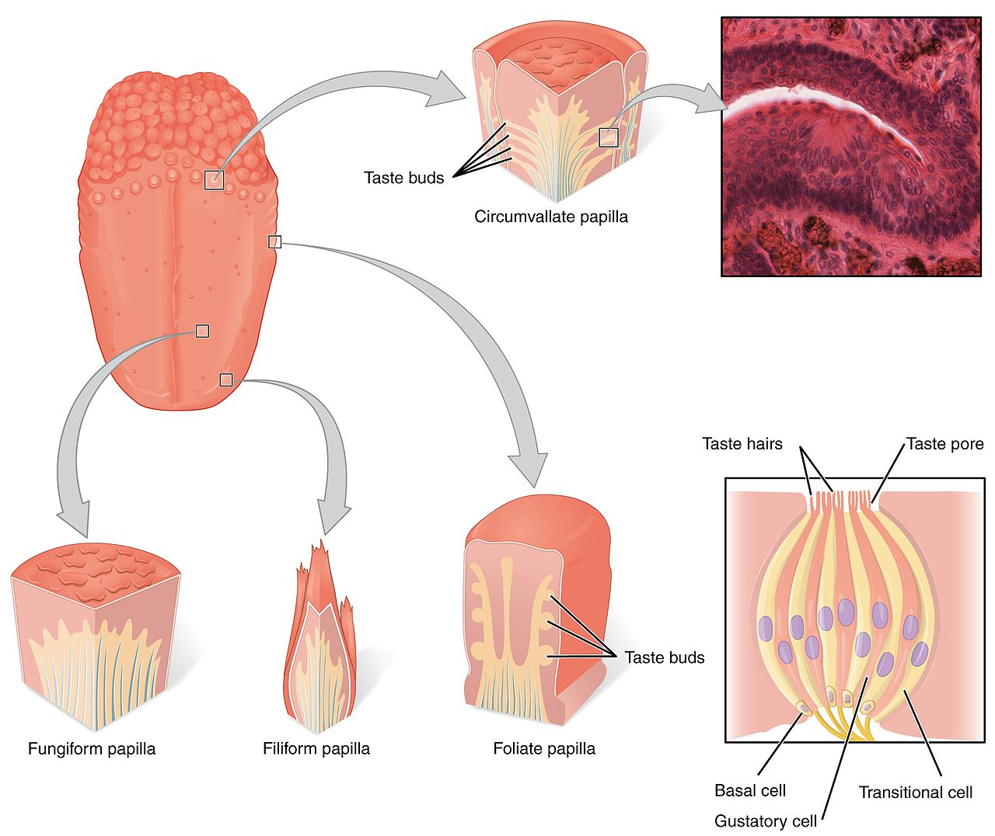
There are four types of lingual papillae found on the surface of the human tongue. These include:
- Filiform papillae are the most abundant of the four types of papillae. They are stretched, conical, grey-white papillae that are covered in a heavy coat of keratinized squamous epithelium. By making the dorsal surface of the tongue rough, these papillae provide friction to allow movement of the food bolus during chewing. These papillae do not possess taste buds.
- Fungiform papillae are weakly keratinized and less abundant than the filiform papillae. However, they are scattered across the entire dorsal surface of the tongue. These highly vascular, mushroom-shaped papillae contain a few taste buds on the apical aspect.
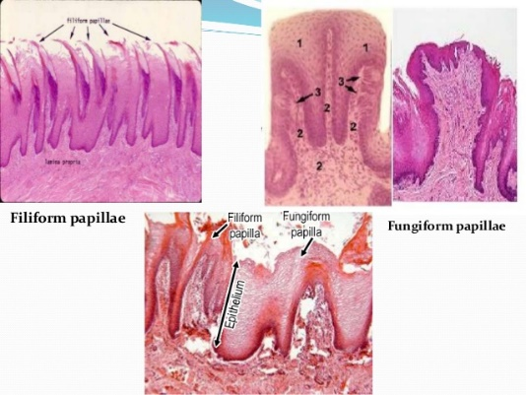
- Foliate papillae appear as bilaterally paired, parallel, longitudinal slits on the posterolateral margin of the tongue, near the sulcus terminalis. The mucosa is non-keratinized and the papillae bear numerous taste buds.
- Circumvallate (Vallate) papillae are organized linearly, as a set of four to six large papillae anterior to each limb of the sulcus terminalis (i.e. eight to twelve papillae in total). In longitudinal section, the characteristic furrow found within the papillae can be appreciated. These moats facilitate the drainage of serous salivary von Ebner glands that empty into the structure. The persistent lubrication creates a favorable environment for gustatory particles to dissolve so that they can be detected by the taste buds
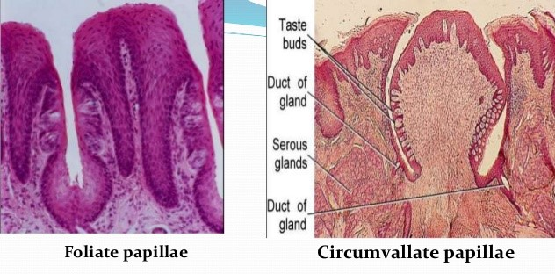

The taste buds
While taste buds are distributed throughout the entire oral cavity, they are at higher concentrations on the tongue.
Each taste bud is clear, oval and covered by stratified squamous epithelium. Each taste bud has about 10 - 14 cells whuch are a combination of elongated taste (gustatory), supportive, and basal stem cells. Majority are the gustatory (taste) cells.

- Neuroepithelial taste cells or gustatory cells in taste buds
They are modified columnar elongated cells that act as receptors. They have darkly-stained elongated central nuclei.
The gustatory cells have an apical taste pore surrounded by numerous microvilli that binds dissolved molecules and brings them closer to the receptors responsible for taste. However, these cells have a relatively high turnover rate, as their shelf life is roughly seven to ten days.
The base of the taste cells os surrounded by sensory nerve fibres that carry the impulses of taste sensation to the brain. There are five gustatory sensations that are perceived by individuals. These are sweet, salty, sour, bitter, and umami(savoury).
- Sweetness is detected at the apex
- saltiness at the anterolateral margins
- sourness at the posterolateral margins
- bitterness at the posterior part of the tongue

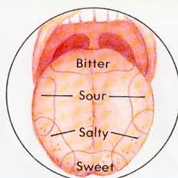

The microvilli found on the apical surface of the taste cells are equipped with various receptors that bind to varying molecules. The reaction generated from this compound-receptor interaction gives rise to varying action potentials that are subsequently perceived as taste. Saltiness is often associated with the cationic component of a compound (i.e. sodium ions), while sourness is related to the acidity (concentration of hydrogen ions) in the compound. Organic compounds such as carbohydrates or amino acids give rise to sweet taste, while bitterness is associated with long-chain organic compounds. The final taste umami (also known as savory), is related to compounds with the left-handed chiral isomer of glutamic acid.
- Supporting cells in taste buds
They ae elongated columnar cells with dark cytoplasm and lightly-stained nuclei. They form the outer wall of the taste bud. Long microvilli extend from surfaces into the taste pore.
- Basal cells
They act as stem cells for renewal of taste cells and supporting cells.

- VASCULATURE OF THE TONGUE
Arterial supply
The vascular supply to the tongue muscles is provided majorly by derivatives of the lingual artery. The lingual artery is supported by other branches of the external carotid artery. The facial artery gives off the ascending palatine and tonsillar arteries that also supply the tongue. The ascending pharyngeal branch of the external carotid artery also supplies the organ.
The lingual artery is a branch of the external carotid artery that traverses the region between the middle pharyngeal constrictor and hyoglossus in order to access the floor of the mouth. It takes a sharp superior turn at the anterior border of hyoglossus as it travels alongside CN IX. On entering the tongue, the lingual artery passes deep to the hyoglossus muscle and give rise to the:
- The dorsal lingual arteries which supply the posterior part (root). They are relatively small derivatives of the lingual artery that arise medial to hyoglossus. The dorsal lingual arteries in addition to supplying the dorsal mucosa of the tongue, also gives branches to the palatoglossus, soft palate, palatine tonsils, and epiglottis. The dorsal lingual arteries are prevented from communicating by the lingual septum.
- Emerging at the anterior limit of the hyoglossus, the sublingual arteries course between the mylohyoid and genioglossus as it travels towards the sublingual glands in the floor of the oral cavity. It supplies the sublingual gland and the floor of the mouth. As it arborizes, one of its branches anastomoses with the submental branches of the facial artery, while another traverses the gingiva(gum) of the mandible to anastomose with the analogous contralateral vessel.
- As the lingual artery terminates near the lingual frenulum on the ventral surface of the tongue, it is referred to as the deep lingual artery. the deep lingual arteries supply the anterior part. The deep lingual arteries communicate with each other near the apex of the tongue.

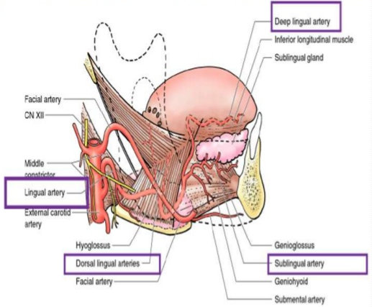

Venous drainage
The veins of the tongue are named similarly to the arteries that they accompany. They are formed from numerous venous tributaries that eventually coalesce.
- The deep lingual veins: it drains the tip of the tongue. As the deep lingual vein forms adjacent to the apex of the tongue, it courses along the ventral surface of the tongue (deep to the mucosa). It anastomoses with the sublingual vein from sublingual salivary gland to become the vena comitans of CN XII. This venous network eventually drains to the lingual vein that later join the facial or the anterior division of the retromandibular veins. Here, they form the common facial vein, which is a tributary to the internal jugular vein. Alternatively, the venae comitantes may drain directly to the internal jugular vein.
- The dorsal lingual veins are responsible for draining the lateral margins and dorsal surface of the tongue. They travel alongside the similarly named artery as they drain into the internal jugular vein.
- The sublingual veins
The sublingual veins in elderly people are often varicose (enlarged and tortuous). All the veins drain directly or indirectly into the internal jugular veins.

Lymphatic drainage of the tongue
Lymph from the tongue takes four routes
- Tip of the tongue and frenulum: drains to submental lymph nodes and then directly to deep cervical nodes.
- The lateral parts of the anterior two-third drain unilaterally to the submandibular lymph nodes.
- Lymph from the posterior third drains directly and bilaterally into the superior deep cervical lymph nodes
- Lymph from the medial part of the anterior two thirds drains directly and bilaterally to the inferior deep cervical lymph nodes
The deep cervical nodes usually involved jugulo-omohyoid and jugulo-digastric vessels.

- INNERVATION OF THE TONGUE
The tongue has multiple sources of innervation based on its embryological origins. The nerve supply to the tongue can be grouped based as efferent fibers that carry motor impulses, general sensory that conveys touch and proprioception, and special afferent that conveys gustatory impulses.
Motor innervation
- All muscles of the tongue, except the palatoglossus (actually a palatine muscle supplied by the vagus nerve(X) of the pharyngeal plexus), receive motor innervation from the hypoglossal nerve (CN XII)

Sensory innervation
The anterior two thirds of the tongue are supplied by:
- the lingual nerve (CN V₃) for general sensation
- the chorda tympani, a branch of the facial nerve (CN VII) transferring nerve fibers to the lingual nerve, for taste
The posterior third of the tongue and the vallate papillae are supplied by:
- the lingual branch of the glossopharyngeal nerve (CN IX) for both general sensation and taste
- Another contribution is made by the internal laryngeal branch of the vagus (CN X) for general sensation and taste
Hence CN VII, CN IX, and CN X provide nerve fibers for taste; those from CN VII are ultimately conveyed by CN V₃
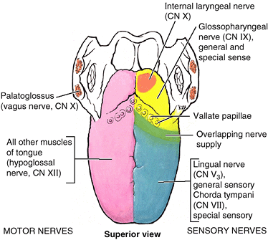

APPLIED ANATOMY
There are a handful of conditions that may be associated with the tongue, often impacting the ability to swallow or speak normally. Some are present from birth, and others may develop from an infection or exposure to cancer-causing substances. Conditions that can affect the tongue include:
- Ankyloglossa
As noted above, the lingual frenulum (from the Latin word meaning “bridle”) is a small fold of mucous membrane that connects the middle of the lower surface of the tongue to the floor of the mouth. An overly large lingual frenulum (tongue-tie/ ankyloglossa) interferes with tongue movements and may affect speech. Too short lingual frenulum, often from birth, causes the tongue to be abnormally retracted into the lower jaw. This lower position also leads to the condition ankyloglossa or tongue tied. This may be rarely checked (or simply ignored), especially if it is at the back of the tongue, and often goes untreated.
It may be recognized with early infancy swallowing problems and speech impairment at school age as the short frenulum may interfere with tongue movements and function.
In unusual cases, a frenectomy (cutting the frenulum) in infants may be necessary to free the tongue for normal movement and speech

- Genioglossus muscle paralysis
When this muscle becomes paralyzed, the tongue falls backward, potentially obstructing the airway and increasing the risk of suffocation.
Total relaxation of the tongue occurs during general anesthesia. As such, this shift of the tongue must be prevented to avoid blocking the airway. This is usually accomplished by inserting a temporary breathing tube during surgery.
- Hypoglossal nerve injury
Trauma to the lower jaw (mandible) may cause a fracture that injures the hypoglossal nerve, resulting in paralysis and eventual shrinking of one side of the tongue. After the injury, the tongue deviates to the paralyzed side when protruded.
- Lingual carcinoma
Cancer, or carcinoma, may affect the tongue. This is more likely due to infections from human papillomavirus (HPV) or from the use of tobacco, including chewing or smoking. ﻿
A lingual carcinoma in the posterior part of the tongue metastasizes to the superior deep cervical lymph nodes on both sides, whereas a tumor in the anterior part usually does not metastasize to the inferior deep cervical lymph nodes until late in the disease. Because these nodes are closely related to the IJV, metastases from the tongue may be widely distributed through the submental and submandibular regions and along the IJVs in the neck.
Cancers of the tongue may require surgical treatment, radiation therapy, and even chemotherapy if metastatic.
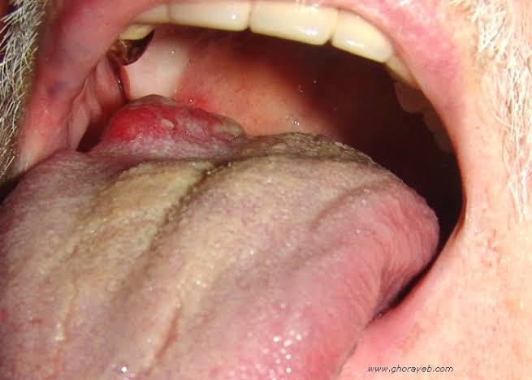

- Lingual thyroid nodule / Aberrant thyroid gland
The thyroid gland typically descends within the embryo along the thyroglossal duct. In some cases, remnants of the thyroid gland may remain behind, resulting in an anomous condition in which follicles of thyroid tissue are found in the substance of the tongue. It occurs when thyrod anlage (primordium) that failed to migrate to its predestined position or from anlage remnants that became detached and were left behind. It appears as a nodular mass in or near the base of tongue just posterior to foramen caecum or even in the neck.
Chief symptoms are dysphagia, dyspnea, dysphonia or fullness of throat.
Treatment include surgical excision, suppressive therapy with supplemental thyroid hormone can reduce the size of the lesion. Long-term thyroid replacement for post-surgical hypothyroidism is necessary

- Thyroglossal duct cyst
Rarely, there can be a cystic remnant of the thyroglossal duct found within the root of the tongue. Most of these cysts are in the neck, close or just inferior to the body of the hyoid bone, producing a painless swelling of the neck at the midline. It may connect with a fistula to the skin’s surface, leading to a non-healing sore (called a thyroglossal fistula) at the neck.
Surgical excision of the cyst may be necessary for the resolution of the problem.
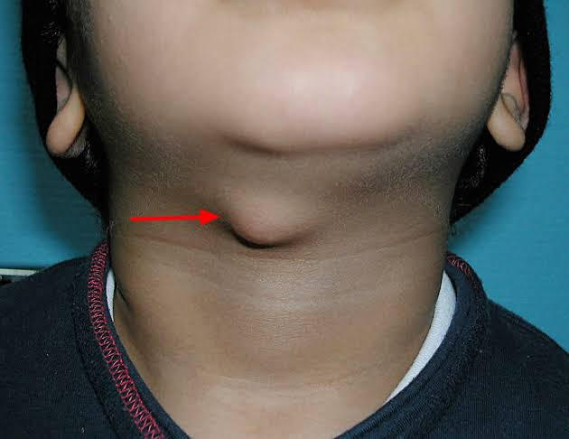
- Pierre robin syndrome
A particular pharyngeal arch defect known as pierre robin syndrome cause glossoptosis (abnormal downward displacement or retraction of the tongue) among other syptoms. This particular defect causes the tongue to bedisplaced posteriorly and may cause airway obstruction or apnea.
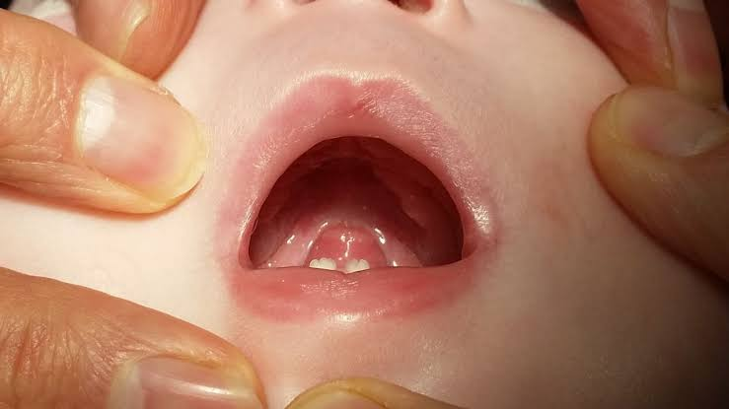

- Candidiasis
A yeast infection commonly known as thrush is caused by Candida albicans that may cause a white-colored plaque on the mucosa lining the tongue and mouth. It occurs more among the immune-suppressed, especially among the young and old.
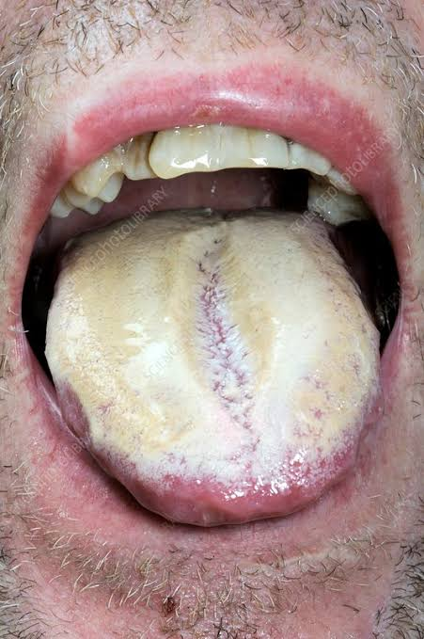

- Hairy tongue syndrome
Hairy tongue is a condition of defective desquamation of the filiform papillae.
The tongue may appear white or black due to overgrowth of the papillae on the dorsal surface of the tongue, usually due to lack of mechanical stimulation and debridement.
It often occurs in individuals with poor oral hygiene. Other contributory factors include tobacco use, tea or coffee drinking which accounts for various colours associated with it.
A thorough scraping may clear off the debris and resolve the unpleasant appearance and associated smell.
HAIRY TONGUE SYNDROME
- Macroglossia
Literally a big tongue, this condition may affect the ability to swallow or breathe normally. It may occur in the setting of Down syndrome, weight gain, or hypothyroidism.
- Microglossia
The presence of an abnormally small tongue.
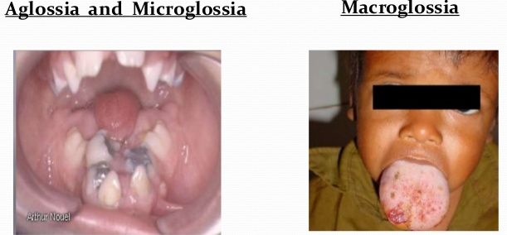
- Geographic tongue
A patchy appearance on the surface of the tongue with ridges and colored spots that migrate over time. Though harmless, it may initially seem concerning.
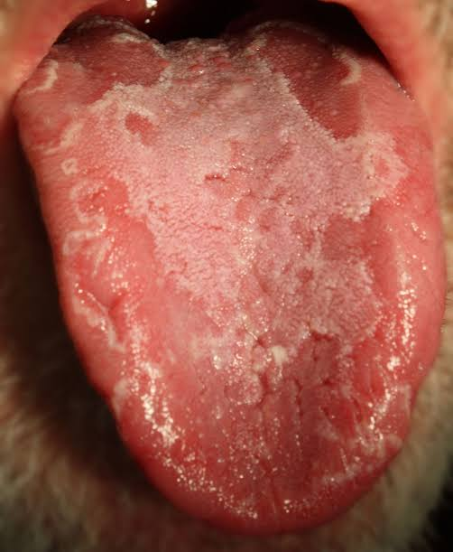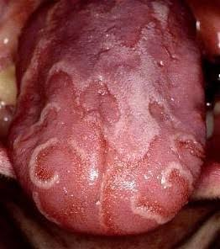
- Burning mouth syndrome
Like it sounds, the symptoms can be unpleasant and causes may be occasionally serious.
- Sleep apnea
The tongue size a00nd position may increase the risk for sleep apnea due to obstruction of airflow within the throat.
QUESTION 2
AIR SINUSES
A sinus is a cavity or hollow space in bone or other tissues.
There are many types of sinuses, for example, paranasal, or in the cerebral meninges, dural sinuses. There are also pericardial sinuses that are important to cardiothoracic surgeons so that they can place a ligature around certain vessels to occlude them during surgery. Other sinuses are found in the kidney, and lymphatic system.
PARANASAL SINUSES
The paranasal sinuses are air-ﬁlled extensions of the respiratory part of the nasal cavity into the following cranial bones: frontal, ethmoid, sphenoid, and maxilla. They are named according to the bones in which they are located. The sinuses continue to invade the surrounding bone, and marked extensions are common in the crania of older individuals.
Respiratory mucosa (lined with pseudostratified columnar epithelium) lines the paranasal sinuses. This respiratory mucosa is ciliated and secretes mucus.
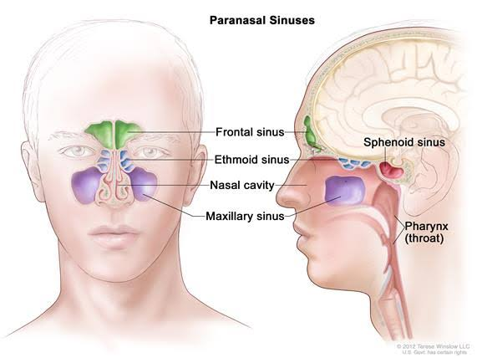

There are 4 paired sinuses in humans. They are:
- The maxillary sinuses: Largest of the paranasal sinuses, located under the eyes in the maxillary bones.
- The frontal sinuses: Located superior to the eyes within the frontal bone
- The ethmoid sinuses: Formed from several discrete air cells within the ethmoid bone between the nose and eyed
- The sphenoid sinuses: Located within the sphenoid bone
The function of the paranasal sinuses is debated. However, they are implicated in several roles, which include:
- Decreasing the relative weight of the skull
- Increasing the resonance of the voice
- Providing a buffer against facial trauma
- Insulating sensitive structures from rapid temperature fluctuations in the nose
- Humidifying and heating inspired air
- Immunological defense

- MAXILLARY SINUSES
The maxillary sinuses are the largest of the paranasal sinuses. There are 2 pyramidal-shaped maxillary sinuses located bilaterally under the eyes in the maxilla of the face. It fills the bone in its entirety to reduce the mass of the maxilla. They occupy the bodies of the maxillae and opens into the center of the semilunar hiatus found in the lateral wall of the middle nasal meatus.
- The apex of the maxillary sinus extends toward and often into the zygomatic bone.
- The base of the maxillary sinus forms the inferior part of the lateral wall of the nasal cavity.
- The roof of the maxillary sinus is formed by the ﬂoor of the orbit.
- The ﬂoor of the maxillary sinus is formed by the alveolar part of the maxilla. The roots of the maxillary teeth, particularly the ﬁrst two molars, often produce conical elevations in the ﬂoor of the sinus.
- the medial border is made up of the nasal cavity
- lateral and anterior border are limited by the cheekbones.
- Posteriorly, two anatomical spaces known as the pterygopalatine fossa and the infratemporal fossa exist.
- The arterial supply of the maxillary sinus is mainly from anterior, middle and posterior superior alveolar branches of the maxillary artery. However, branches of the descending and greater palatine arteries (branches of facial artery) supply the ﬂoor of the sinus.
- The maxillary vein supplies venous drainage.
- The submandibular lymph nodes are the main destination during lymphatic drainage.
Each maxillary sinus drains by one or more openings, the maxillary ostium (ostia), into the ethmoidal infundibulum, which opens into the middle nasal meatus of the nasal cavity by way of the semilunar hiatus. There is typically only one ostium per maxillary sinus; however, cadaver studies have shown 10% to 30% have an accessory ostium.
- Innervation of the maxillary sinus is from the anterior, middle, and posterior superior alveolar nerves, which are branches of the maxillary nerve (CN V₂).
The size of the maxillary sinus at adult stage is approximately 15 mL, making it the largest paranasal sinus.

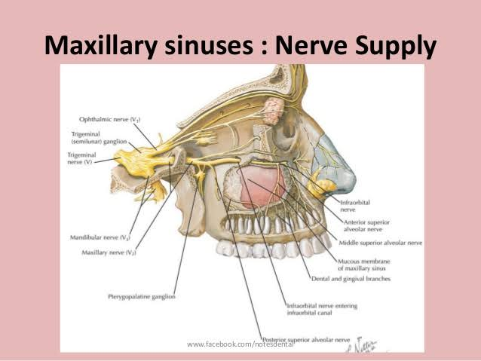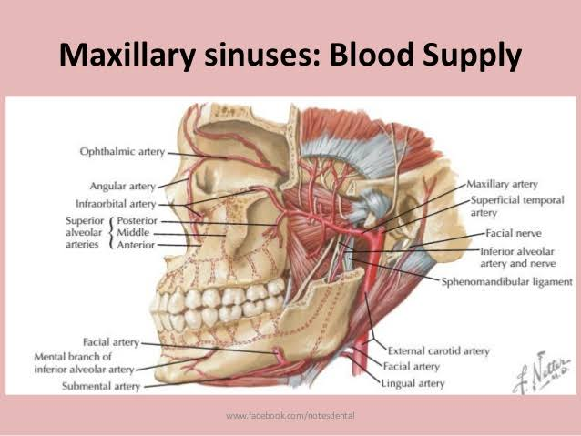

- FRONTAL SINUSES
The triangular-shaped (tight and left) frontal sinuses are found in the frontal bone superior to the orbits. The right and left frontal sinuses are between the outer and inner tables of the frontal bone, posterior to the superciliary arches and the root of the nose
These sinuses vary in size. This pair of sinuses are irregular in shape when compared to one another and is underdeveloped at birth. They reach their full size and shape around seven to eight years of age. Frontal sinuses are usually detectable in children by 7 years of age.
- Anteriorly, the frontal sinuses are contained by the forehead and the superciliary arches.
- superiorly and posteriorly by the anterior cranial fossa
- Inferiorly by the bony orbit, the anterior ethmoidal sinuses and the nasal cavity.
- Medially the sinuses face one another, separated by the midline

The right and left frontal sinuses are rarely of equal size, and the septum between them is not usually situated entirely in the median plane. The frontal sinuses vary in size from approximately 5 mm to large spaces extending laterally into the greater wings of the sphenoid.
Often a frontal sinus has two parts:
- a vertical part in the squamous part of the frontal bone and
- a horizontal part in the orbital part of the frontal bone
- Arterial supply: is by the supraorbital, supratrochlear and anterior ethmoidal arteries
- Venous drainage is by ophthalmic and supraorbital veins.
- Innervation: The frontal sinuses are innervated by ophthalmic nerve, including the branches of the supra-orbital and supratrochlear nerves (CN V1).
- Lymphatic drainage: The right and left sinuses each drain through a frontonasal duct into the ethmoidal infundibulum, which opens into the semilunar hiatus of the middle nasal meatus. They open at the lateral wall of the middle meatus which then continues as the semilunar hiatus, which drains the maxillary sinus.

Several anatomical spaces/structures are important to frontal sinus anatomy:
- Frontal recess: Drainage space between the frontal sinus and semilunar hiatus that is bounded by the posterior wall of the agger nasi cell, lamina papyracea, and the middle turbinate.
- Frontal sinus infundibulum: Space that drains into the frontal recess that is located superior to the agger nasi cells
- Frontal cells: anterior ethmoid cells that pneumatize the frontal recess. These cells may cause obstruction or persistent sinus disease. They are located posterior and superior to the agger nasi cell, and there are 4 types as classified by Bent and Kuhn:
- Type I: Single cell above the agger nasi cell but below the floor of the frontal sinus
- Type II: Multiple cells above the agger nasi, may extend into the frontal sinus
- Type III: Single large cell that extends supraorbitally through the floor of the frontal sinus, attaches to the anterior table
- Type IV: Single isolated cell that is contained within the frontal sinus

- ETHMOIDAL SINUSES
The ethmoidal cells (sinuses) are small invaginations of the mucous membrane of the middle and superior nasal meatus into the ethmoid bone between the nasal cavity and the orbit.
- Superior to the ethmoidal sinus is the anterior cranial fossa and the frontal bone,
- laterally the orbit can be found
- the nasal cavity is situated medially
The ethmoid sinuses are unique because they are the only paranasal sinuses that are more complex than just a single cavity. On each side of the midline, anywhere from three to eighteen ethmoidal air cells may be grouped together. These air cells are smaller individual sinuses grouped together to form one large one which encompass the anterior, middle and posterior nasal meatuses.
The ethmoidal cells usually are not visible in plain radiographs before 2 years of age but are recognizable in CT scans.
- Arterial supply: The ethmoid sinuses are supplied by the anterior and posterior ethmoid arteries, respectively. These arteries are branches of the ophthalmic artery, which is a branch off of the internal carotid artery. This is an important anatomical relationship to realize because endovascular embolization of the ethmoid arteries should be avoided when treating epistaxis due to the possibility of retrograde movement of the embolization material into the internal carotid artery resulting in possible Cerebrovascular Accident (CVA, also called Stroke). The posterior lateral nasal branches also provide an ample blood supply.
- Venous drainage: is by maxillary and ethmoid veins.
- Lymphatic drainage:
- The anterior ethmoidal cells drain directly or indirectly into the middle nasal meatus through the ethmoidal infundibulum.
- The middle ethmoidal cells open directly into the middle meatus and are sometimes called “bullar cells” because they form the ethmoidal bulla, a swelling on the superior border of the semilunar hiatus.
- The posterior ethmoidal cells sends its own to the retropharyngeal lymph nodes and open directly into the superior meatus.
- Innervation: The ethmoidal cells are supplied by the anterior and posterior ethmoidal branches of the nasociliary nerves (CN V1). The posterior lateral superior and inferior nasal nerves help innervate it.
NOTE: The ethmoid bulla is the largest of the anterior ethmoid cells that lies above the infundibulum. This structure is important because the anterior ethmoid artery courses over the roof of this cell.
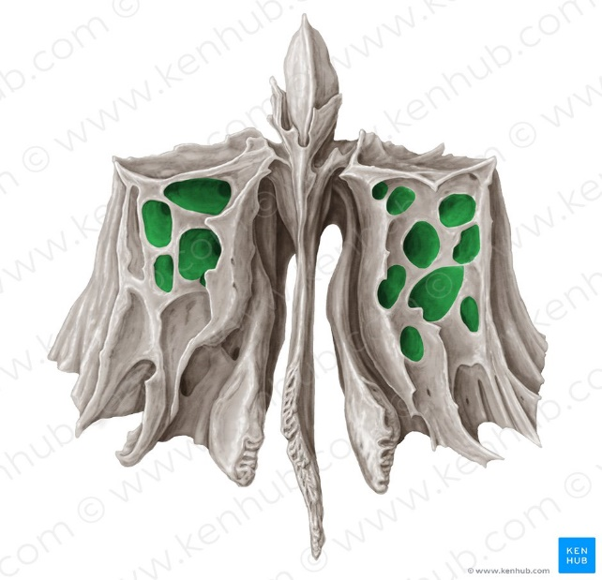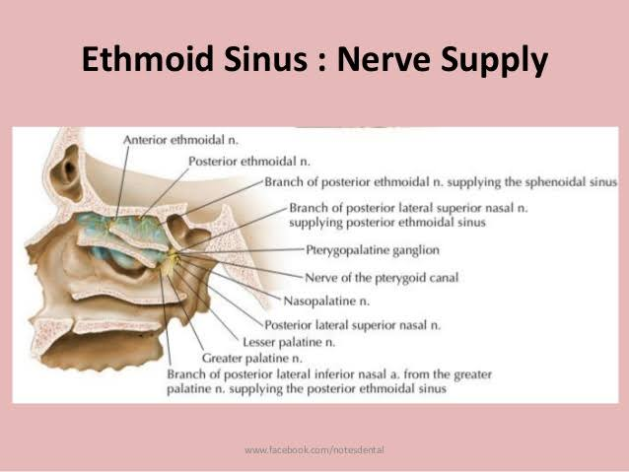
- SPHENOIDAL SINUSES
The most posterior of all the sinuses in the head, the sphenoidal sinuses are large and irregular, just like their septum, which is made by the sphenoid bone. The sphenoidal sinuses are located centrally and posteriorly within the body of the sphenoid, but they may extend into the wings of this bone. They are unevenly divided and separated by a bony septum. Because of this extensive pneumatization (formation of air cells), the body of the sphenoid is fragile. Only thin plates of bone separate the sinuses from several important structures:
- the optic nerves and optic chiasm. The optic nerve is also located adjacent to the lateral wall of the sinus and can be dehiscent in up to 5% of individuals.
- the pituitary gland
- the internal carotid arteries, and in 25% of patients, it is dehiscent (rupture) in this area
- the cavernous sinuses.
The sphenoidal sinuses are derived from a posterior ethmoidal cell that begins to invade the sphenoid at approximately 2 years of age. In some people, several posterior ethmoidal cells invade the sphenoid, giving rise to multiple sphenoidal sinuses that open separately into the sphenoethmoidal recess located within the superior meatus.
- Arterial supply: The posterior ethmoidal arteries and the posterior lateral nasal branches supply the sphenoidal sinuses.
- Venous drainage: is via the maxillary vein.
- The lymphatic drainage occurs in the same way as the posterior ethmoid sinus.
- Innervation:The posterior ethmoidal nerve and the orbital branch of the pterygopalatine ganglion innervate them.

CLINICAL ANATOMY
- When there is trauma to the face, the paranasal sinuses can act as a “crumple zone” protecting the more delicate structures of the brain from injury.
- This ethmoidal bulla is important because the anterior ethmoid artery courses over the roof of this cell. Hence, damage to the ethmoidal bulla would injure the anterior ethmoid artery leading to haemorrhage.
- The ethmoid sinuses are supplied by the anterior and posterior ethmoid arteries, respectively. These arteries are branches of the ophthalmic artery, which is a branch off of the internal carotid artery. This is an important anatomical relationship to realize because endovascular embolization of the ethmoid arteries should be avoided when treating epistaxis due to the possibility of retrograde movement of the embolization material into the internal carotid artery resulting in possible Cerebrovascular Accident (CVA, also called Stroke).
- Sinusitis
Paranasal sinuses are prone to inflammation and infection.
Sinusitis is an extremely common outpatient case which presents as an inflammation of the epithelia of the sinuses. The causes can be either viral or bacterial infection, or an allergic reaction. The drainage of mucus is interrupted. The inflammation can be acute or chronic.
Maxillary sinuses are the most frequently affected. The maxillary sinus may be involved from any process in the teeth or the gums. The frontal and maxillary sinuses may be involved in allergies.
Depending on the cause, sinusitis is treated with antivirals, antibiotics and antihistamines, including corticosteroids, decongestant, nasal irrigation, and hydration. Rarely surgical intervention may be required to enhance drainage.
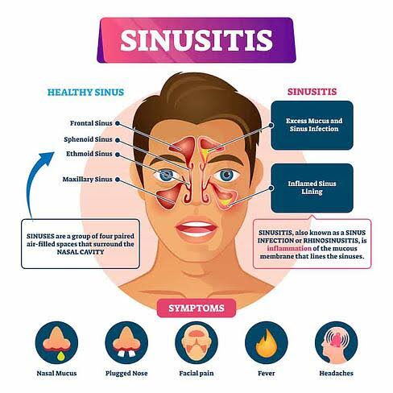
- Malignancies of the paranasal sinuses
Malignancies of the paranasal sinuses are rare. The majority of cancers occur in the maxillary sinus and are more common in men than women. Maxillary sinus malignancies occur between ages 45 to 70, and the most frequent is a sarcoma. Even though metastases are rare, these malignancies are locally invasive and destructive. Diagnosis in most cases is delayed, and the prognosis is poor.
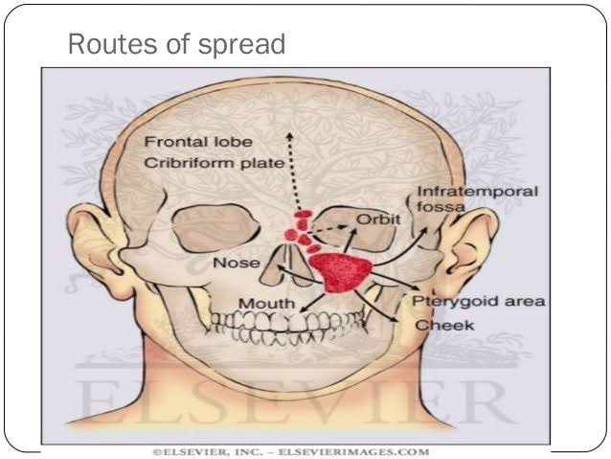

- Acute rhinosinusitis (ARS) and chronic rhinosinusitis (CRS)
Acute rhinosinusitis (ARS) and chronic rhinosinusitis (CRS) are both defined as symptomatic inflammation of the nose and paranasal sinuses. The two are distinguished based on the duration of the complaints. Generally speaking, acute rhinosinusitis is widely considered to be an infectious disorder. On the other hand, chronic rhinosinusitis is typically defined as an inflammatory disorder.
In ARS, the underlying etiology is typically viral or bacterial, and occasionally fungal. The pathogenesis of ARS involves infection followed by tissue invasion.
The most widely accepted classification system divides CRS into CRS with and without nasal polyps (CRSwNP and CRSsNP, respectively) based on nasal endoscopy. Originally, it was felt that CRSsNP was a disease process characterized by persistent inflammation that led to incomplete resolution of ARS. CRSwNP, on the other hand, was felt to be a noninfectious disease process with unclear etiology, perhaps related to atopy. Current research has instead revealed that the etiology and pathogenesis of either form of CRS is much more complex.
