ADEBARA FAITH INUMIDUN
17/SCI05/001
MEDICINE AND SURGERY
300 LEVEL
2019/2020

ASSIGNMENT:
- Write an essay on the cavernous sinus
- Discuss the walls of the nose

Question 1
The dural venous sinuses are venous channels found between the periosteal and meningeal layers of dura matter in the brain which are responsible for the venous drainage of the brain, skull, orbit and internal ear. The blood in the dural sinuses ultimately drains into the internal jugular veins in the neck. They are lined by endothelium, and their walls are thick but devoid of muscular tissue. They have no valves.
These sinuses include: Superior and Inferior sagittal sinuses, Straight sinus, Sigmoid sinus, Transverse sinuses, Superior and inferior petrosal sinuses, Cavernous sinuses, Intercavernous sinuses, Sphenoparietal sinus, Basilar sinus.

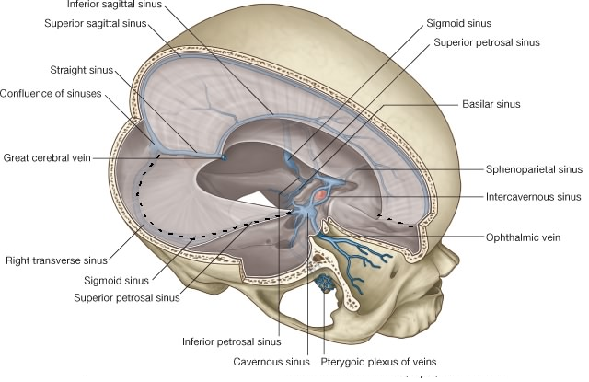

CAVERNOUS SINUSES
The human brain is a highly vascular organ responsible for coordinating a myriad of processes throughout the body. Therefore, it is important that a pathway exists to return blood that enters the cranium to systemic circulation. The left and right cavernous sinuses are one of several drainage pathways for the brain that sits in the middle. In addition to receiving venous drainage from the brain, it also receives tributaries from parts of the face.
Functions
- The cavernous sinus works as a conduit. Cranial nerves leaving the brainstem travel through the cavernous sinus before entering the orbit to innervate extraocular and intrinsic eye muscles
- Also, different venous tributaries drain into the cavernous sinus. They are the superior ophthalmic vein, the anterior branch of the inferior ophthalmic vein, the superficial middle cerebral vein, the sphenoparietal sinus and Efferent hypophyseal veins.
- After collecting venous blood from these different veins, the cavernous sinus drains to the superior and inferior petrosal sinuses, which then join the sigmoid sinus to form the internal jugular vein. The internal jugular vein exits the brain through the jugular foramen and connects with the subclavian vein to become the right or left brachiocephalic vein
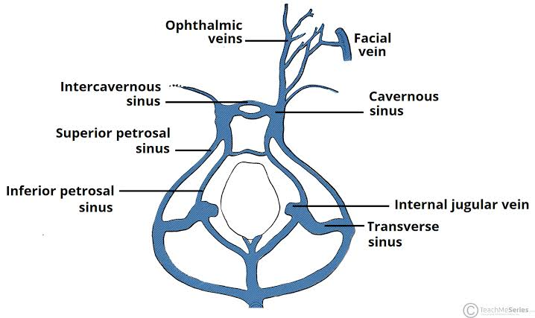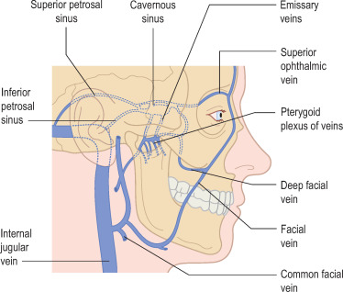
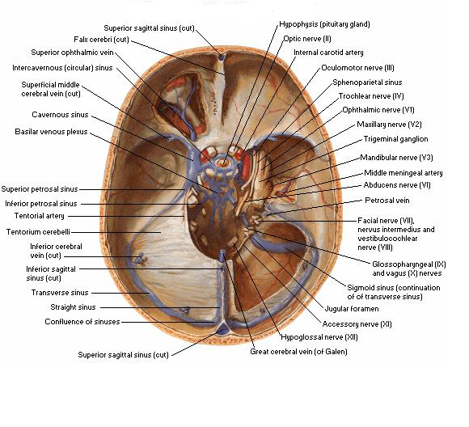
Location
The cavernous sinus is located in the middle cranial fossa, on either side of the Sella turcica (or pituitary fossa) of the sphenoid bone. It extends from the superior orbital fissure anteriorly to the petrous part of the temporal bone posteriorly, and is about 1 cm wide and 2 cm long. Although they are not truly trabeculated cavities like the corpora cavernosa of the penis, the numerous plexuses, however, give the cavities their characteristic sponge-like appearance.

Borders
Anterior- superiororbital fissure
Posterior- petrous part of the temporal bone
Medial- body of the sphenoid
Lateral – meningeal layer of the dura matter running from the roof to the floor of the middle cranial fossa
Roof- meningeal layer of the dura matter that attaches to the anterior and middle clinoid process of the sphenoid bone
Floor- endosteal layer of dura matter that overlies the base of the greater wing of the sphenoid bone.
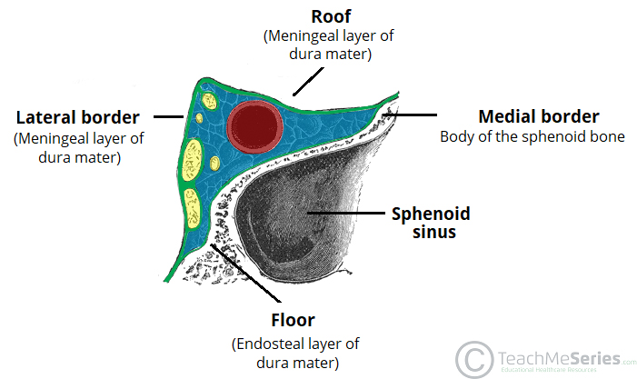

Structures passing through each cavernous sinus from medial to lateral are:
- Internal carotid artery
- Abducent nerve [CN VI]
Structures in the lateral wall of each cavernous sinus are, from superior to inferior:
- the oculomotor nerve [CN III]
- the trochlear nerve [CN IV]
- the ophthalmic nerve [CN V₁]
- the maxillary nerve [CN V₂]
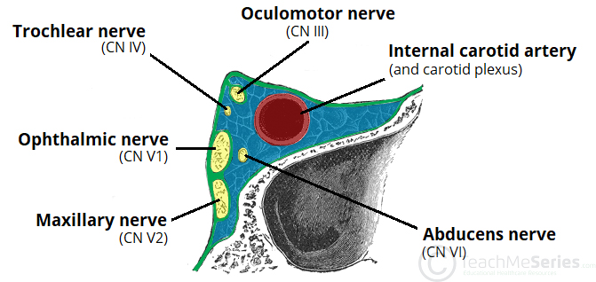
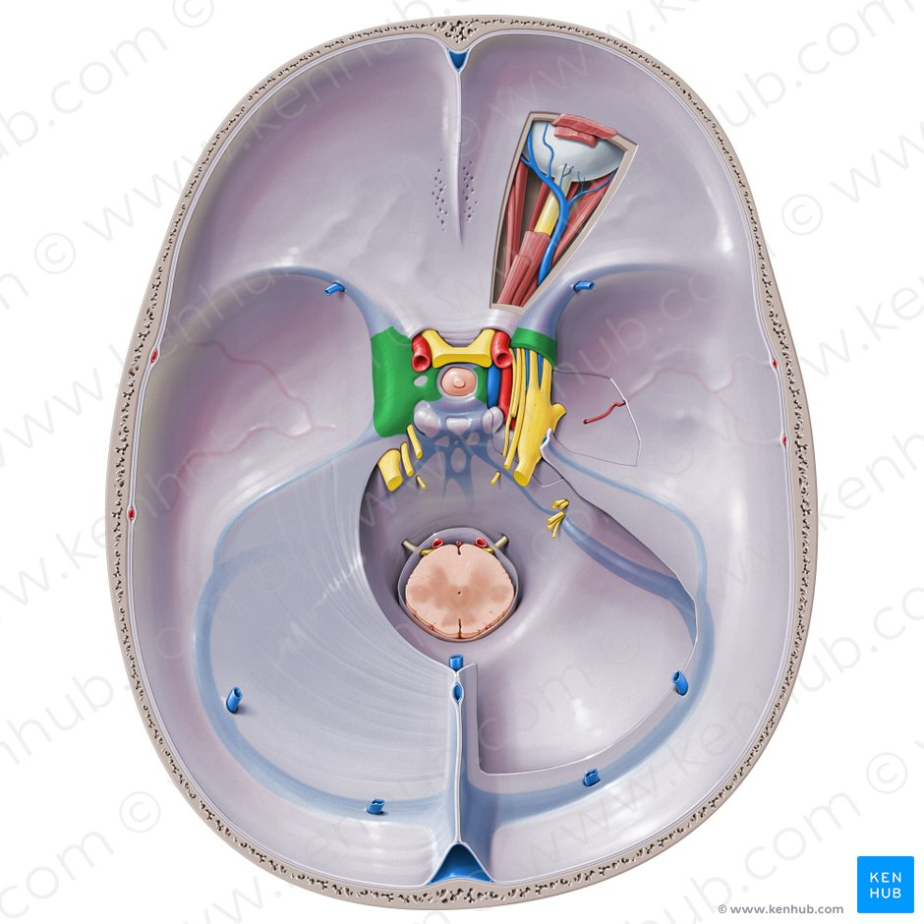
- Internal carotid artery
In addition to the thin walled veins that traverse the cavernous sinus, a long arterial vessel also uses the area as a conduit. The internal carotid artery (a branch of the common carotid artery) – along with its postganglionic sympathetic plexus from the superior cervical ganglion – gains access to the cavernous sinus posteriorly. As the petrous part of the internal carotid artery leaves the carotid canal, it curves vertically and superiorly above foramen lacerum to enter the cavernous sinus. Here, the artery is also referred to as the cavernous part.
Within the sinus, the internal carotid artery travels anteriorly, in a horizontal manner until it reaches the anterior limit of the sinus. Here it curves vertically and superiorly to exit the sinus through its roof and become the cerebral part of the internal carotid artery.
- NOTE: the cavernous part of the internal carotid artery is the only arterial vessel in the body that is completely surrounded by venous networks. This is thought to allow for heat exchange between the warm arterial blood and cooler venous circulation. This fact is of great clinical significance.
- Abducent nerve (CN VI)
This motor nerve leaves the pons and gains access through the posterior part of the sinus after passing the apical portion of the petrous temporal bone. It has also been known to access the cavernous sinus by way of the petrosal sinus, adjacent to the clivus.
Within the cavernous sinus, it takes an inferolateral course, relative to the internal carotid artery. It exits the sinus by way of the superior orbital fissure to gain access to the orbit, where it innervates the lateral rectus muscle of the eyeball.
- Oculomotor nerve (CN III)
The other nerves travelling through the cavernous sinus do so between the endothelial lining and the dura mater of its lateral wall. The most superior of the four nerves in the lateral wall is the oculomotor nerve (CN III).
At the posterior aspect of the roof of the cavernous sinus, the free and attached edges of tentorium cerebelli forms a space through which CN III enters the lateral wall of the sinus. It takes an anterior, inferomedial course (relative to the other nerves in the lateral wall) towards the anterior extremity of the sinus. Here it bifurcates into its superior and inferior rami that pass through the superior orbital fissure.
Along with sympathetic fibers from the internal carotid plexus, CN III provides motor supply to inferior oblique, levator palpebrae superioris, and the inferior, medial and superior recti muscles.
- Trochlear nerve (CN IV)
The smallest of the cranial nerves, the trochlear nerve (CN IV), enters the posterior aspect of the cavernous sinus after leaving the posterior part of the brainstem and decussating(crossing) with the same nerve from the opposite side. It continues anteriorly in the lateral wall of the cavernous sinus, inferior to CN III and passes through the superior orbital fissure at the anterior aspect of the sinus.
Once in the orbit, CN IV has the responsibility of innervating the muscles of the eyeball that are responsible for inferolateral motions.
- Ophthalmic (CN V₁) and maxillary (CN V₂) divisions of Trigeminal nerve (CN V)
Two of the three branches of the trigeminal nerve (CN V) pass through the cavernous sinus. Prior to entering the cavernous sinus, the proximal portion of the nerve lies in Meckel’s cave, where it forms the trigeminal ganglion. After leaving the cave, the mandibular division (CN V3) courses inferiorly to pass through foramen ovale (without entering the cavernous sinus).
The other two branches, the ophthalmic and the maxillary (CN V₁ and CN V₂, respectively), travel through the lateral wall of the sinus. Both take courses inferior to CN III and CN IV, however, CN V₂ is the most inferior of them all. Both CN V₁ and CN V₂ branches in the sinus travels horizontally.
CN V₂ leaves the sinus via foramen rotundum, while the three branches of CN V₁ exit the cranial fossa via the superior orbital fissure.
CN V₁ and CN V₂ are purely sensory and supply specific regions of the face

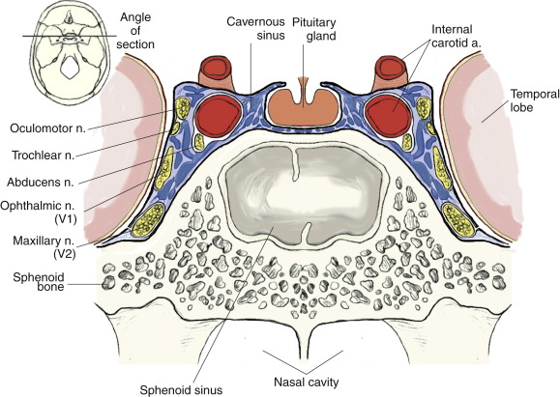
Relations

There are numerous structures surrounding the cavernous sinus that are noteworthy.
- Superiorly:
- optic tract,
- optic chiasma,
- cerebral part of internal carotid artery.
- Inferiorly:
- foramen lacerum and
- the junction of the body and gretaer wing of sphenoid bone
- Medially:
- walls of the pituitary fossa with the Hypophysis cerebri (or pituitary gland),
- the sphenoid bone and sphenoidal air sinus.
- Laterally:
- medial aspect of the temporal lobe with uncus.
- Anteriorly:
- superior orbital fissure and the apex of the orbit.
- Posteriorly:
- apex of petrous temporal bone

Communications
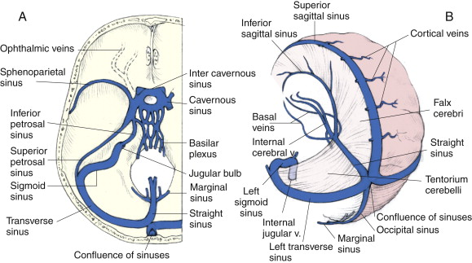
The cavernous sinus is an unconventional venous system in the sense that it does not have a unidirectional flow of blood. Owing to the fact that there are no valves in the sinus and its connected veins, the direction of blood flow is dependent on venous pressure. The veins that communicate with the cavernous sinus are:
- Superior ophthalmic vein
- Inferior ophthalmic vein
- Superficial middle cerebral vein
- Middle meningeal vein
- Hypophyseal veins
Superior ophthalmic vein
The superior ophthalmic vein receives blood from the ethmoidal, nasofrontal, vorticose (drains the ocular choroid), and central retinal and nasofrontal veins. It drains into the anterior part of the sinus via the superior orbital fissure.
The inferior ophthalmic vein
The inferior ophthalmic vein receives blood from the lacrimal sac, eyelids, the inferior rectus and inferior oblique muscles, the vorticose vein, and from the anterior and medial wall of the orbit.
It then runs posteriorly toward the lower part of the orbit and divides into two branches. The anterior branch joins the cavernous sinus, while the other one drains into the pterygoid plexus).
The superficial middle cerebral vein
At the point where the internal carotid artery emerges, the superficial middle cerebral vein pierces the roof of the sinus. Here, it drains blood from the cortices that are adjacent to it as it courses through the lateral sulcus.
The sphenoparietal sinus
The sphenoparietal sinus receives blood from some branches of the middle meningeal vein before draining into the cavernous sinus). The sphenoparietal sinus drains into the anterior ends of each cavernous sinus. These small sinuses are along the inferior surface of the lesser wings of the sphenoid and receive blood from the diploic and meningeal veins.
Efferent hypophyseal veins
Additionally, efferent hypophyseal veins of both the adenohypophysis and neurohypophysis drain to the cavernous sinus.

Anterior and posterior intercavernous sinuses and drainage
The left and right cavernous sinuses communicate by way of the anterior and posterior intercavernous sinuses. These vessels travel anteriorly and posteriorly (respectively) around the infundibulum of the pituitary gland, deep to the diaphragma sellae, between the layers of dura mater.
The cavernous sinus in turn drains to the superior and inferior petrosal sinuses. Both sinuses join the sigmoid sinus to become the internal jugular vein. The internal jugular vein exits the brain through the jugular foramen and connects with the subclavian vein to become the right or left brachiocephalic vein.

CLINICAL ANATOMY
  - The cavernous part of the internal carotid artery is the only arterial vessel in the body that is completely surrounded by venous networks. This is thought to allow for heat exchange between the warm arterial blood and cooler venous circulation. This fact is of great clinical significance.
  - Carotid-cavernous sinus fistula
It is the only anatomic location in the body in which an artery travels completely through a venous structure. If the internal carotid artery ruptures within the cavernous sinus, an arteriovenous fistula is created (more specifically, a carotid-cavernous fistula).
A carotid – cavernous sinus fistula is an abnormal communication between the internal carotid artery and the cavernous sinus caused by a tear in the artery wall, either traumatic or spontaneous. The sinus communicates directly with the veins of the orbit, so arterial pressure can be transmitted to the ophthalmic veins, which may become pulsatile. If arterial pressure is reduced because of this leak, a decrease in perfusion to ocular tissue will occur.
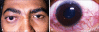

  - Cavernous sinus syndrome
Cavernous sinus syndrome is a medical emergency and life-threatening disorder that presents with different symptoms depending on what structure is affected. Lesions affecting the cavernous sinus may affect isolated nerves or all the nerves traversing through it.
A severe lesion involving the entire sinus will present with total ophthalmoplegia, due to CN III, IV, and VI injury, accompanied with fixed and dilated pupils due to compression of the superficial parasympathetic fibres of the CN III. When CN V₁ and CN V₂ are involved, sensory loss in the face, scalp, maxilla, nasal cavity, sinuses, and palate occurs.
Cavernous sinus syndrome can lead to Horner’s syndrome. Horner’s syndrome occurs when the sympathetic plexus around the internal carotid is damaged.
Potential causes of cavernous sinus syndrome include:
- metastatic tumors
- direct extension of nasopharyngeal tumours,
- meningioma
- pituitary tumors or pituitary apoplexy (The pituitary gland lies between the two paired cavernous sinuses. An abnormally growing pituitary adenoma, sitting on the bony Sella turcica, will expand in the direction of least resistance and eventually compress the cavernous sinus)
- aneurysms of the cavernous part of the internal carotid artery. In case of rupture of a cavernous aneurysm, a carotid-cavernous fistula is created, leading to a pulsating exophthalmos on physical examination
- carotid-cavernous fistula
- bacterial infection causing cavernous sinus thrombosis
- aseptic cavernous sinus thrombosis
- idiopathic granulomatous disease (Tolosa–Hunt syndrome), and
- fungal infections.
NOTE: Cavernous sinus syndrome is a medical emergency, requiring prompt medical attention, diagnosis, and treatment.
  - Cavernous sinus thrombosis (CST)
It refers to the formation of a clot within the cavernous sinus. This most common cause of CST is infection; which typically spreads from an extracranial location such as the orbit, paranasal sinuses, or the ‘danger zone’ of the face. Infection is able to spread in this manner due to the anastomosis between the facial vein and superior ophthalmic veins.
Infections of the face or orbit can be dangerous. An infected embolus that forms in a facial or orbital vein can readily pass into the cavernous sinus via an ophthalmic vein because these veins do not have valves, forming a cavernous sinus thrombosis. From there the infection may spread to the dura venous sinuses. Infections may also be introduced by facial lacerations and by bursting pimples in the areas drained by the facial vein.
A cavernous sinus thrombosis can be fatal and must be treated aggressively with antibiotics.
Common clinical features include headache, unilateral periorbital oedema, proptosis (eye bulging), photophobia and cranial nerve palsies.
The abducens nerve (CN VI) is most commonly affected. Where the cause is infection, thrombosis of the cavernous sinus can rapidly progress to meningitis.
Treatment is typically with antibiotic therapy.
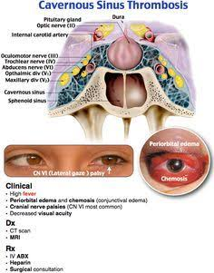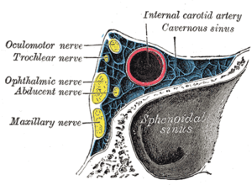
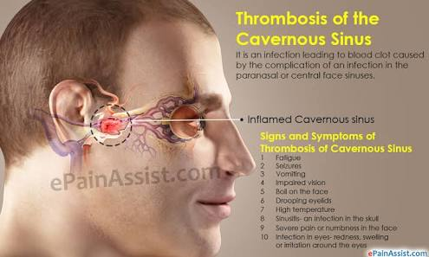
  - Facial veins and implication to cavernous sinus infection
Blood from the medial angle of the eye, lips, and nose usually drain via the facial vein. However, blood from these parts may also drain superiorly through the facial vein, to the superior ophthalmic, to the cavernous sinus. By doing so, it provides a pathway for infections from the face to spread to the cavernous sinus and from the sinus to the brain.
Another way for infections to spread from the face to the brain is via the inferior ophthalmic vein. In fact, the inferior ophthalmic vein communicates with the pterygoid plexus of veins, and the pterygoid plexus communicates with the cavernous sinus via the emissary's vein. Gravity dictates the blood flow from the cavernous sinus to the pterygoid plexus; however, in the case of inflammation or obstruction, the pressure gradient can be reversed. Because there are no valves in the brain’s venous sinus, blood will flow from the pterygoid plexus to the cavernous sinus carrying bacteria with it.

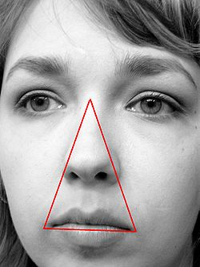
DANGER TRIANGLE OF THE FACE
Question 2
WALLS OF THE NOSE
The nose is the part of the respiratory tract superior to the hard palate. It contains the peripheral organ of smell. The nose is the most prominent part of the human face. It has internal and external parts.
EXTERNAL PART
The external nose is the visible portion that projects from the face. It also functions to protect the inner nose and allows the entry of air. The external part of the nose consists of a root (superiorly), apex (inferiorly), dorsum, nares (nostrils) and the separating nasal septum. Its skeleton is mainly cartilaginous (small bony contributions are present). The bony component are nasal, maxillae and frontal bones. The Cartilaginous component are alar cartilages (major, minor), lateral processes, septal cartilage. The skin over the cartilaginous part of the nose is covered with thicker skin, which contain many sebaceous glands
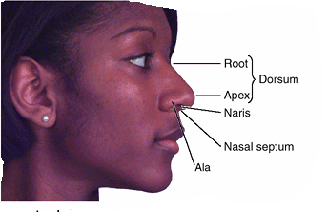

INTERNAL PART
The internal part of the nose is termed the nasal cavity. It is involved in respiration, olfaction, speech and taste. The two nasal cavities sit within the external nose and the adjacent skull. The cavities open anteriorly to the face through the two nares. Posteriorly the cavities communicate with the nasopharynx by two apertures called choanae.
Besides the anterior and posterior apertures (chonae), each nasal cavity has a
- roof,
- floor,
- lateral wall
- and medial walls.
The nasal cavity is divided into three regions, aligned as if a 3-floors building.
- The vestibule is located just inside the anterior external opening of the nose (1st floor) and it contains hair follicles.
- The largest region is the respiratory region, which is lined with respiratory epithelium (2nd floor), and
- The olfactory region, a small area located inside the skull at the superior apex of the cavity, which is lined with olfactory cells and receptors (3rd floor).
There are 12 cranial bones in total that contribute to the nasal cavity structure, which include
- the paired nasal, maxilla, palatine and lacrimal bones, as well as
- the unpaired ethmoid, sphenoid, frontal and vomer bones.
Among all of them, the ethmoid bone is the most important element, for two reasons: first, it makes the greatest portion of the nasal skeletal framework by forming the roof and walls of the nasal cavities; and second, it contains ethmoidal cells which, as a group, are one of the four paranasal sinuses.
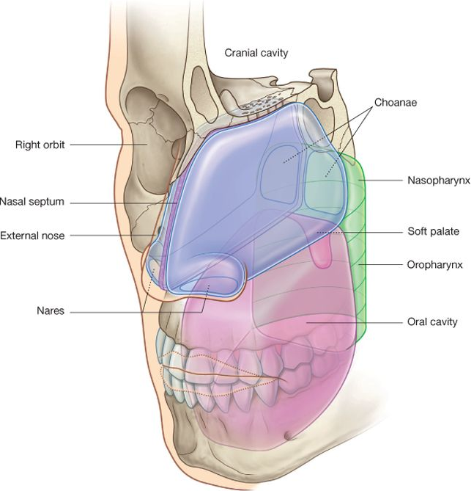

The two nasal cavities communicate with four bony recesses called the paranasal sinuses. They are named according to the bones they are placed within, as the: sphenoidal, maxillary, and frontal sinuses, and the ethmoidal cells. All of the sinuses are covered by respiratory mucosa and innervated by the trigeminal nerve (CN V).

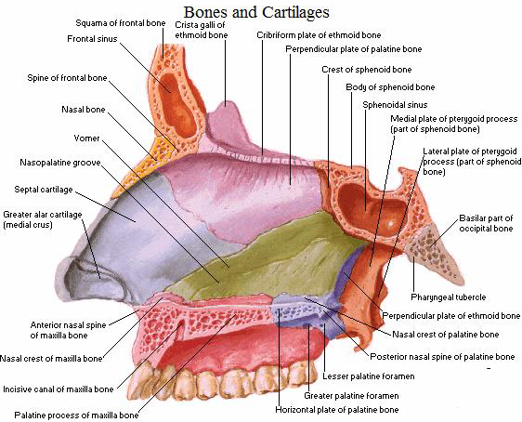

The roof of the Nasal Cavity
The mucosa of the roof of the nasal cavity contains perforations that communicate with the cribriform plate. Within these perforations are the olfactory axons.
- Anterior: nasal spine of the frontal bone and nasal bone.
- Posterior: cribriform plate of the ethmoid and the body of the sphenoid
The floor of the Nasal Cavity
The floor of the nasal cavity is broader than that of the roof.
- Anterior: the palatine process of the maxilla.
- Posterior: horizontal plate of the palatine bone
The incisive canal is located in the floor of the nasal cavity, posterior to the central incisor, and lateral to the nasal septum. This structure transmits the nasopalatine nerve into the oral cavity and the greater palatine artery into the nasal cavity.

Medial wall of the nasal cavity (nasal septum)
The medial wall is formed by the nasal septum. The nasal septum partitions the nasal cavity into two equal but separate compartments. It is covered by squamous epithelium, which differs from the lateral walls of the nasal cavity. It has a:
- bony part
- a soft mobile cartilaginous part
The bony components of the nasal septum are
- perpendicular plate of the ethmoid bone
- Vomer bone
- nasal crest of the maxillary bone
- nasal crest of palatine bone
The bony segment of the septum is pneumatized, and when it over expands, it has the potential to obstruct airflow
The cartilaginous part of the nasal septum is
- septal cartilage
Quadrangular (septal) cartilage:
This is the most anterior portion of the septum. The septal cartilage has a tongue-and-groove articulation with the edges of the bony septum. It contains the Kiesselbach plexus.
Attachments:
- Superior: nasal bone
- Inferior: anterior nasal spine of the maxilla
- Posterior-Superior: perpendicular plate of the ethmoid
- Posterior-Inferior: vomer and maxillary crest
The thin perpendicular Plate of the Ethmoid:
This is a vertical projection from the cribriform plate of the ethmoid inferiorly to the septal cartilage and is continued superior to the cribriform plate as the crista galli. It forms the superior part of the nasal septum.
Vomer:
It is a thin flat bone located inferior and slightly posterior to the perpendicular plate of the ethmoid, forming the posteroinferior part of the nasal septum. It is attached inferiorly to the nasal crest of the maxilla and palatine bone.
Nasal Crest of the Maxilla and Palatine Bone:
Together these bones form the inferior support for the septal cartilage.
Anterior Nasal Spine of the Maxilla:
This is a bony projection formed by the paired maxillary bones. It located anterior to the piriform aperture and are palpable at the superior portion of the philtrum of the upper lip.

Lateral Wall of the Nasal Cavity
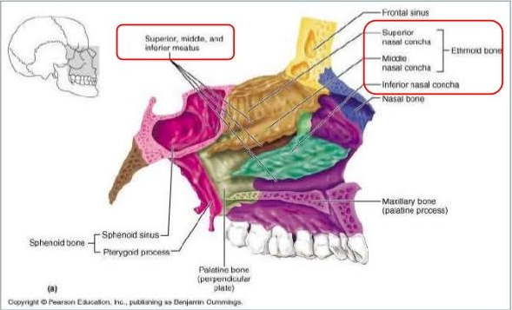
The nasal cavity's lateral wall has three medially projecting inferiorly curved bones called conchae.
The conchae are:
- Superior concha
- Middle concha
- Inferior concha
- Supreme concha (this is a normal variant)
The middle and superior conchae are part of the ethmoid bone, whereas the inferior concha is a separate bone altogether.
The inferior concha is the longest and broadest and is formed by an independent bone (of the same name, inferior concha) covered by a mucous membrane that contains large vascular spaces that can enlarge to control the caliber of the nasal cavity. When infected or irritated, the mucosa may swell rapidly, blocking the nasal passage(s) on that side
The lateral walls are irregular owing to these nasal conchae, which project inferomedially, somewhat like louvers. These conchae, when covered by mucosa, are termed turbinates. The turbinates augment the surface area of the nasal cavity to aid in its functions of warming, and humidifying the air and for heat exchange.
The turbinates create four channels. Three of these channels are termed meatuses, and the fourth is the sphenoethmoidal recess.
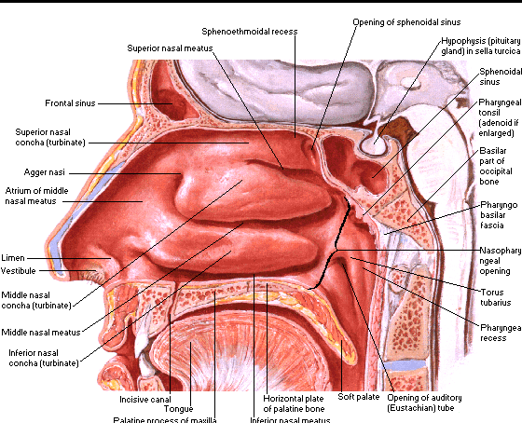
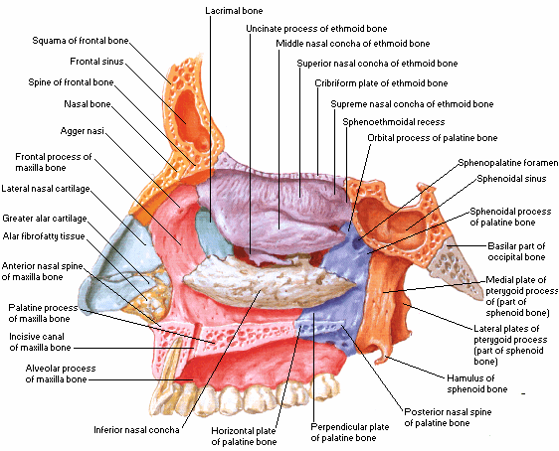
The nasal cavity is thus divided into 5 passages:
1) a posterosuperiorly placed sphenoethmoidal recess, between the superior concha and the nasal cavity roof
- 3 laterally located nasal meatus:
2) superior nasal meatus, between the middle and superior conchae
3) middle nasal meatus, between the inferior and middle conchae
4) inferior nasal meatus, between the floor and inferior conchae
5) and a medially placed common nasal meatus into which the four lateral passages open

- The sphenoethmoidal recess:
It lies superoposterior to the superior concha and inferior to the nasal cavity roof, which is the drainage site of the sphenoid sinus. It receives the opening of the sphenoidal sinus, an air-filled cavity in the body of the sphenoid.
- The superior nasal meatus:
It is a narrow passage inferior to the superior and superior to the middle nasal conchae. The posterior ethmoidal sinuses open into this superior nasal meatus through one or more orifices.
- The middle nasal meatus:
It is located inferior to the middle turbinate and superior to the inferior turbinate. is longer and deeper than the superior one.
There are several structures within this meatus. This is the drainage site of the frontal, anterior ethmoid, and maxillary sinuses
- The anterosuperior part of this passage leads into a funnel-shaped opening, the ethmoidal infundibulum through which it communicates with the frontal sinus through a passage known as the frontonasal duct
- the anterior ethmoidal cells open directly or indirectly on the ethmoidal infundibulum
The ethmoidal infundibulum leads inferiorly into a semicircular groove called the semilunar hiatus
- The maxillary sinuses open into the semilunar hiatus
Superior to the semilunar hiatus is a rounded elevation called the ethmoidal bulla. The ethmoidal bulla is only visible when the middle concha is removed. The bulla is a swelling formed by middle ethmoidal cells that form the ethmoidal sinuses.
Anterior and inferior to the semilunar hiatus is a hook like process called the uncinate process of the ethmoid bone. This process articulates with the inferior nasal concha.
- The inferior nasal meatus:
Itis a horizontal passage inferolateral to the inferior nasal concha. It is located inferior to the inferior turbinate and superior to the floor of the nasal cavity.
The nasolacrimal duct, which drains tears from the lacrimal sac at the medial aspect of the eye, opens into the anterior part of this meatus via Hasner's valve.
- The common nasal meatus:
It is the medial part of the nasal cavity between the conchae and the nasal septum, into which the lateral recesses and meatus open.

The Arterial Supply
- The arterial supply of the medial and lateral walls of the nasal cavity is from five sources:
- Anterior ethmoidal artery (from the ophthalmic artery)
- Posterior ethmoidal artery (from the ophthalmic artery)
- Sphenopalatine artery (from the maxillary artery)
- Greater palatine artery (from the maxillary artery)
- Septal branch of the superior labial artery (from the facial artery)
Kiesselbach's Plexus (Little's Area)
Kiesselbach's plexus is an anastomotic arterial plexus involving all five arteries supplying the septum. It is a vascular anastomosis of the anterior ethmoid artery, superior labial artery, greater palatine artery, and the terminal branch of the posterior septal branch of the sphenopalatine artery.
This vascular plexus is located in the anterior nasal septum and is the most common site of epistaxis.
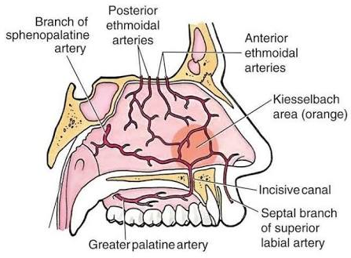
Woodruff's Plexus
Woodruff's plexus is a vascular anastomosis between the sphenopalatine artery and the ascending pharyngeal artery.
It is located on the lateral wall of the nasal cavity in the area posterior to the middle and inferior turbinates.
- The external nose also receives blood from
- Anterior ethmoidal artery
- Septal branch of the superior labial artery
- Nasal branches of the infraorbital artery
- Lateral nasal branches of the facial artery
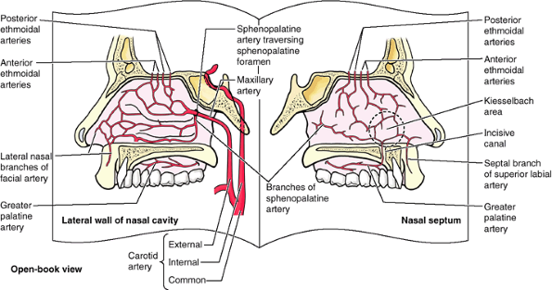
Venous Drainage
- The names of the veins that drain the nose and nasal cavity follow that of the arteries with which they pair.
- The maxillary branches drain either into the cavernous sinus or the pterygoid plexus located in the infratemporal fossa.
- The veins of the anterior nasal cavity drain into the facial vein.
Of note, infections located between the oral commissure and nasal bridge, have the potential to become intracranial infections. These must be treated promptly to prevent the extension of infection.
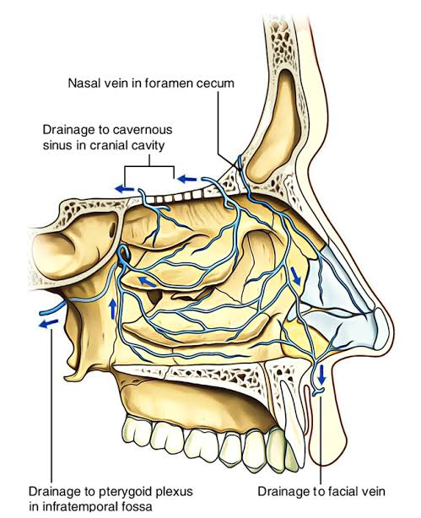

Lymphatics
- The anterior nasal cavity drains anteriorly to the face that then makes its way to the submandibular lymph nodes.
- The lymphatics of the posterior nasal cavity and paranasal sinuses drain into the upper cervical lymph nodes and retropharyngeal lymph nodes.

Innervation
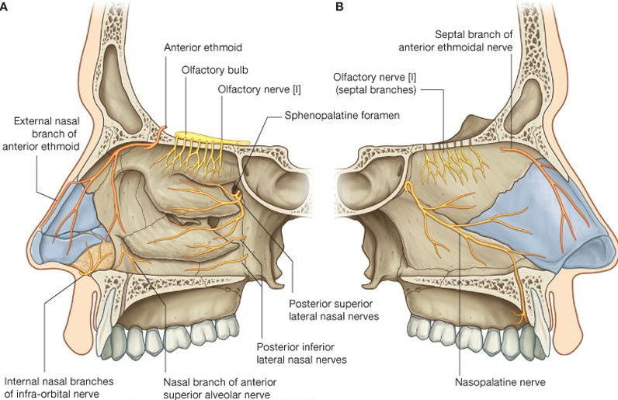

The nose is innervated by three cranial nerves:
- Olfactory Nerve (CN I)
The olfactory nerve transmits signals from the nasal cavity to the brain to give the sense of olfaction (sense of smell). The olfactory epithelium is in the superior portion of the nasal cavity. Within this epithelium are sensory cilia that project up through the cribriform plate to the olfactory bulb. From the olfactory bulb, signals are sent through the olfactory nerve proper to a network of secondary neurons for processing before ending up in the brain.
- Trigeminal Nerve (CNV)
The trigeminal nerve is the sensory innervation to the external and internal nose. The branches are the ophthalmic (CN V₁), maxillary (CN V₂), and mandibular (CN V₃). Sympathetic and parasympathetic fibres run with these branches to supply their target tissues. The ophthalmic and maxillary branches innervate and provide general sensation to the nose and nasal cavity

- Ophthalmic Branches (CN V₁): As the ophthalmic nerve begins to branch, it gives off a nasociliary branch, which then provides the anterior and posterior ethmoid nerves.
- The anterior ethmoid nerve gives off an external branch that supplies the nasal tip, an internal branch that supplies the anterosuperior nasal cavity and a septal branch that supplies the anterior superior nasal septum.
- The posterior ethmoid nerve supplies the posterosuperior nasal cavity. Two other branches of the ophthalmic branch of the trigeminal nerve are the supratrochlear and infratrochlear nerves that supply the nasal dorsum.
- Maxillary Branches (CN V₂): The maxillary branches of the trigeminal nerve that innervate the nose and nasal cavity branch in or near the pterygopalatine fossa then enter the nasal cavity. The only external nasal branch is the infraorbital nerve, which supplies the malar and lateral nose.
- The nasopalatine nerve traverses the nasal septum from posterior to anterior in a downward projection to enter the incisive canal. It supplies the posterior and inferior nasal septum as well as mucosa just posterior to the incisors.
- The greater palatine nerve follows the greater palatine artery down the palatine canal, giving off posterior inferior lateral nasal nerves that supply the posterior lateral wall of the nasal cavity.
- The posterior superior lateral nasal nerve and posterior superior medial nasal nerve, both pass through the sphenopalatine foramen to supply the lateral and medial walls of the nasal cavity, respectively.
- The superior alveolar nerve is the last branch of V₂, and it supplies the anterior septum and the area near the nasal vestibule.

CLINICAL ANATOMY
  - Epitaxis (nose bleed)
Epistaxis (nosebleed) is relatively common because of the rich blood supply to the nasal mucosa.
Epistaxis is usually caused by:
- a trauma
- sinus infection
- rhinitis
- an arid environment
- hypertension
- hematologic disorders
- neoplasms
Mild epistaxis may also result from nose picking, which tears veins in the vestibule of the nose. Epistaxis is also associated with infections and hypertension.
Spurting of blood from the nose results from rupture of arteries
The most common form is anterior epistaxis which occurs along the septum and arises from kiesselbach's plexus. Posterior epistaxis is usually due to the maxillary artery.
Depending on the area of the bleed, various treatments are available since the blood will either run out of the nose in an anterior case or down the throat in a posterior case.

  - Rhinitis
Rhinitis is another clinical term and its simple name is a stuffy nose. An inflammation causes nasal congestion, sneezing, rhinorrhoea or a runny nose and nasal itching. The most common cause is allergic reactions e.g. hay fever. Swelling of the mucosa occurs readily because of its vascularity.
This is systematically treated with decongestants, antihistamines and steroids.
Infections of the nasal cavities may spread to the:
- Anterior cranial fossa through the cribriform plate
- Nasopharynx and retropharyngeal soft tissues
- Middle ear through the pharyngotympanic tube (auditory tube), which connects the tympanic cavity and nasopharynx
- Paranasal sinuses
- Lacrimal apparatus and conjunctiva
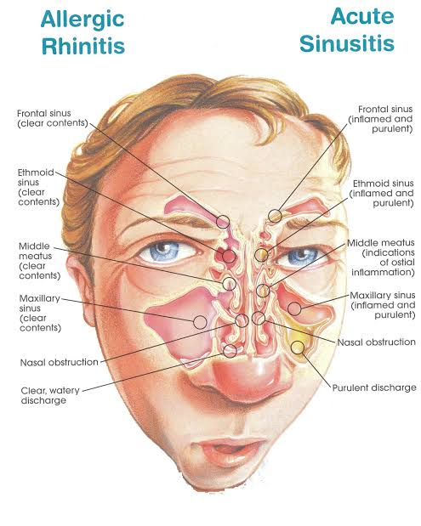
  - A deviated septum
A deviated septum means that the bony midline of the nasal cavity is off centre i.e. the thin wall that separates your right and left nasal passages is displaced to one side.
It is caused either due to a trauma or birth defects and this results in partial or total occlusion of one side of the cavity.
When a deviated septum is severe, it can block one side of your nose and reduce airflow, causing difficulty breathing. The additional exposure of a deviated septum to the drying effect of airflow through the nose may sometimes contribute to crusting or bleeding in certain people.
The treatment is surgical and a septoplasty is usually performed.
