Name: OMOSEEBI OLUWANIFEMI AUSTINE
Matric no.: 19/MHS09/018
Department: Dentistry
Course code: CHM 102
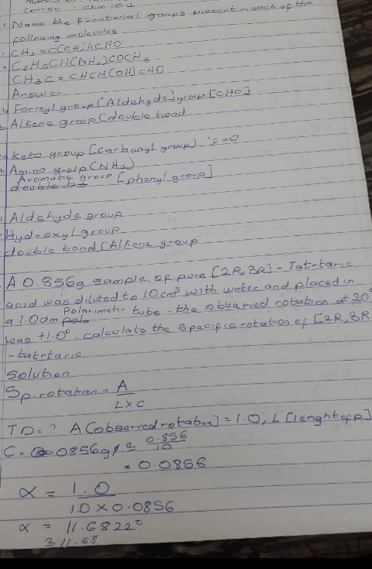
Solutions to Assignment
